University of Essex Online
MSc Cybersecurity
Individual Project: Executive Summary
Module: Security and Risk Management
Student ID: 12700830
Module Tutor: Dr. Godfried Williams
Submission Date: 13 July 2026
Word Count: 2,000
Contents
List of Tables 2
Table of Figures 3
Executive Summary 4
Introduction 5
Risk Identification and classification 6
Selection and Justification of the Quantitative Risk Modelling Approach 8
Assumptions and Data Sources 11
Quantitative Risk Analysis 12
Results and Interpretation 16
Conclusion 18
References 20
Appendices 21

List of Tables
Table 1. Classification of Key Risks 7

Table of Figures

Figure 1 Source: Created by the author based on Aven (2015), Hubbard (2020), Metropolis and Ulam (1949), and Stoneburner et al. (2002). 10

Executive Summary
Pampered Pets is preparing to expand its operations through an international supply chain and a network of automated warehouses as part of its ongoing digital transformation. Although these developments are expected to improve operational efficiency and support future growth, they also introduce new sources of uncertainty that may affect product quality, supply chain continuity and overall business resilience. To support informed decision-making, this report evaluates these uncertainties using a quantitative Monte Carlo simulation model.
The assessment identifies six principal operational risk categories associated with the proposed transformation and develops a probability-based model using assumptions derived from the case study, published academic research and recognised risk management guidance. By simulating 10,000 possible operational scenarios, the model estimates the likelihood of disruption and demonstrates how multiple operational risks may interact under conditions of uncertainty, providing a more realistic basis for strategic decision-making than deterministic assessment alone.
The findings indicate that operational disruption should be regarded as an expected management challenge during international expansion rather than an exceptional event. Supply chain disruption emerged as the most significant operational concern, while the possibility of multiple concurrent risk events highlighted the importance of strengthening organisational resilience before implementation. Overall, the assessment demonstrates that quantitative risk analysis provides management with a robust evidence base for anticipating uncertainty, prioritising risk mitigation activities and supporting sustainable business growth through more informed strategic decisions.

Introduction
Pampered Pets has reached a significant stage in its digital transformation. Following the successful implementation of the recommendations proposed in the previous assessment, the company plans to expand its operations through an international supply chain and a network of automated warehouses. While these developments are expected to improve production capacity, operational efficiency and global market reach, they also introduce new sources of operational uncertainty. Increased dependence on international suppliers, automated technologies and cloud-based services means that disruptions originating outside the organisation could have a direct impact on product quality and the continuity of supply.
As organisations expand beyond domestic operations, many of the factors influencing business performance become increasingly difficult to control. Supplier disruption, logistics delays, cybersecurity incidents and failures within automated systems may all interrupt operations, delay customer orders and damage organisational reputation if they are not managed effectively. Modern risk management therefore extends beyond identifying individual threats; it seeks to understand how uncertainty may influence organisational objectives so that management decisions are supported by evidence rather than assumption (Aven, 2015). As Hubbard (2020) argues, expressing uncertainty quantitatively provides decision-makers with a stronger basis for action than relying solely on qualitative judgements.
The importance of effective risk management is heightened by Pampered Pets' expanding customer profile, which includes prestigious clients such as HRH the King and Prince Albert II of Monaco. For an organisation operating in premium markets, maintaining consistent product quality and reliable product availability is essential to protecting customer confidence and organisational reputation.
Against this background, this report applies a quantitative Monte Carlo simulation model to evaluate how uncertainty may influence product quality and supply chain continuity during Pampered Pets' proposed transformation. The findings are then interpreted to develop evidence-based recommendations that strengthen organisational resilience, support informed strategic decision-making and improve preparedness for future operational disruption.

Risk Assessment Methodology

Risk Identification and classification
The proposed international expansion introduces new business relationships, technologies and operational processes that were not considered in the previous assessment. As Pampered Pets becomes increasingly dependent on international suppliers, automated warehouses and cloud-based services, the organisation is exposed to new sources of uncertainty that could affect both product quality and supply chain resilience.
Consequently, the first step is to identify the principal sources of uncertainty introduced by these changes before evaluating their likelihood and potential impact. Aven and Thekdi (2025) argue that organisational change increases uncertainty around business objectives, making systematic risk assessment essential before strategic decisions are implemented. This perspective is consistent with ISO 31000:2018, which recommends reviewing organisational risks whenever significant internal or external changes occur (ISO, 2018).
Effective quantitative analysis depends on identifying the right risks at the outset. If important sources of uncertainty are overlooked during this stage, subsequent probability estimates and modelling results may provide a misleading picture of the organisation's true exposure. Sutton (2021) emphasises that effective information risk management should support organisational objectives rather than focusing solely on technical threats. Similarly, NIST SP 800-30 identifies risk identification as the starting point for analysing threats, vulnerabilities and their potential business consequences (Stoneburner et al., 2002).In the context of Pampered Pets, the primary objective is to preserve the company's reputation for high-quality products while maintaining a reliable international supply chain. Therefore, the risks identified in this section focus on those most likely to affect these business objectives.
The principal risks associated with the proposed digital transformation have been classified into six categories, as presented in Table 1. These categories have been organised according to the aspect of the business they are most likely to influence rather than their perceived severity. At this stage, the purpose is to establish the scope of the assessment rather than to rank individual risks. Their relative likelihood and business significance will be determined later using an appropriate quantitative risk modelling approach.

Table 1. Principal Risks Associated with the Digital Transformation of Pampered Pets
Risk Category | Example Risk | Potential Business Impact
Supply Chain Risks | Supplier disruption, transport delays, customs issues or geopolitical events | Material shortages, delayed deliveries, reduced product availability
Product Quality Risks | Defective or counterfeit raw materials; inconsistent supplier quality | Reduced product quality, customer complaints, product recalls and reputational damage
Technology & Automation Risks | Warehouse robotics failure, inventory management system outage or software malfunction | Production delays, order fulfilment disruption, increased operational costs
Cybersecurity Risks | Ransomware, phishing attacks or unauthorised access to operational systems | Business interruption, data compromise and disruption to warehouse or supply chain operations.
Regulatory & Compliance Risks | Failure to comply with UK GDPR or international trade regulations | Financial penalties, legal action and damage to organisational reputation.
Third-Party Dependency Risks | Cloud service outage, payment gateway failure, outsourced IT service disruption or logistics platform failure | Business interruption, reduced operational resilience and customer service disruption.
The risks identified in Table 1 establish the scope of the quantitative assessment presented in the following sections. However, identifying risks alone does not indicate how likely they are to occur or which pose the greatest threat to the organisation's objectives. To support evidence-based decision-making, these risks must now be evaluated using an appropriate quantitative risk modelling technique capable of estimating their probability under conditions of uncertainty.

Selection and Justification of the Quantitative Risk Modelling Approach
Having identified and classified the principal risks associated with the proposed digital transformation, the next stage of the assessment is to select an appropriate quantitative risk modelling technique. Different quantitative methods are designed to address different decision-making problems; therefore, the selected approach should reflect the objectives of the assessment and the nature of the uncertainties being analysed. For this assessment, three quantitative approaches introduced during the module were evaluated: Bayes' Theorem, Multi-Criteria Decision Analysis (MCDA) and Monte Carlo Simulation.
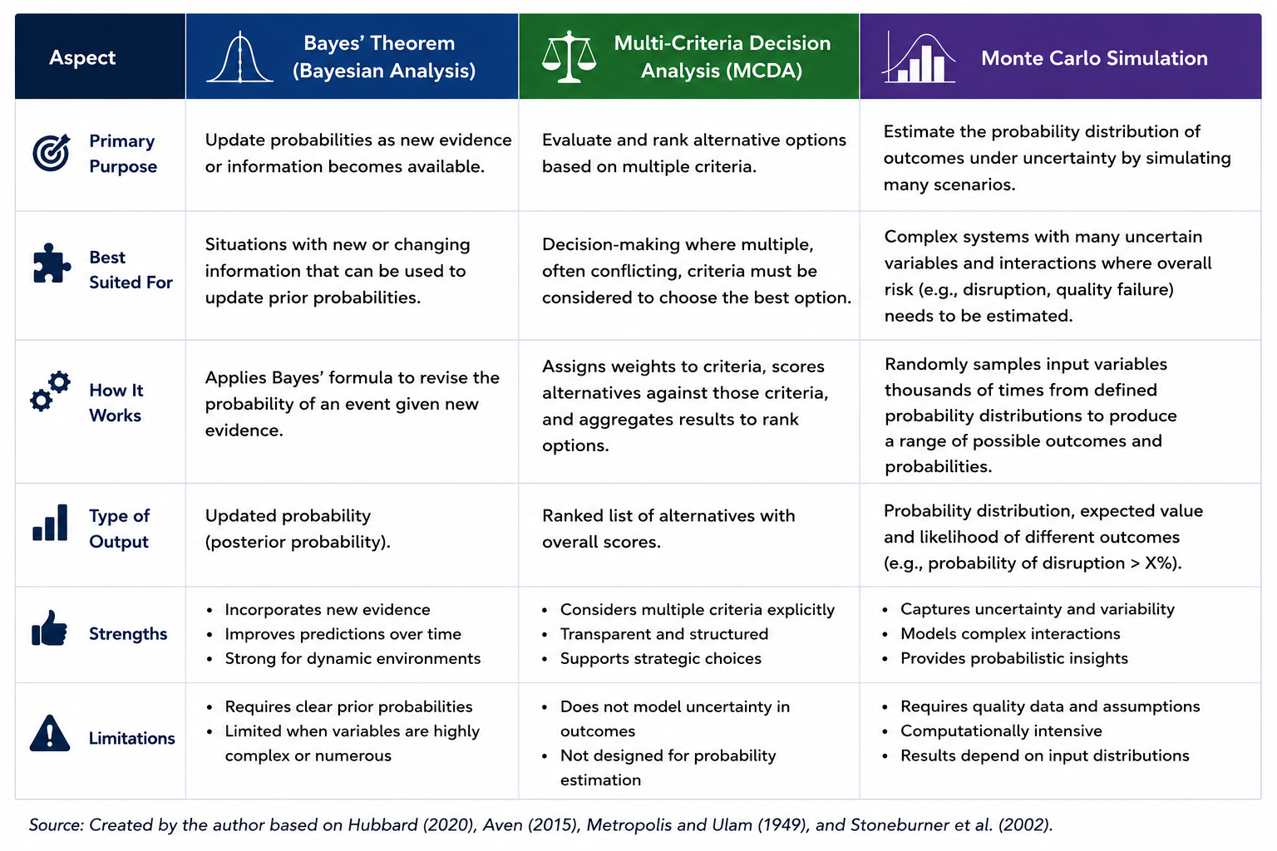
Figure 1. Comparison of quantitative risk modelling approaches considered for the Pampered Pets risk assessment.
Source: Created by the author based on Aven (2015), Hubbard (2020), Metropolis and Ulam (1949), Vose (2008), and Stoneburner et al. (2002).
Figure 1 demonstrates that each quantitative technique has been developed to address a different type of decision-making problem under conditions of uncertainty. Bayes' Theorem is designed to update the probability of an event when new evidence becomes available, making it particularly suitable for environments where information changes over time. MCDA, on the other hand, supports decision-making by comparing alternative options against multiple weighted criteria and is widely used when organisations need to select the most appropriate strategy or investment. In contrast, Monte Carlo Simulation estimates the probability of uncertain outcomes by repeatedly simulating thousands of possible scenarios using probability distributions assigned to key input variables. Unlike the other two techniques, it produces a probability distribution rather than a single deterministic result, allowing decision-makers to understand both the likelihood and range of potential outcomes (Hubbard, 2020; Aven, 2015).
Although Bayes' Theorem and MCDA are valuable quantitative techniques, they do not fully address the objectives of this assessment. The primary challenge facing Pampered Pets is not to update existing probabilities or compare alternative business strategies, but to estimate the likelihood that multiple uncertain events could collectively affect product quality and supply chain performance following international expansion. These events, including supplier disruption, warehouse automation failures and cybersecurity incidents, may occur independently or simultaneously, making the overall level of risk difficult to predict using deterministic methods alone. Monte Carlo Simulation is therefore considered the most appropriate approach because it models uncertainty by repeatedly simulating a large number of possible outcomes using probability distributions assigned to key input variables. This enables management to estimate the probability of disruption and understand the range of potential outcomes before making strategic decisions (Metropolis and Ulam, 1949; Hubbard, 2020; Vose, 2008).
Considering both the comparison in Figure 1 and the objectives of this assessment, Monte Carlo Simulation was selected as the primary quantitative risk modelling technique. Its ability to model multiple sources of uncertainty simultaneously makes it particularly suitable for assessing the combined effects of supplier disruption, automation failures and digital dependencies introduced by Pampered Pets' international expansion. The following section defines the assumptions, input variables and data sources used to construct the quantitative model.

Assumptions and Data Sources
The reliability of any quantitative risk assessment depends on the quality of the assumptions and data used to construct the model. As Pampered Pets is a fictional case study, no historical operational data or internal risk records are available for analysis. Consequently, a number of reasonable assumptions were developed to enable the quantitative assessment while ensuring that they remained consistent with the business scenario presented in the case study. Aven and Thekdi (2025) emphasise that risk analysis should be transparent about the assumptions that underpin decision-making, particularly where uncertainty exists and complete information is unavailable. Similarly, Popov, Lyon and Hollcroft (2022) argue that clearly documented assumptions improve the credibility and reproducibility of quantitative risk assessments.
The assumptions adopted for this assessment are summarised in Table 2. They define the scope of the model and establish a consistent basis for estimating the probability of events that may affect product quality and supply chain resilience. Where company-specific information was unavailable, assumptions were informed by the case study, peer-reviewed academic literature and recognised international standards rather than unsupported judgement. This approach reflects accepted practice in quantitative risk assessment, where transparent assumptions supported by credible evidence provide a more reliable basis for decision-making under conditions of uncertainty (Aven and Thekdi, 2025; Popov, Lyon and Hollcroft, 2022).

Table 2. Assumptions Used in the Quantitative Risk Model
Assumption | Justification | Supporting Source
The business operates an international supply chain involving multiple suppliers and logistics providers. | Reflects the digital transformation described in the case study and provides the operational context for modelling supply chain uncertainty. | Aven & Thekdi (2025
Individual risk events (e.g., supplier disruption, cyberattack and warehouse automation failure) are treated as independent events for modelling purposes. | Simplifies the Monte Carlo model while allowing each risk variable to be analysed using its own probability distribution. | Popov, Lyon & Hollcroft (2022)
Historical company data are unavailable. | Pampered Pets is a fictional organisation; therefore, no internal historical records exist to support statistical modelling. | Aven & Thekdi (2025)
Probability estimates are based on credible published sources and reasonable assumptions rather than exact operational records. | Ensures that assumptions remain transparent, realistic and supported by credible evidence rather than arbitrary estimates. | Sutton (2021); ISO 31000:2018
The operational environment remains stable throughout the simulation period. | Assumes that no major external events (such as significant regulatory change or global crises) occur during the period being modelled, allowing the analysis to focus on the identified operational risks. | Popov, Lyon & Hollcroft (2022)

Quantitative Risk Analysis
Following the identification of key risks and the definition of the underlying assumptions, a quantitative risk analysis was undertaken using Monte Carlo Simulation. This technique was selected because it enables uncertainty to be represented through repeated simulation of multiple risk scenarios, providing probability-based estimates rather than single deterministic outcomes. In this assessment, the model evaluates the combined influence of the identified operational risks on product quality and supply chain continuity, thereby supporting more informed decision-making under conditions of uncertainty (Aven and Thekdi, 2025; Popov, Lyon and Hollcroft, 2022; Metropolis and Ulam, 1949).
The model was developed around the six operational risks identified in Section 2.1, ensuring a clear link between the qualitative risk assessment and the quantitative analysis. Rather than introducing additional variables, the simulation quantified the uncertainty associated with the existing risk register, allowing the cumulative effect of multiple operational events to be examined. This approach reflects good risk management practice because organisational risks rarely occur in isolation and should therefore be assessed collectively rather than independently (Popov, Lyon and Hollcroft, 2022).
Table 3. Input Variables Used in the Monte Carlo Risk Model
Input Variable | Description | Relationship to Table 1 | Supporting Source
Supplier Disruption | Failure or delay of international suppliers affecting production continuity. | Supply Chain Risk | Fahimnia et al. (2019)
Product Quality Failure | Defective or inconsistent products resulting from poor-quality materials or production processes. | Product Quality Risk | Pineiro-Chousa et al. (2017)
Warehouse Automation Failure | Failure of automated warehouse systems affecting order fulfilment and inventory management. | Technology & Automation Risk | Sutton (2021)
Cybersecurity Incident | Cyberattack affecting operational systems, availability or business continuity. | Cybersecurity Risk | Ridley, McCloskey and Mountain (2018)
Third-Party Service Failure | Failure of cloud services, logistics platforms or outsourced service providers. | Third-Party Dependency Risk | Sutton (2021)
Regulatory Compliance Failure | Failure to comply with GDPR or international regulations resulting in operational disruption or financial penalties. | Regulatory & Compliance Risk | ISO 31000:2018
The input variables presented in Table 3 represent the operational events most likely to influence product quality and supply chain continuity during the transformation programme. Collectively, they capture uncertainties associated with international suppliers, warehouse automation, cybersecurity, third-party service providers and regulatory compliance. By incorporating these variables into a single simulation model, the assessment moves beyond qualitative judgement and provides a structured method for evaluating how different combinations of risks may affect organisational performance.
To represent uncertainty, the model employed Triangular probability distributions for each risk variable using minimum, most likely and maximum estimates. This approach was considered appropriate because historical operational data for Pampered Pets were unavailable, whereas realistic ranges could be derived from the case study, supporting academic literature and recognised industry guidance. Triangular distributions are widely used in quantitative risk analysis where reliable empirical data are limited but informed estimates can reasonably be justified (Hubbard, 2020). Their simplicity also makes them particularly suitable for executive-level decision support because the underlying assumptions remain transparent and easy to interpret.
To operationalise the simulation, probability parameters were assigned to each risk variable using evidence drawn from the case study and the literature reviewed in Section 2.3. These parameters defined the range within which each risk could vary during the simulation. Table 4 summarises the probability estimates adopted for each operational risk.
Table 4. Estimated Probability Parameters for the Monte Carlo Simulation
Risk Variable | Minimum Probability | Most Likely Probability | Maximum Probability
Supplier disruption | 10% | 20% | 35%
Product quality failure | 5% | 10% | 20%
Warehouse automation failure | 7% | 15% | 25%
Cybersecurity incident | 8% | 15% | 30%
Third-party service failure | 6% | 12% | 25%
Regulatory compliance failure | 3% | 8% | 15%
During each of the 10,000 iterations, the simulation randomly sampled values from the specified probability distributions using the parameter ranges presented in Table 4. The sampled values were then aggregated to estimate the combined probability of product quality failure and supply chain disruption under varying operational conditions. By repeating this process thousands of times, the model generated a probability distribution of possible outcomes rather than a single deterministic estimate, providing a more realistic representation of operational uncertainty.
The probability parameters used in the simulation should be regarded as modelling assumptions derived from the case study and informed by peer-reviewed literature, recognised international standards and expert judgement rather than historical operational data for Pampered Pets. Consequently, the simulation provides evidence-based estimates to support strategic decision-making rather than precise predictions of future events. A screenshot of the completed simulation model is provided in Appendix A, while the full Microsoft Excel simulation workbook is submitted alongside this report.

Results and Interpretation
The Monte Carlo model developed in the previous section was executed using 10,000 iterations to explore how uncertainty may affect Pampered Pets' proposed digital transformation and international expansion. Rather than producing a single predicted outcome, the simulation generated a range of plausible operational scenarios based on the probability distributions assigned to six key risk variables. This reflects the central value of Monte Carlo simulation: uncertainty is not ignored or reduced to one estimate, but explored through repeated sampling of possible outcomes (Metropolis and Ulam, 1949; Hubbard, 2020). For management, this is useful because strategic decisions are rarely made with complete information, particularly during periods of organisational change (Aven and Thekdi, 2025).
The simulation reveals a consistent pattern: operational disruption should be regarded as an expected feature of Pampered Pets' transformation rather than an unlikely exception. This conclusion is supported by the model's estimated 62.2% probability of at least one operational disruption occurring and a mean overall risk score of 1.0, indicating that a typical simulated scenario involved one significant operational event. These findings do not suggest that the transformation is excessively risky or should be avoided. Instead, they highlight the importance of embedding risk management into planning from the outset, allowing uncertainty to be managed proactively rather than addressed only after disruption occurs. This reflects Aven's (2015) argument that effective risk management is concerned with improving decisions under uncertainty rather than attempting to eliminate uncertainty altogether.
Perhaps the clearest pattern emerging from the simulation is the prominence of supply chain risk. The model estimated a 43.3% probability of supply chain disruption, compared with 33.5% for quality-related disruption. While the numerical difference is relatively small, its strategic significance is much greater. Pampered Pets can strengthen its internal quality processes through training, monitoring and operational controls, yet it has far less influence over supplier reliability, logistics networks and external market conditions. As the organisation expands internationally, this imbalance means that its greatest exposure may lie outside its direct control. This observation supports the work of Fahimnia et al. (2019), who argue that global sourcing and digital supply chain integration increase both organisational capability and systemic vulnerability. Consequently, strengthening supplier resilience, improving supply chain visibility and developing contingency arrangements should be viewed as strategic investments rather than routine operational activities.
The statistic that deserves the greatest attention, however, is the 22.1% probability of multiple risk events occurring simultaneously. This finding changes the discussion because it shows that Pampered Pets should not prepare only for isolated incidents. A supplier disruption occurring at the same time as a warehouse automation failure or cybersecurity incident could affect inventory availability, customer service and recovery capacity at once. In practice, this type of compound disruption is often more difficult to manage than a single failure because it stretches people, systems and decision-making at the same time. The simulation therefore supports Aven and Thekdi's (2025) view that risk assessment should consider the combined effects of uncertainty, rather than treating risks as separate and independent problems.
The findings should still be interpreted with caution. The model is based on probability ranges developed from the case study, academic literature and informed judgement rather than historical operational data from Pampered Pets. It also assumes that the six risk variables operate independently, although real-world risks often influence one another. For example, supplier disruption could increase the likelihood of quality problems, while cybersecurity incidents could affect warehouse operations. These simplifications were necessary to keep the model transparent and proportionate to the scope of the assessment. They do not invalidate the results, but they do mean that the simulation should be used as a decision-support tool rather than a precise prediction of future events (Hubbard, 2020).
Taken together, the results show that Monte Carlo simulation adds value because it helps management understand the shape of uncertainty, not just the existence of risk. The model identifies where disruption is most likely, where compound events may occur, and where resilience planning should be prioritised. For Pampered Pets, the main lesson is clear: digital transformation and international expansion may create opportunities, but they also increase exposure to interconnected operational risks. A probabilistic model does not remove that uncertainty, but it gives management a stronger basis for planning, prioritising controls and making evidence-informed decisions before disruption becomes reality.

Conclusion
This report set out to evaluate the operational risks associated with Pampered Pets' proposed digital transformation and international expansion by applying a quantitative Monte Carlo simulation model. Building on the identified operational risks, the assessment combined evidence from the case study, academic literature and recognised risk management guidance to estimate how uncertainty may affect product quality and supply chain continuity. Rather than relying solely on qualitative judgement, the analysis provided a structured and evidence-informed basis for understanding the potential consequences of strategic organisational change. The simulation demonstrated that operational disruption should be regarded as a realistic consequence of the proposed transformation rather than an exceptional event. In particular, the results highlighted supply chain disruption as the most significant operational concern and showed that multiple risk events may occur simultaneously, increasing the complexity of managing organisational resilience. These findings reinforce the importance of considering uncertainty as an integral part of strategic planning, particularly where digital technologies, international suppliers and third-party services become increasingly interconnected.
Overall, the assessment demonstrates that quantitative risk analysis provides decision-makers with a stronger foundation for managing uncertainty than qualitative assessment alone. Although the model is based on informed assumptions rather than historical organisational data, it offers valuable insight into the nature, likelihood and potential interaction of operational risks. By adopting an evidence-based approach to risk management, Pampered Pets will be better positioned to strengthen organisational resilience, protect product quality and support sustainable international growth while making more informed strategic decisions.

References

Aven, T. (2015) Risk Analysis. 2nd edn. Chichester: John Wiley & Sons.
Aven, T. and Thekdi, S. (2025) Risk Science. Abingdon: Routledge.
Fahimnia, B., Pournader, M., Siemsen, E., Bendoly, E. and Wang, C. (2019) Behavioral Operations and Supply Chain Management—A Review and Literature Mapping. Decision Sciences, 50(6), pp. 1127–1183.
Hubbard, D.W. (2020) The Failure of Risk Management: Why It's Broken and How to Fix It. 2nd edn. Hoboken, NJ: John Wiley & Sons.
International Organization for Standardization (ISO) (2018) ISO 31000:2018 Risk management – Guidelines. Geneva: International Organization for Standardization.
Metropolis, N. and Ulam, S. (1949) ‘The Monte Carlo Method’, Journal of the American Statistical Association, 44(247), pp. 335–341.
Pineiro-Chousa, J., Vizcaíno-González, M., López-Cabarcos, M.Á. and Romero-Castro, N. (2017) ‘Managing Reputational Risk through Environmental Management and Reporting: An Options Theory Approach’, Sustainability, 9(3), 376.
Popov, G., Lyon, B.K. and Hollcroft, B.D. (2022) Risk Assessment: A Practical Guide to Assessing Operational Risks. 2nd edn. Hoboken, NJ: John Wiley & Sons.
Stoneburner, G., Goguen, A. and Feringa, A. (2002) Risk Management Guide for Information Technology Systems. NIST Special Publication 800-30. Gaithersburg, MD: National Institute of Standards and Technology.
Sutton, D. (2021) Information Risk Management. London: BCS, The Chartered Institute for IT.
Vose, D. (2008) Risk Analysis: A Quantitative Guide. 3rd edn. Chichester: John Wiley & Sons.

Appendices

Appendix A. Microsoft Excel Monte Carlo Simulation Model
This appendix provides screenshots of the Microsoft Excel Monte Carlo simulation model used to generate the quantitative risk analysis presented in Section 2.4.
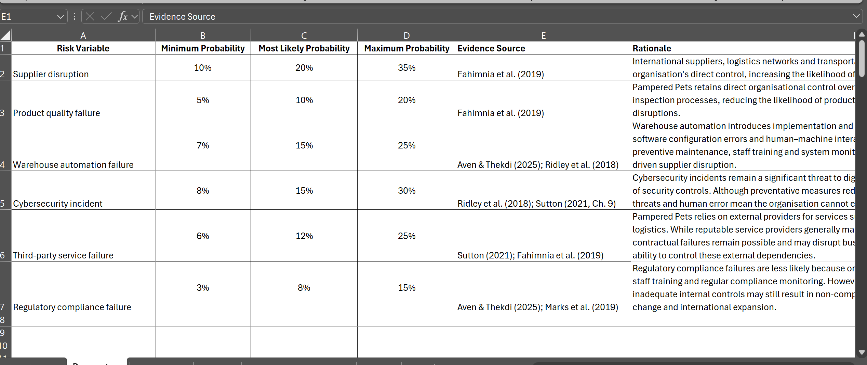
Figure A1. Monte Carlo simulation input parameters implemented in Microsoft Excel.

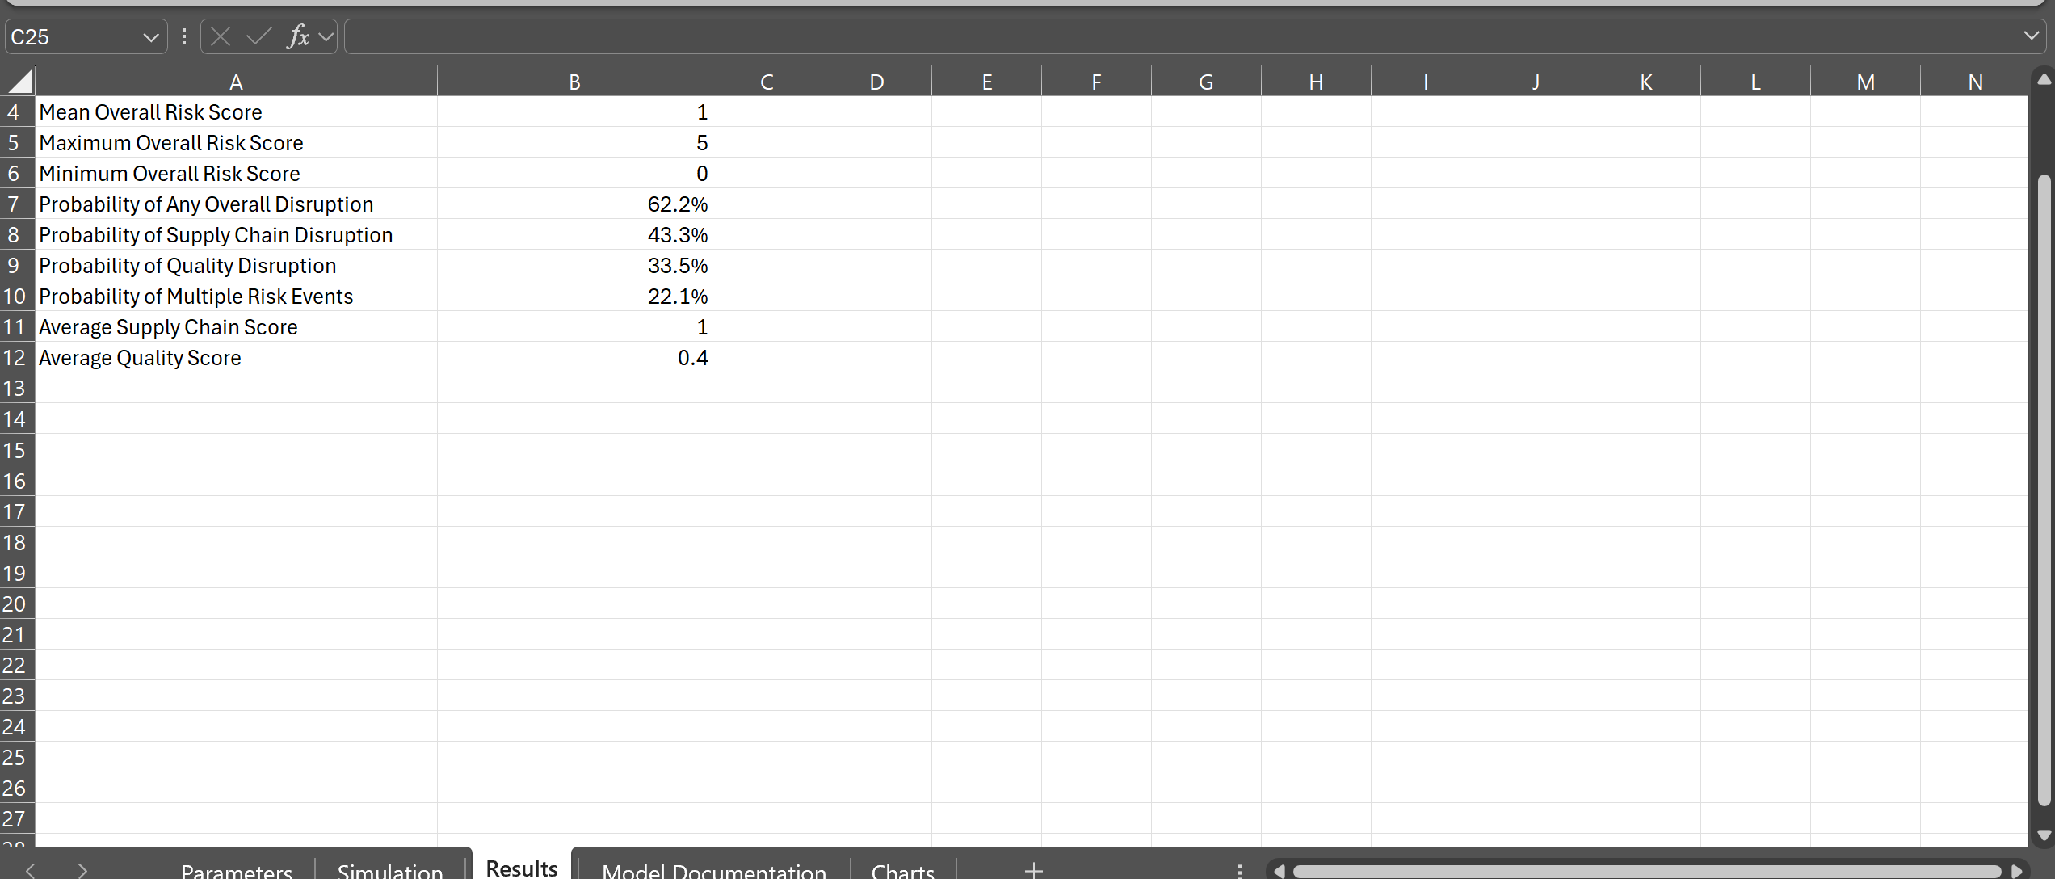
Figure A2. Monte Carlo simulation results after 10,000 simulation iterations.

