
University of Essex Online – MSc Cybersecurity
Individual Project: Executive Summary
Student ID: 12700830
Tutor: Dr Godfried Williams
13 July 2026
Word Count: 1826
Table of Contents
1 Introduction 5
2 Risk Assessment Methodology 5
2.1 Risk Identification and classification 5
2.2 Selection and Justification of the Quantitative Risk Modelling Approach 7
2.3 Assumptions and Data Sources 8
2.4 Quantitative Risk Analysis 10
2.5 Results and Interpretation 12
3 Conclusion 14
References 15
Appendices 17
Appendix A. Microsoft Excel Monte Carlo Simulation Model 17

List of Tables

Table 1. Principal risks associated with the Pampered Pets digital transformation 6
Table 2. Assumptions used in the quantitative risk model 9
Table 3. Estimated probability parameters for the Monte Carlo simulation. 10
Table 4. Input variables used in the Monte Carlo risk model 11

Table of Figures

Figure 1. Comparison of quantitative risk modelling approaches considered for the Pampered Pets risk assessment. Source: Created by the author based on Aven (2015), Hubbard (2020), Metropolis and Ulam (1949), Vose (2008), and Stoneburner et al. (2002). 7
Figure 2. Microsoft Azure active-active disaster recovery architecture using Azure Front Door across two regions. 13

Executive Summary
Pampered Pets plans to extend its digitalisation programme through an international supply chain and automated warehouses. These changes may increase efficiency and market reach, but they also create uncertainty around product quality, availability and operational resilience. This report estimates those risks through a quantitative Monte Carlo simulation and translates the results into business priorities.
Six operational risk categories were modelled using triangular probability distributions informed by the case study, academic literature and recognised guidance. Across 10,000 iterations, the model estimated a 33.5% probability of quality-related disruption, a 43.3% probability of supply-chain disruption, a 62.2% probability of at least one operational disruption, and a 22.1% probability of multiple events occurring together.
The findings indicate that strengthening supply-chain resilience should be the organisation's highest commercial priority, followed by enhanced quality assurance and continuous availability of the online service. Pampered Pets should diversify suppliers, strengthen incoming-quality assurance and implement an active-active, multi-region disaster recovery architecture that is regularly tested to demonstrate recovery time and recovery point objectives of less than one minute. Security, UK GDPR compliance and an exit plan that limits cloud vendor lock-in should be treated as core business requirements rather than later technical additions.

Introduction
Pampered Pets' proposed international supply chain and automated warehouses offer growth and efficiency, but they also increase dependence on external suppliers, digital platforms and automated operations. Disruption could affect product quality, order fulfilment and the reputation attached to high-profile customers such as HRH the King and Prince Albert II of Monaco.
Risk management must therefore examine how uncertainty affects business objectives rather than merely list threats (Aven, 2015). Quantitative analysis provides management with a stronger basis for action than qualitative judgement alone (Hubbard, 2020). This report applies Monte Carlo simulation to estimate quality and supply-chain disruption, interpret compound risk and prioritise controls, including business continuity and disaster recovery.

Risk Assessment Methodology

Risk Identification and classification
The proposed expansion introduces six material risk categories: supply-chain disruption, product-quality failure, warehouse automation failure, cybersecurity incidents, third-party service failure and regulatory non-compliance. These six risk categories were identified because they directly influence product availability, customer confidence, and operational continuity during digital transformation.
Aven and Thekdi (2025) emphasise that organisational change increases uncertainty, while ISO 31000 requires risk review when significant internal or external changes occur (ISO, 2018). NIST SP 800-30 similarly treats risk identification as the basis for analysing threats and business consequences (Stoneburner et al., 2002). Table 1 therefore defines the scope of the quantitative model without prematurely ranking the risks.
Table 1. Principal risks associated with the Pampered Pets digital transformation
Risk Category | Example Risk | Potential Business Impact
Supply Chain Risks | Supplier disruption, transport delays, customs issues or geopolitical events | Material shortages, delayed deliveries, reduced product availability
Product Quality Risks | Defective or counterfeit raw materials; inconsistent supplier quality | Reduced product quality, customer complaints, product recalls and reputational damage
Technology & Automation Risks | Warehouse robotics failure, inventory management system outage or software malfunction | Production delays, order fulfilment disruption, increased operational costs
Cybersecurity Risks | Ransomware, phishing attacks or unauthorised access to operational systems | Business interruption, data compromise and disruption to warehouse or supply chain operations.
Regulatory & Compliance Risks | Failure to comply with UK GDPR or international trade regulations | Financial penalties, legal action and damage to organisational reputation.
Third-Party Dependency Risks | Cloud service outage, payment gateway failure, outsourced IT service disruption or logistics platform failure | Business interruption, reduced operational resilience and customer service disruption.
Table 1 establishes the risk universe. The next task is to select a method capable of estimating likelihood and combined exposure under limited organisational data.

Selection and Justification of the Quantitative Risk Modelling Approach
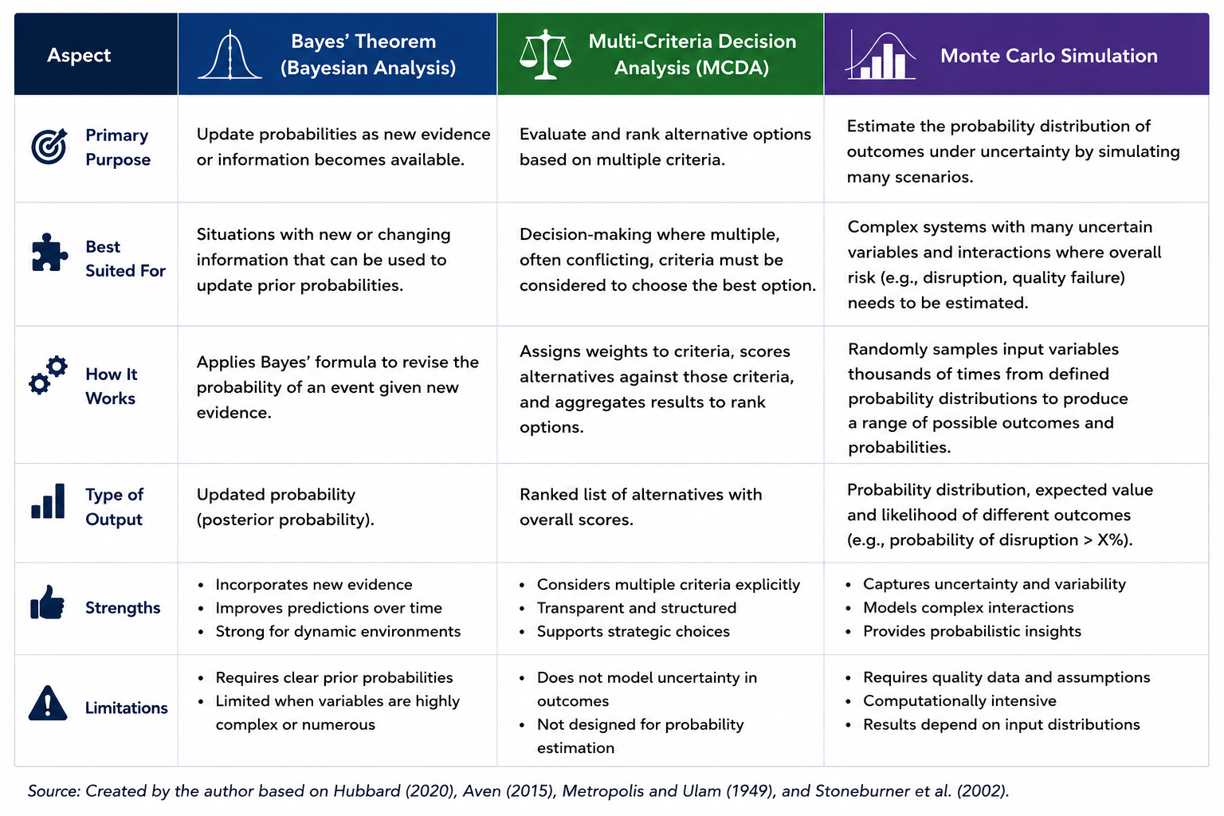
Three approaches were considered: Bayes' Theorem, Multi-Criteria Decision Analysis (MCDA) and Monte Carlo simulation. Bayes is useful when probabilities can be updated as new evidence arrives; MCDA compares options against weighted criteria; Monte Carlo repeatedly samples uncertain inputs to produce a distribution of plausible outcomes rather than one deterministic estimate (Aven, 2015; Hubbard, 2020).
Figure 1. Comparison of quantitative risk modelling approaches considered for the Pampered Pets risk assessment.
Source: Created by the author based on Aven (2015), Hubbard (2020), Metropolis and Ulam (1949), Vose (2008), and Stoneburner et al. (2002).
Figure 1 compares the strengths and limitations of the three modelling approaches, illustrating why Monte Carlo simulation provides the most suitable framework for analysing multiple interacting uncertainties within Pampered Pets' expanding supply chain. Bayes and MCDA are valuable, but the present decision is neither an evidence-updating exercise nor a choice between investment alternatives. Pampered Pets needs to estimate how several uncertain events may affect quality and availability separately or together.
Monte Carlo simulation was therefore selected because it can model multiple probability distributions simultaneously and show both individual and compound disruption. Its repeated-sampling logic is well established and suited to risk analysis where decision-makers need a range of possible outcomes (Metropolis and Ulam, 1949; Hubbard, 2020; Vose, 2008).
The model links the six risks in Table 1 to transparent assumptions, input ranges and 10,000 simulation iterations.

Assumptions and Data Sources
Pampered Pets is a fictional case study, so no internal loss history or operational risk records were available. The model therefore uses explicit assumptions supported by the scenario, academic literature and recognised standards. Transparency is essential because assumptions shape the credibility and reproducibility of quantitative analysis (Aven and Thekdi, 2025; Popov, Lyon and Hollcroft, 2022).
Table 2 records the principal assumptions, including stable operating conditions and the simplifying treatment of risk events as independent. This assumption keeps the model proportionate, although real-world dependencies are considered when interpreting the results.

Table 2. Assumptions used in the quantitative risk model
Assumption | Justification | Supporting Source
The business operates an international supply chain involving multiple suppliers and logistics providers. | Reflects the digital transformation described in the case study and provides the operational context for modelling supply chain uncertainty. | Aven & Thekdi (2025)
Individual risk events (e.g., supplier disruption, cyberattack and warehouse automation failure) are treated as independent events for modelling purposes. | Simplifies the Monte Carlo model while allowing each risk variable to be analysed using its own probability distribution. | Popov, Lyon & Hollcroft (2022)
Historical company data are unavailable. | Pampered Pets is a fictional organisation; therefore, no internal historical records exist to support statistical modelling. | Aven & Thekdi (2025)
Probability estimates are based on credible published sources and reasonable assumptions rather than exact operational records. | Ensures that assumptions remain transparent, realistic and supported by credible evidence rather than arbitrary estimates. | Sutton (2021); ISO 31000:2018
The operational environment remains stable throughout the simulation period. | Assumes that no major external events (such as significant regulatory change or global crises) occur during the period being modelled, allowing the analysis to focus on the identified operational risks. | Popov, Lyon & Hollcroft (2022)
The assumptions in Table 2 provide a transparent basis for the simulation by defining how uncertainty is represented where historical organisational data are unavailable. Although simplifying assumptions such as risk independence may not fully reflect operational reality, they enable a consistent and reproducible quantitative analysis. The resulting probability estimates should therefore be interpreted as decision-support evidence rather than precise predictions.

Quantitative Risk Analysis
The simulation quantified the six risks identified in Section 2.1 using triangular distributions defined by minimum, most-likely and maximum probabilities. This distribution was chosen because reliable historical data were unavailable, while plausible ranges could be justified from the case study and literature(Hubbard, 2020). Tables 3 and 4 summarise the quantitative inputs used in the Monte Carlo model. Table 3 presents the minimum, most likely and maximum probability estimates assigned to each risk variable. Table 4 then links each simulation variable to the operational risks identified in Table 1 together with the supporting evidence used to justify its inclusion in the model.
Table 3. Estimated probability parameters for the Monte Carlo simulation.
Risk Variable | Minimum Probability | Most Likely Probability | Maximum Probability
Supplier disruption | 10% | 20% | 35%
Product quality failure | 5% | 10% | 20%
Warehouse automation failure | 7% | 15% | 25%
Cybersecurity incident | 8% | 15% | 30%
Third-party service failure | 6% | 12% | 25%
Regulatory compliance failure | 3% | 8% | 15%

Table 4. Input variables used in the Monte Carlo risk model
Input Variable | Description | Relationship to Table 1 | Supporting Source
Supplier Disruption | Failure or delay of international suppliers affecting production continuity. | Supply Chain Risk | Fahimnia et al. (2019)
Product Quality Failure | Defective or inconsistent products resulting from poor-quality materials or production processes. | Product Quality Risk | Pineiro-Chousa et al. (2017)
Warehouse Automation Failure | Failure of automated warehouse systems affecting order fulfilment and inventory management. | Technology & Automation Risk | Sutton (2021)
Cybersecurity Incident | Cyberattack affecting operational systems, availability or business continuity. | Cybersecurity Risk | Sutton (2021)
Third-Party Service Failure | Failure of cloud services, logistics platforms or outsourced service providers. | Third-Party Dependency Risk | Sutton (2021)
Regulatory Compliance Failure | Failure to comply with GDPR or international regulations resulting in operational disruption or financial penalties. | Regulatory & Compliance Risk | ISO 31000:2018

The Monte Carlo model was implemented in Microsoft Excel using 10,000 simulation iterations. Appendix A provides extracts from the implementation, while the complete Microsoft Excel simulation workbook accompanies this report as a separate submission. The resulting probability estimates are presented and interpreted in Section 2.5.

Results and Interpretation
The simulation estimated a 62.2% probability of at least one operational disruption and a mean overall risk score of 1.0, meaning that a typical scenario contained one significant event. This does not imply that the transformation should be abandoned; it means risk controls must be designed into implementation rather than added after disruption.
Supply-chain disruption was the largest exposure at 43.3%, compared with 33.5% for quality-related disruption. Pampered Pets can directly improve internal quality through monitoring and process controls, but it has less control over suppliers, logistics and geopolitical conditions. Supplier diversification, visibility and contingency stock should therefore receive the highest commercial priority (Fahimnia et al., 2019).
The 22.1% probability of multiple simultaneous events is also material. A supplier delay combined with an automation or cybersecurity failure could affect inventory, customer service and recovery capacity at the same time. The result supports assessing uncertainty as an interacting portfolio rather than as isolated risks (Aven and Thekdi, 2025).
The findings remain subject to limitations. Probability ranges were derived from literature and informed judgement, and the model treats risks as independent even though supplier, cyber and automation failures may influence one another. The results should therefore guide decisions and scenario testing, not be treated as precise forecasts (Hubbard, 2020).
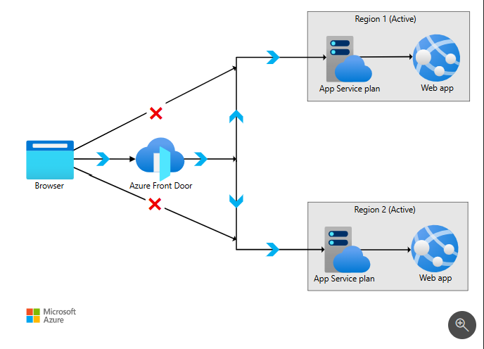
Based on these findings, the following recommendations are prioritised according to their contribution to reducing operational risk and protecting business continuity. First, protect availability through dual sourcing, supplier quality checks, safety stock for critical materials and real-time supply-chain monitoring. Second, implement business continuity and disaster recovery on Microsoft Azure using an active-active deployment across two regions behind Azure Front Door, with automated health-based routing, replicated application services, encrypted backups and a data service configured to meet the required recovery point.
Figure 2. Microsoft Azure active-active disaster recovery architecture using Azure Front Door across two regions.
Source: Microsoft (2026a).
The solution should be regularly tested through failover exercises to demonstrate compliance with the required recovery time objective (RTO) and recovery point objective (RPO) of less than one minute, rather than assuming these targets can be achieved (Microsoft, 2026a; Microsoft, 2026b).
Third, embed MFA, least privilege, logging, incident response and tested restoration procedures to support UK GDPR security and availability obligations (ICO, 2023).
Vendor lock-in should be reduced through containerised workloads, infrastructure-as-code, standard interfaces, documented data-export procedures and contractual exit provisions. These controls reduce, rather than eliminate, dependence on a single cloud provider by improving application portability and facilitating future migration if business requirements change. This approach balances the resilience benefits of Azure's native services with the longer-term objective of avoiding excessive vendor lock-in.

Conclusion
The analysis shows that Pampered Pets' expansion creates a meaningful probability of quality and supply-chain disruption, with supply-chain exposure and compound events requiring the greatest management attention. Monte Carlo simulation provides a transparent basis for prioritising controls while acknowledging uncertainty and limited historical data.
Commercial priorities should therefore be prioritised as follows: strengthen supplier resilience and quality assurance; deploy and regularly test an active-active BC/DR solution capable of achieving recovery objectives of less than one minute; then maintain security, UK GDPR compliance and cloud portability through governance, contractual exit provisions and the use of portable technologies to reduce vendor lock-in.

References

Aven, T. (2015) Risk Analysis. 2nd edn. Chichester: John Wiley & Sons.
Aven, T. and Thekdi, S. (2025) Risk Science. Abingdon: Routledge.
Fahimnia, B., Pournader, M., Siemsen, E., Bendoly, E. and Wang, C. (2019) Behavioral Operations and Supply Chain Management—A Review and Literature Mapping. Decision Sciences, 50(6), pp. 1127–1183.
Hubbard, D.W. (2020) The Failure of Risk Management: Why It's Broken and How to Fix It. 2nd edn. Hoboken, NJ: John Wiley & Sons.
Information Commissioner's Office (ICO) (2023) A guide to data security. Available at: https://ico.org.uk/for-organisations/uk-gdpr-guidance-and-resources/security/a-guide-to-data-security/ (Accessed: 11 July 2026).
International Organization for Standardization (ISO) (2018) ISO 31000:2018 Risk management – Guidelines. Geneva: International Organization for Standardization.
Metropolis, N. and Ulam, S. (1949) ‘The Monte Carlo Method’, Journal of the American Statistical Association, 44(247), pp. 335–341.
Microsoft (2026a) Tutorial: Create a highly available multi-region app in Azure App Service. Available at: https://learn.microsoft.com/azure/app-service/tutorial-multi-region-app (Accessed: 11 July 2026).
Microsoft (2026b) Reliability in Azure Cosmos DB. Available at: https://learn.microsoft.com/azure/reliability/reliability-cosmos-db (Accessed: 11 July 2026).
Pineiro-Chousa, J., Vizcaíno-González, M., López-Cabarcos, M.Á. and Romero-Castro, N. (2017) ‘Managing Reputational Risk through Environmental Management and Reporting: An Options Theory Approach’, Sustainability, 9(3), 376.
Popov, G., Lyon, B.K. and Hollcroft, B.D. (2022) Risk Assessment: A Practical Guide to Assessing Operational Risks. 2nd edn. Hoboken, NJ: John Wiley & Sons.
Stoneburner, G., Goguen, A. and Feringa, A. (2002) Risk Management Guide for Information Technology Systems. NIST Special Publication 800-30. Gaithersburg, MD: National Institute of Standards and Technology.
Sutton, D. (2021) Information Risk Management. London: BCS, The Chartered Institute for IT.
Vose, D. (2008) Risk Analysis : A Quantitative Guide. 3rd edn. Chichester: John Wiley & Sons.

Appendices

Appendix A. Microsoft Excel Monte Carlo Simulation Model
This appendix provides extracts from the Microsoft Excel Monte Carlo simulation model used to generate the quantitative risk analysis presented in Section 2.4. The complete Microsoft Excel simulation workbook accompanies this report as a separate submission.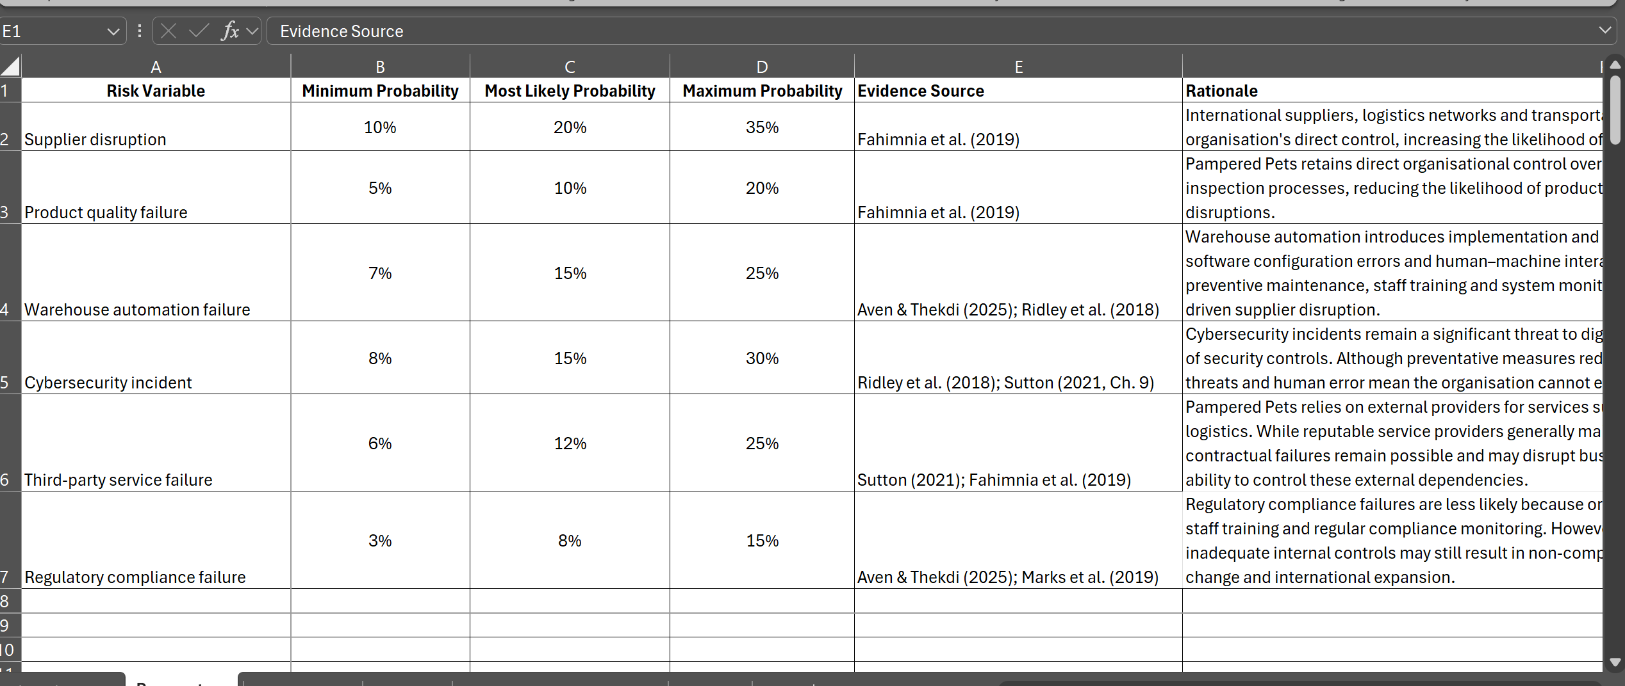
Figure A1. Monte Carlo simulation input parameters implemented in Microsoft Excel.
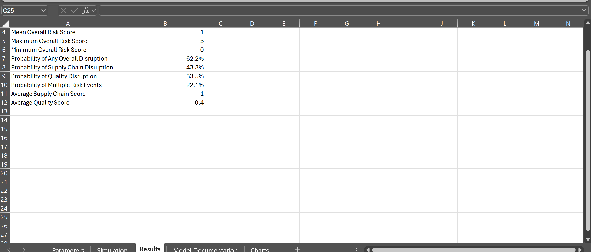
Figure A2. Monte Carlo simulation results after 10,000 simulation iterations.

