Secure MySQL Migration to Azure Database for MySQL
Complete implementation, troubleshooting and validation record

Project summary
This project documents a complete migration of a local MySQL workload into Azure Database for MySQL Flexible Server using Azure Database Migration Service (DMS). The final design used Oracle MySQL 8.4 in Docker on Kali Linux, StrongSwan for an IPsec/IKEv2 site-to-site VPN, a non-overlapping Azure migration VNet, VNet peering, Azure Private DNS and TLS-protected MySQL sessions. The migration completed successfully and the target data was independently verified from an Azure Ubuntu VM.
This became a much more realistic migration exercise than I originally expected. The main challenges were source-platform compatibility, MySQL authentication, DMS privileges, changing public IP addresses, VPN negotiation, overlapping Azure address spaces and private target connectivity. I worked through each issue separately, using the result of each test to decide the next change rather than repeatedly rebuilding the environment.

Objectives
- Build a repeatable local database source with representative customer and order data.
- Migrate the database to Azure Database for MySQL Flexible Server using Azure DMS.
- Keep the Azure target on private networking rather than exposing it directly to the public Internet.
- Connect the local lab to Azure through a site-to-site IPsec/IKEv2 VPN.
- Require TLS for database client sessions used during validation.
- Validate the migration independently by querying the Azure target after DMS reported completion.
- Capture troubleshooting evidence suitable for a technical portfolio.

Final architecture
Layer | Resource / configuration | Purpose
Local source | Kali Linux + Docker mysql:8.4; 192.168.78.3:3307 | Stable Oracle MySQL 8.4 source for DMS.
Database | cloud_migration_lab | Two application tables: customers and orders.
Hybrid VPN | StrongSwan ↔ Azure VPN Gateway V2 | Encrypted route between local lab and Azure.
Migration VNet | mysql-migration-dms-vnet-v2, 10.10.0.0/16 | Non-overlapping network for DMS and validation VM.
Gateway subnet | 10.10.1.0/24 | Azure VPN Gateway subnet.
Target VNet | rg-mysql-migration-lab-vnet, 10.0.0.0/24 | Private Azure MySQL network.
Peering | dms-v2-to-mysql-target | Private V2-to-target routing.
Private DNS | mysql-cloud-migration-lab.private.mysql.database.azure.com | Private target name resolution from V2.
DMS | mysql-migration-service-v2 | Offline migration engine.
Validation VM | mysql-v2-test-vm, 10.10.0.5 | Independent DNS, TCP, TLS and post-migration checks.

Implementation chronology

1. Initial MariaDB path
I initially built the source database with MariaDB on Kali Linux. That gave me a useful starting point for the schema and connectivity tests, but Microsoft’s DMS support matrix for Azure Database for MySQL lists supported MySQL-family sources rather than MariaDB, and the offline DMS guidance expects a supported MySQL Community Edition source. I also encountered authentication and compatibility issues, including a dump/import problem involving the utf8mb4_uca1400_ai_ci collation. At that point I decided not to force MariaDB into a migration path for which it was not listed as a supported source, and rebuilt the final source with Oracle MySQL 8.4.
That decision became an important part of the project. MariaDB remains in this record because it explains how the final design was reached, but the migration that I completed and validated used Oracle MySQL 8.4 as the source.

2. Oracle MySQL and the Docker pivot
I then installed and tested Oracle MySQL 8.4 locally. The previous MariaDB data directory caused initialization problems, so I separated the old data and started with a clean MySQL environment. Password-protected TCP authentication on the host installation still behaved inconsistently despite several authentication, TLS and RSA checks. Rather than spend more time on host-package interactions, I moved the source to the official mysql:8.4 Docker image. This gave me a cleaner and more reproducible source for the migration.
The final source container was named mysql-migration-source and exposed container port 3306 on host port 3307. I created cloud_migration_lab with customers and orders tables and a dedicated migration_user account. DMS initially reported insufficient source privileges, so the account was granted the required REPLICATION CLIENT, RELOAD and FLUSH_TABLES privileges in addition to access to the migration database.

3. Securing the source connection with TLS
The MySQL source exposed TLS and supported TLS 1.2/1.3. Validation was performed with --ssl-mode=REQUIRED. A successful session from the V2 Azure VM negotiated TLS_AES_256_GCM_SHA384. MySQL documents TLS as the mechanism for protecting client/server database traffic in transit, and NIST SP 800-52 Rev. 2 provides broader TLS selection and configuration guidance.
mysql --connect-timeout=10 --protocol=TCP --ssl-mode=REQUIRED -h <SOURCE_PRIVATE_IP> -P 3307 -u migration_user -p
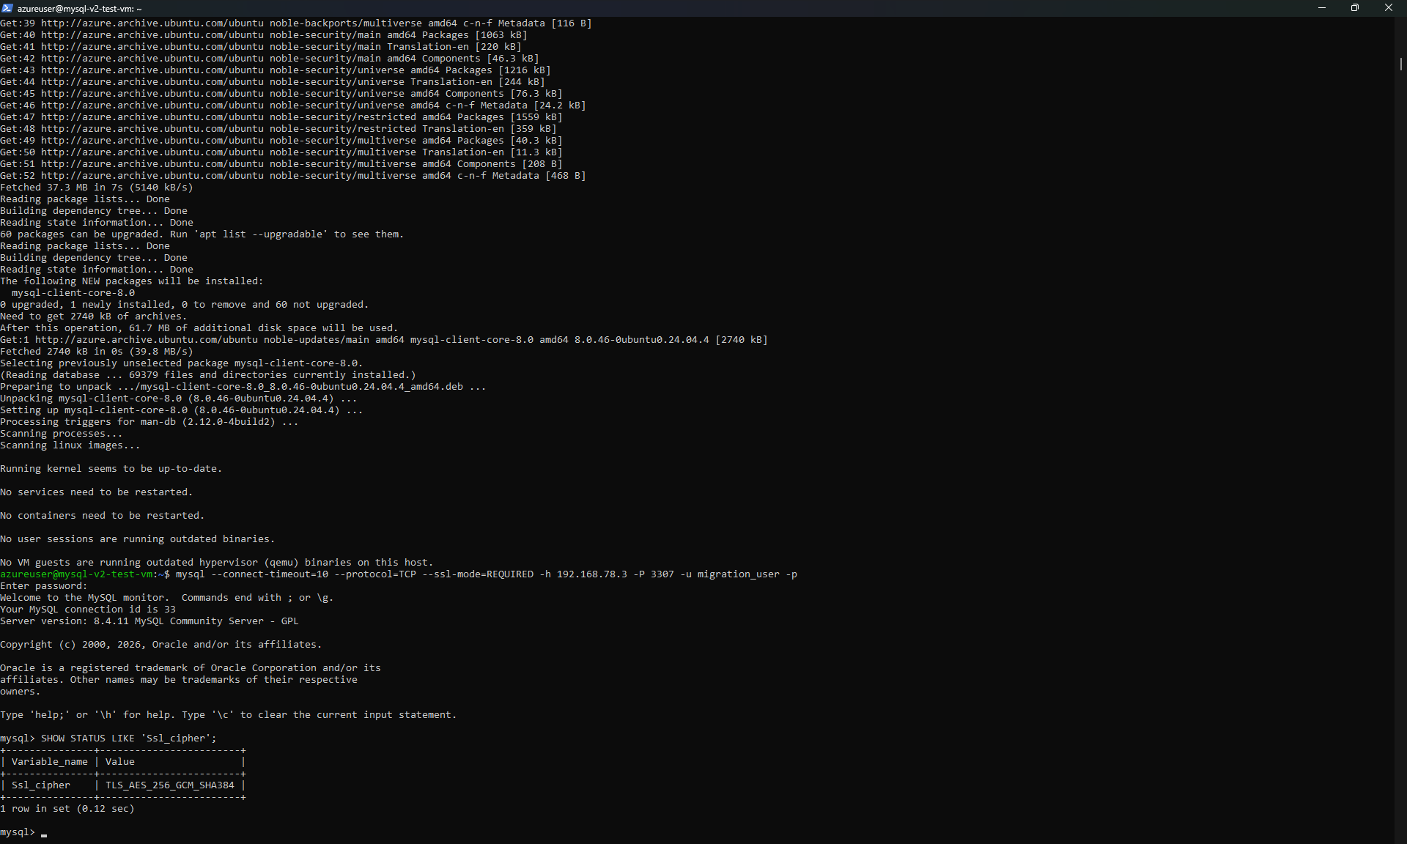
Evidence: TLS-required connection from the V2 validation VM to the local MySQL source; cipher TLS_AES_256_GCM_SHA384.

4. Why point-to-site VPN was not enough
The early Azure setup included point-to-site connectivity, but that did not provide the DMS service with a usable route to the nested local Kali/Docker source. I therefore moved to a site-to-site design. StrongSwan on Kali acted as the local VPN endpoint and Azure VPN Gateway provided the Azure endpoint. During testing, the tunnel failed when the home public IP changed (and when a separate consumer VPN altered the visible public IP). Updating the Azure Local Network Gateway to the current public IP restored the expected endpoint relationship.

5. IPsec/IKE negotiation and routing
StrongSwan initially reported NO_PROPOSAL_CHOSEN. After aligning the IKE/ESP proposals with Azure, the security association established successfully. IP forwarding was enabled on Kali and the local source subnet 192.168.78.0/24 was advertised across the tunnel. NIST describes IPsec with IKE as a standard mechanism for protecting communications across IP networks (Barker et al., 2020).
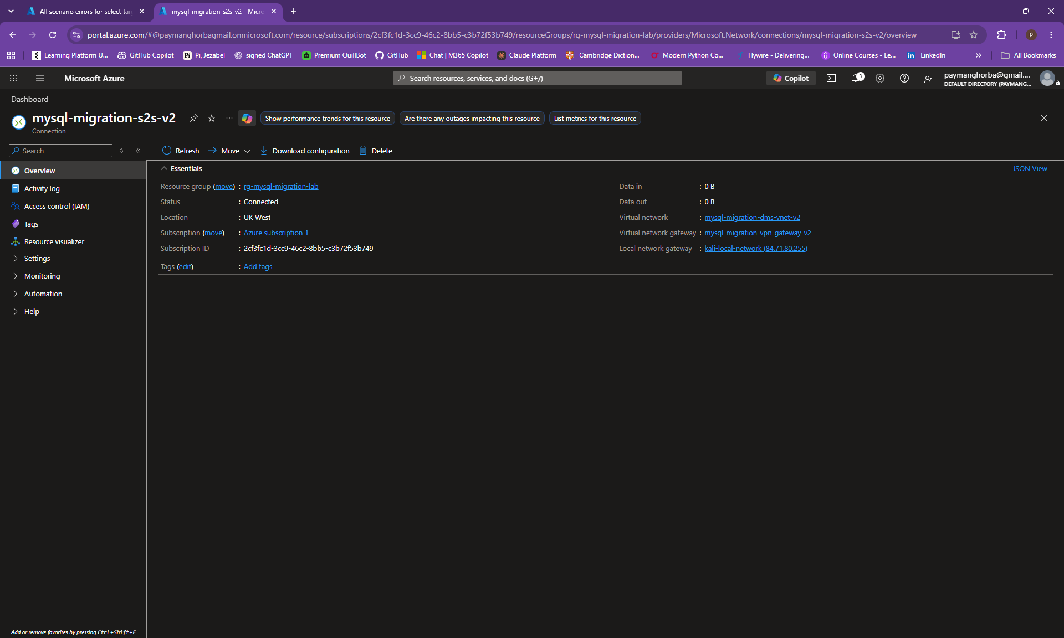
Evidence: Azure V2 site-to-site connection mysql-migration-s2s-v2 showing Connected status.

6. DMS target failure and the overlapping VNet root cause
The original DMS service could reach the source after the VPN and privilege issues were fixed, but target validation failed with a MySQL connection error. Investigation showed that the original DMS VNet used 10.0.0.0/16 while the Azure MySQL VNet used 10.0.0.0/24. Azure rejected direct VNet peering because the address spaces overlapped. This was the decisive architecture issue.

7. V2 network redesign
Instead of renumbering the existing MySQL network or disturbing the original lab resources, I created mysql-migration-dms-vnet-v2 with 10.10.0.0/16 and GatewaySubnet 10.10.1.0/24. This VNet was peered with the MySQL target VNet. The MySQL private DNS zone was linked to V2 so that the public-style server FQDN resolved to the private target address from the migration network. Microsoft documents VNet peering and Private DNS linking as core mechanisms for private Flexible Server connectivity.
A new VPN gateway (mysql-migration-vpn-gateway-v2) and site-to-site connection (mysql-migration-s2s-v2) were then created directly in V2. The old and new tunnels temporarily coexisted during validation.

8. Independent V2 validation
Before running the migration again, I wanted proof that the redesigned network worked from end to end. I created mysql-v2-test-vm in the V2 default subnet and used it as an independent validation point. The Azure MySQL FQDN resolved through private DNS to 10.0.0.4, TCP 3306 reached the Azure target, and TCP 3307 reached the local source through the site-to-site VPN. I then installed the MySQL client and confirmed TLS-authenticated access to the source. This meant the network path was proven before DMS was brought back into the test.

9. New DMS service and successful offline migration
Because the original classic DMS service was bound to the old VNet, a second service, mysql-migration-service-v2, was used in the V2 network. The project MySqlToAzureDbForMySQL-v2 ran the activity MySQL-Offline-Migration-v2. DMS reported cloud_migration_lab as Completed with 2 of 2 tables migrated in 12 seconds.
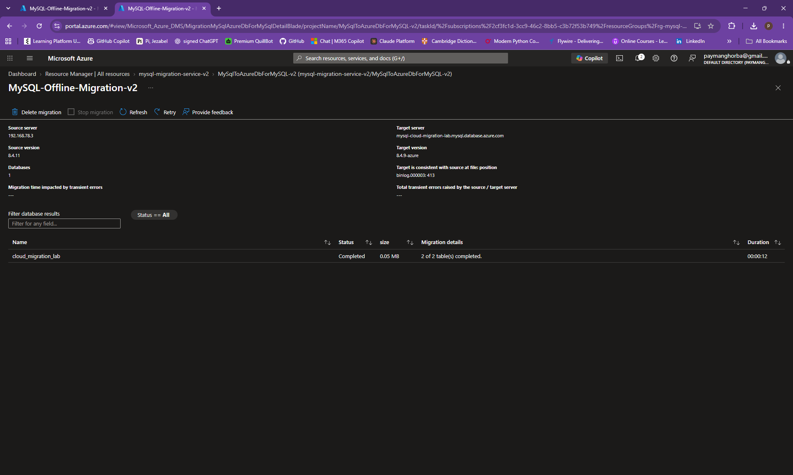
Evidence: final DMS activity showing cloud_migration_lab Completed and 2 of 2 tables migrated.

10. Post-migration verification
The final check was performed independently from mysql-v2-test-vm. I connected to the Azure target with TLS required, confirmed that cloud_migration_lab existed, selected it, listed the migrated tables and queried both application tables. The customers table contained Alice Brown and David Smith. The orders table contained the expected Laptop and Monitor records. This proved that the target was not only reachable but contained readable migrated data.
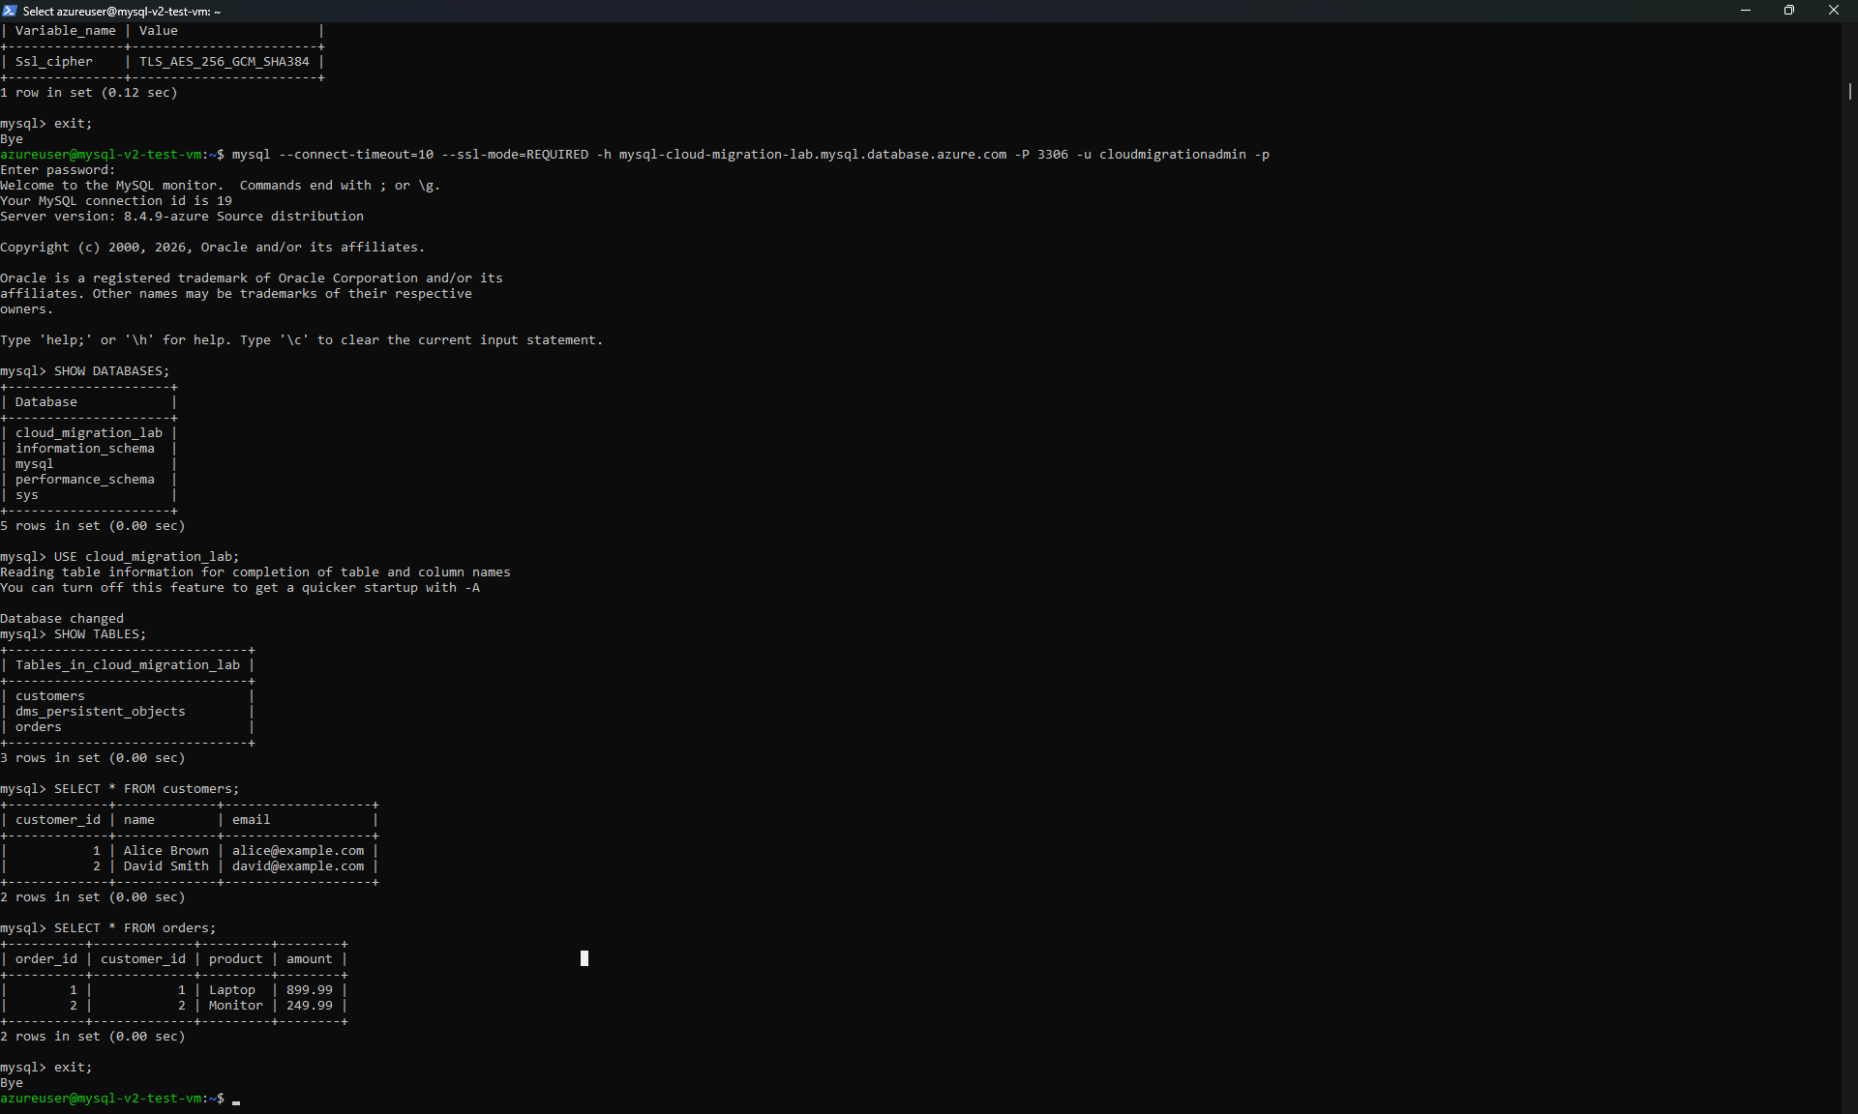
Evidence: direct Azure-target verification showing cloud_migration_lab, customers, orders and the migrated records.

Key troubleshooting record
Problem | Diagnosis | Resolution / lesson
MariaDB source path | Poor fit for the selected DMS MySQL workflow; collation/authentication complications. | Rebuilt final source on Oracle MySQL 8.4; documented MariaDB only as an early design stage.
Host MySQL TCP authentication | Persistent 1045 behaviour during local testing. | Moved the source into the official MySQL 8.4 Docker image to reduce host-package ambiguity.
DMS source validation | Missing REPLICATION CLIENT, RELOAD and FLUSH_TABLES privileges. | Granted only the required migration privileges plus database access.
VPN tunnel down | Local public IP changed; Azure LNG still referenced the previous endpoint. | Updated the Local Network Gateway and kept the consumer VPN disabled during S2S testing.
IKE negotiation failure | StrongSwan/Azure proposal mismatch. | Aligned IKE/ESP proposals and re-established the security association.
DMS target connection failure | Original DMS VNet 10.0.0.0/16 overlapped target VNet 10.0.0.0/24. | Created clean V2 VNet 10.10.0.0/16 and used peering + private DNS.
Classic DMS network binding | Existing DMS could not simply be moved to the new VNet. | Used mysql-migration-service-v2 in the proven V2 network.
Evidence quality | A DMS 'Completed' status alone does not prove readable application data. | Queried the Azure target directly and captured customers/orders results.

Security decisions
- Azure MySQL was accessed through private VNet integration rather than a directly exposed database endpoint.
- The migration network used VNet peering and a linked Azure Private DNS zone for private target connectivity.
- The local-to-Azure path used an IPsec/IKEv2 site-to-site VPN.
- MySQL client validation used --ssl-mode=REQUIRED and confirmed an encrypted TLS cipher.
- A dedicated migration account was used instead of using the database root account for DMS.
- SSH key permissions on the Windows client were restricted so OpenSSH would accept the private key.
- Temporary validation resources were intended to be deleted after evidence capture.

Security limitations of the temporary lab
This was a temporary learning environment rather than a production deployment. Before publishing the repository, all screenshots and configuration examples must be checked so that passwords, pre-shared keys and private SSH key material are excluded. In a production implementation I would use centrally managed secrets such as Azure Key Vault where appropriate, rotate migration credentials and VPN secrets, remove temporary public SSH access, enforce least privilege, enable monitoring and logging, and use formal change, rollback and cutover procedures.

Validation checklist
- Source MySQL 8.4.11 running and reachable on TCP 3307.
- Source TLS session established with TLS_AES_256_GCM_SHA384.
- V2 site-to-site VPN status Connected.
- Private DNS resolved the Azure MySQL server to its private address.
- V2 VM reached Azure MySQL on TCP 3306.
- V2 VM reached local MySQL on TCP 3307 through the VPN.
- DMS activity completed 2 of 2 application tables.
- Azure target contained cloud_migration_lab.
- customers and orders tables were readable and contained the expected records.

Outcome
The final architecture achieved the project objective: a local Oracle MySQL 8.4 database was migrated into Azure Database for MySQL Flexible Server through a private, encrypted hybrid network. The project also produced a stronger result than a simple migration demo because the final design was reached through evidence-driven troubleshooting of database compatibility, identity/privilege requirements, VPN behaviour, address planning, DNS and TLS.

References and technical sources
Barker, E., Dang, Q., Frankel, S., Scarfone, K. and Wouters, P. (2020) Guide to IPsec VPNs. NIST SP 800-77 Rev. 1. https://doi.org/10.6028/NIST.SP.800-77r1
McKay, K. and Cooper, D. (2019) Guidelines for the Selection, Configuration, and Use of Transport Layer Security (TLS) Implementations. NIST SP 800-52 Rev. 2. https://doi.org/10.6028/NIST.SP.800-52r2
Microsoft (2026a) Private Network Access using virtual network integration for Azure Database for MySQL - Flexible Server. https://learn.microsoft.com/en-us/azure/mysql/flexible-server/concepts-networking-vnet
Microsoft (2026b) About Azure VPN Gateway. https://learn.microsoft.com/en-us/azure/vpn-gateway/vpn-gateway-about-vpngateways
Oracle (2026) MySQL 8.4 Reference Manual: Using Encrypted Connections. https://dev.mysql.com/doc/refman/8.4/en/encrypted-connections.html
Microsoft (2026c) Azure Database Migration Service supported scenarios. https://learn.microsoft.com/en-us/azure/dms/resource-scenario-status
Microsoft (2026d) Tutorial: Migrate MySQL to Azure Database for MySQL offline using DMS. https://learn.microsoft.com/en-us/azure/dms/tutorial-mysql-azure-mysql-offline-portal

Repository publishing note
Before publishing the repository, every screenshot and configuration file should be checked for passwords, pre-shared keys, private SSH keys and database credentials. Only sanitised evidence should be committed. The screenshots selected for this project focus on the final technical result and avoid reproducing password or private-key material.

