1) Structure & naming
Full name: Payman Ghorbani
student ID: pg25304
Referencing style: Harvard
Word-limit: Maximum 3850

1. Practical Work details
IDE used for Python programming: JetBrains PyCharm
Module’s name: Advanced Object-Oriented Design and Programming October 2025
All of my code and document uploaded to my github account available at: My GitHub link: https://github.com/pg25304
I installed and configured Git on my PyCharm for version control and commit and push any amendment or new code to my GitHub repositories

Advanced Object-Oriented Design and Programming Module:
This module is designed to take your understanding of object-oriented programming (OOP) to the next level, equipping you with the skills to design, develop, and maintain scalable, secure, and efficient software systems. Whether you are pursuing a career in Computer Science, Cyber Security, Data Science, or Artificial Intelligence, this module will provide you with the advanced techniques and practical experience needed to excel in these fields. We are excited to guide you through this journey and help you become a well-rounded, socially conscious software engineer.
This module builds on foundational OOP principles and introduces advanced concepts such as design patterns, software architecture, concurrency, secure coding practices, and clean code techniques. You will explore how to write maintainable, reusable, and efficient code while considering critical themes like Equality, Diversity, and Inclusion (EDI), sustainability, and entrepreneurship. The module is structured to provide a balance of theoretical knowledge and practical application, ensuring that you can apply what you learn to real-world challenges in software development.
This module is designed to challenge and inspire you. Embrace the learning journey, collaborate with peers, and apply the skills gained to build innovative and impactful software solutions. We look forward to your contributions and success in this module!
The module aims to provide students with:
- Advanced OOP Concepts: Deepen your understanding of OOP principles, design patterns, and software architecture.
- Practical Application: Apply your knowledge through coding exercises, case studies, and a capstone project.
- Real-World Relevance: Learn how to design software that addresses societal challenges, including sustainability and inclusivity.
- Collaborative Learning: Engage with peers and instructors through live seminars and online forums.
- Career Preparation: Gain skills that are highly relevant to careers in cybersecurity, data science, AI, and more.

On completion of this module, you will be able to:
- Understand and implement secure coding practices in software development.
- Apply advanced object-oriented principles to solve complex software problems.
- Utilise design patterns to create reusable, maintainable, and flexible code.
- Design software architectures suitable for large-scale systems, ensuring security and robustness.
- Develop software solutions that are adaptable for AI models and efficient for data science tasks.
What To Expect From This Module
Throughout this 12-week module, you will engage with a variety of topics and activities designed to deepen your understanding of advanced OOP concepts. Here’s a glimpse of what you can expect:
- Weekly Topics: Each week, you will explore a new aspect of advanced OOP, starting with a recap of core OOP principles and progressing to advanced topics like design patterns, concurrency, secure coding, and software architecture.
- Practical Exercises: You will work on coding exercises and projects that reinforce the concepts covered in lectures. These exercises will help you apply theoretical knowledge to practical problems, such as implementing design patterns, writing thread-safe code, and refactoring code to improve maintainability.
- Case Studies: Real-world case studies will be used to illustrate how advanced OOP techniques are applied in industries like cybersecurity, data science, and AI.
- Capstone Project: In the final week, you will complete a capstone project that integrates all the concepts learned throughout the module. This project will challenge you to design and implement a complex software system using advanced OOP principles.
- Collaborative Learning: You will participate in live seminars, discussion forums, and group activities, allowing you to interact with peers and instructors, share ideas, and solve problems collaboratively.
How To Succeed In This Module
To make the most of this module and achieve success, consider the following tips:
- Engage Actively: Participate in live seminars, discussion forums, and collaborative activities. Active engagement will help you clarify doubts, gain new perspectives, and deepen your understanding of the material.
- Practice Regularly: OOP is a skill that improves with practice. Regularly work on the coding exercises and projects provided in the module. Experiment with different design patterns and refactoring techniques to build confidence in your coding abilities.
- Manage Your Time: This module is intensive, with weekly topics and assessments. Create a study schedule that allows you to stay on top of the material and complete assignments on time.
- Seek Feedback: Take advantage of formative assessments and feedback from tutors. Use this feedback to improve your work and prepare for summative assessments.
- Think Critically: As you work through case studies and projects, consider how the concepts you’re learning can be applied to real-world problems. Think critically about how software design can address societal challenges, such as sustainability and inclusivity.

Unit 1: Introduction and Recap of Object-Oriented Programming (OOP)

Welcome to Unit 1. This week marks the beginning of your journey into advanced OOP concepts. Whether you’re revisiting OOP principles or building on your existing knowledge, this week will set the foundation for the more advanced topics we’ll explore in the coming weeks. Let’s dive in and refresh your understanding of the core concepts that make OOP such a powerful tool in software development.
In this unit, we shall:
- Revisit Key OOP Concepts: We’ll revisit the four pillars of OOP—Inheritance, Polymorphism, Abstraction, and Encapsulation—and discuss their importance in software design.
- Review of Classes, Objects, and Access Control: You’ll review how classes and objects work, including constructors, destructors, and access control mechanisms (e.g., public, private, protected).
- Introduce the role of OOP in Large-Scale and Secure Software Design: We’ll introduce how OOP principles are applied in designing large-scale, secure software systems.
- Implement Practical Exercise: You’ll implement basic class hierarchies in Python or Java to reinforce your understanding of OOP concepts.
By the end of this unit, you will be able to:
- Understand and explain the four key OOP concepts: Inheritance, Polymorphism, Abstraction, and Encapsulation.
- Describe the role of classes, objects, constructors, destructors, and access control in OOP.
- Apply OOP principles to design basic class hierarchies in Python or Java.
- Recognise the importance of OOP in large-scale and secure software design.
Week 1 serves as the foundation for the entire module. The concepts covered this week—Inheritance, Polymorphism, Abstraction, Encapsulation, and the use of classes and objects—are essential for understanding the more advanced topics we will explore in later weeks. These include design patterns, software architecture, concurrency, and secure coding practices. By revisiting and reinforcing these core OOP principles, you will be well-prepared to tackle the challenges of designing scalable, maintainable, and secure software systems in the weeks to come.

How do I learn unit one material:
Setting up a web GitHub Account as follows: https://github.com/pg25304
Downloading JetBrains PyCharm IDE and installed Git for version control for practicing code
Preparing and Attending at seminar 1
Studying the related Lecture Cast and took notes and saved in a Word document called: Unit 1- lecture cast - Introduction and recap OOP.docx ; available at: https://github.com/pg25304/msc-cybersecurity-portfolio/blame/main/M4-Advanced%20Object%20Oriented%20Design%20%26%20Programming%2020C-12W/Unit%201-%20lecturecast%20-%20Introduction%20and%20recap%20OOP.docx
Took Quiz test of lecture cast ,demonstrated on screenshot below:

Mastering the concepts by writing 25 individual introductory code using Jupyter Notebook, evidence: https://github.com/pg25304/msc-cybersecurity-portfolio/tree/main/Jupyter%20Notebook%20exercises

Unit 2: SOLID Principles of Object-Oriented Design

In this unit, we shall:
- Explore SOLID Principles:
  - Single Responsibility Principle (SRP): A class should have only one reason to change.
  - Open/Closed Principle (OCP): Software entities should be open for extension but closed for modification.
  - Liskov Substitution Principle (LSP): Subtypes must be substitutable for their base types.
  - Interface Segregation Principle (ISP): Clients should not be forced to depend on interfaces they do not use.
  - Dependency Inversion Principle (DIP): High-level modules should not depend on low-level modules; both should depend on abstractions.
- Apply SOLID to Real-World Systems:
  - We’ll explore how these principles improve maintainability and scalability in real-world software systems.
  - Case studies will demonstrate how SOLID principles are applied in practice to solve complex design problems.
- Engage in Practical Exercise:
  - You’ll refactor an existing codebase to adhere to the SOLID principles, giving you hands-on experience in applying these concepts to improve code quality.
By the end of this unit, you will be able to:
- Understand and explain each of the five SOLID principles and their importance in object-oriented design.
- Apply the SOLID principles to refactor code, making it more maintainable and scalable.
- Recognise how SOLID principles are used in real-world systems to improve software design.
Week 2 builds on the foundational OOP concepts covered in Week 1 and introduces the SOLID principles, which are critical for advanced object-oriented design. These principles provide a framework for creating software that is maintainable, scalable, and adaptable—key qualities for large-scale and secure systems. Understanding and applying SOLID principles will prepare you for the more advanced topics we will cover in later weeks, such as design patterns, software architecture, and secure coding practices. This week’s focus on clean, maintainable code is essential for the rest of the module and your future as a software engineer.

How do I learn:

Researching, reading, and comprehending SOLID principle including SRP, OCP, LSP, ISP, DIP using both University recommended reading resources and online resources.
Preparing and attending at Seminar 2: Title: SOLID Principles of Object-Oriented Design. Utilize AI as an assistant for debugging and completing the code exercises (click on view raw):
https://github.com/pg25304/msc-cybersecurity-portfolio/blob/main/M4-Advanced%20Object%20Oriented%20Design%20%26%20Programming%2020C-12W/seminar%202%20SOLID.docx
mastering the SOLID principles by writing individual code for each concept available at: https://github.com/pg25304/msc-cybersecurity-portfolio/tree/main/SOLID%20Creational%20Structural%20Behavioural%20Design%20Patterns-OOP/SOLID%20Design%20Pattern%20-%20Classes
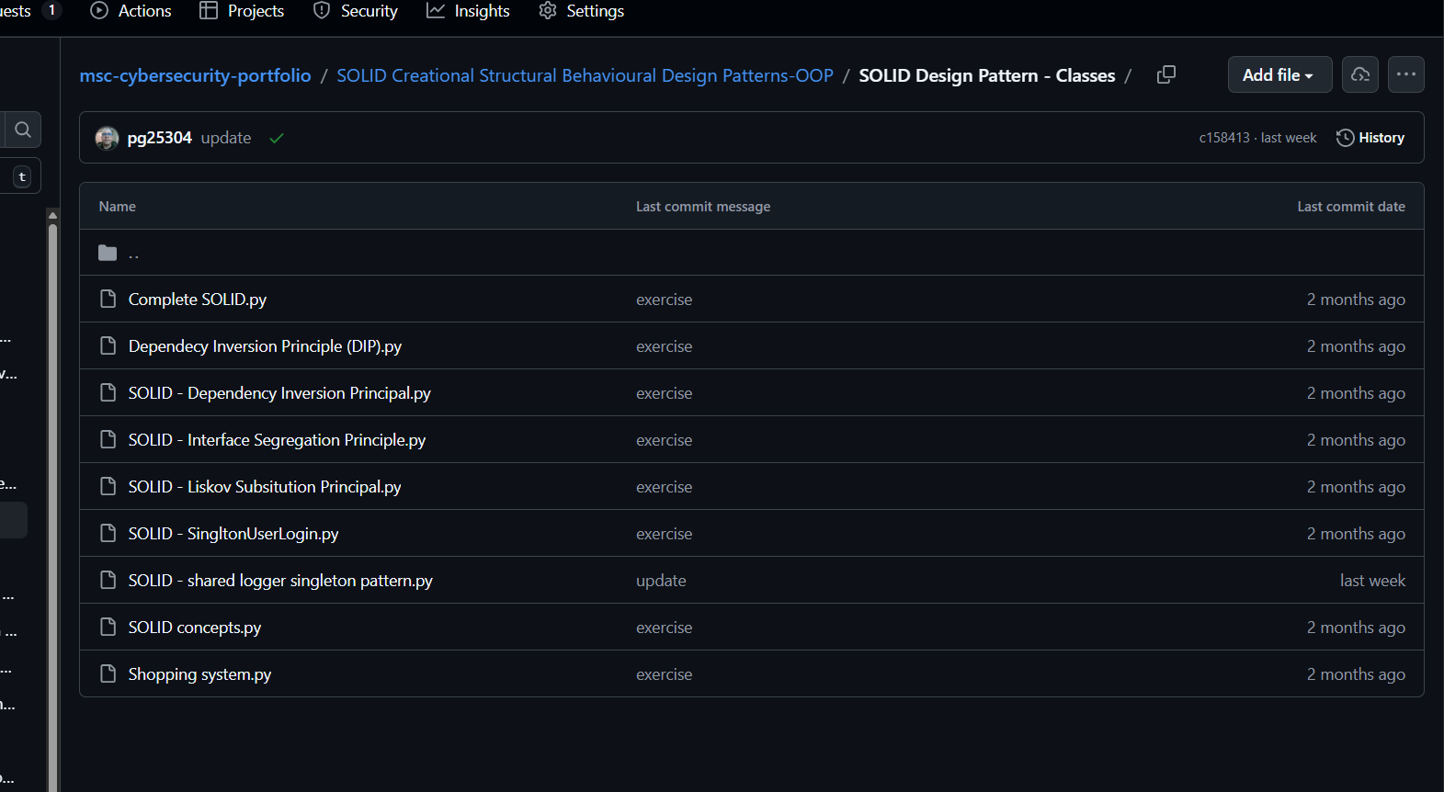

Unit 3: Design Patterns I - Creational Patterns

In this unit, we shall:
- Discuss Design Patterns:
  - We will discuss what design patterns are, why they matter, and how they help solve common software design problems.
- Focus on Five Key Creational Design Patterns:
  - Singleton: Ensures a class has only one instance and provides a global point of access to it.
  - Factory Method: Defines an interface for creating objects but let's subclasses alter the type of objects created.
  - Builder: Separates the construction of a complex object from its representation.
  - Prototype: Allows cloning of objects without making the code dependent on their classes.
  - Abstract Factory: Provides an interface for creating families of related or dependent objects.
- Review a Case Study:
  - We will examine how creational patterns are used in real-world software development, with examples from industry applications.
- Engage in Practical Exercise:
  - You will implement the Factory Method pattern in a simple software project, giving you hands-on experience with applying creational patterns.
By the end of this unit, you will be able to:
- Understand and explain what design patterns are and why they are important in software development.
- Identify and apply key creational design patterns, including Singleton, Factory Method, Builder, Prototype, and Abstract Factory.
- Recognise how creational patterns are used in real-world software systems to improve flexibility and maintainability.
- Implement the Factory Method pattern in a practical coding exercise.
Week 3 builds on the foundational OOP concepts and SOLID principles covered in previous weeks, introducing you to design patterns, which are essential for advanced software design. Creational patterns, in particular, provide solutions for object creation, a critical aspect of software development. Understanding these patterns will prepare you for the structural and behavioural patterns we will cover in later weeks, as well as for designing scalable and maintainable systems in your future projects. This week’s focus on creational patterns is a key step in mastering advanced object-oriented design.

How do I learn:
I studied and completed the lecture cast and took notes then created a Word document for further review available at (View raw): https://github.com/pg25304/msc-cybersecurity-portfolio/blob/main/M4-Advanced%20Object%20Oriented%20Design%20%26%20Programming%2020C-12W/OOP-Unit3-Creaational%20Design%20Patterns.docx
I have done the final Quiz of lecture cast, screenshot below as evidance
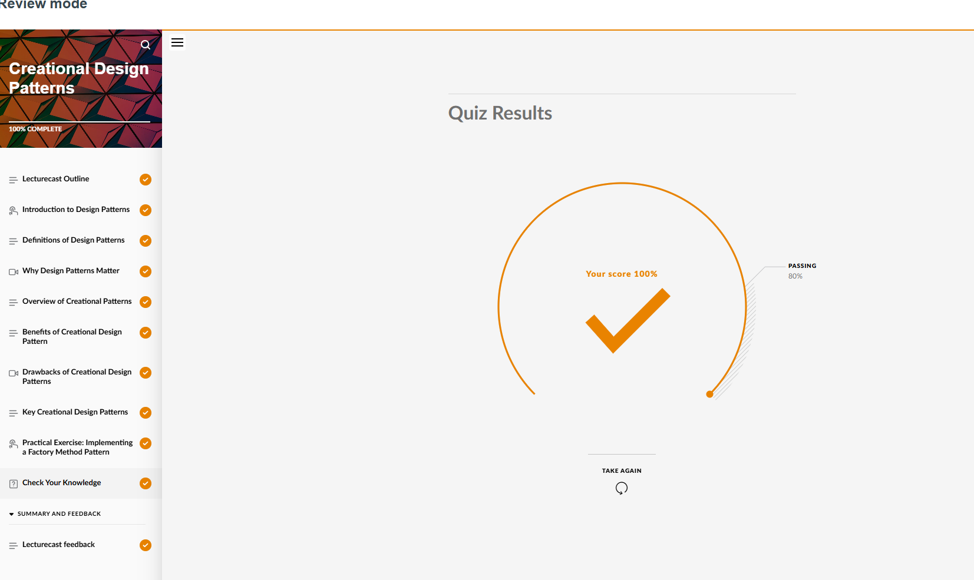
Developing Python solution for all different creational design patterns including Abstract Factory, Factory Method, Prototype, Singleton, Unit 3 lecture cast practice exercise, and builder available at:
https://github.com/pg25304/msc-cybersecurity-portfolio/tree/main/SOLID%20Creational%20Structural%20Behavioural%20Design%20Patterns-OOP/Creational%20Design%20Pattern%20-%20Objects

Unit 4: Design Patterns II - Structural Patterns
Welcome to Unit 4. This week, we continue our exploration of design patterns, focusing on structural patterns. These patterns help you organise classes and objects into larger, more flexible structures, enabling you to build modular and maintainable software systems. By the end of this week, you’ll understand how structural patterns can enhance code functionality and be able to apply them in real-world scenarios. Let’s dive into the world of structural design patterns!
In this unit, we shall:
- Provide an Overview of Seven Key Structural Design Patterns:
  - Adapter: Allows incompatible interfaces to work together.
  - Bridge: Separates an object’s abstraction from its implementation.
  - Composite: Composes objects into tree structures to represent part-whole hierarchies.
  - Decorator: Adds behaviour to objects dynamically without altering their structure.
  - Facade: Provides a simplified interface to a complex subsystem.
  - Proxy: Provides a surrogate or placeholder for another object to control access to it.
  - Flyweight: Reduces memory usage by sharing data between similar objects.
- Discuss How Structural Patterns Enable Modular and Flexible Code:
  - We’ll discuss how these patterns help you create systems that are easier to extend, modify, and maintain.
- Review a Case Study:
  - We’ll examine real-world applications of structural patterns, such as their use in network security systems, to understand their practical benefits.
- Engage in Practical Exercise:
  - You’ll use the Decorator pattern to enhance the functionality of an existing codebase, giving you hands-on experience with applying structural patterns.
By the end of this unit, you will be able to:
- Understand and explain the purpose and use of key structural design patterns, including Adapter, Bridge, Composite, Decorator, Facade, Proxy, and Flyweight.
- Recognise how structural patterns enable modular, flexible, and maintainable code.
- Apply the Decorator pattern in a practical coding exercise to dynamically enhance code functionality.
- Analyse real-world examples of structural patterns in action, such as in network security systems.

What I have done
Reading and research a variety of resources
Writing code for structural designs including Adapter, Bridge, compose, decorator,façade, proxy, Queue available at:
https://github.com/pg25304/msc-cybersecurity-portfolio/tree/main/SOLID%20Creational%20Structural%20Behavioural%20Design%20Patterns-OOP/Structural%20Design%20Pattern
Prepare and attend in Unit 4 Seminar
I have done Collaborative Discussion 1 including writing 3 individual code for Adapter ,Bridge and composite and discuss with my classmates, evidence screenshot below


Unit 5: Design Patterns III - Behavioural Patterns

Welcome to Unit 5. This week, we delve into behavioural design patterns, which focus on how objects interact and communicate with each other. These patterns help you design systems that are flexible, efficient, and easy to maintain by defining clear communication pathways between objects. By the end of this week, you will understand how behavioural patterns can improve the interaction between objects and be able to apply them in real-world scenarios. Let’s explore how these patterns can enhance your software design skills!
In this unit, we shall:
- Provide an Introduction to Six Key Behavioural Design Patterns:
  - Strategy: Allows you to define a family of algorithms, encapsulate each one, and make them interchangeable.
  - Observer: Defines a one-to-many dependency between objects so that when one object changes state, all its dependents are notified.
  - Chain of Responsibility: Passes a request along a chain of handlers, where each handler either processes the request or passes it to the next handler.
  - Template Method: Defines the skeleton of an algorithm in a method, deferring some steps to subclasses.
  - Command: Encapsulates a request as an object, allowing you to parameterise clients with different requests.
  - State: Allows an object to alter its behaviour when its internal state changes.
- Discuss the Application of Behavioural Patterns:
  - We will discuss how these patterns enable efficient interaction and communication between objects, making your code more modular and easier to maintain.
- Review a Case Study:
  - We will examine how the Observer pattern is used in cybersecurity systems to monitor and respond to changes in system state.
- Engage in Practical Exercise:
  - You will implement the Strategy pattern in a project, giving you hands-on experience with applying behavioural patterns.
By the end of this unit, you will be able to:
- Understand and explain the purpose and use of key behavioural design patterns, including Strategy, Observer, Chain of Responsibility, Template Method, Command, and State.
- Recognise how behavioural patterns enable efficient interaction and communication between objects.
- Apply the Strategy pattern in a practical coding exercise to make your code more flexible and reusable.
- Analyse real-world examples of behavioural patterns in action, such as the Observer pattern in cybersecurity systems.
Week 5 builds on the creational and structural patterns covered in previous weeks, shifting the focus to behavioural patterns, which are essential for defining how objects interact and communicate. Understanding these patterns is crucial for designing systems that are flexible, efficient, and easy to maintain. This week’s exploration of behavioural patterns prepares you for the advanced topics in software architecture, concurrency, and secure coding that we will cover in later weeks. Behavioural patterns are a key tool in your software design toolkit.

What I have done
Reading and researching a variety of online resources
Writing 8 piece of code for different Behavioural Design patterns including Command, Observer, State, Chain of responsibility, Template, and etc. available at:
https://github.com/pg25304/msc-cybersecurity-portfolio/tree/main/SOLID%20Creational%20Structural%20Behavioural%20Design%20Patterns-OOP/Behavioural%20Design%20Patterns
Unit 5 Lecture cast , evidence screenshot below:
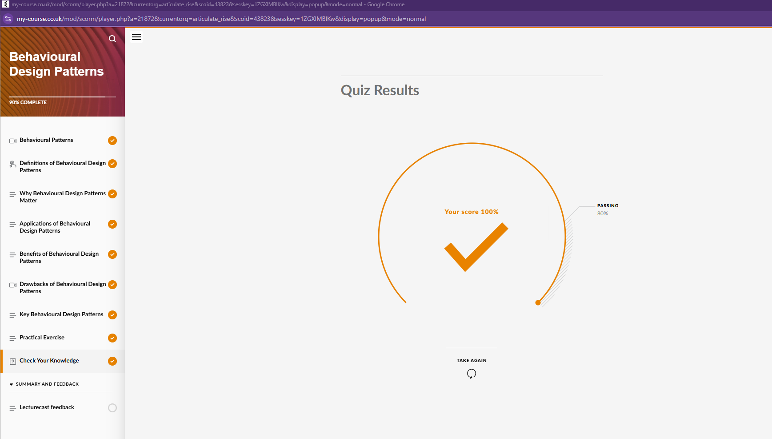
I have done Collaborative Discussion 2, evidence screenshot below and created a document for further reference available at (click on View raw): https://github.com/pg25304/msc-cybersecurity-portfolio/blob/main/M4-Advanced%20Object%20Oriented%20Design%20%26%20Programming%2020C-12W/OOP-Unit5-Collaborative%20Discussion%202.docx
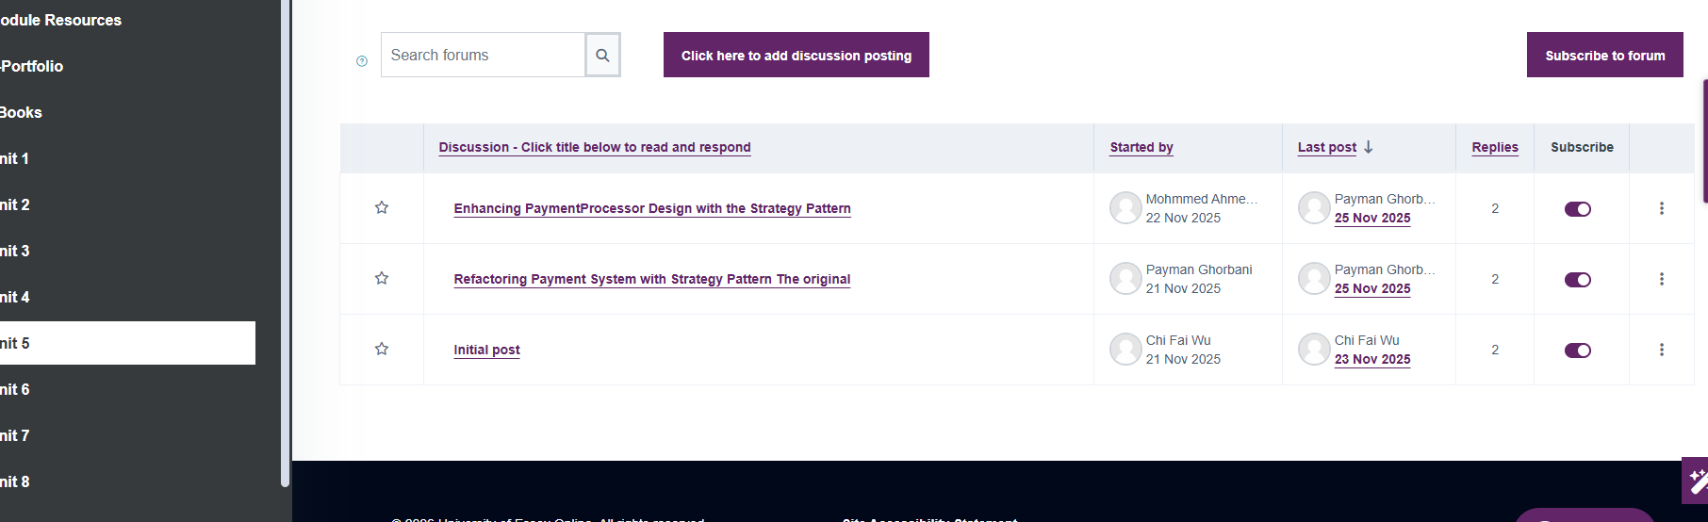

Unit 6: Concurrency and Parallelism in Object-Oriented Design
Welcome to Unit 6. This week, we explore the critical topics of concurrency and parallelism in object-oriented design. As software systems become more complex, the ability to handle multiple tasks simultaneously is essential for building efficient and responsive applications. By the end of this week, you will understand how to write thread-safe code and address common concurrency issues, preparing you to design robust and scalable systems. Let’s dive into the world of concurrent programming!
In this unit, we shall:
- Provide an Introduction to Concurrency:
  - We will cover the basics of threads, processes, and synchronisation, explaining how they enable concurrent execution in software systems.
- Explore Object-Oriented Approaches to Writing Thread-Safe Code:
  - We will explore how object-oriented principles can be applied to write thread-safe code, ensuring that your programs run correctly in a multi-threaded environment.
- Discuss Common Concurrency Issues and Solutions:
  - We will discuss common concurrency problems such as race conditions and deadlocks, and how to solve them using synchronization techniques and best practices.
- Engage in Practical Exercise:
  - You will write thread-safe code in Python, giving you hands-on experience with managing concurrency in an object-oriented context.
By the end of this unit, you will be able to:
- Understand and explain the basics of concurrency, including threads, processes, and synchronisation.
- Apply object-oriented principles to write thread-safe code that avoids common concurrency issues.
- Identify and resolve common concurrency problems such as race conditions and deadlocks.
- Implement thread-safe code in Python through a practical exercise.
Week 6 builds on the design patterns and OOP principles covered in previous weeks, introducing you to concurrency and parallelism, which are essential for designing modern, high-performance software systems. Understanding how to write thread-safe code and handle concurrency issues is crucial for building scalable and responsive applications. This week’s focus on concurrency prepares you for the advanced topics in software architecture and secure coding that we will cover in later weeks, as well as for real-world scenarios where concurrent programming is a necessity.

What I have done to learn:
Reading and research a variety of online resources. Takes note and a comprehensive notes document for further study available at:
https://github.com/pg25304/msc-cybersecurity-portfolio/blob/main/M4-Advanced%20Object%20Oriented%20Design%20%26%20Programming%2020C-12W/OOP-Unit6-implementing%20Concurrency.docx
I have successfully done the Assessment: Individual Coding Exercise) available at: https://github.com/pg25304/BankingSystemProject

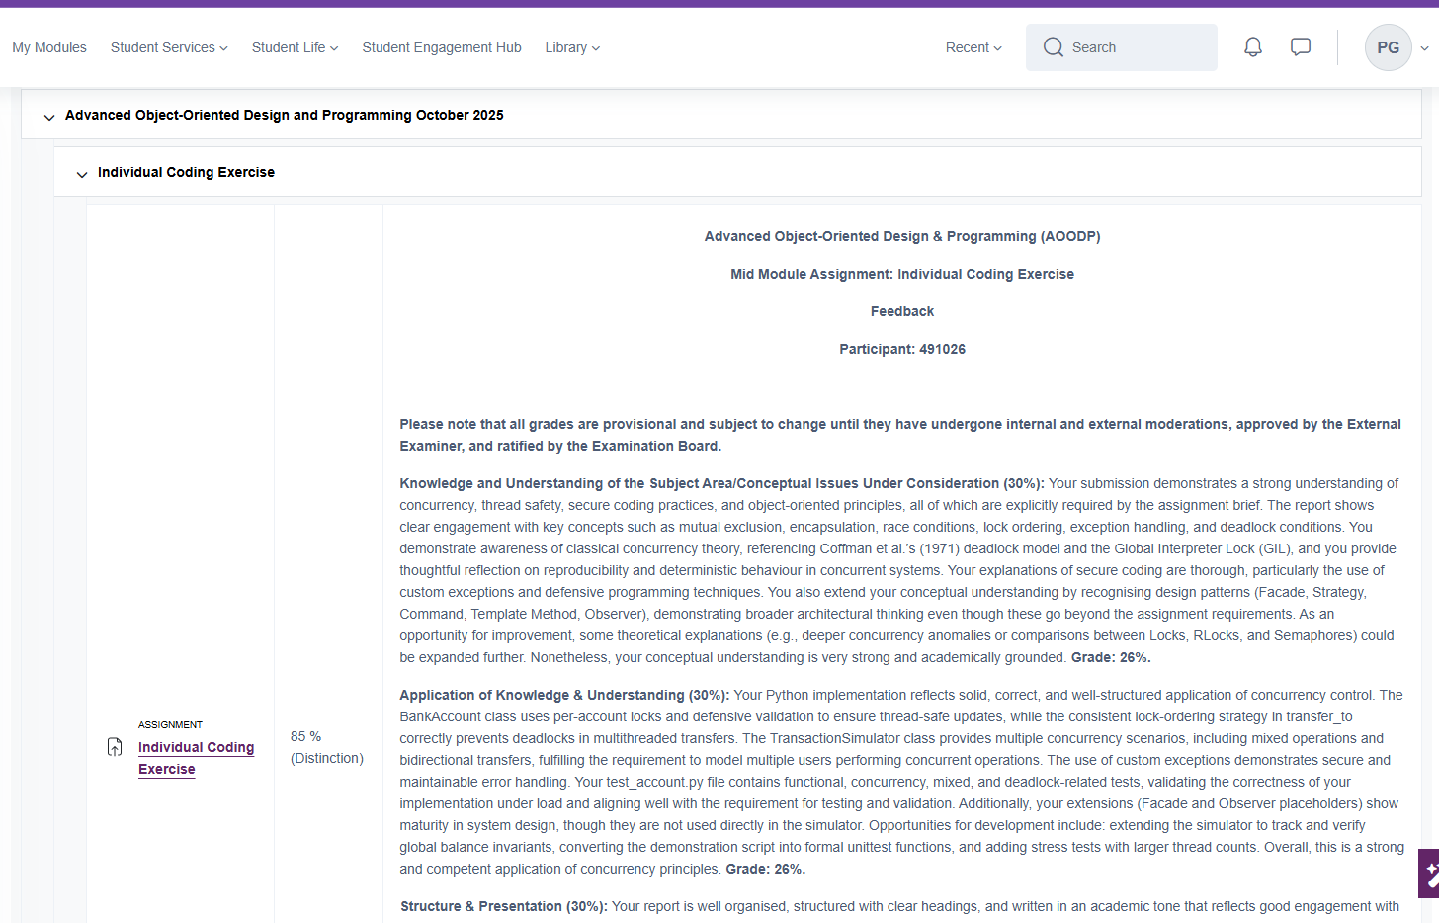

I did preparation and attend on Unit 6 seminar.
Writing 7 pieces of code to practice Concurrency concept available at: https://github.com/pg25304/msc-cybersecurity-portfolio/tree/main/SOLID%20Creational%20Structural%20Behavioural%20Design%20Patterns-OOP/Concurrency

Unit 7: Secure Coding Practices in Object-Oriented Programming
Welcome to Unit 7. This week, we shift our focus to secure coding practices, a critical aspect of modern software development. As software systems become more complex and interconnected, ensuring their security is paramount. By the end of this week, you will understand the importance of secure coding, recognise common vulnerabilities in object-oriented systems, and learn techniques to write secure, robust code. Let’s dive into the world of secure software design!
In this unit, we shall:
- Discuss the Importance of Secure Coding in Software Development:
  - We will discuss why secure coding is crucial in today’s software landscape and how it helps protect systems from malicious attacks.
- Explore Common Vulnerabilities in OO Systems:
  - We will explore common vulnerabilities in object-oriented systems, such as injection attacks, buffer overflows, and other security risks.
- Introduce Secure Coding Techniques:
  - We will cover key techniques for writing secure code, including input validation, proper authentication, and exception handling.
- Engage in Practical Exercise:
  - You will refactor an existing codebase to eliminate security vulnerabilities, giving you hands-on experience with applying secure coding practices.
By the end of this unit, you will be able to:
- Understand and explain the importance of secure coding in software development.
- Identify common vulnerabilities in object-oriented systems, such as injection attacks and buffer overflows.
- Apply secure coding techniques, including input validation, proper authentication, and exception handling.
- Refactor a codebase to eliminate security vulnerabilities through a practical exercise.
Week 7 builds on the object-oriented design principles and concurrency topics covered in previous weeks, introducing you to secure coding practices, which are essential for building robust and secure software systems. Understanding how to write secure code is crucial for protecting systems from vulnerabilities and attacks, especially in fields like cybersecurity, data science, and AI. This week’s focus on secure coding prepares you for the advanced topics in software architecture and secure system design that we will cover in later weeks.

What I have done:
Researching and reading including lecture (refer to screenshot below) cast and took nots for further usage, available at (click on View raw): https://github.com/pg25304/msc-cybersecurity-portfolio/blob/main/M4-Advanced%20Object%20Oriented%20Design%20%26%20Programming%2020C-12W/Unit%207%20lecturecast%20Secure%20Coding%20Practices.docx


I have done activity in Collaborative Discussion 3 as shown below:


Writing 4 Python code practicing secure coding principle available at:
https://github.com/pg25304/SecureCoding

Unit 8: Refactoring and Code Smells
Welcome to Unit 8. This week, we focus on refactoring and code smells, essential practices for maintaining clean, readable, and maintainable code. As software systems evolve, it’s crucial to continuously improve their design to avoid technical debt and ensure long-term sustainability. By the end of this week, you’ll understand how to identify code smells and apply refactoring techniques to improve your code. Let’s dive into the art of refactoring!
In this unit, we shall:
- Provide an Introduction to Code Smells:
  - We will discuss what code smells are, how to detect them, and why they indicate potential issues in your codebase.
- Provide an Introduction to Refactoring Techniques:
  - We will cover various refactoring techniques to improve code maintainability and readability, ensuring your code remains clean and efficient as it evolves.
- Engage in Practical Exercise:
  - You will refactor an existing codebase to eliminate code smells, applying object-oriented principles to improve its design.
By the end of this unit, you will be able to:
- Understand and explain what code smells are and how to detect them in a codebase.
- Apply refactoring techniques to improve code maintainability and readability.
- Refactor an existing codebase to eliminate code smells, using object-oriented principles.
- Recognise the importance of refactoring in maintaining high-quality, sustainable software systems.
Week 8 builds on the object-oriented design principles, design patterns, and secure coding practices covered in previous weeks, introducing you to refactoring and code smells. These practices are essential for maintaining clean, readable, and maintainable code as software systems evolve. Understanding how to refactor code and eliminate code smells is crucial for reducing technical debt and ensuring long-term sustainability. This week’s focus on refactoring prepares you for the advanced topics in software architecture and system design that we’ll cover in later weeks

What I did to master the concepts
Study and research a variety of online resources Preparing and attending in seminar Unit 8. File name is: OOP-Unit 8 Seminar PreparationRefactoring & code smells.docx available at: https://github.com/pg25304/msc-cybersecurity-portfolio/tree/main/M4-Advanced%20Object%20Oriented%20Design%20%26%20Programming%2020C-12W

Exercising the concept of refactoring and code smell using PyCharm available at: https://github.com/pg25304/SecureCoding
I have done Formative activity including Collaborative Discussion 4 as shown below:
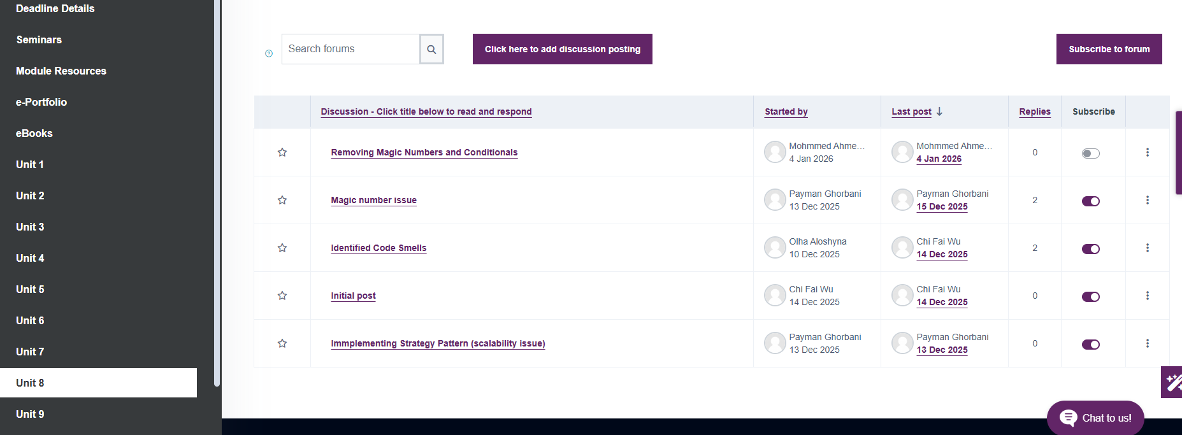

Unit 9: Object-Oriented Software Architecture

Welcome to Unit 9. This week, we shift our focus to software architecture, a critical aspect of designing scalable, maintainable, and secure systems. As software systems grow in complexity, choosing the right architecture becomes essential for ensuring long-term success. By the end of this week, you’ll understand the role of object-oriented design in software architecture and be able to apply these principles to design robust systems. Let’s explore the world of software architecture!
In this unit, we shall:
- Provide an Introduction to Software Architecture:
  - We will cover key architectural styles, including layered architecture, microservices, and monolithic applications, and discuss their strengths and weaknesses.
- Explore the Role of Object-Oriented Design in Scalable and Maintainable Architectures:
  - We will explore how object-oriented design principles contribute to creating architectures that are scalable, maintainable, and secure.
- Review a Case Study:
  - We will examine a case study on designing a secure architecture for a large-scale system, highlighting the importance of architecture in real-world applications.
- Engage in Practical Exercise:
  - You will build a simple object-oriented-based software architecture, giving you hands-on experience with applying architectural principles.
By the end of this unit, you will be able to:
- Understand and explain key software architecture styles, including layered architecture, microservices, and monolithic applications.
- Recognise the role of object-oriented design in creating scalable, maintainable, and secure architectures.
- Analyse a case study on designing a secure architecture for a large-scale system.
- Apply architectural principles to build a simple object-oriented-based software architecture.
Week 9 builds on the object-oriented design principles, design patterns, and refactoring techniques covered in previous weeks, introducing you to software architecture. Understanding how to design scalable, maintainable, and secure architectures is crucial for building large-scale systems. This week’s focus on software architecture prepares you for the Test-Driven Development (TDD) and Unit Testing and the advanced topics in system design that we will cover in the final couple of weeks of the module.

What I did to learn this unit:

Research and reading many online resources including Unit 9 lecture cast as shown below:
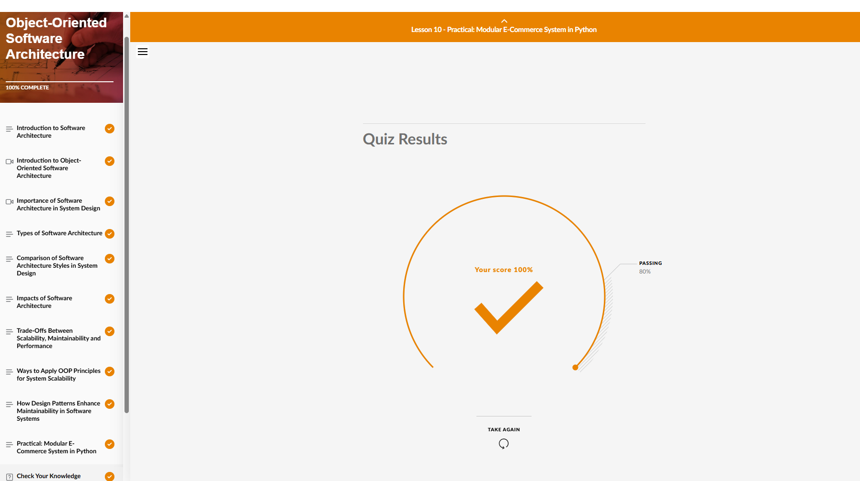
Taking notes of lecture cast for the future reference available at (click on View raw): https://github.com/pg25304/msc-cybersecurity-portfolio/blob/main/M4-Advanced%20Object%20Oriented%20Design%20%26%20Programming%2020C-12W/OOP%20Unit%209%20Object-Oriented%20Software%20Architecture%20Lecturecast.docx
I did the Case study activity and developing a solution for a simple e-commerce solution however, I later refactor my solution and turn it as an approximately a business grade solution as my Capstone Project (Unit 12) available at : https://github.com/pg25304/ecommerce-capstone-project

Unit 10: Test-Driven Development (TDD) and Behaviour Driven Development (BDD)
Welcome to Unit 10. This week, we explore Test-Driven Development (TDD) and unit testing, essential practices for ensuring code quality and reducing bugs. By writing tests before writing code, you can design more robust and reliable software systems. By the end of this week, you’ll understand the principles of TDD and be able to apply them to develop software components. Let’s dive into the world of testing!
In this unit, we shall:
- Provide an Introduction to Test-Driven Development (TDD):
  - We will discuss the principles of TDD, which involve writing tests before writing the actual code, and how this approach improves software design and quality.
- Explore the Importance of Unit Testing:
  - We will explore why unit testing is essential for ensuring code quality, reducing bugs, and maintaining software over time.
- Engage in Practical Exercise:
  - You will write test cases and use TDD to develop a software component, giving you hands-on experience with this development approach.
By the end of this unit, you will be able to:
- Understand and explain the principles of Test-Driven Development (TDD) and its benefits.
- Recognise the importance of unit testing in ensuring code quality and reducing bugs.
- Apply TDD principles to write test cases and develop a software component.
- Reflect on how TDD and unit testing can improve the quality and maintainability of your code.
Week 10 builds on the object-oriented design principles, refactoring techniques, and software architecture topics covered in previous weeks, introducing you to Test-Driven Development (TDD) and unit testing. These practices are essential for ensuring code quality, reducing bugs, and maintaining software over time. Understanding TDD and unit testing prepares you for the Dependency Injection and Inversion of Control (IoC) and the final assessment, where you will apply these principles to develop a complex software system.

What I have done to learn the contents of Unit 10:

Research, reading and taking notes of a variety of online resource to master the concepts of unit 10 available at (click on View raw): https://github.com/pg25304/msc-cybersecurity-portfolio/blob/main/M4-Advanced%20Object%20Oriented%20Design%20%26%20Programming%2020C-12W/OOP-Unit%2010%20-%20Test-Driven%26%20Behaviour-Driven%20Development.docx
I have done case study “Object-oriented software architecture and test-driven development for e-learning platform” available at:
https://github.com/pg25304/Test-DrivenDevelopment-ElearningPlatform

Preparing and attending at Unit 10 seminar (click on View raw) by reviewing the concepts in advance

Unit 11: Dependency Injection and Inversion of Control (IoC)
Welcome to Unit 11. This week, we explore Dependency Injection (DI) and Inversion of Control (IoC), two powerful design principles that make your code more flexible, modular, and testable. By decoupling components and managing dependencies effectively, you can create systems that are easier to maintain and extend. By the end of this week, you’ll understand how DI and IoC work and be able to apply them in your projects. Let’s dive into the world of dependency management!
In this unit, we shall:
- Provide an Introductuion to Dependency Injection (DI) and Inversion of Control (IoC):
  - We’ll discuss the principles of DI and IoC, explaining how they help decouple components and manage dependencies in a system.
- Explore How DI Frameworks Make Code Flexible and Testable:
  - We’ll explore how DI frameworks like Spring and Google Guice simplify dependency management, making code more flexible, modular, and easier to test.
- Engage in Practical Exercise:
  - You’ll implement dependency injection in a Python application, giving you hands-on experience with applying these principles.
By the end of this unit, you will be able to:
- Understand and explain the principles of Dependency Injection (DI) and Inversion of Control (IoC).
- Recognise how DI frameworks like Spring and Google Guice make code more flexible, modular, and testable.
- Apply DI principles to implement dependency injection in a Python application.
- Reflect on how DI and IoC can improve the maintainability and scalability of your software systems.
Week 11 builds on the object-oriented design principles, design patterns, and software architecture topics covered in previous weeks, introducing you to Dependency Injection (DI) and Inversion of Control (IoC). These principles are essential for creating flexible, modular, and testable systems. Understanding DI and IoC prepares you for the capstone project and the final assessment, where you will apply these principles to design and implement a complex software system.

What I have done to master the concepts of Unit 11
Researching and reading a variety of online resources including lecture cast of Unit 11 as shown below:
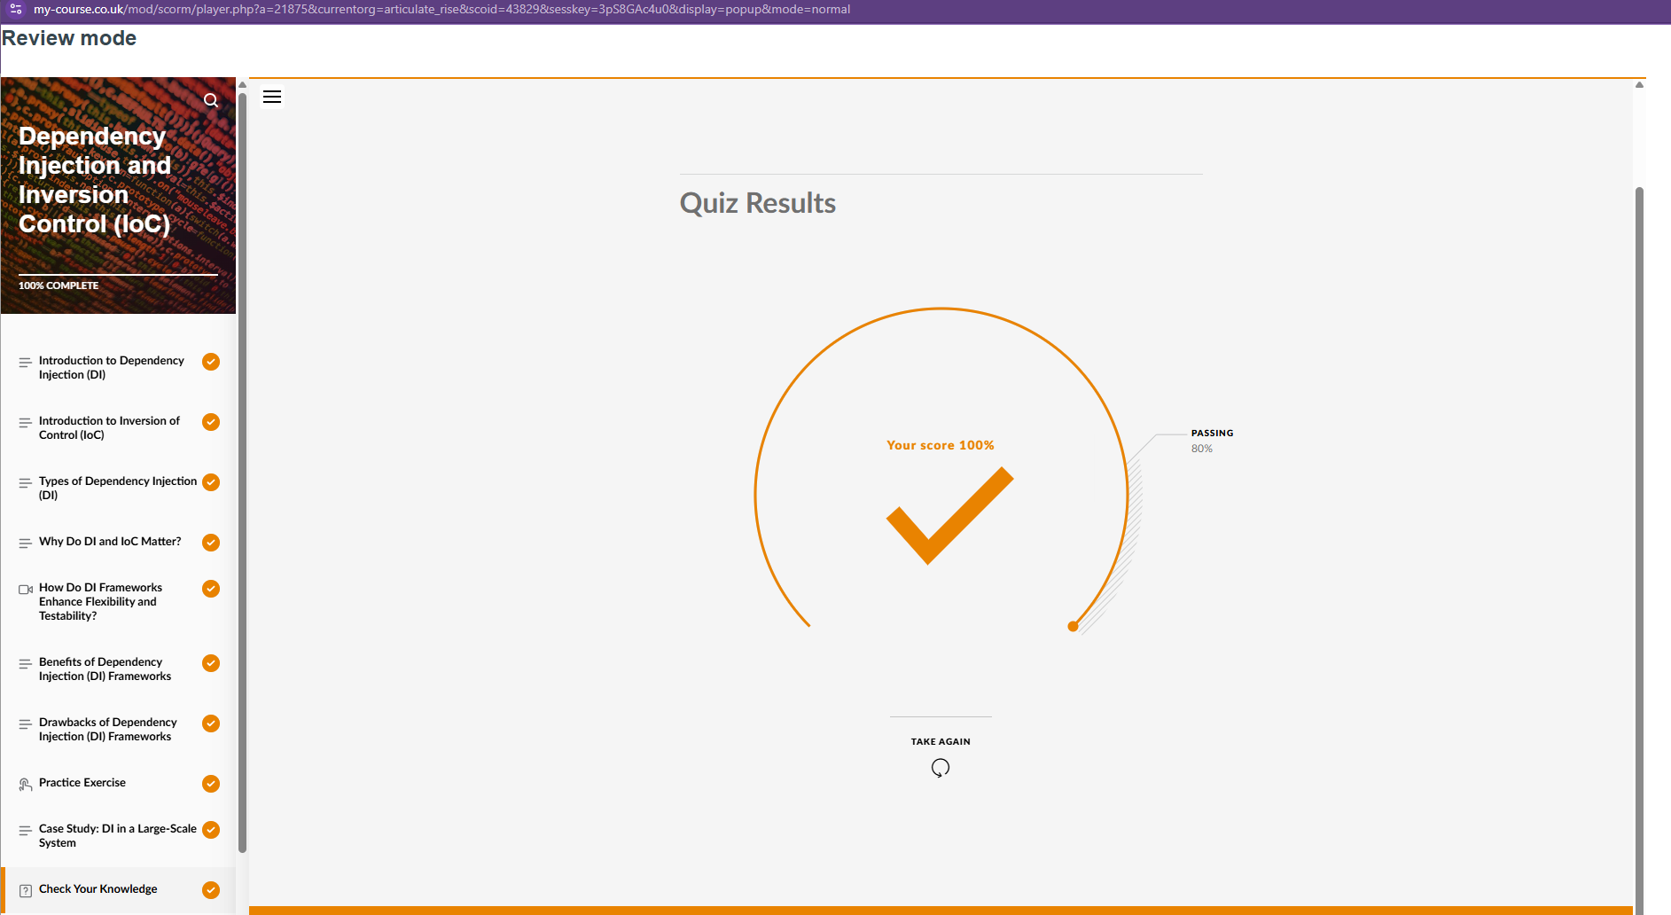
Taking note and create a document for further reference (click on View raw):
https://github.com/pg25304/msc-cybersecurity-portfolio/blob/main/M4-Advanced%20Object%20Oriented%20Design%20%26%20Programming%2020C-12W/Unit11%20Dependency%20Injection%20and%20Inversion%20Control.docx
I have done the case study regarding Dependency Injection and Inversion of Control available at:
https://github.com/pg25304/Dependency-Injection-Inversion-of-Control

Unit 12: Recent Developments and Review

Welcome to Unit 12. In this final week, you’ll bring together all the knowledge and skills you’ve acquired throughout the course to complete your Capstone Project. This is your opportunity to design and implement a complex software system that solves real-world problems in cybersecurity, data science, or AI. Additionally, we’ll review key concepts and prepare for the final assessment. Let’s finish strong and showcase everything you’ve learned!
In this unit, we shall:
- Provide an Introduction to the Capstone Project:
  - You will design and implement a complex software system using advanced object-oriented design principles, design patterns, and secure coding practices.
  - The project will focus on solving real-world problems in cybersecurity, data science, or AI, allowing you to apply your skills to practical scenarios.
- Review Key Concepts:
  - We will review the key concepts covered throughout the module, including OOP principles, design patterns, secure coding practices, software architecture, and testing strategies.
  - This review will help you consolidate your knowledge and prepare for the final assessment.
By the end of this unit, you will be able to:
- Design and implement a complex software system using advanced object-oriented design principles, design patterns, and secure coding practices.
- Apply your knowledge to solve real-world problems in cybersecurity, data science, or AI.
- Review and consolidate key concepts from the module to prepare for the final assessment.
- Present your Capstone Project effectively and provide constructive feedback on peer projects.
Week 12 is the culmination of the entire module, bringing together all the concepts and skills you’ve learned over the past 11 weeks. The Capstone Project allows you to apply advanced object-oriented design principles, design patterns, and secure coding practices to a real-world problem, demonstrating your ability to design and implement complex software systems. The review of key concepts and group presentations provide an opportunity to consolidate your knowledge and showcase your work, preparing you for the final assessment and future challenges in software development.

What I have done to master the Unit 12 contents
I have read a variety of online resources to complete my capstone project and end of module assessment.
I have done the end of module Assessment which this document is a part of that.
As Mentioned before I improved and refactor my e-commerce solution as my capstone project I also prepare a PowerPoint presentation to demonstrate my project both available at:
https://github.com/pg25304/ecommerce-capstone-project

Capstone Project
Project available at: https://github.com/pg25304/ecommerce-capstone-project/tree/master/business
Project Overview and Seminar Task Satisfaction
This project addresses the requirements of the seminar task thoroughly, encapsulating real-world scenarios in an e-commerce application. Below is a detailed analysis of how the design satisfies the requirements.

1. Object-Oriented Design Principles
Encapsulation
- The project effectively groups related functionality into classes, ensuring encapsulation.
- For example:
  - UserService encapsulates the logic for user registration and login.
  - OrderService encapsulates order creation and product stock management.
  - Validators encapsulate input sanitization and validation logic.
Inheritance
- The BaseRepository class demonstrates inheritance:
  - It provides a standard interface (save and find methods) for other repositories like UserRepository and ProductRepository, ensuring consistency.
- All repositories inherit from BaseRepository, sharing its abstract structure.
Polymorphism
- Polymorphism is evident in the interchangeable repository implementations:
  - For instance, repositories like UserRepository and a potential alternative like TestUserRepository can be swapped seamlessly since they extend BaseRepository.
Abstraction
- The project's layered architecture demonstrates abstraction effectively:
  - Presentation layer focuses on communication with external systems (e.g., controllers).
  - Business layer handles application logic (e.g., services).
  - Data layer is responsible for data access and storage (e.g., repositories).
Conclusion: The project applies encapsulation, inheritance, polymorphism, and abstraction, showcasing a robust understanding of object-oriented design.

2. Design Patterns
Creational Patterns
- The Strategy Pattern provides a flexible way to handle password validation:
  - The PasswordValidationStrategy is an abstract class, and implementations like BasicPasswordValidationStrategy and StrongPasswordValidationStrategy demonstrate how strategies can be swapped dynamically to meet different requirements.
Structural Patterns
- The project uses Dependency Injection to decouple components:
  - For example, UserService accepts a password_validation_strategy during initialization.
Behavioral Patterns
- The Strategy Pattern is also a behavioral pattern, seen in its use for password validation:
  - This allows the system to adapt to varying validation requirements dynamically.
Conclusion: The project demonstrates the application of Creational, Structural, and Behavioral design patterns, making it modular, flexible, and extendable.

3. Secure Coding Practices
Input Validation
- Email and password inputs are validated using utilities in validators.py:
  - validate_email ensures the email follows a proper format.
  - validate_password ensures passwords meet defined strength requirements.
  - sanitize_input prevents injection-based attacks by escaping special characters.
Authentication
- Secure password handling is implemented using bcrypt:
  - Passwords are hashed during registration and verified securely during login.
Exception Handling
- Exception handling ensures the system behaves predictably under invalid input or runtime errors:
  - For instance, during user registration in UserController, ValueError is caught to handle validation errors gracefully.
Conclusion: The project incorporates secure practices, including input validation, authentication, and exception handling, ensuring data integrity and user safety.

4. Real-World Problem Solving
This project addresses real-world e-commerce challenges:
- Authentication: Provides user login and registration capabilities, ensuring access control.
- Order Management: Manages product availability and order creation.
- Product Catalogue: Implements product listing and data retrieval.

Final Thoughts
This project satisfies the capstone seminar requirements:
- Object-Oriented Design Principles: Fully demonstrated through encapsulation, inheritance, polymorphism, and abstraction.
- Design Patterns: Implements creational, structural, and behavioural patterns, especially the Strategy Pattern.
- Secure Coding Practices: Includes robust input validation, secure password handling, and comprehensive exception handling.
This project is an exemplar of applying best practices to solve real-world e-commerce problems, showcasing design principles and patterns effectively.
2. reflection.
In the beginning of the course I checked the material of the module and listen to my tutor first session regarding what we are going to do. I found it scarry and I felt a bit nerves and I told my tutor it is scarry, but he calmly responded that do not worry Payman I will provide everything that you need to facilitate your journey. That was a heart-warming quote for me and I appreciate that.
Moreover, based on my experience and knowledge I had conquered much more challenging tasks by determination, organisation and hard working before this course while I was less confident about my English language and programming during my IT Degree and graduated by first class degree.
moreover, at the beginning of the course, I knew that it is a challenging course. And I took a Python course and made myself familiar with syntax, and this was a big help to gain my confident and reduce the stress and pressure.
This nervousness or pressure came from the fact that I am a perfectionist person, and I always desire for the excellency, and there were a lot to learn from this course.
So, I set up 4-8 hours study every day, and step by step I regained not only my confident and reduced the pressure and nervousness I but also start enjoying the course. I want to emphasise that without my tutor amazing support it was much more difficult to conquer this feeling.
I am nearly at the end of the module, and I feel confident and satisfied with my effort even though I have not received my mark .

3. Skill Development
Academic skills:
I had to plan to be able successfully pass this module. I had already work in different position and I gained and improve some critical thinking and problem-solving skills as I worked 4 years as a service desk technician. Upon that the material of the course helped me to improve these skills by doing all the tasks in each unit. For each task I had to exercise and use these skills to be able to solve the issue.
Employability skills:
as I mentioned in my reflection due to difficulty of the task I had to be able to make a plan and in my plan, I had to specify and imbedded my study time during my normal life. Moreover, managing to hit all of deadline for assessments furthermore attending in all seminars or any other event arranged bu the university was exercising my time management and communication skills and improve these skills.
Collaborative discussions in the module was a great environment to built upon my current communication and teamwork skills where I communicate, learn and work with my classmate to fix an issue or improve my work.
I also used PyCharm, git and GitHub to provide a development environment which is a necessary real world hard skill (employability skill) for a developer for developing, collaborative, and sharing their solutions.

4. Professional Development Plan
My strength: understanding well the requirement and provide a proper software architecture design for solution
Area for improvement: “Need to improve secure coding practices”
Future Goal: as I am on a cybersecurity course and Python skills is a valuable skill as mentioned below:
Python is widely used in the cybersecurity field for tasks like:
Automating security tools and scripts
Analyzing network traffic and logs
Developing security applications and tools
Performing penetration testing and vulnerability assessments
Many cybersecurity professionals rely on Python for its simplicity, flexibility, and extensive libraries (e.g., Scapy, Nmap, and Metasploit). Having Python programming skills will not only enhance your learning experience in cybersecurity but also make you a more competitive candidate in the job market. So I am going to carry on improving this skill.
Action plan:
Target 1: Graduating with first class master’s degree including my Python programming skills
Time: already started since July 2025 until July 2027 my graduation
Daily study time: 4-8 hours
Python study : ½ hour Monday, Wednesday, and Friday
Target 2 : Improving and rewriting my CV; as well as seeking and finding a security related job
Every day 1/2 hour per day until get the job

5. Any specific requirements
Use this document to write the task I asked.
check all the assignment requirements are fulfilled.
Please improve my English language writing to an Academic writing.
If you have any doubt or need to choose option, ask me.
This should be as a human writing and should not be write in a way to detect as an AI generated writing.

