OpenFaaS Serverless Migration and Continuous Integration/Continuous Delivery Implementation
Technical Project Report for GitHub and LinkedIn Portfolio

Executive Summary
I designed and implemented a practical OpenFaaS serverless deployment on Kubernetes, beginning with a Python Hypertext Transfer Protocol (HTTP) function and extending the project into a container-registry and continuous integration and continuous delivery (CI/CD) workflow. The implementation uses Docker Desktop Kubernetes for local validation, OpenFaaS installed through Helm, GHCR for image distribution, GitHub for version control and GitHub Actions for automated testing, building and image publication. The deployed function was verified as a healthy Kubernetes pod and successfully invoked through the OpenFaaS gateway.
A major focus of the project was operational security. I used secure credential handling, least-privilege repository and package permissions, separated token purposes, revoked and rotated an accidentally exposed credential, and replaced a personal registry token in CI with GitHub's repository-scoped GITHUB_TOKEN. I also documented unsuccessful experiments and troubleshooting rather than presenting only the final working configuration.

1. Project Objectives
- Deploy OpenFaaS on a working Kubernetes environment and understand its platform components.
- Develop and deploy a stateless Python serverless function.
- Package and distribute the function through a container registry.
- Introduce repeatable automated testing and container-image publication.
- Apply practical security controls to authentication, tokens and package permissions.
- Capture troubleshooting decisions and limitations as part of the engineering evidence.
- Identify a credible path from local validation to a managed cloud Kubernetes platform.

2. Architecture
The implemented flow is: source code in GitHub -> pytest in GitHub Actions -> OpenFaaS container build -> GHCR publication -> controlled OpenFaaS deployment -> Kubernetes pod -> Hypertext Transfer Protocol (HTTP) invocation through the OpenFaaS gateway. OpenFaaS is designed around containerised functions on Kubernetes, with the gateway providing function routes and Prometheus collecting operational metrics (OpenFaaS, 2026).
The current deployment target is a local Docker Desktop Kubernetes cluster. The CI pipeline is cloud-hosted by GitHub, but the final local deployment is intentionally manual because the GitHub-hosted runner does not have direct network access to the local gateway. This avoids describing the project as full continuous deployment when only the test/build/publish stages are automated.

3. Platform Preparation
I initially discovered that kubectl was still pointing to an older Azure Kubernetes Service (AKS) context. I changed the active context to docker-desktop and verified that the single Docker Desktop control-plane node was Ready. I installed Helm, added the OpenFaaS chart repository, created separate openfaas and openfaas-fn namespaces, and deployed OpenFaaS. The gateway, Prometheus, Alertmanager, NATS and queue worker reached Running state.
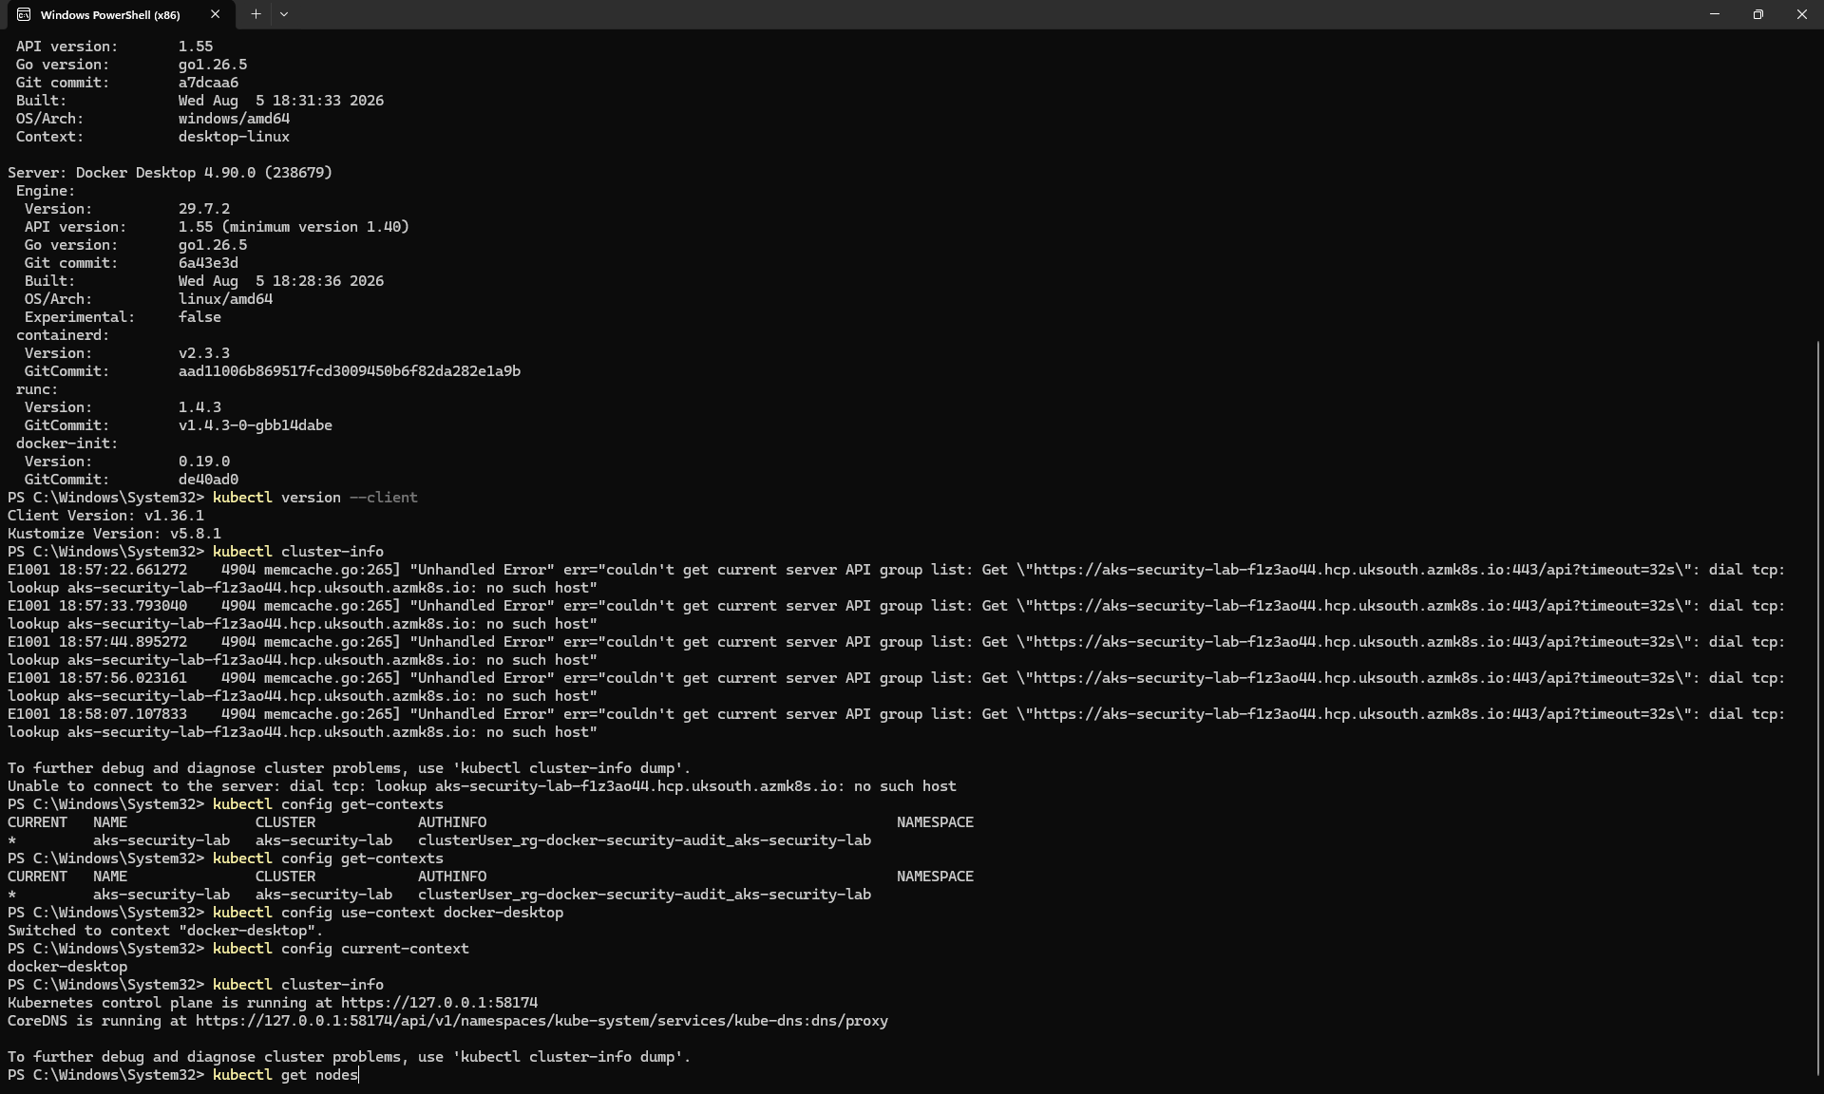
Figure 1. Kubernetes context correction from the previous AKS context to the Docker Desktop cluster and cluster verification.
The gateway was exposed locally using kubectl port-forward on port 8080. I installed faas-cli and authenticated by reading the Kubernetes basic-auth Secret into a variable and piping the decoded value to faas-cli login through standard input. This avoided embedding the administrator password directly in command history.

4. Function Development
I used the official python3-http template and created a function named hello-python. The handler returns a compact JSON health-style response containing the service name, status, Kubernetes platform label and an International Organization for Standardization (ISO) formatted Coordinated Universal Time (UTC) timestamp.
import json
from datetime import datetime, timezone
def handle(event, context):
response = {
"service": "OpenFaaS Serverless Demo",
"status": "running",
"platform": "Kubernetes",
"timestamp": datetime.now(timezone.utc).isoformat()
}
return {
"statusCode": 200,
"headers": {"Content-Type": "application/json"},
"body": json.dumps(response)
}
The function is deliberately stateless. This keeps the execution model simple and makes the workload suitable for replication because no request depends on local state from a previous invocation.

5. Windows Build Issue and Windows Subsystem for Linux (WSL) Resolution
The first significant implementation problem occurred when faas-cli build was executed from Windows. The CLI interpreted the Windows drive prefix in the template path as a URL scheme and returned an unsupported protocol scheme error. Repeating the build from Git Bash did not resolve the issue.
I moved the build stage to Ubuntu 24.04 under Windows Subsystem for Linux (WSL) while keeping the project on the Windows-mounted project path. Docker integration was verified against the Docker Desktop engine. A second issue then appeared: outbound Hypertext Transfer Protocol Secure (HTTPS) from WSL to GitHub/OpenFaaS endpoints stalled while my VPN was active. After disabling the VPN, HTTPS connectivity returned and I installed the native Linux faas-cli. The function then built successfully. This troubleshooting sequence is retained because it demonstrates the environmental dependencies behind an apparently simple serverless build.
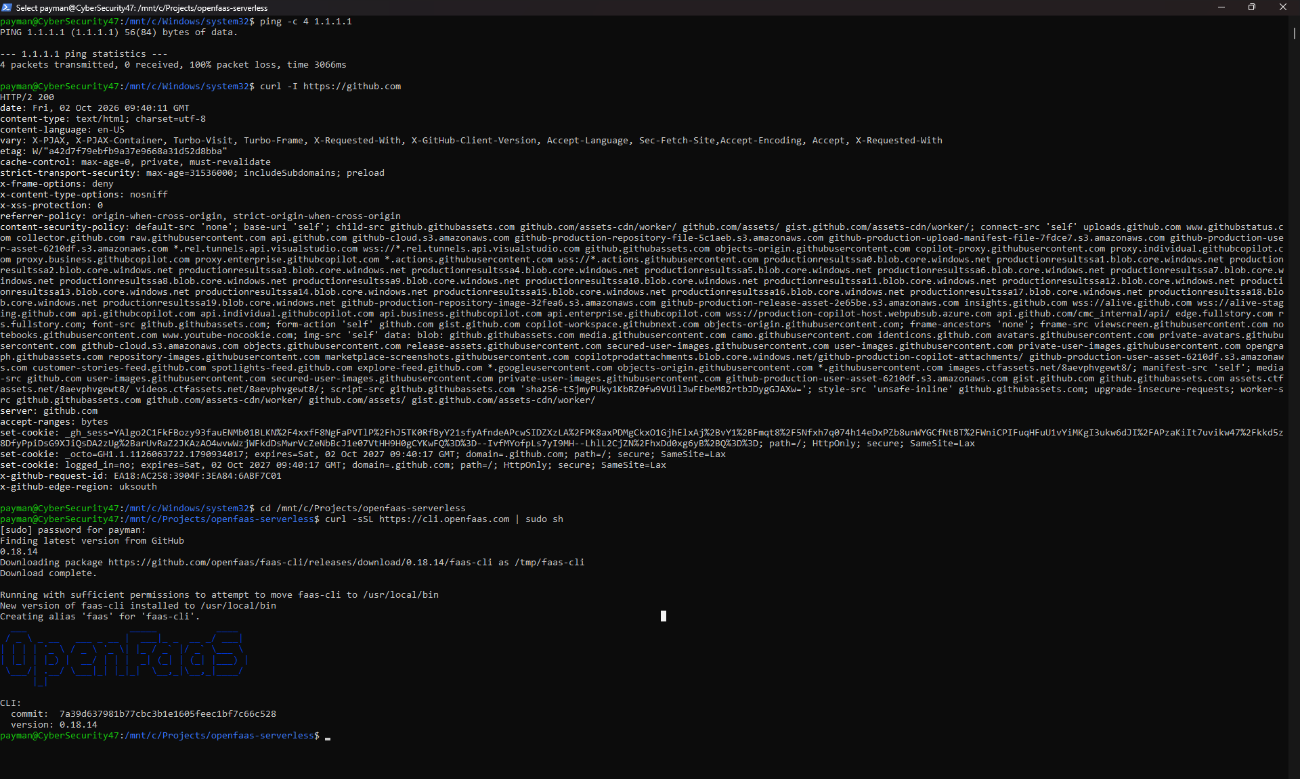
Figure 2. Windows Subsystem for Linux networking and OpenFaaS CLI troubleshooting evidence after VPN interference was isolated.

6. Container Registry and OpenFaaS Deployment
The first deployment attempt was rejected because the OpenFaaS Community Edition workflow required a public function image. I therefore created the GHCR image ghcr.io/pg25304/hello-python:latest, authenticated to GHCR, tagged and pushed the image, and changed the package visibility to Public. I treat this public visibility as an edition/product constraint for the lab rather than a production security recommendation.
After updating stack.yaml to use the GHCR image, faas-cli deploy returned Hypertext Transfer Protocol (HTTP) 202 Accepted. Kubernetes showed the function pod as 1/1 Running with no restarts, and an HTTP request to the gateway returned the expected JSON response. A later redeployment created a fresh Kubernetes pod and the function was invoked again successfully.
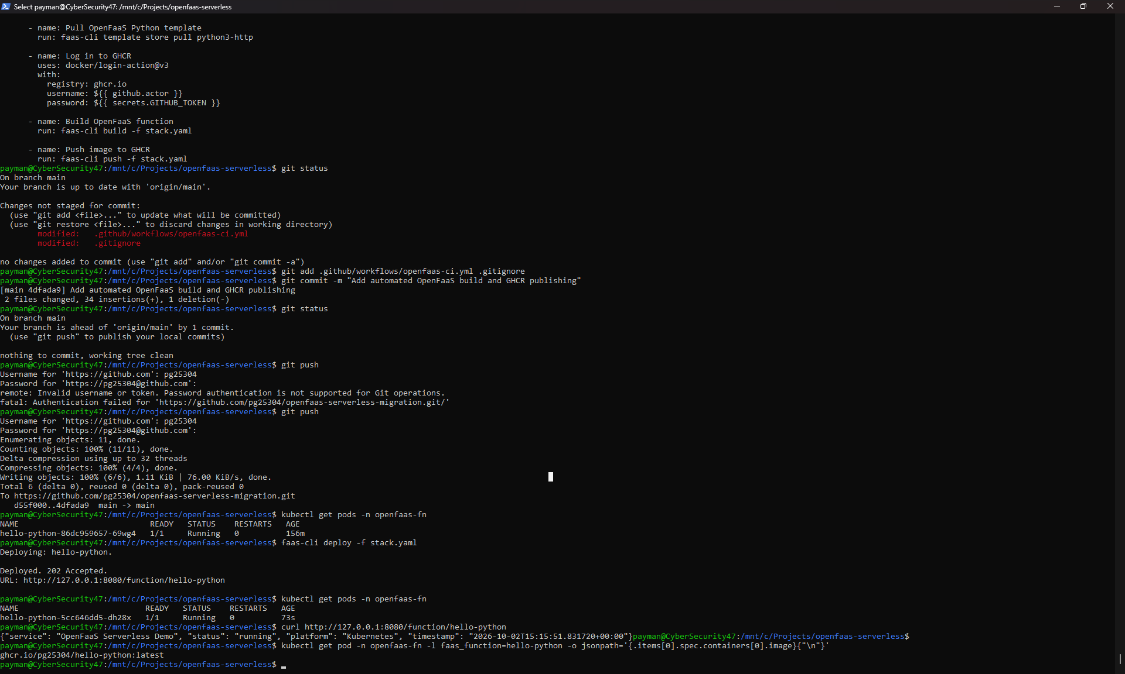
Figure 3. End-to-end local deployment verification: new Kubernetes pod, successful function response and GHCR image in use.

7. Automated Testing
The scaffolded test file did not initially execute correctly because it used a relative import without the required package context. I replaced it with a functional pytest that imports the handler, checks HTTP status 200, parses the JSON body and verifies the service, status, platform and timestamp fields. The corrected test completed successfully.
import json
from handler import handle
def test_handle():
response = handle(None, None)
assert response["statusCode"] == 200
body = json.loads(response["body"])
assert body["service"] == "OpenFaaS Serverless Demo"
assert body["status"] == "running"
assert body["platform"] == "Kubernetes"
assert "timestamp" in body

8. GitHub Actions CI/CD
I first introduced a test-only GitHub Actions workflow and then expanded it to two jobs: test, followed by build-and-publish. The second job installs faas-cli, pulls the OpenFaaS Python template, authenticates to GHCR, builds the function and publishes the image. OpenFaaS documents faas-cli build, push and deploy as the native building blocks for continuous integration and continuous delivery (CI/CD) workflows (OpenFaaS, 2026).
The workflow uses contents: read and packages: write for the automatically generated GITHUB_TOKEN. GitHub states that GITHUB_TOKEN is created for the workflow job, is limited to the repository and expires automatically; GitHub also recommends it for workflows publishing packages rather than storing a personal access token where it is not required (GitHub, 2026).
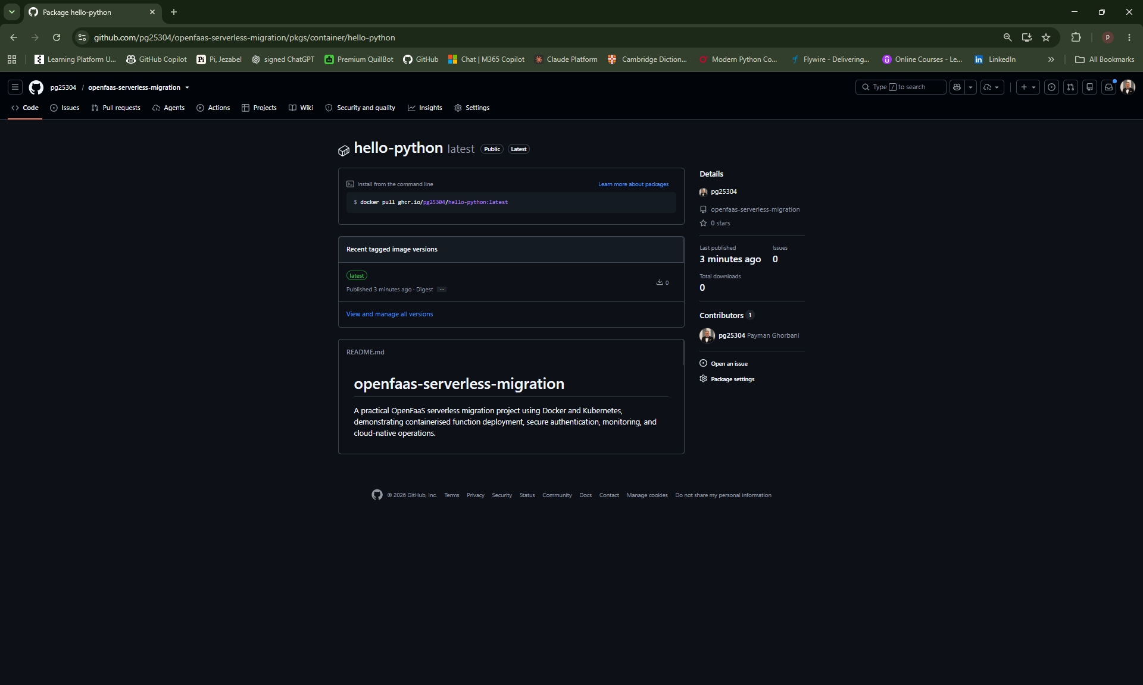
Figure 5. GitHub Container Registry package showing the latest image published by the automated workflow.
The first full build-and-publish run passed testing and image building but failed when pushing to GHCR with permission_denied: write_package. The root cause was package-level Actions access: the repository had not been granted write permission to the existing GHCR package. After granting the repository Write access under the package's Manage Actions access settings, I reran the workflow and both jobs completed successfully. The GHCR package then showed a newly published latest image.
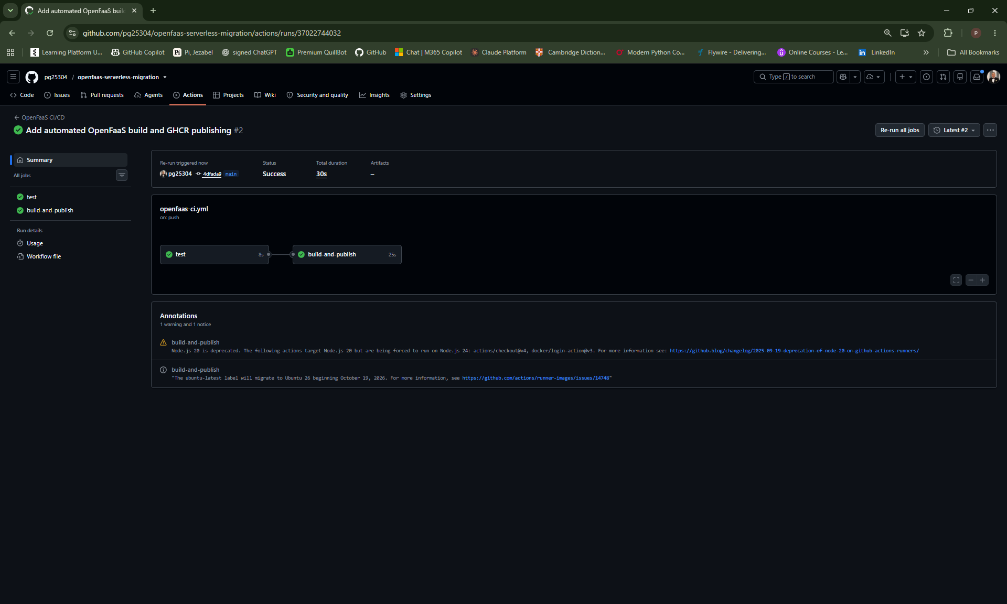
Figure 4. Successful GitHub Actions CI/CD run with both test and build-and-publish jobs completed.

9. Security Engineering

9.1 Credential handling
I avoided storing the OpenFaaS administrator password in source files and supplied it to the CLI through standard input. I also checked the project for obvious token/password strings before the initial source commit.

9.2 Least privilege and token separation
I did not use one broad credential for every purpose. Registry access and repository push access were treated separately. The repository token was limited to the specific repository and was only extended with workflow write permission when GitHub rejected the workflow-file push. For automated GHCR publication, the workflow uses GITHUB_TOKEN rather than a stored personal registry token. This reduces the lifetime and scope of CI credentials (GitHub, 2026).
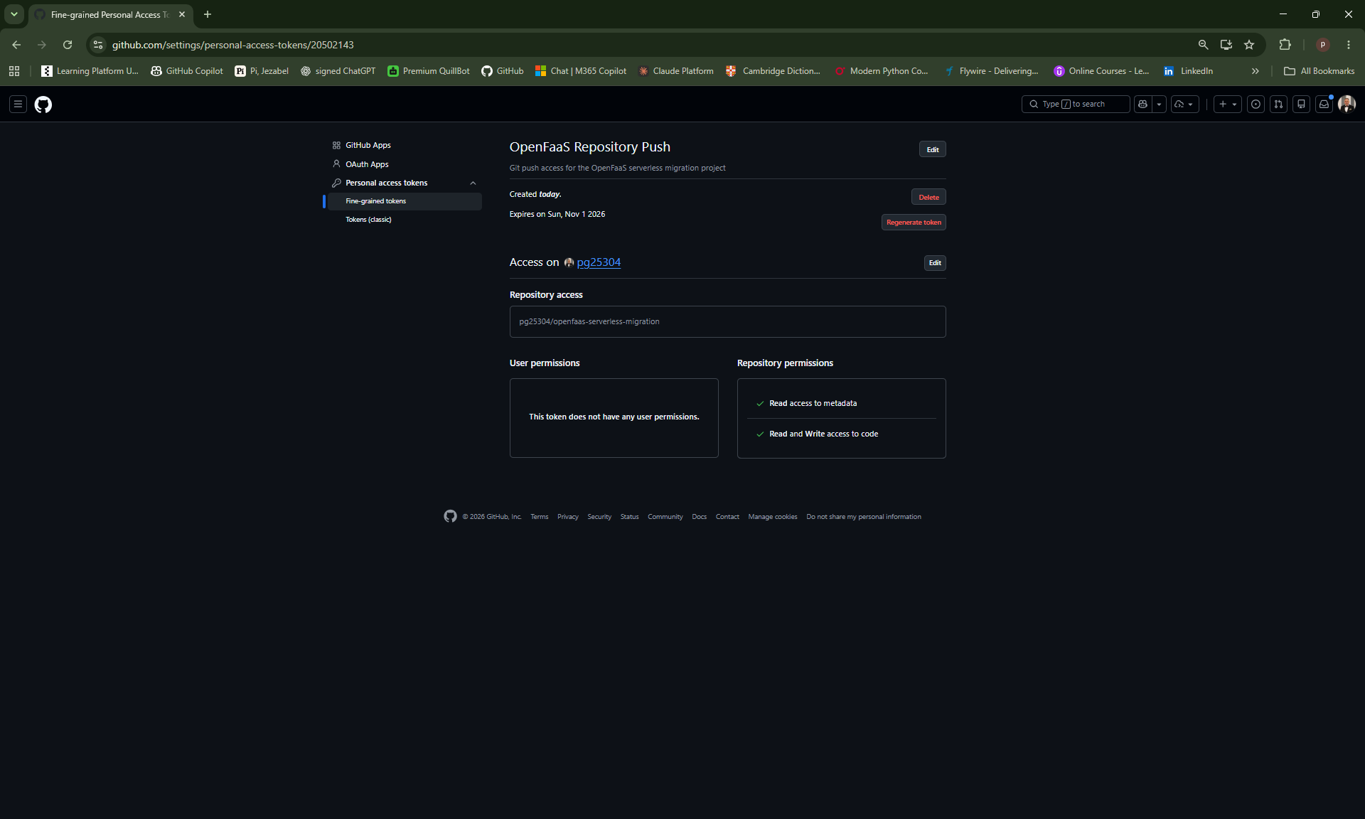
Figure 6. Fine-grained repository token configuration demonstrating repository-specific, limited permissions. No token value is displayed.

9.3 Credential exposure and rotation
During the lab, a personal access token was accidentally visible in a screenshot. I treated the token as compromised, revoked it immediately and created a replacement with limited permissions and a short expiry. The exposed value is not reproduced in this report or intended for GitHub/LinkedIn evidence. This incident reinforced the need to review screenshots and terminal output before publication.

9.4 Public image constraint
The GHCR function image was made public to satisfy the OpenFaaS Community Edition constraint encountered during deployment. Public visibility is not inherently more secure. For a production design I would normally prefer controlled registry access, together with vulnerability scanning, image signing/attestation, immutable image tags and stronger supply-chain controls.

9.5 Transport and production controls
The local lab gateway was reached through localhost port forwarding. For an Internet-facing deployment, OpenFaaS recommends HTTPS to protect traffic from snooping and tampering. A production design would additionally require appropriate identity, network policy, secrets management, audit logging and workload security controls.

10. Monitoring and Scaling Experiment
Prometheus was deployed with OpenFaaS and I confirmed that invocation metrics increased after load was generated against the function. This demonstrated that the platform was collecting function activity. I also configured minimum and maximum scaling labels and generated both burst and sustained requests.
I did not observe the function scale beyond one replica, so I do not present autoscaling as a successful project result. Current OpenFaaS documentation distinguishes the OpenFaaS Pro autoscaler from legacy Community Edition scaling and describes different scaling modes and targets (OpenFaaS, 2026). The correct conclusion from my test is therefore that monitoring was verified, while automatic horizontal scaling was not demonstrated in this environment.

11. Operational Benefits
The project demonstrated several operational advantages of the serverless model. The application code remained small while OpenFaaS and Kubernetes provided routing and workload execution. Container packaging made the function portable, and Kubernetes can maintain desired workload state by restarting containers or replacing failed replicas (Kubernetes, 2026). The GitHub Actions pipeline also created a repeatable path from a source change to a tested and published container artefact.
At the same time, the implementation showed that 'serverless' is a responsibility shift rather than the absence of servers. Kubernetes, OpenFaaS, networking, credentials, monitoring and the image supply chain still require engineering and governance.

12. Limitations
- The Kubernetes cluster is local Docker Desktop infrastructure rather than a managed production cloud cluster.
- GitHub Actions automates testing, building and GHCR publication, but deployment to the local OpenFaaS gateway is still manually triggered.
- The function image currently uses the mutable latest tag; immutable commit-SHA or digest-based deployment would improve traceability and deterministic rollouts.
- The GHCR image is public because of the Community Edition constraint encountered in the lab.
- Autoscaling was investigated but not successfully demonstrated, so no performance or elasticity claim is made from that experiment.

13. Future Improvements: Azure AKS and Full Deployment
The strongest next stage is to move the OpenFaaS deployment target from Docker Desktop Kubernetes to Azure Kubernetes Service (AKS). AKS is a managed Kubernetes service in which Azure operates the control plane and reduces much of the cluster-management overhead (Microsoft, 2026). This would turn the current local validation into a genuinely cloud-hosted deployment and better align the project with cloud infrastructure and cloud security practice.
For a future production-oriented version, I would use immutable image tags tied to Git commits, deploy through a controlled GitHub environment, prefer short-lived/federated Azure authentication where applicable, enforce TLS, strengthen registry and workload access controls, add image vulnerability scanning and signing/attestation, and centralise logs and metrics. AKS still follows a shared-responsibility model: Microsoft manages the Kubernetes control plane, while workload, identity, networking and data security remain customer responsibilities (Microsoft, 2026).

14. Conclusion
I completed the original OpenFaaS objective and extended it into a broader cloud-native delivery exercise. The final implementation demonstrates a working Python function on Kubernetes, GHCR-based container distribution, automated pytest validation, automated OpenFaaS image building and publication, secure credential handling, monitoring and documented troubleshooting.
The project also produced useful engineering lessons. CI/CD permissions need to be considered at both repository and package level; credentials exposed during development must be treated as compromised and rotated; and serverless abstractions do not remove infrastructure responsibility. The current system is therefore a strong local proof of concept, with AKS providing a clear future path toward managed cloud deployment and a fuller continuous-deployment architecture.

References
GitHub (2026) GITHUB_TOKEN. GitHub Docs. Available at: https://docs.github.com/en/actions/concepts/security/github_token (Accessed: 2 October 2026).
GitHub (2026) Publishing and installing a package with GitHub Actions. GitHub Docs. Available at: https://docs.github.com/en/packages/managing-github-packages-using-github-actions-workflows/publishing-and-installing-a-package-with-github-actions (Accessed: 2 October 2026).
Kubernetes (2026) Self-Healing. Kubernetes Documentation. Available at: https://kubernetes.io/docs/concepts/architecture/self-healing/ (Accessed: 2 October 2026).
Microsoft (2026) What is Azure Kubernetes Service (AKS)? Microsoft Learn. Available at: https://learn.microsoft.com/en-us/azure/aks/what-is-aks (Accessed: 2 October 2026).
Microsoft (2026) Secure your Azure Kubernetes Service (AKS) deployment. Microsoft Learn. Available at: https://learn.microsoft.com/en-us/azure/aks/secure-aks (Accessed: 2 October 2026).
OpenFaaS (2026) OpenFaaS Documentation. Available at: https://docs.openfaas.com/ (Accessed: 2 October 2026).
OpenFaaS (2026) Auto-scaling your functions. Available at: https://docs.openfaas.com/architecture/autoscaling/ (Accessed: 2 October 2026).
OpenFaaS (2026) CI/CD with OpenFaaS. Available at: https://docs.openfaas.com/reference/cicd/intro/ (Accessed: 2 October 2026).
OpenFaaS (2026) OpenFaaS Stack. Available at: https://docs.openfaas.com/architecture/stack/ (Accessed: 2 October 2026).

