ASSIGNMENT-9

Name: VSS PAVAN GANESH KUMAR RollNo: 241000089
Branch : CSE

1.
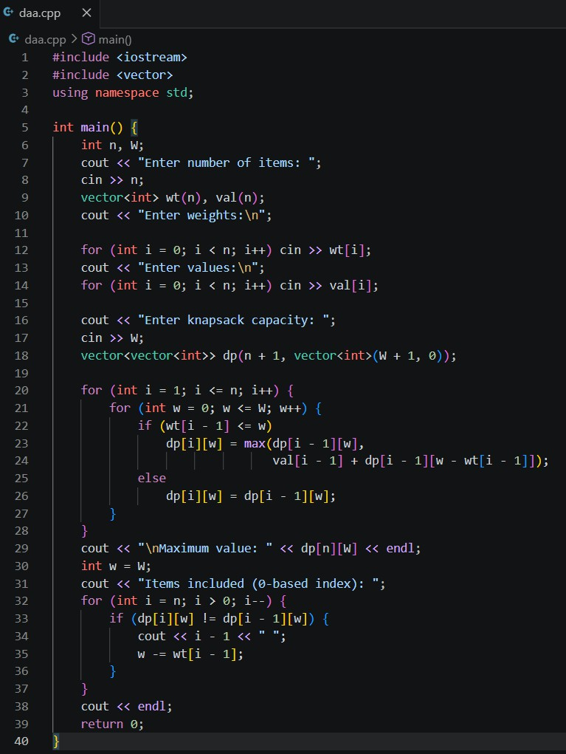

Output :
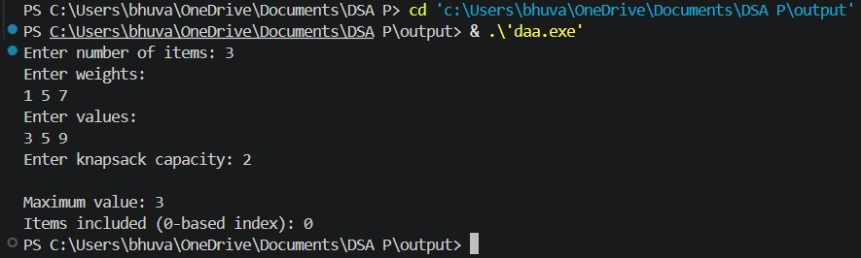

2.
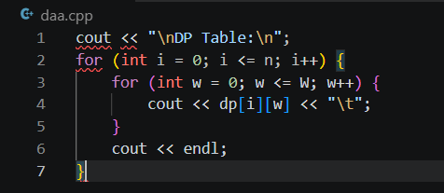

3.
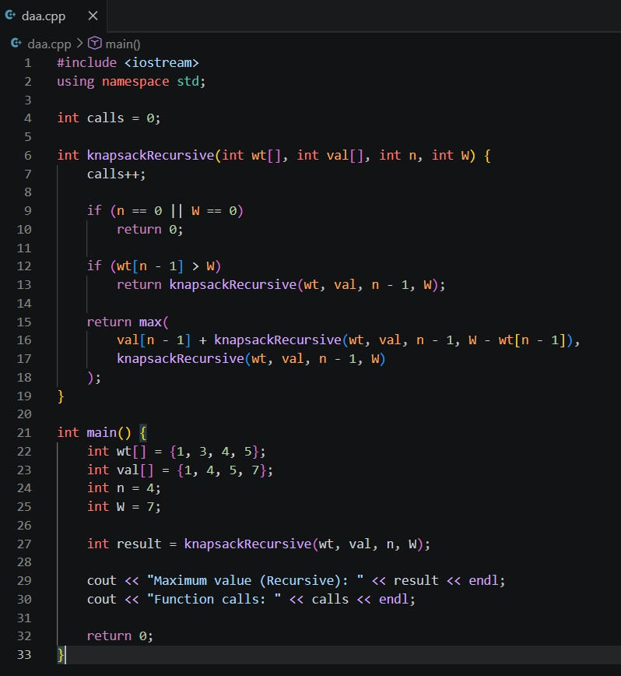

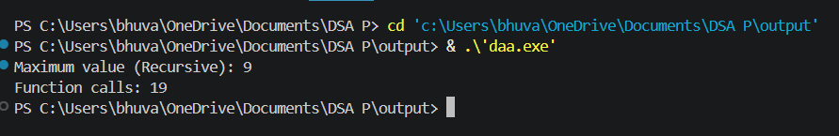
Output:

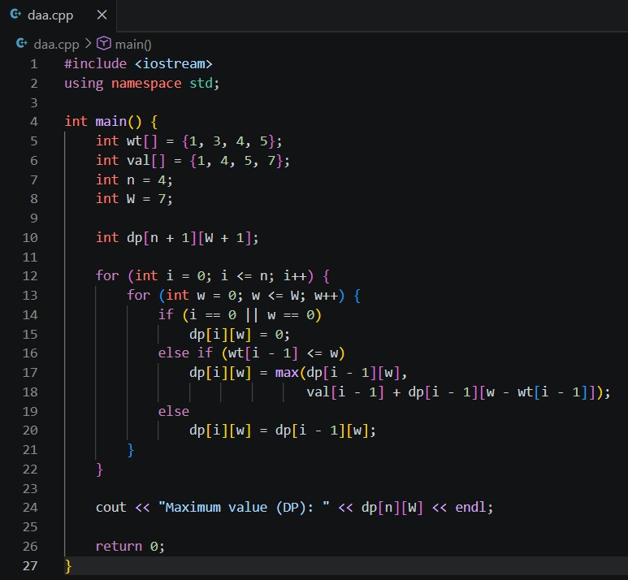
Bottom Up DP :

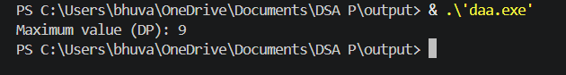
Output:

TimeComplexityComparison:

Approach | Time  Complexity | Reason
Recursive | O(2ⁿ) | Eachitem→include/exclude→ exponential tree
DP (Tabulation) | O(n×W) | Each state computed once

