|  |
| --- |
| **Experiment No.9** |
| Aim: To implement Non-Restoring division algorithm using c-programming |
| Name: Parth Manoj Gajare |
| Roll no: 14 |
| Date of Performance: |
| Date of Submission: |

**Aim -**  To implement Non-Restoring division algorithm using c-programming.

**Objective -**

1. To understand the working of Non-Restoring division algorithm.
2. To understand how to implement Non-Restoring division algorithm using cprogramming.

**Theory:**

In each cycle content of the register, A is first shifted and then the divisor is added or subtracted with the content of register A depending upon the sign of A. In this, there is no need of restoring, but if the remainder is negative then there is a need of restoring the remainder. This is the faster algorithm of division.

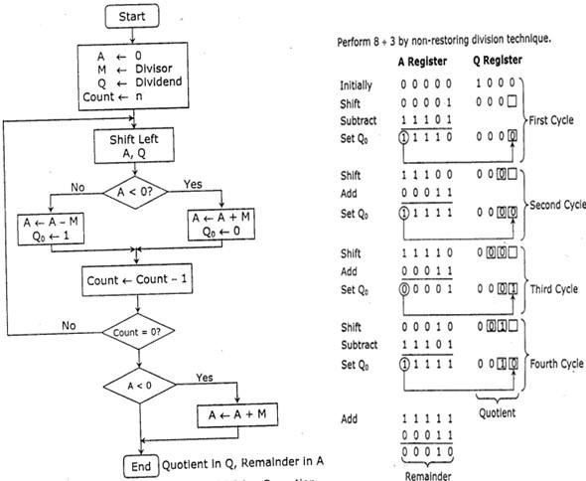

**Program -**  #include <stdio.h>

void binaryPrint(int n, int bits) { for (int i = bits - 1; i >= 0; i--) {

printf("%d", (n >> i) & 1);

} printf("\n");

}

int main() { int M, Q, A = 0, count; int n;

printf("Enter the divisor (M): "); scanf("%d", &M); printf("Enter the dividend (Q): "); scanf("%d", &Q); printf("Enter the number of bits: "); scanf("%d", &n); count = n;

printf("\nInitial values:\n"); printf("A: "); binaryPrint(A, n); printf("Q: "); binaryPrint(Q, n); printf("M: "); binaryPrint(M, n); printf("\n");

while (count > 0) {

A = (A << 1) | ((Q >> (n - 1)) & 1); Q = Q << 1;

printf("After left shift:\n"); printf("A: "); binaryPrint(A, n); printf("Q: "); binaryPrint(Q, n);

if (A >= 0) { A = A - M; printf("After

subtraction (A >= 0):\n");

} else {

A = A + M; printf("After addition

(A < 0):\n");

}

printf("A: "); binaryPrint(A, n);

if (A >= 0) { Q = Q | 1;

} else {

Q = Q & ~(1);

}

printf("After updating Q0:\n"); printf("A: "); binaryPrint(A, n); printf("Q: "); binaryPrint(Q, n); printf("\n");

count--;

}

if (A < 0) { A = A + M; printf("Final correction (if A < 0, add M to A):\n"); printf("A: "); binaryPrint(A, n);

}

printf("\nFinal quotient (Q): "); binaryPrint(Q, n); printf("Final remainder (A):

"); binaryPrint(A, n); return 0;

}

**Output:**

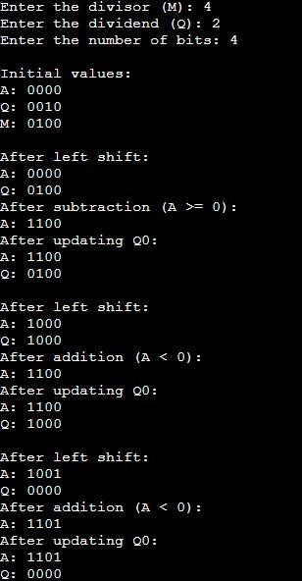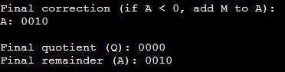

# Conclusion -

In this experiment, we successfully implemented the Non-Restoring Division Algorithm in C to divide two unsigned integers represented in binary form. The algorithm effectively demonstrates the process of binary arithmetic, including addition, subtraction, and bitwise shifting. Through stepby-step execution, we observed how the quotient and remainder are derived based on the initial dividend and divisor. This implementation not only reinforces the understanding of binary operations but also highlights the efficiency of Non-Restoring Division in handling division tasks without requiring restoration in every step. Overall, the experiment provides valuable insights into algorithm design and binary number manipulation in programming.