Lab2

I have implemented Rent metrics service...

Rent Metrics:

Rent metrics is used to know available houses at particular area in any country. By using this, user can select his/her own house based on the cost. They can also know whether it is single or double bed room flat. In this i print few attributes i.e. address, room rent, Bedrooms available and posted date. In this i used Rent Metrics API.

The following is the screen shot of home page for Rent metrics..

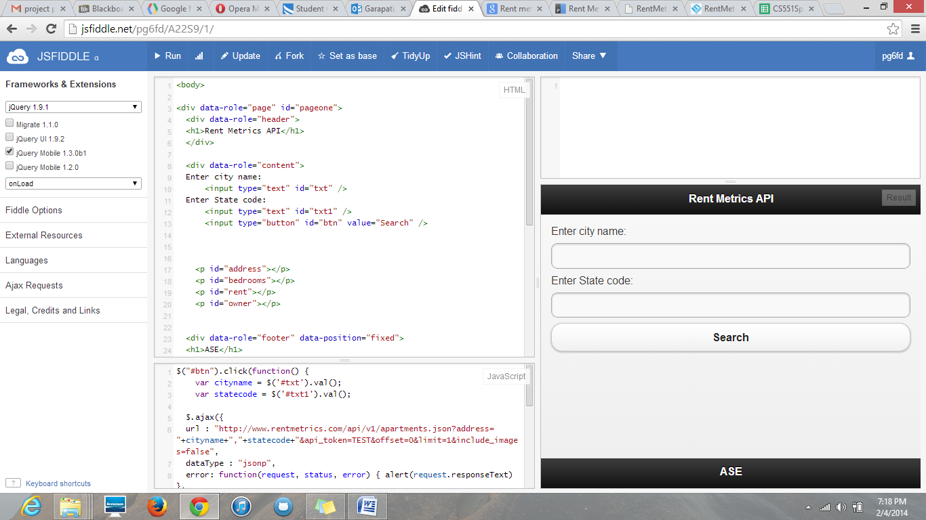

Now we have to enter details i.e city name and state code...

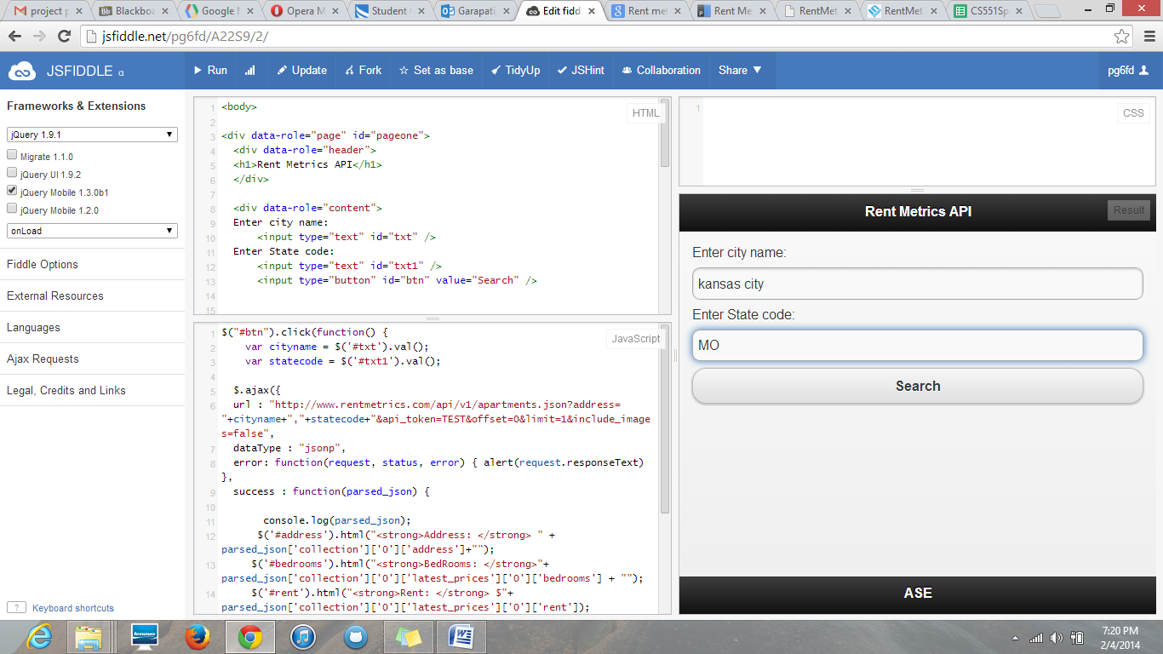

On clicking serch button we get apartments available in the city..

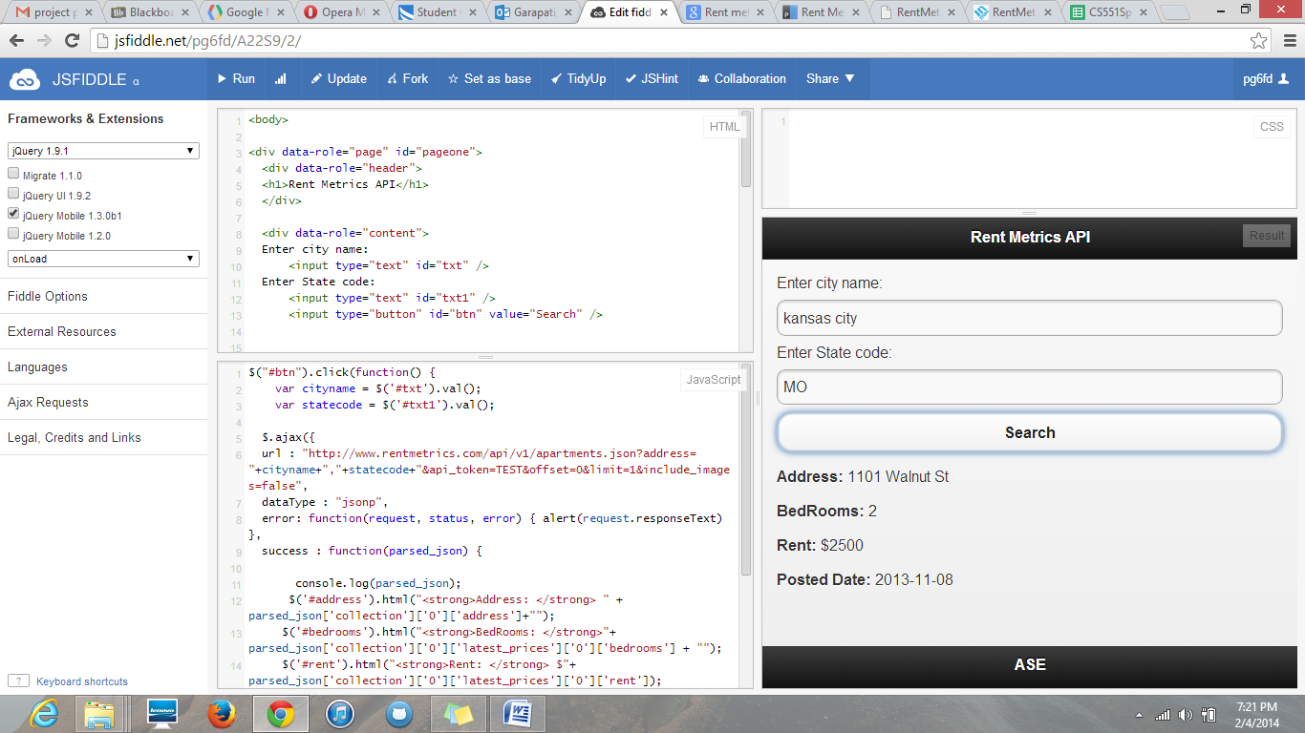

In this , i limit the value to one, that's why we get one apartment with address and rent.. In order to get all we have to use for loop..

Now enter different city name and state code we get the following screenshot..

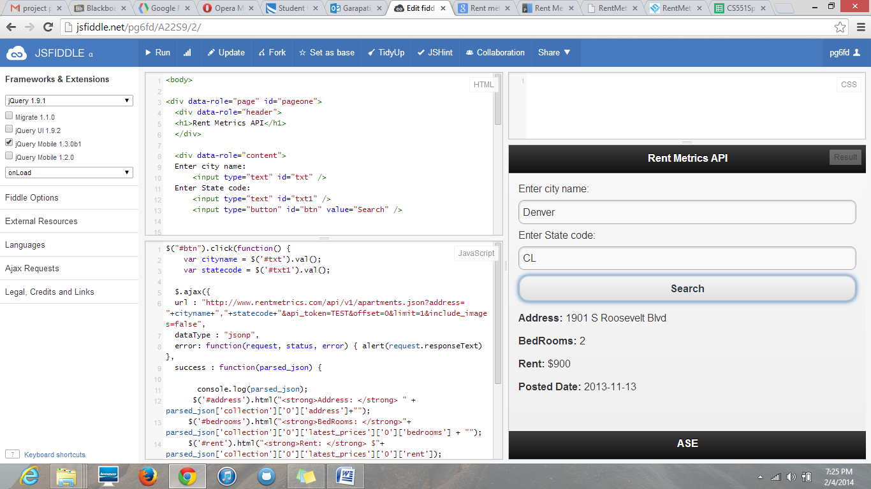

Now i entered a city and state code from different country i.e. Canada...

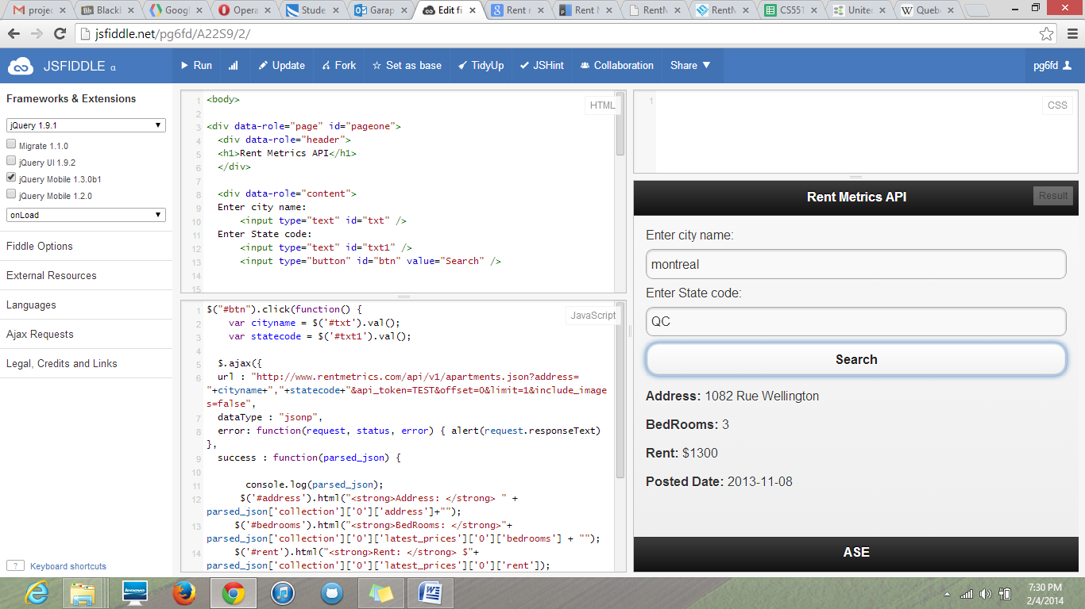

Js fiddle link... http://jsfiddle.net/pg6fd/A22S9/2/