LAB 1

**SCRUMDO:**

I already have Scrum do account...so i just login with my details..

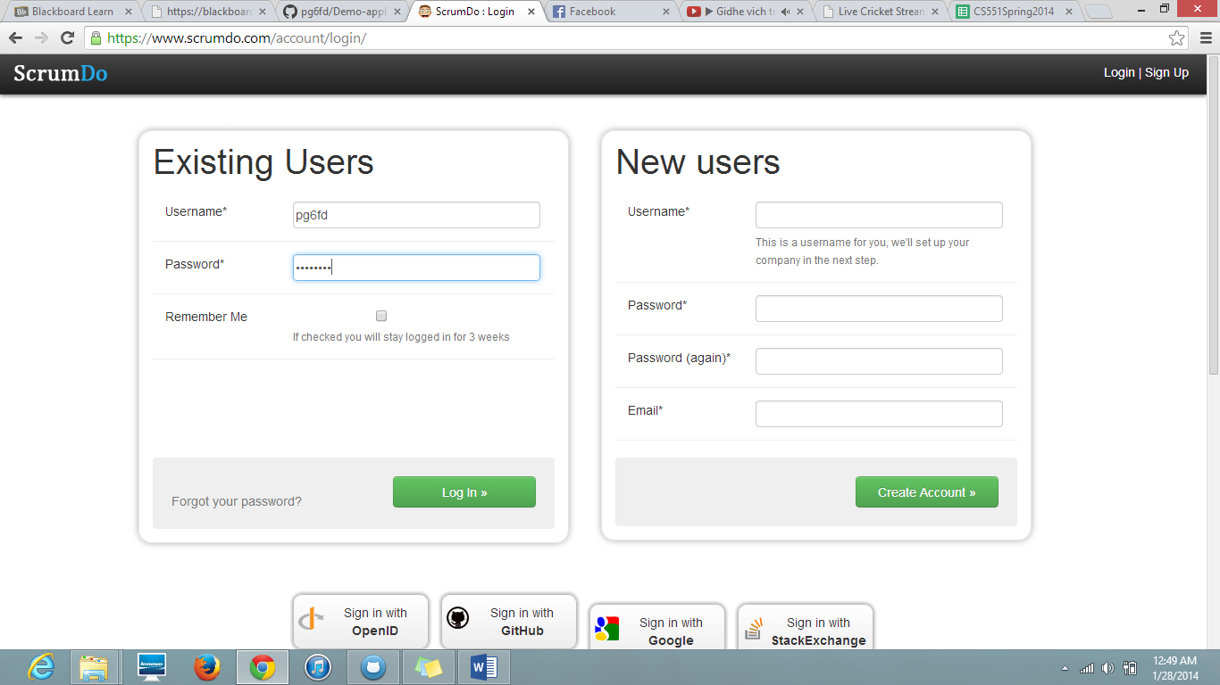

Now i have created an organization , which is shown below..

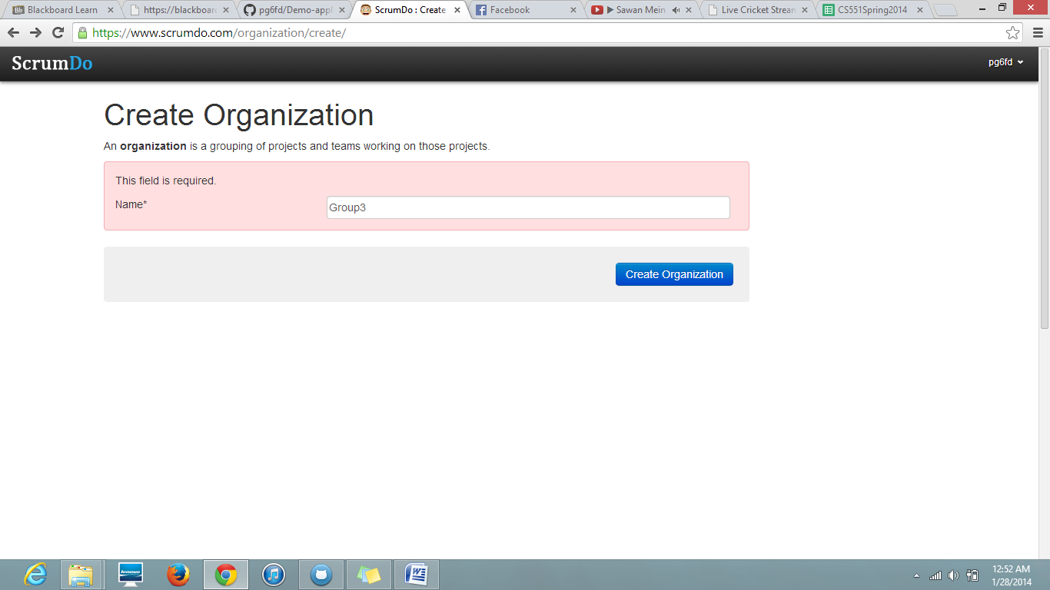

I have created project as" UMKC project" and in that i wrote a story.

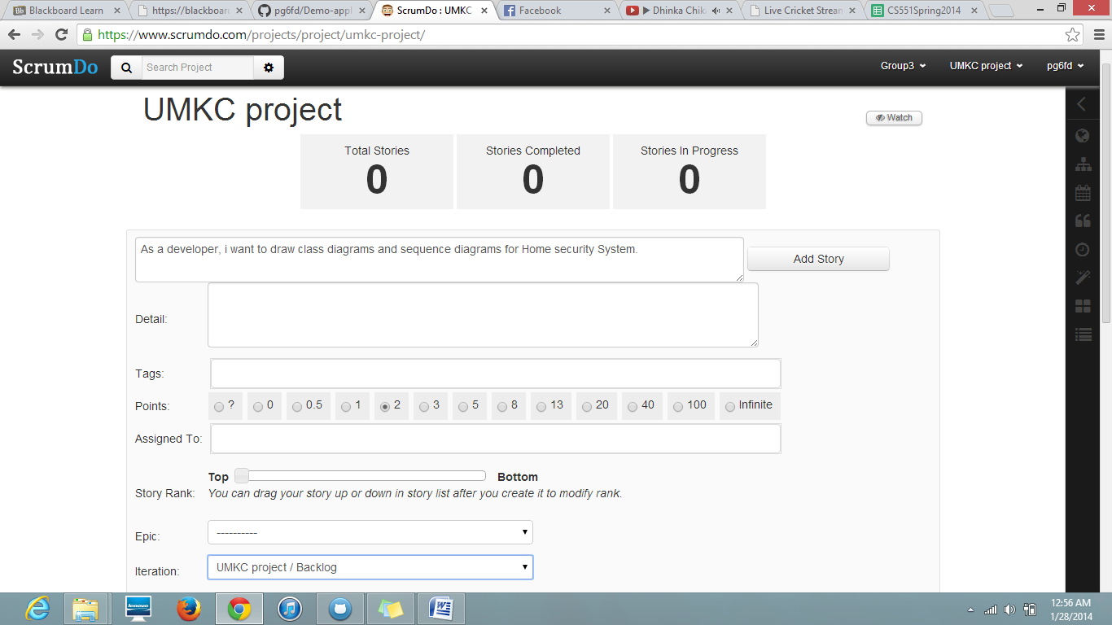

Iam developing class diagrams and sequence diagrams so it should be in Doing mode which as shown below...

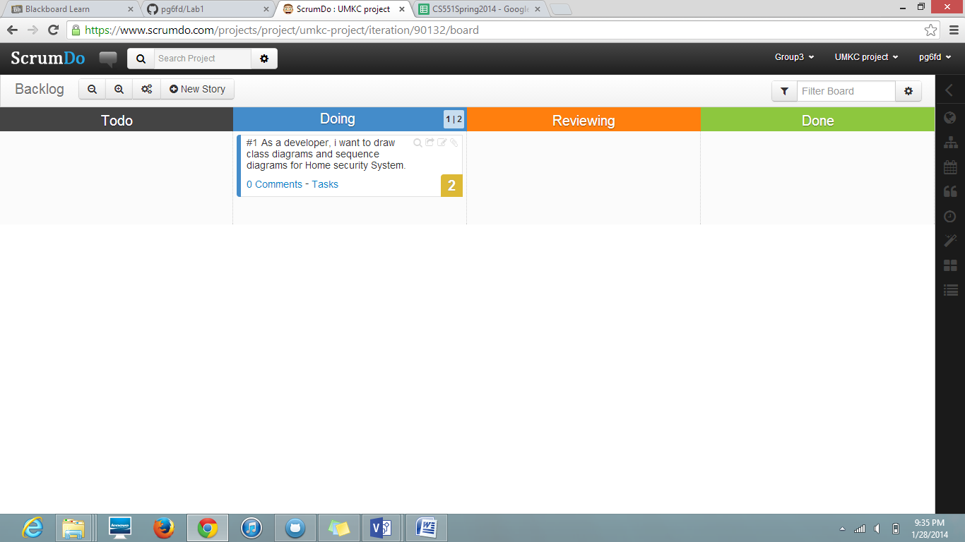

My work was done so i have put that story in done condition,.

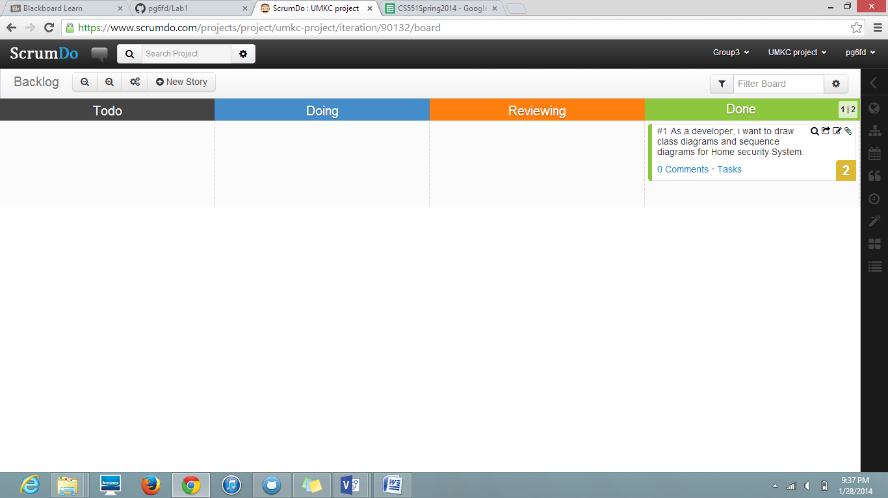

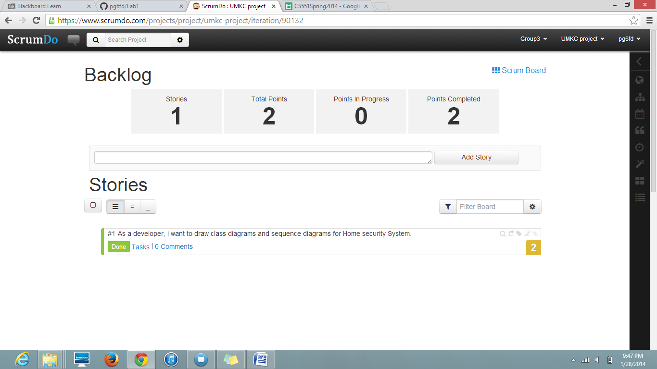

**GITHUB:**

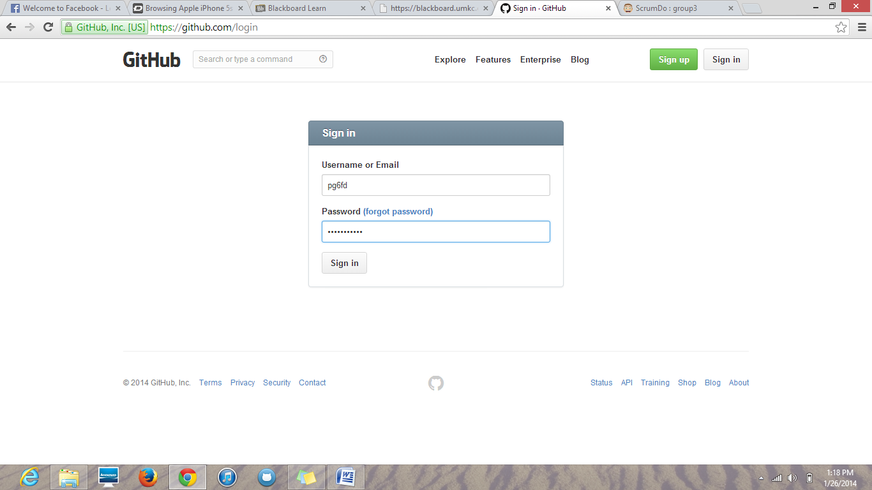

Creating a new repository i.e. Demo application ASE

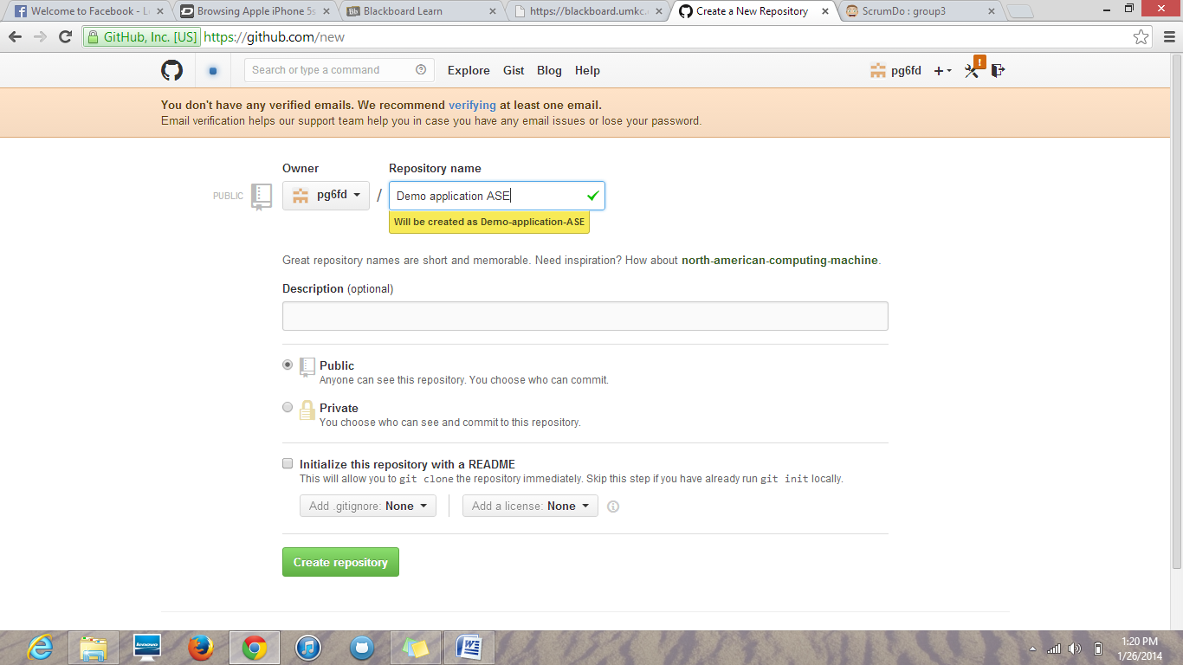

Git hub on local windows and cloning the demo application ASE which was created on remote git hub account..

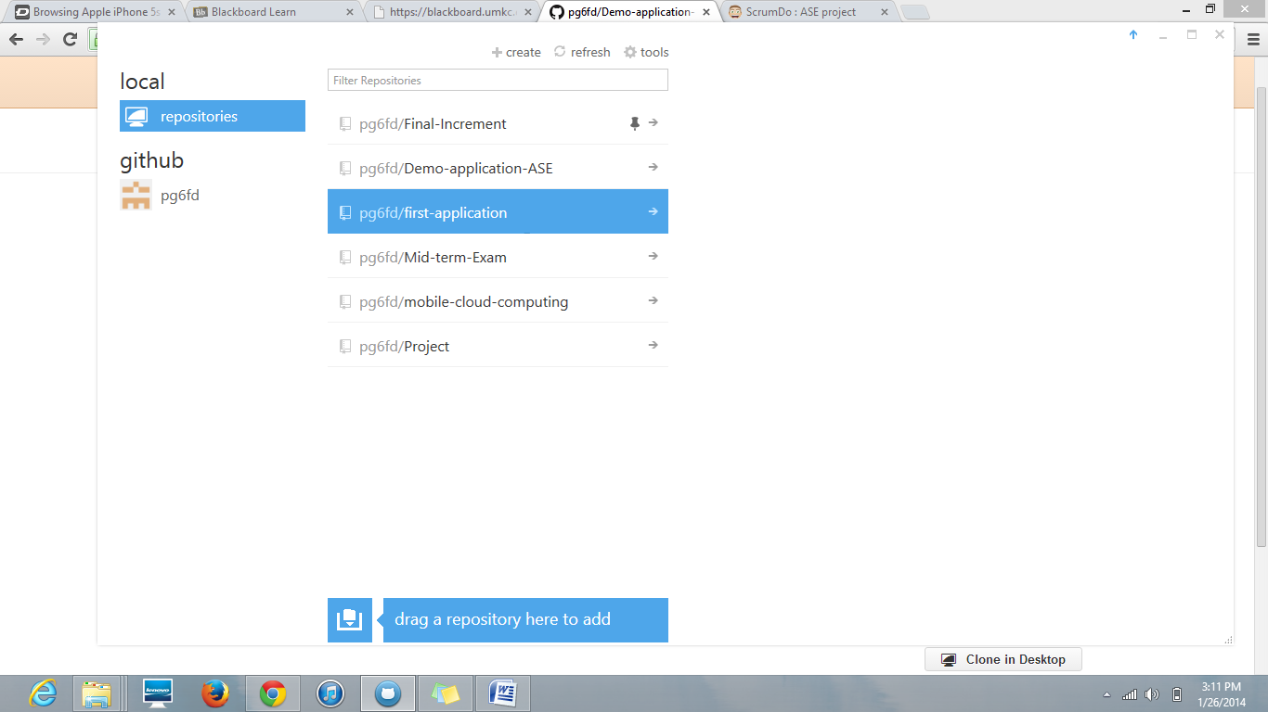

After cloning to desk top i have created some text document in my documents folder and i have committed it in local desktop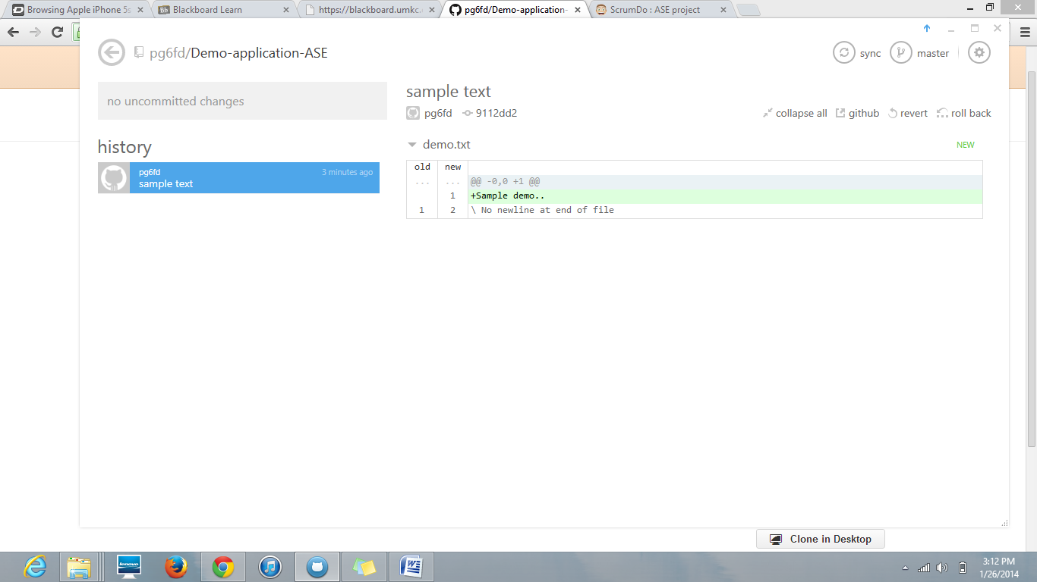

Now the text document appears in remote git hub account i.e. it appears directly under demo application ASE repository.

