Implementing mash up application using the following services.

1. I implemented mash up application by integrating google maps with social networking sites like Face book and Twitter.

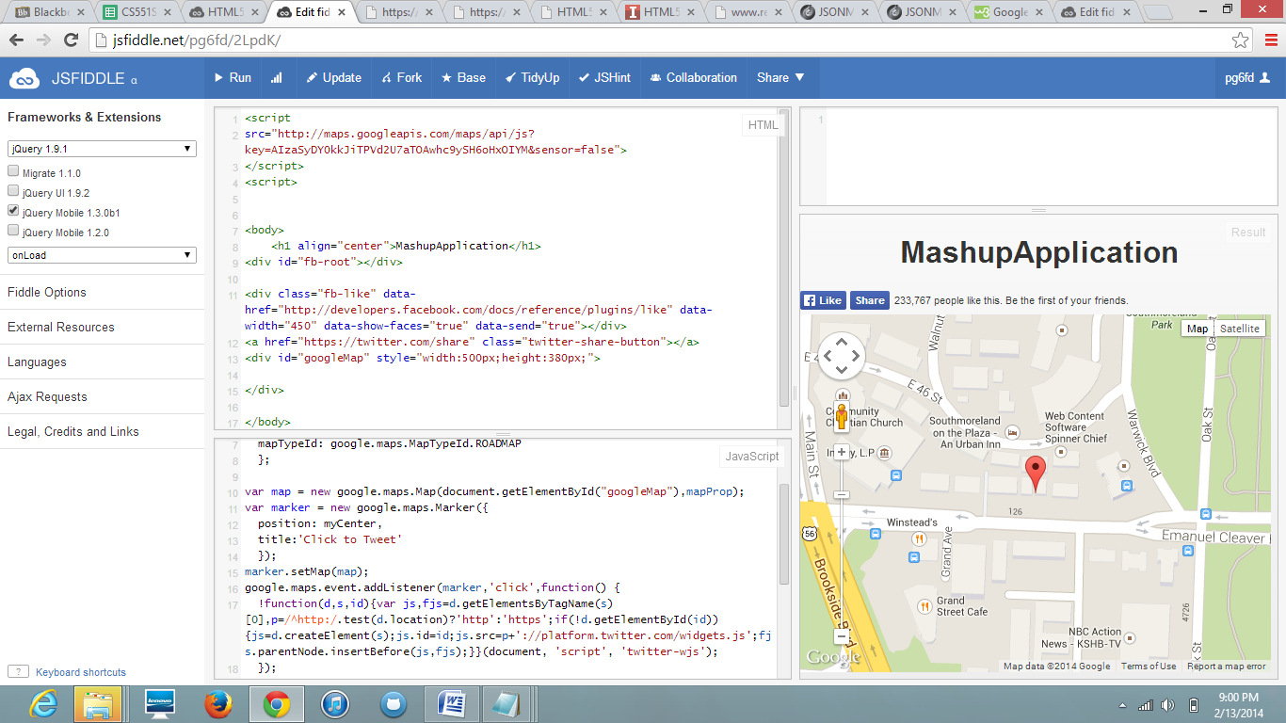

On clicking on the marker,we get tweet button. By that we can tweet directly to all followers.

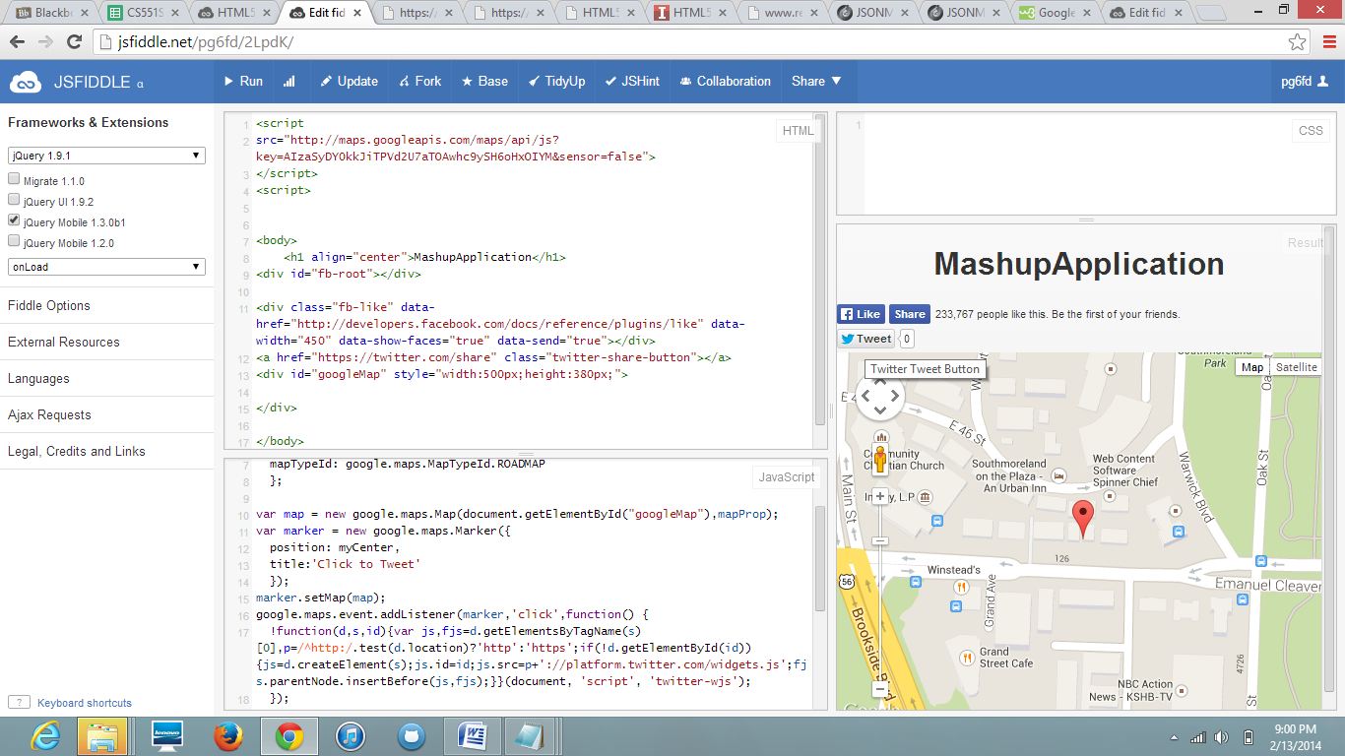

On clicking tweet button, we can tweet directly and is posted to our wall...

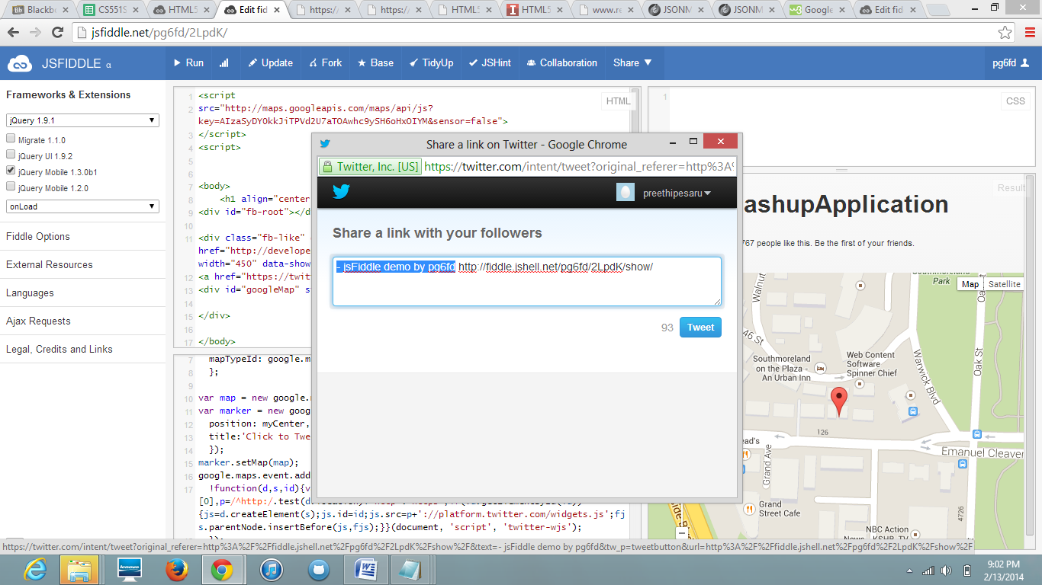

On clicking the face book like button we get the face book login page, and from that we can directly login to face book account and can directly like that page.

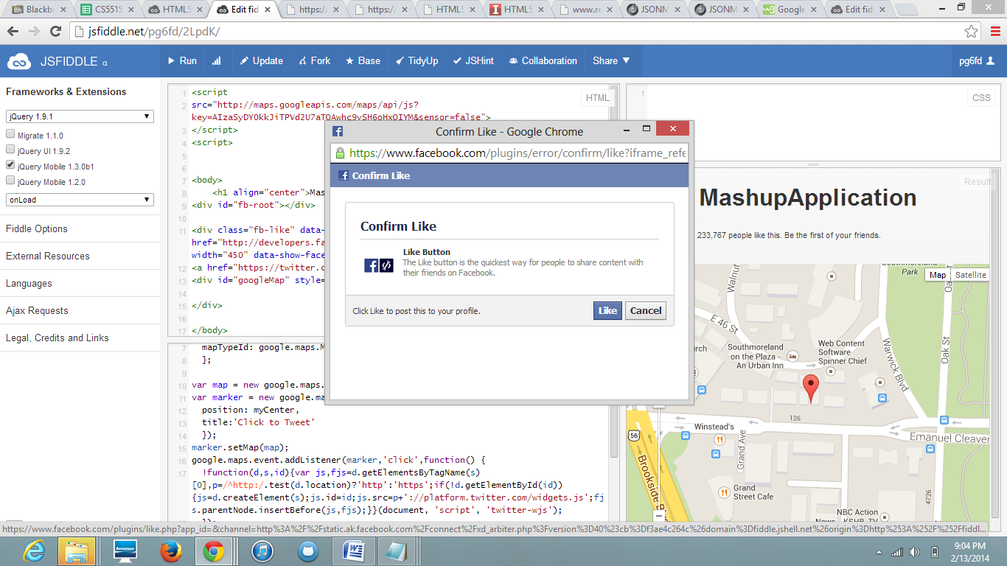

On clicking the like button, it automatically counts the no of likes...and it directly post to our wall in face book..

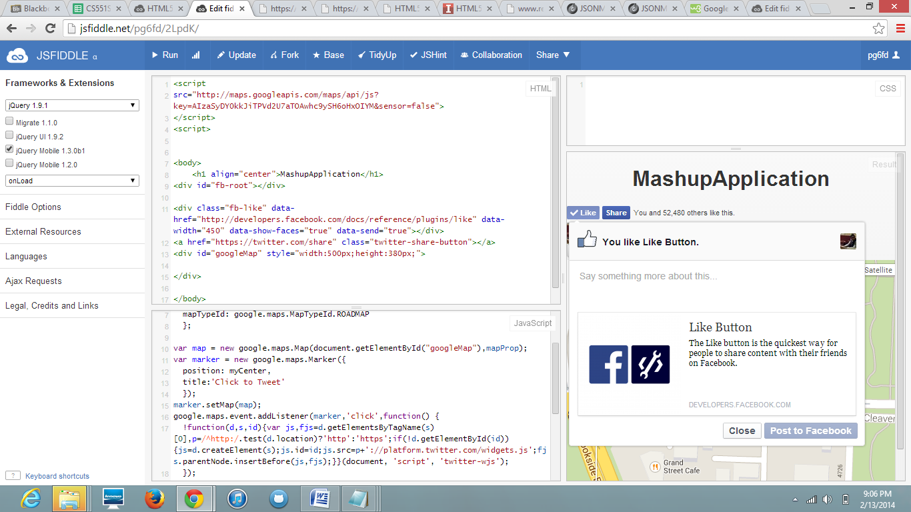

3.Implementation of my own Restful web service using visual studio....

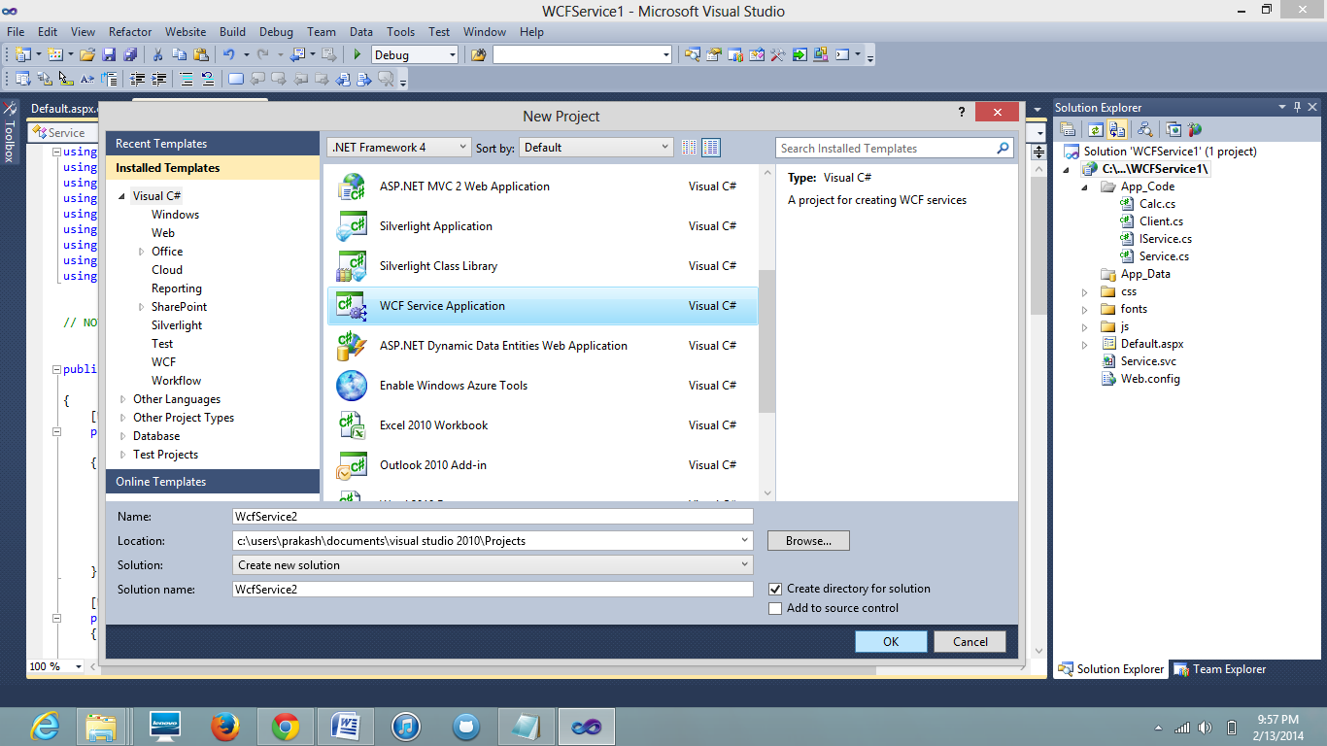

Next i developed some code for simple mathematical operations like Addition, subtraction, Multiplication and Division...

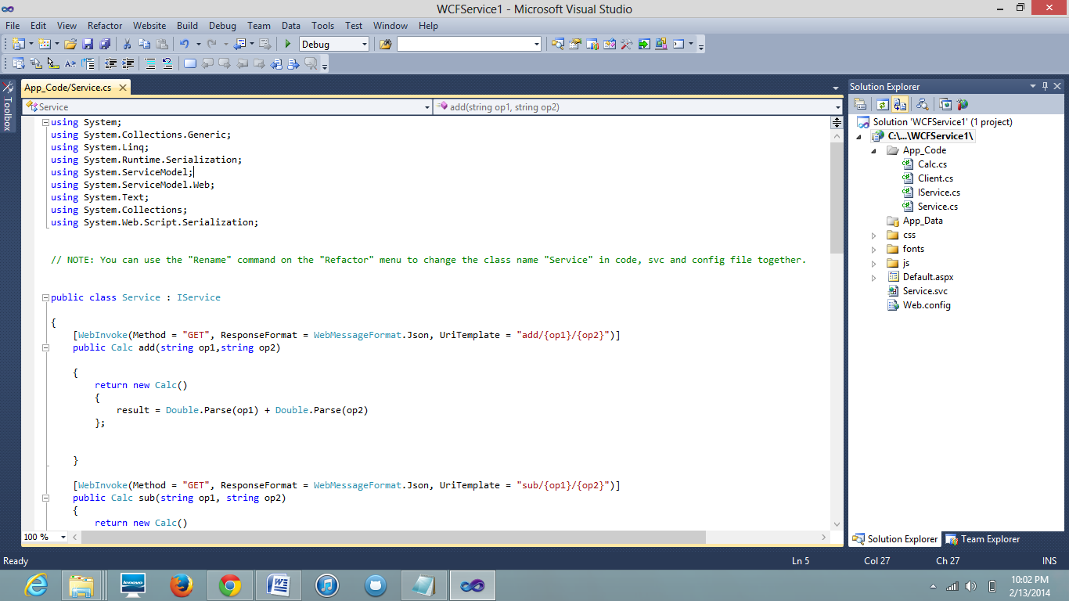

Now executing all operations by using Debug option, which is shown in the following screen shot..

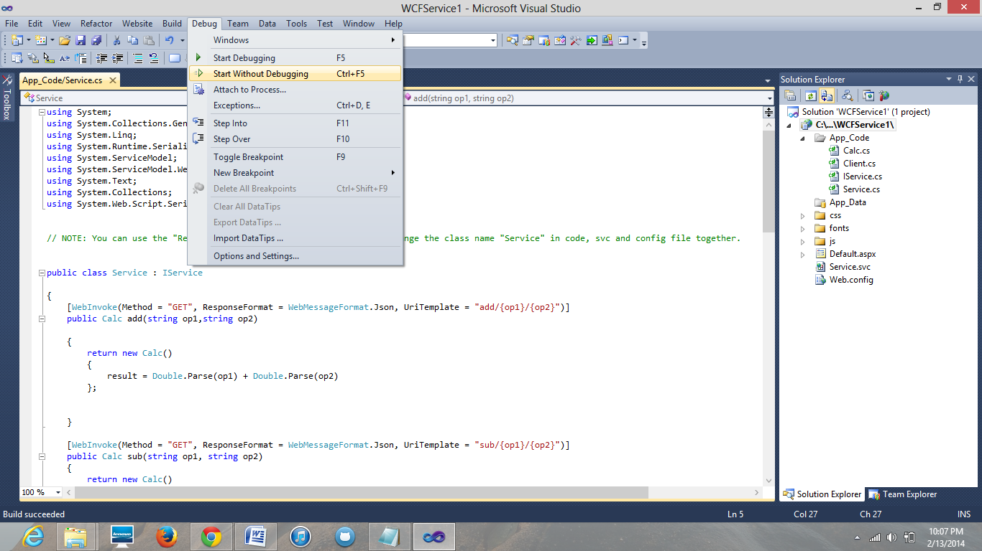

After clicking on that, the following page appears..

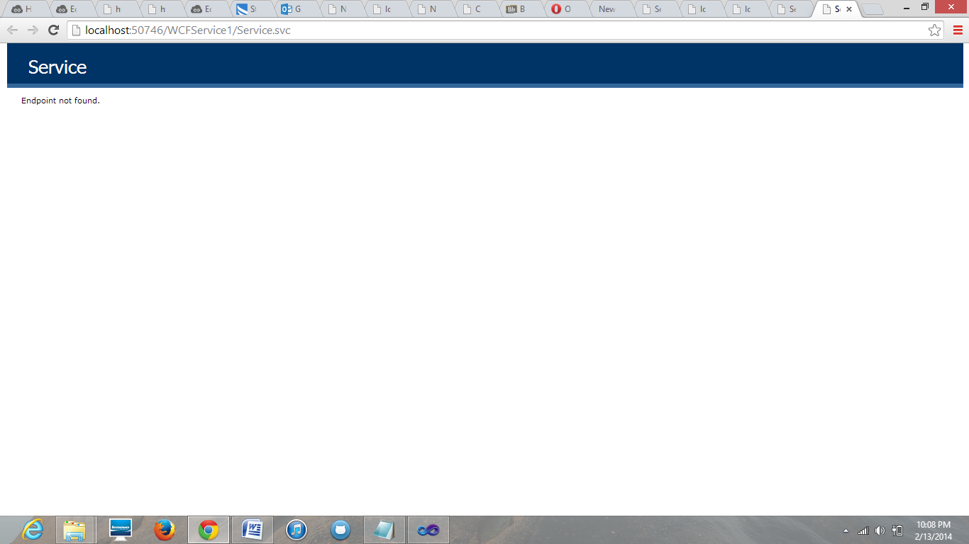

Now we have to include end point, then we get result..i.e add/10/20

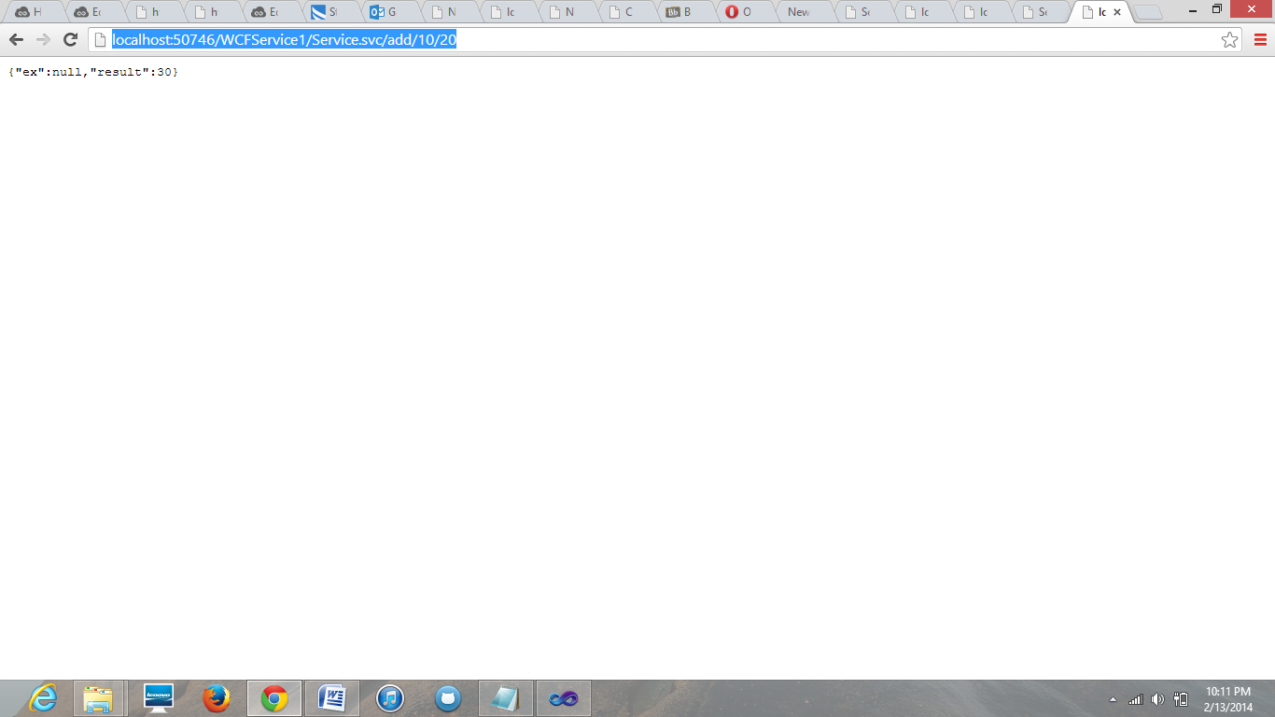

Same process repeats... for subtraction, Multiplication and division..

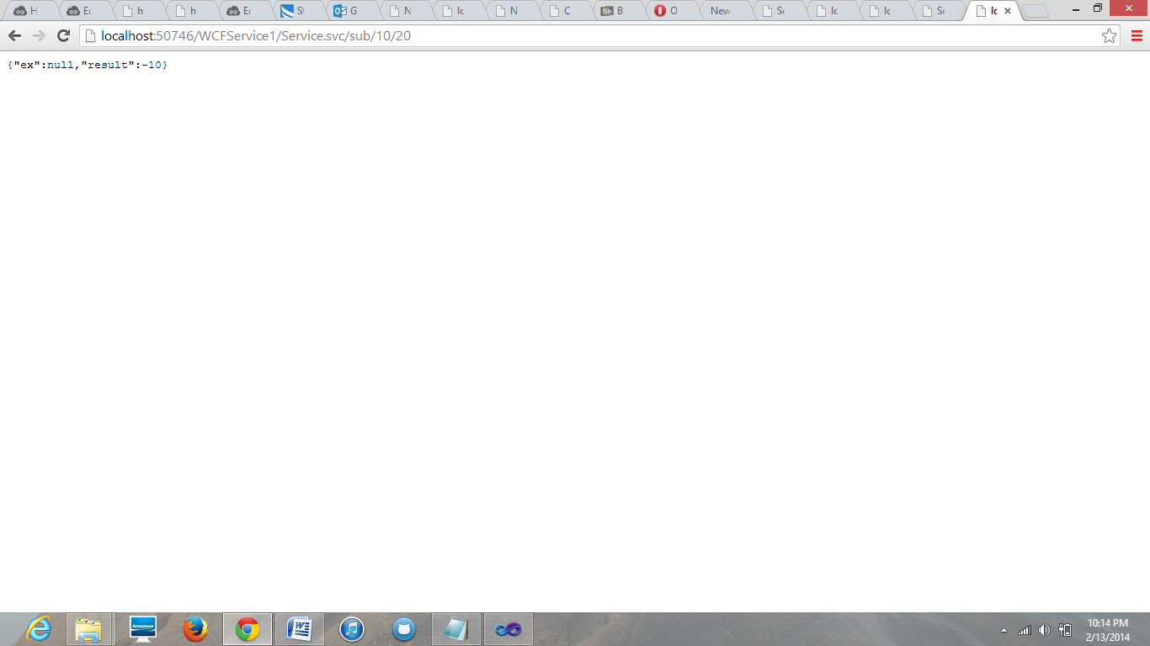

For multiplication..

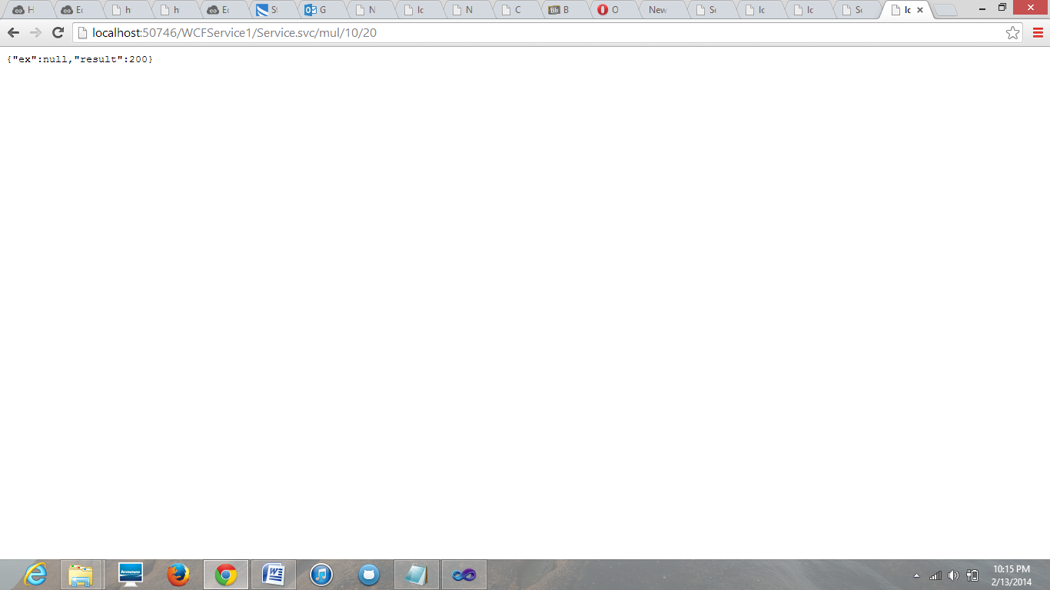

For division...

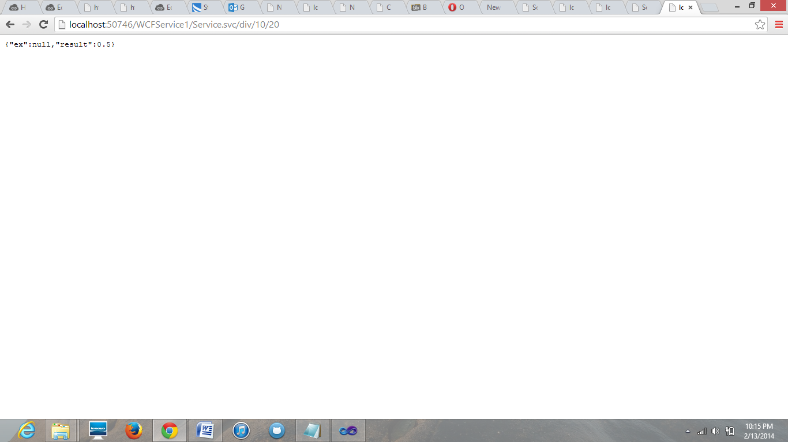

Now i developed web client using asp.net which consumes Calculator Rest web service. For this i used Twitter boot strap for Css..

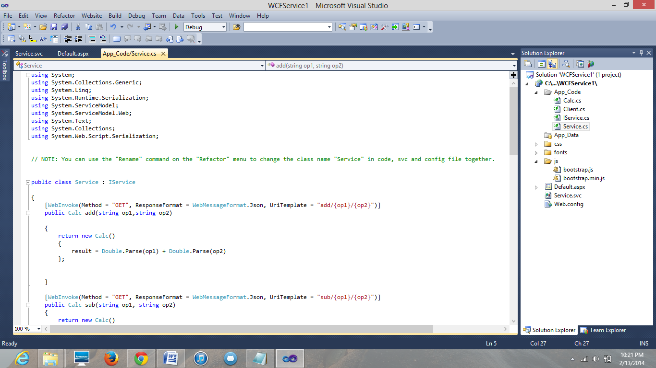

Now executing, Calculator application we get.

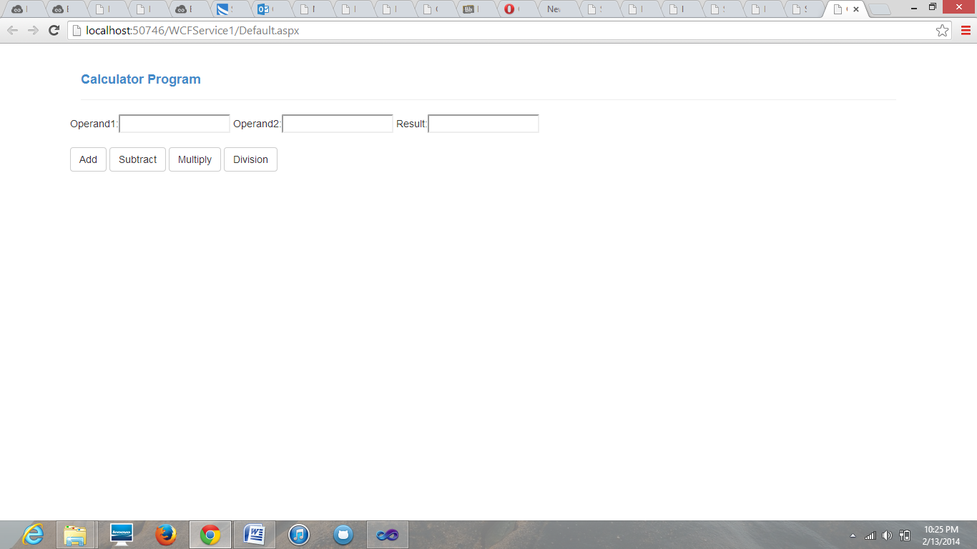

now by substituting values we get resultant ..

