**Report**

**1. Design..**

a**. Architecture Diagram**:

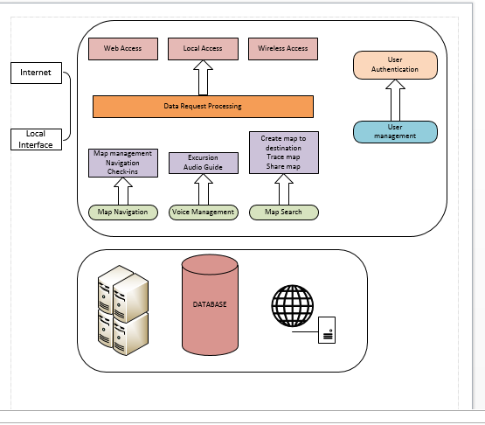

B**. Class Diagram**:

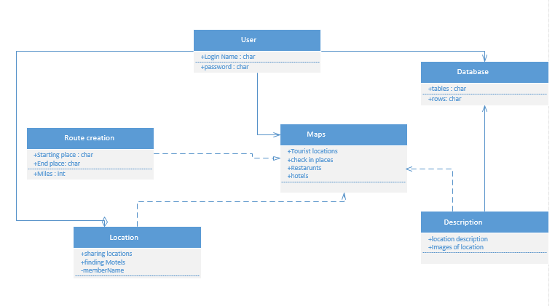

2. **Features Implemented**.

a**. Web services**: For development of this Travelling web app, i used HTML for Home pages, for displaying i used for JSP and also i used Servelts for response. I used Google maps API for displaying maps . In this, i mainly used Google maps API for searching the tourist spots in particular location and also for displaying check in places which are visited.

B**. Database**:

In this app, i mainly used Oracle database 10g for storing and retrieving the values. I used because for storing the all the suggested routes when one person travelling from one place to another place. And in that the user can select the best possible route and that route is selected without any user interference and i developed code for displaying the best route from database.

In this, Google maps API is directly used for retrieving the restaurants, hotels etc which are located near to that user selected location.

3. **Include Screen shots of the features**.

The following is the home page for my web app.. which consists of login and sign up button..

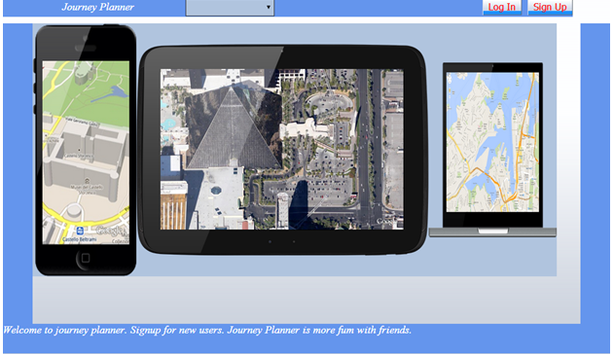

When we click on login the following screen shot appears and which is used for already registered users..

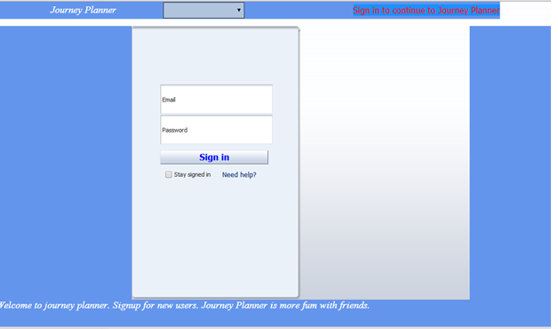

For non registered users there is sign up button when we click on that the following screen shot appears..

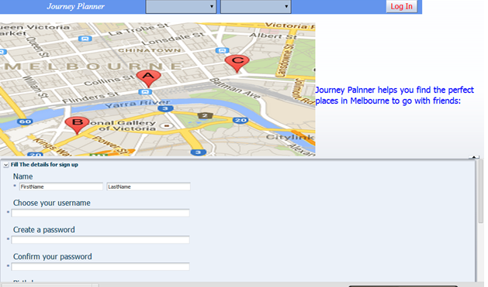

Then i implemented the travel guide page i.e. when user login with their details...

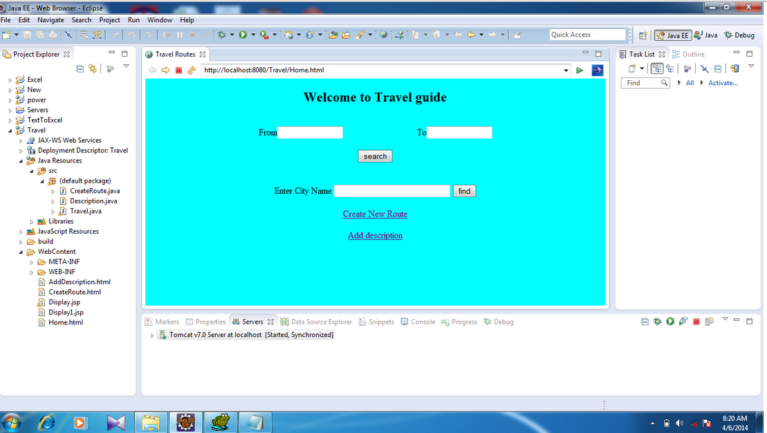

Then i created route for travelling user from one place to another place... which is done by me and all these values are stored in local database...

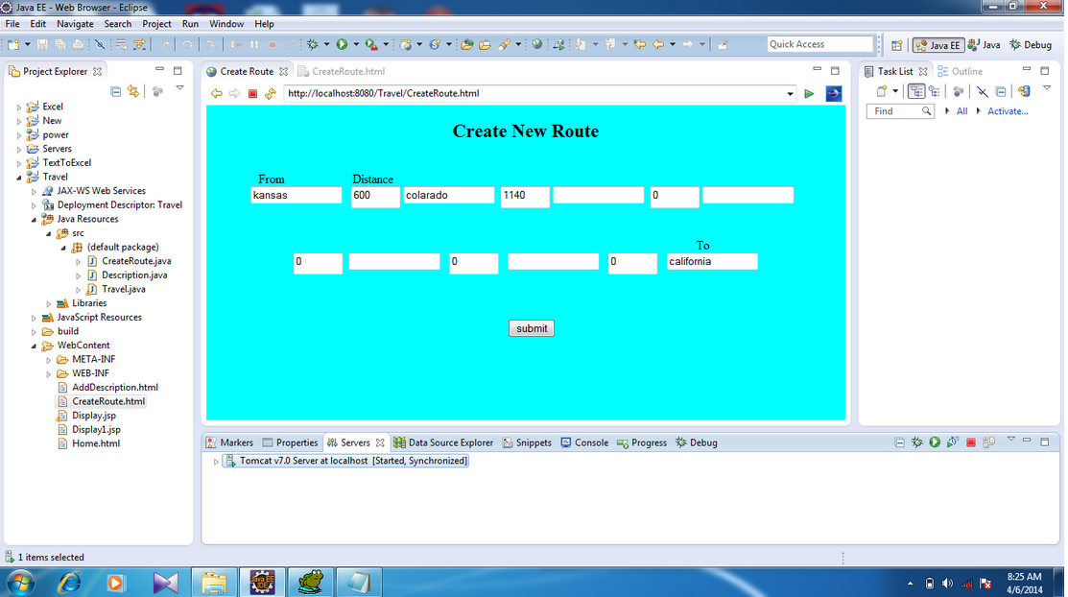

The following is the screen shot for user to select place and when user clicks on submit button..

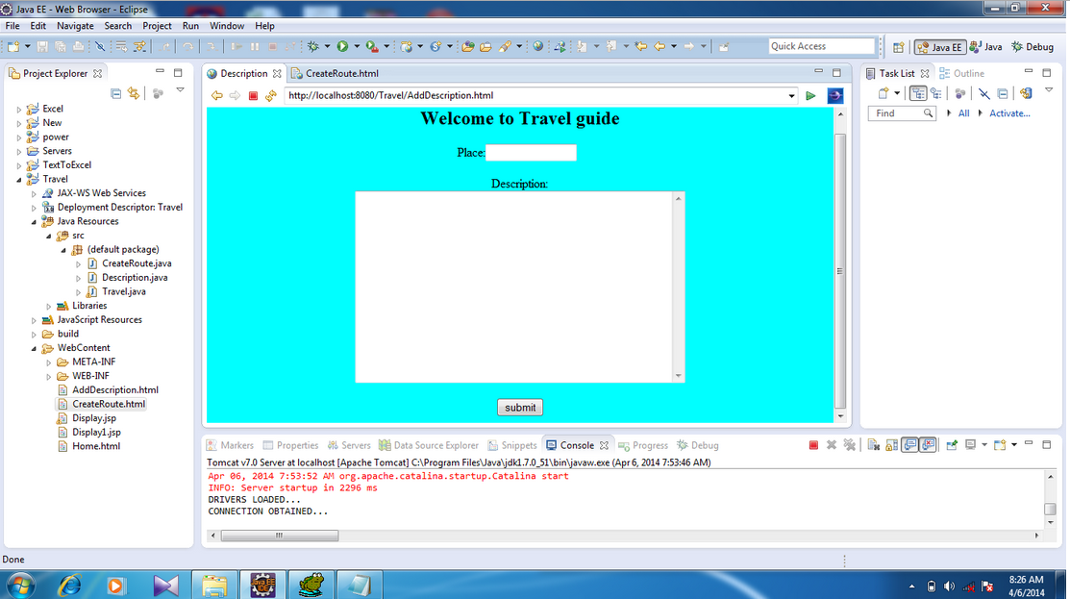

When user clicks on submit button the following screen shot appears.. and here i select California and i get all description about California..

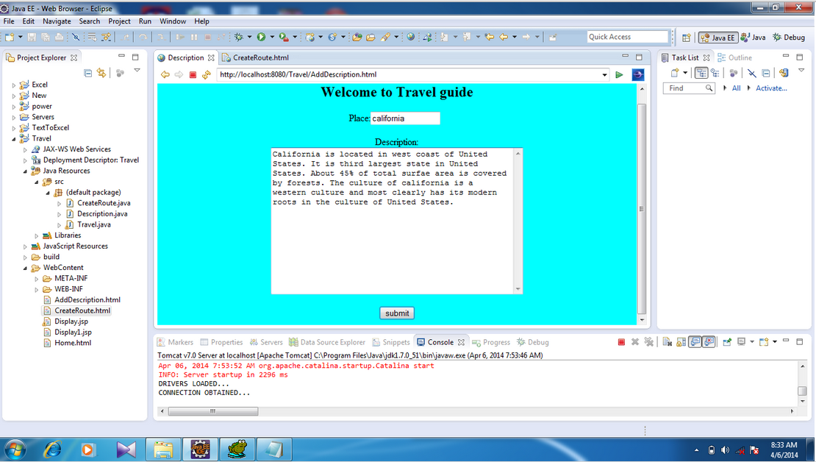

Now the user wants to travel from kansas city to California... and here the best route is selected

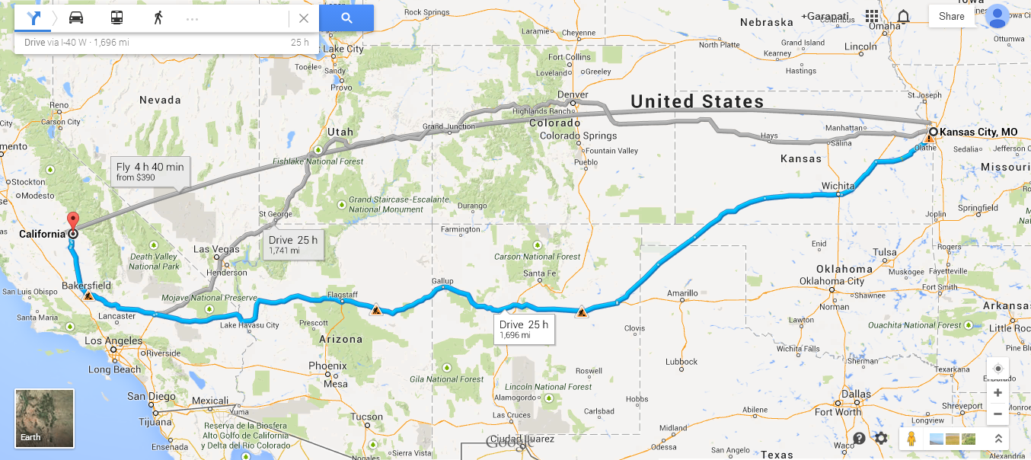

When the user wants to know about Restaurants in California.. user just search in search bar the following screen shot appears.. it directly redirects goes to Google maps ..

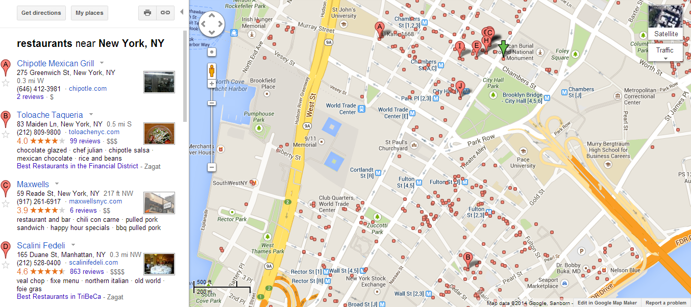

4. **Include Web services and Web site URLS**:

Web services: SOAP and JSON.

Web site URLS:

<http://plnnr.com/>

<https://developers.google.com/maps/documentation/javascript/>

<https://foursquare.com/>

5. **Github link:**

6**. Limitations**:

In this app , i developed travelling between only two locations... and i created route for only limited no of locations.

7**. References**:

<http://plnnr.com/>

<https://developers.google.com/maps/documentation/javascript/>

<https://foursquare.com/>