**Second Increment Report   
Due Date: October 18, 2013**

**Steps followed in the Project:**

Using the HTML pages we have designed queries will be generated to get the data from YouTube by sending a GET request from the web service as given:

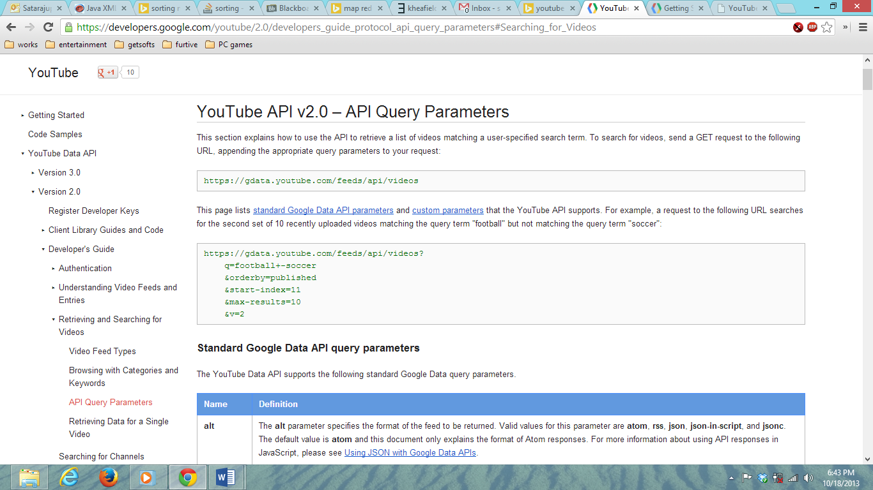

The YouTube returns XML data with the search query results as shown:

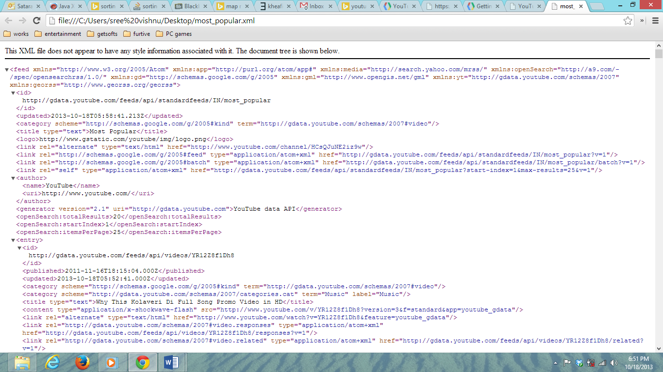

After getting all the XML results from the search queries a map Reduce XML parser (we still are developing) to extract the attributes of the video.

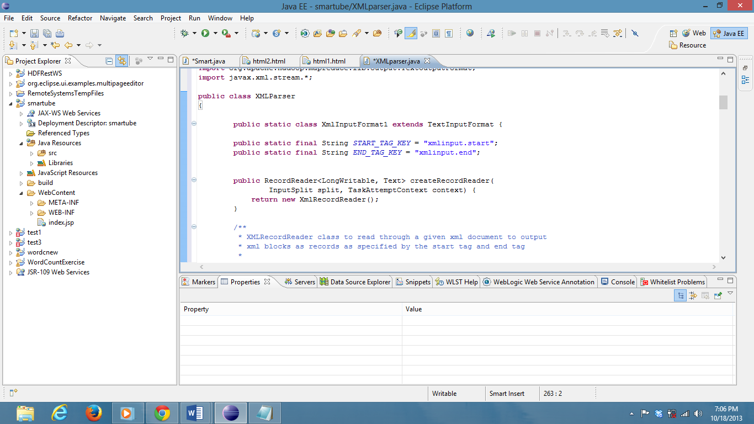

The attributes are used in the Map Reduce Sorting algorithm to sort to give the results.

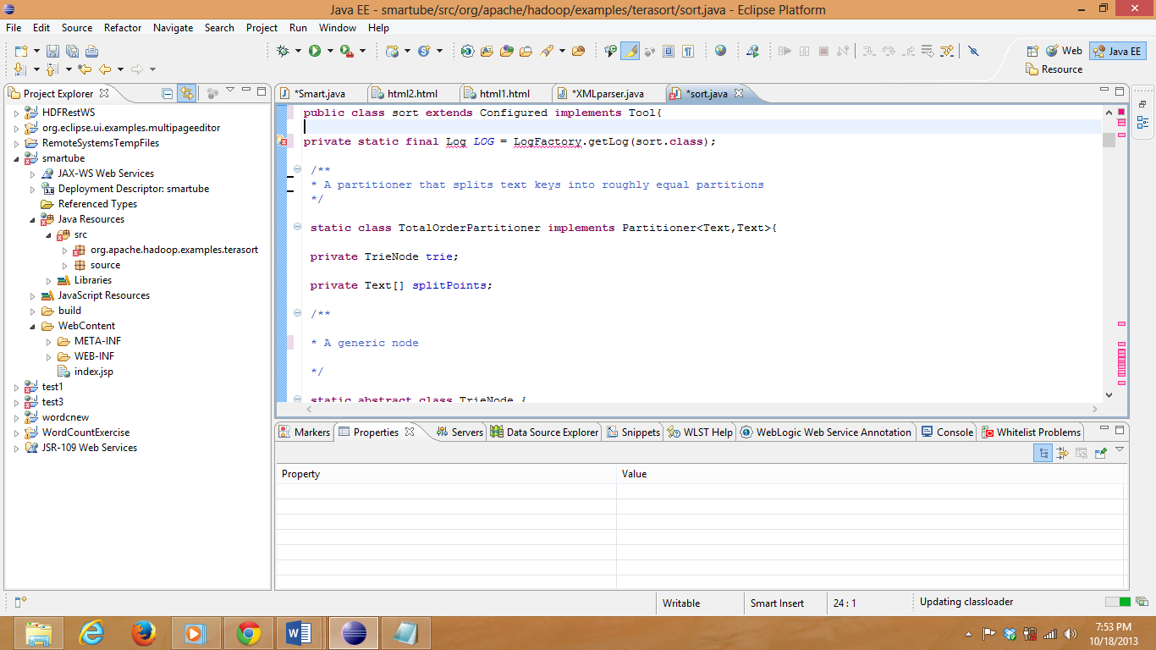

The XML parser is again used to write the results got from the sorting algorithm to a XML file.

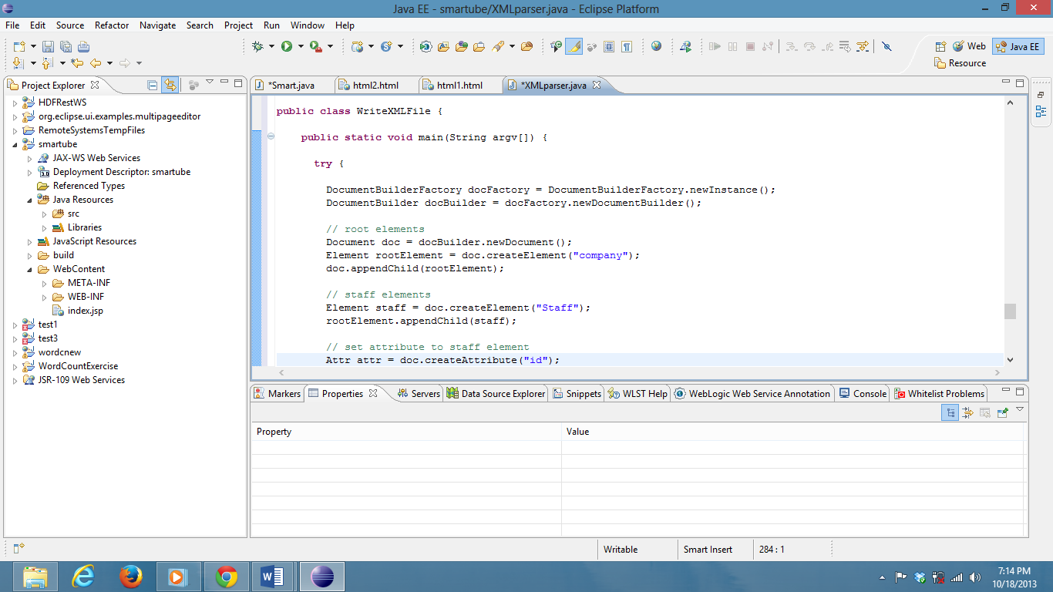

The XML file is used to display the results in the HTML Results page.