Lab Report.

*The following is the screen shot of Restful service code....*

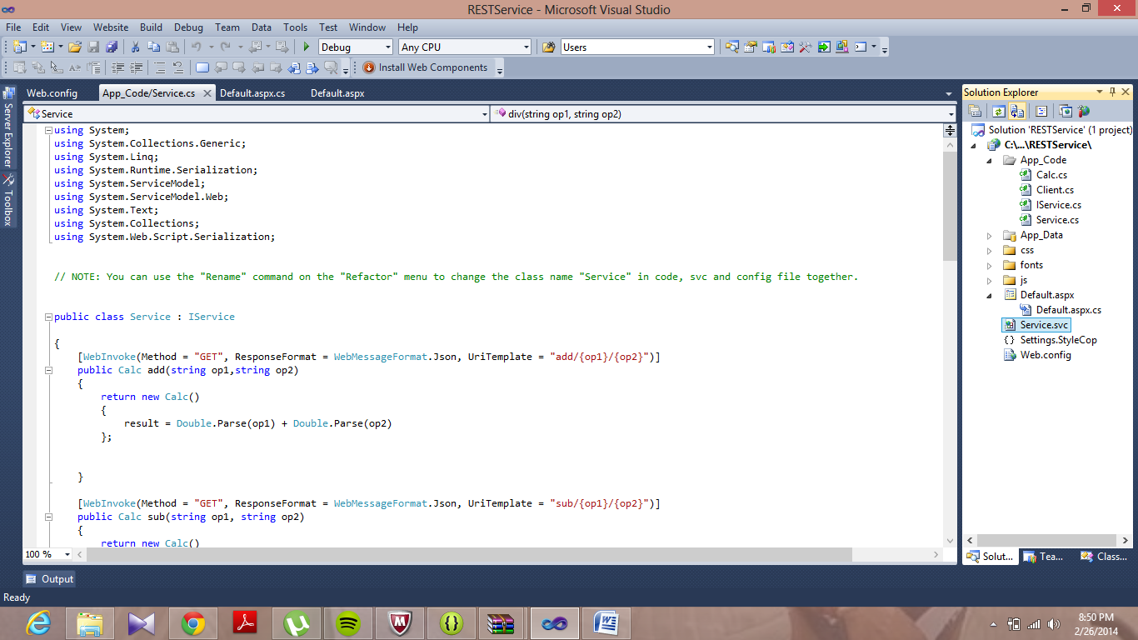

***The following is the screen shot of output of restful service...i.e. i developed calculator***

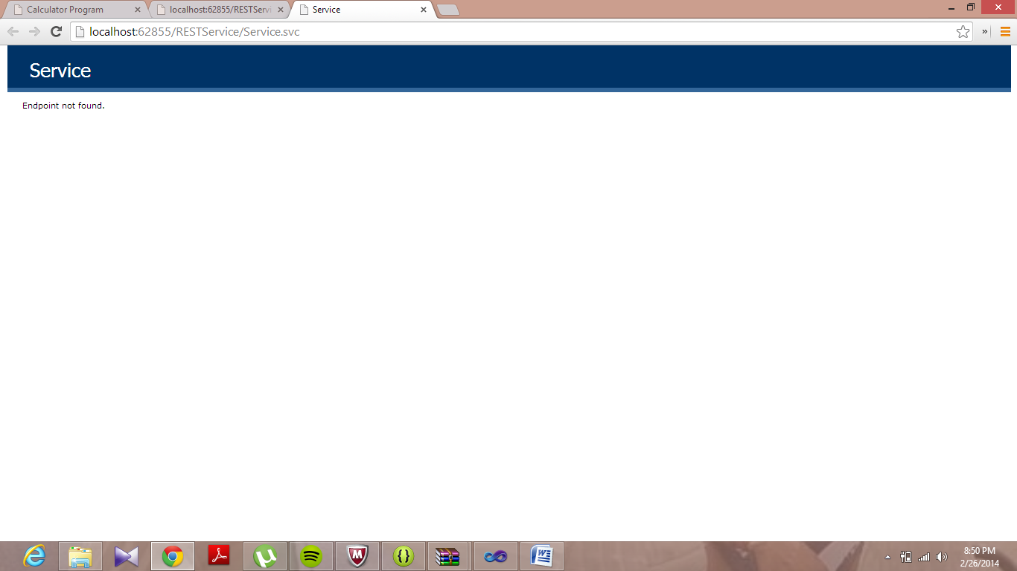

The following is the screen shot of addition ....i.e. adding 10 and 20 result is shown as 30

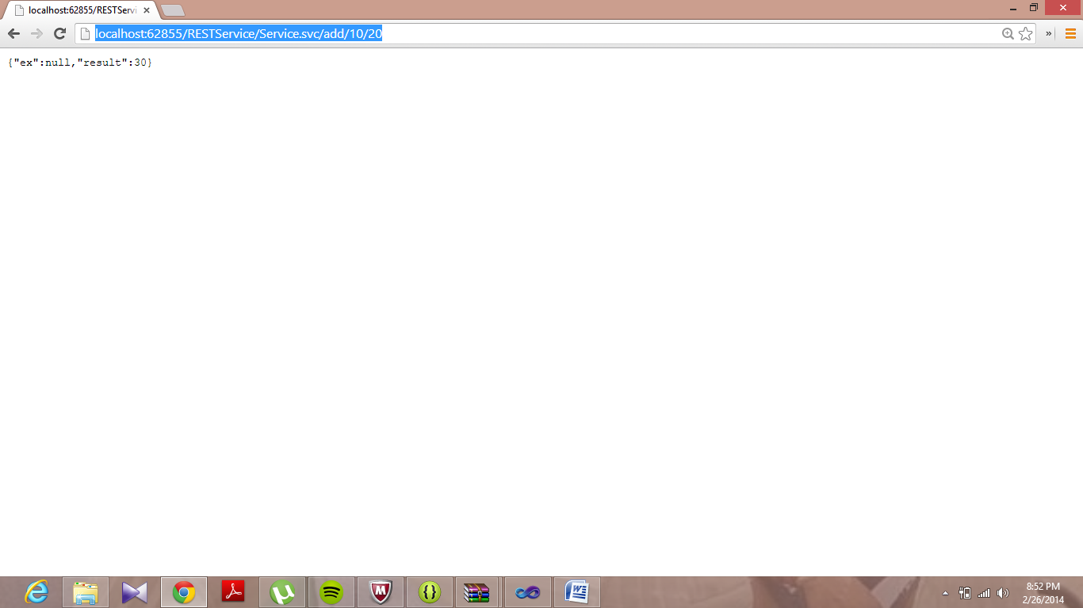

The following is the screen shot for subtraction of 10 and 20 ....

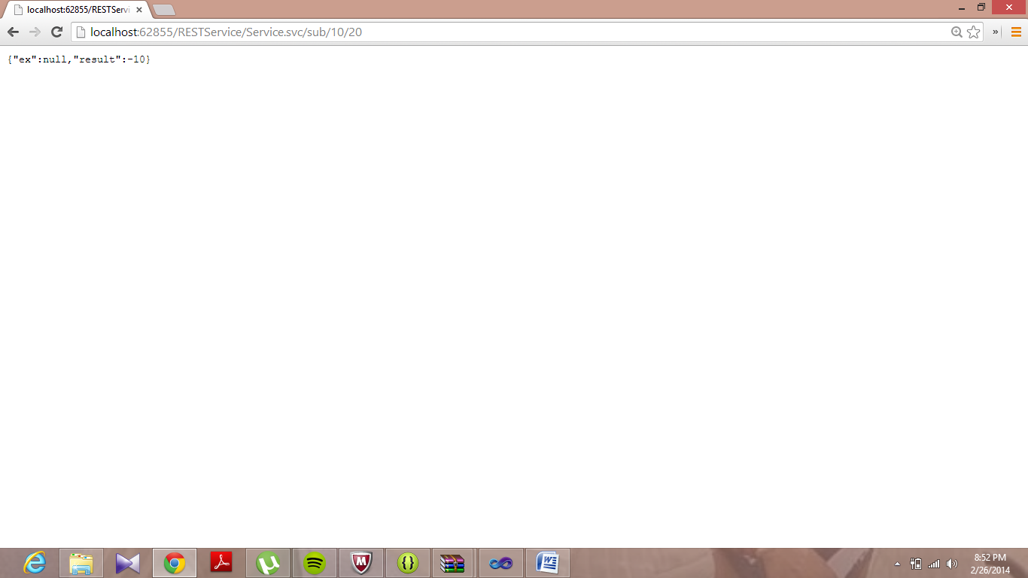

The following is the screen shot for multiplication....

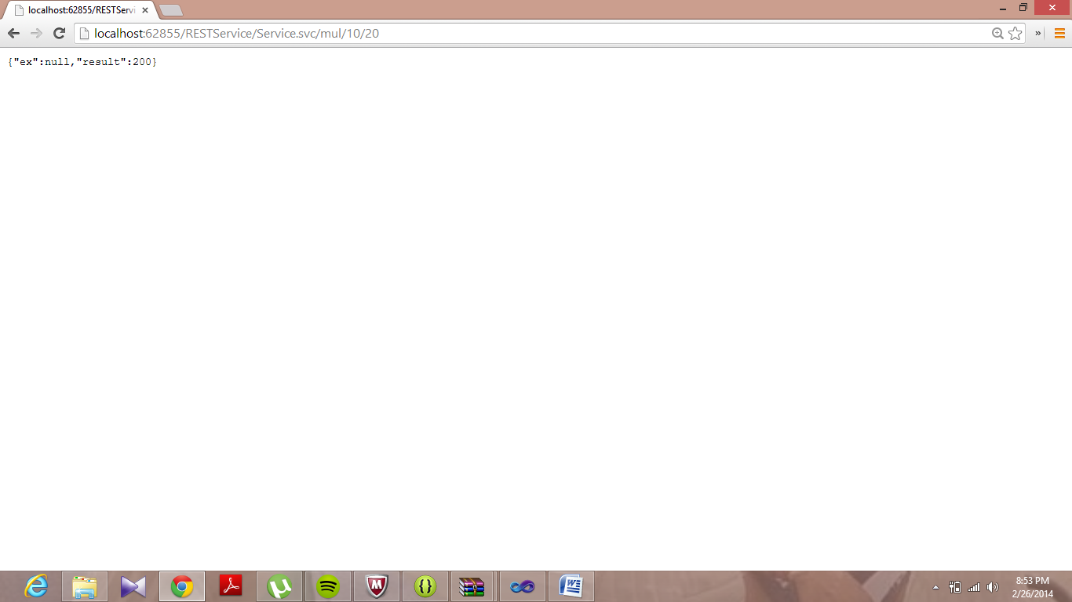

The following is the screen shot for division....

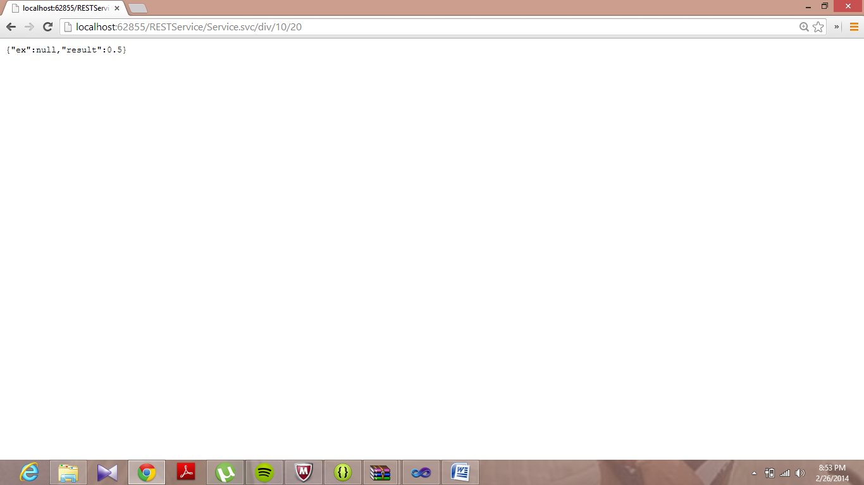

The following is the code for development of client application...

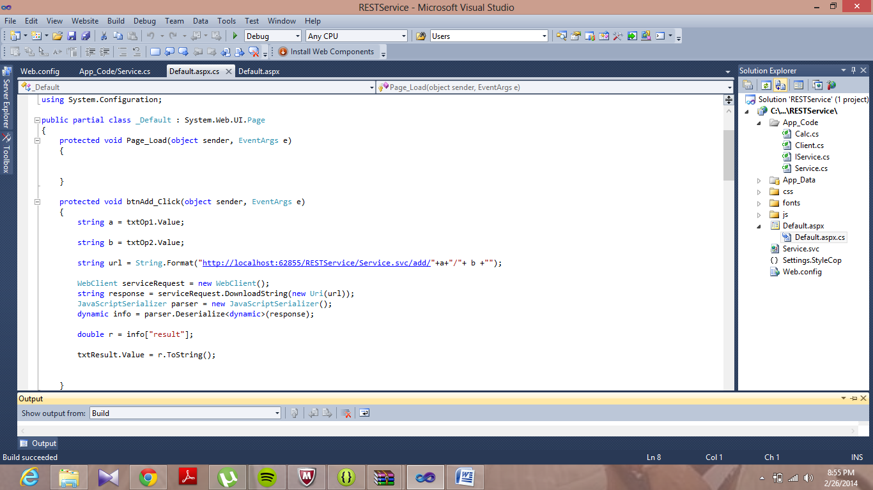

when we run the code , we get the following output.... i.e. calculator

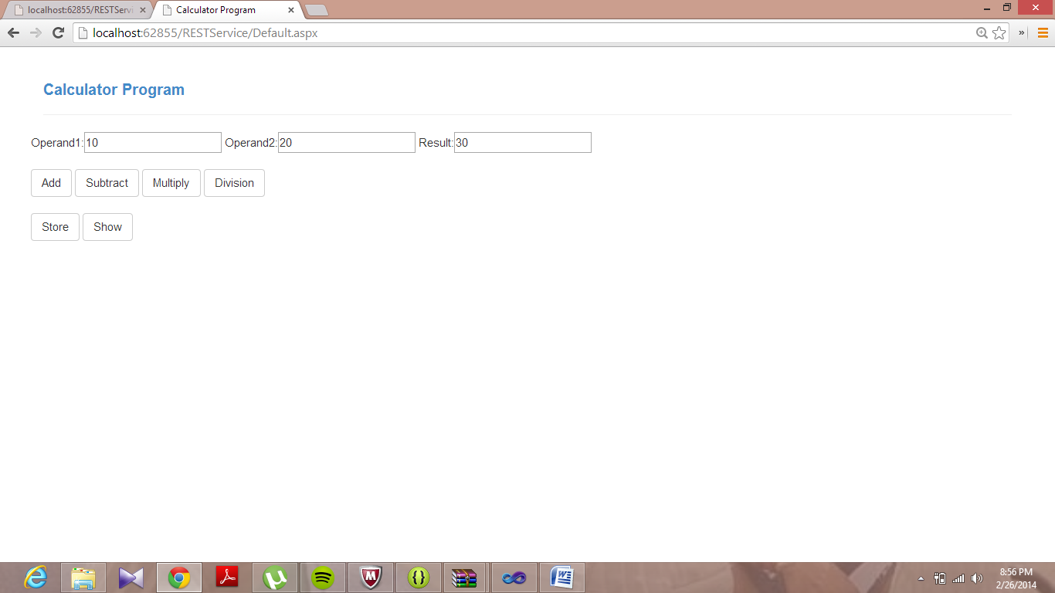

At bottom we see that there is one store button which is used to store values...and when click on that it stores successfully....

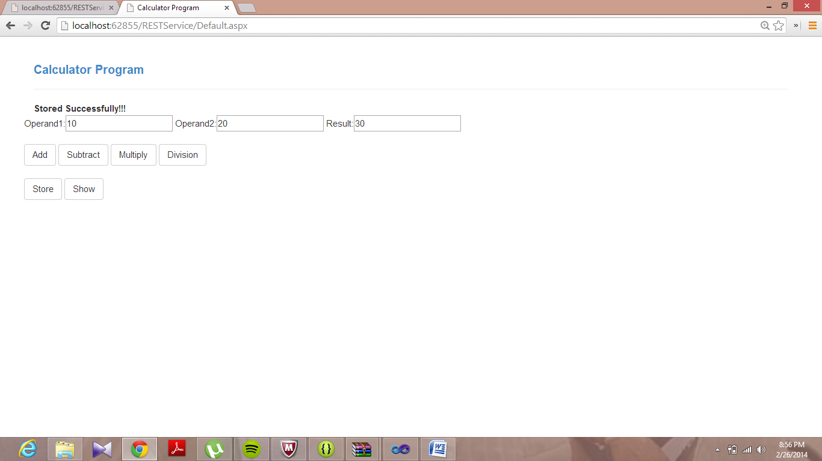

When we click on show button we get values which are stored in database...In the following screen shot we can see that all values which are already stored in database..

