***Swinney Genie***

**Advanced Software Engineering Project**

**Increment One Report**

**Existing Services/API:**

No existing services or API were used as the project we are developing is requires services which are new and no existing services provides these. All the source code and services are written and implemented in C# using visual studio. The interface was developed using HTML5, CSS, Jquery and Jquery Mobile.

**Design of Services:**

* ***Stories(Scrum Do):***For First increment , we developed user and Admin interfaces . In this period we developed login page for user and page for admin to note down the details of user before entering into swinney and also we developed a page for user to check whether court is empty or not.
* ***WSDL(Service Description****):* Two services would be used in the project. One is to store the student check in data which includes the game or court he is going to, the list of items he is playing.And when the student is getting out of the Swinney his data is to be cleared. This is done by updating the database through the service.This is done by the admin.Other service would be getting the stored data in the database by the push service. The data retrieved is displayed accordingly in the interface to the user.
* ***SequenceDiagram****:*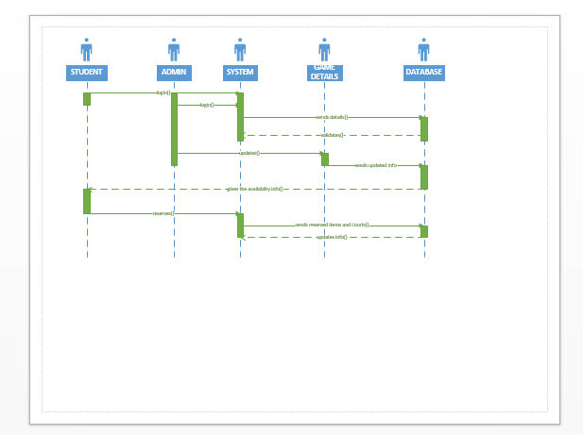
* *ClassDiagram:*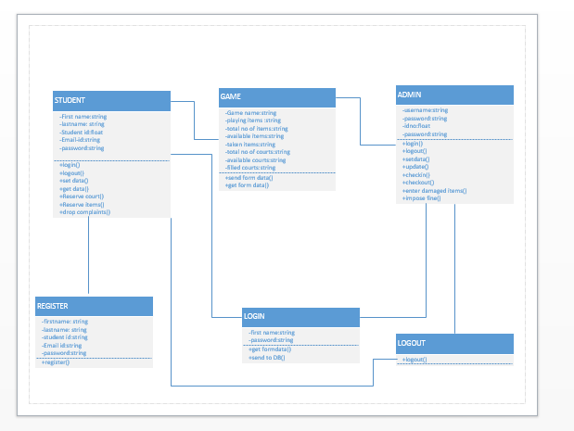
* ***Design of Mobile Client Interface:***

Two separate interfaces were developed one for the user and one for the admin. The respective persons can select their interface from the Home page designed giving the brief details of the Swinney Recreational center.

**User Interface** has gives the details of the user, has the map of Swinney which displays the number of courts and the players playing on it. It also displays the items left individually. The user has been provided with a logout button to exit the system.

**Admin Interface**logins into his interface through the login page provided. After logging in ithas the input box to enter the students IDs who enter into the Swinney. The admin can select the game he chooses and court he goes to and the item he chooses through the drop down menu provided. After selecting this the admin has given a check in button to the save the preferences to into the database.The interface has also a checkout button to check out the student who leaves the Swinney. The admin page has provided with logout button to exit the system.

* ***Design of Unit test Cases(using Nunit tool):***

As there are three services in our project storing the data, delete the data and retrieve the data. Each service is tested individually using Nunit testing tool using the Assert.AreEqual function and depending the type of the service used. (Rest or Soap).

**IMPLEMENTATION:**

**Implementation of Services**:

In this project, we want to use "C#" visual studio for implementation of web application i.e. Swinney Genie. For this we use web service application which is installed in C#. After the completion of successful running of app on web, then we want to deploy it on IIS server.

**Implementation of User Interface:**

The user interface is implemented by using HTML, Jquery, Twitter Bootstrap and Css. In our project we developed two interfaces one is" ADMIN interface" and another one is" USER interface". The following are the screen shots of both interfaces.

The screenshot here gives the Home Page of the Project which has the user login as seen.

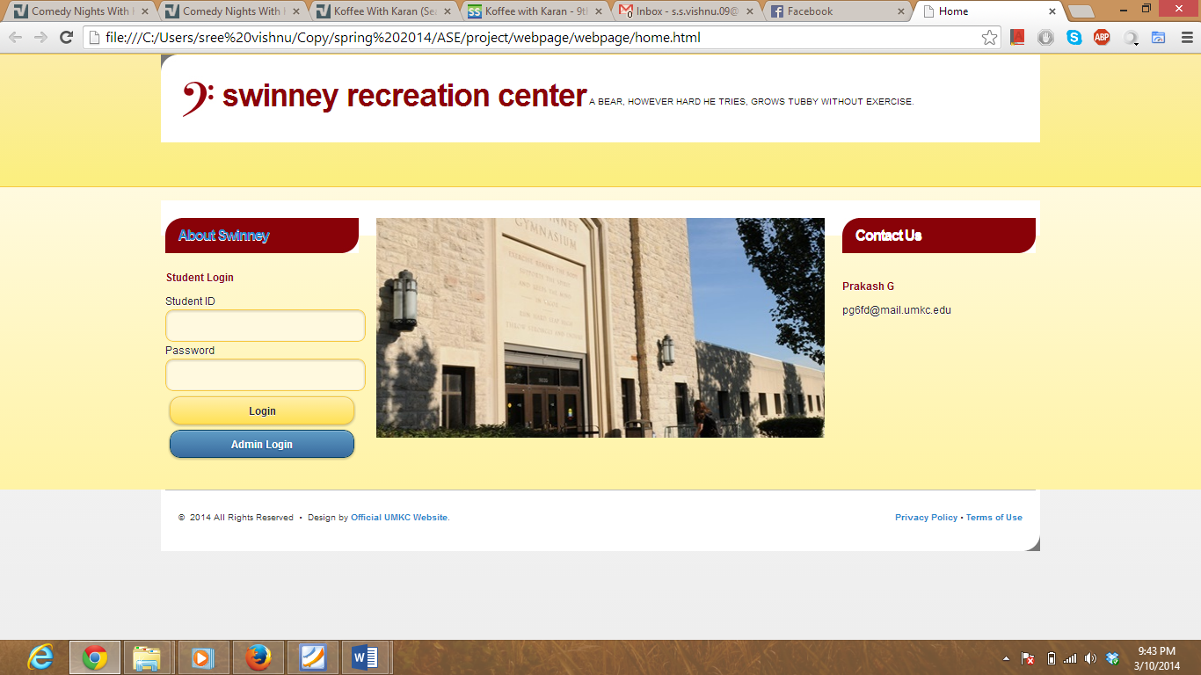

The following is the screen shot of Admin Login.

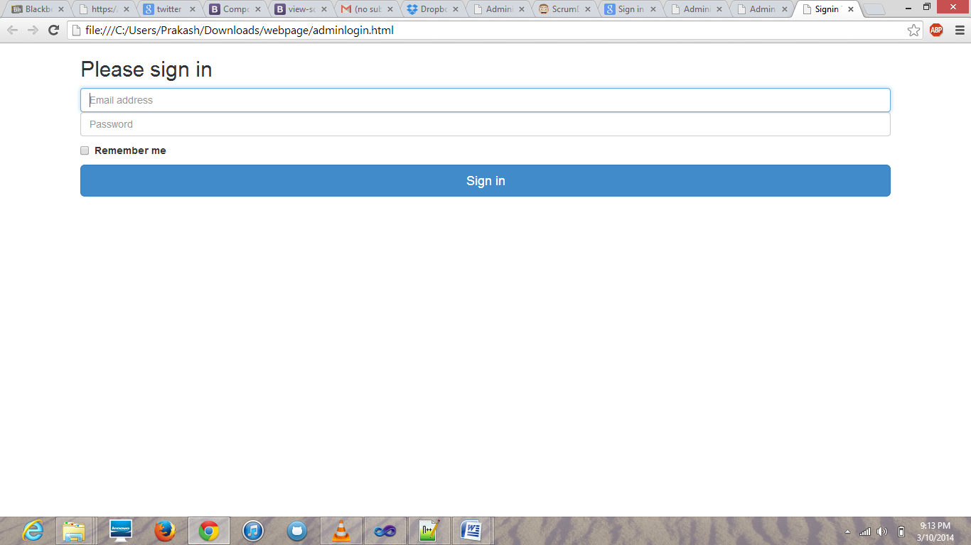

The following is the screen shot for admin to enter details of user Before entering into swinney.

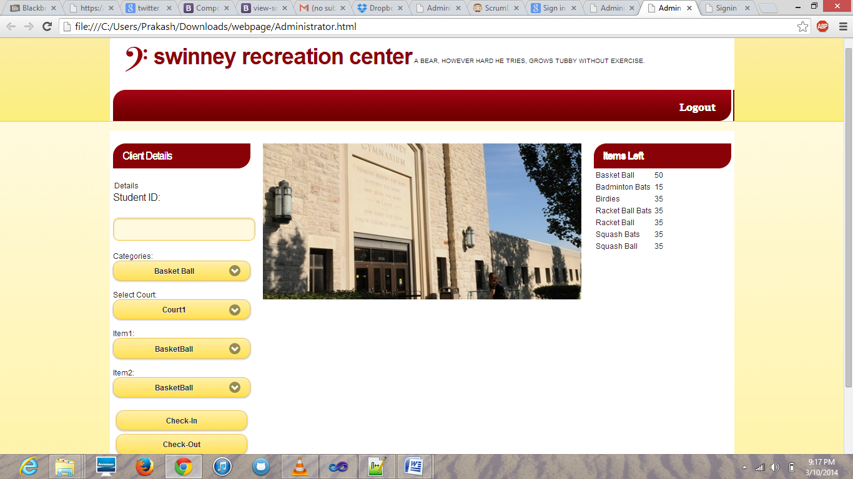

The following is the screen shot for user to check whether court is empty or not....

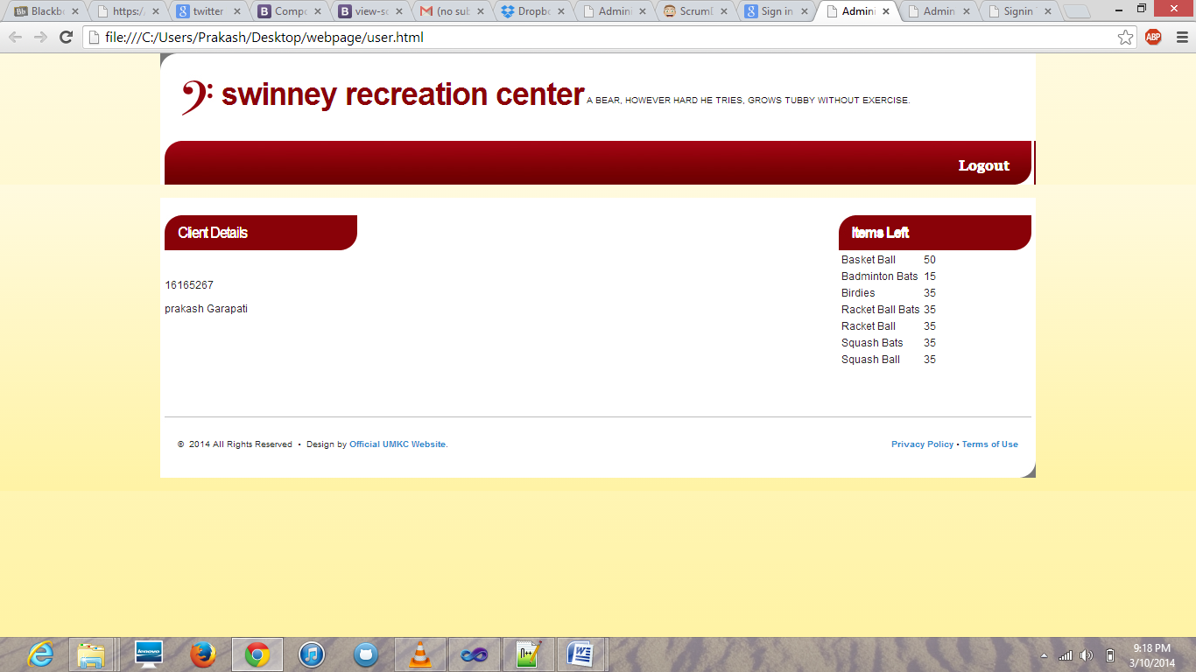

The following is the screen shot of scrum do story , when work is in ToDo condition...

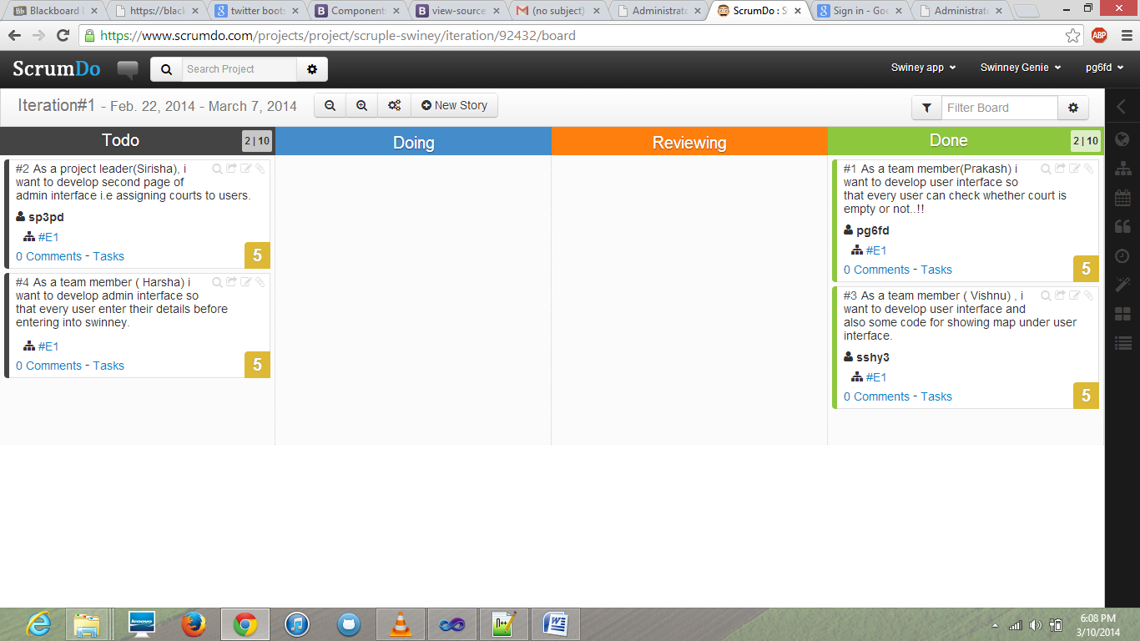

The following is the screen shot when the work is in done condition.

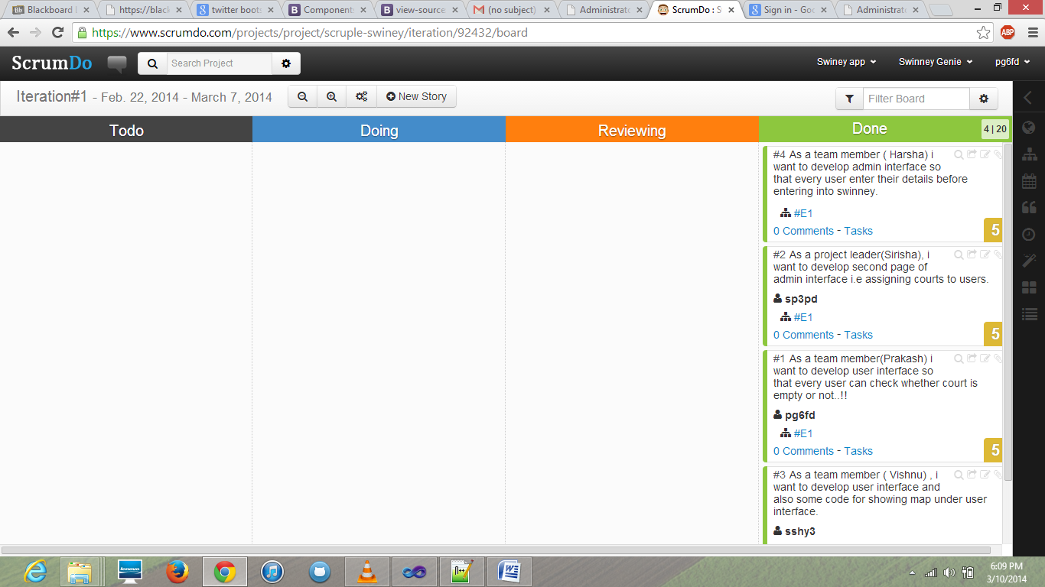

**Implementation of Testing:**

Each module of the total project is tested using Nunit testing tool as C# is used to develop the services. As the services are still in the development stage performing the testing is not possible.

**Deployment:**

The source code and scrum do links are posted onto the links provided.

**Prakash Garipati**

**Sirisha Pakalapati**

**Harsha Verepalli**

**Sree Vishnu Satarajupalli**