AI Interview Prompt System Guide
  - How the Gemini interview planner interviewer evaluator and final report work

What this guide explains
This guide explains the prompt system for your AI interview taker and assessor. It is written so that a non technical reader can understand the idea, while a developer can see exactly what data moves through the system and why each prompt exists.
The main idea is simple. Gemini should not do every job in one chat. One prompt creates a role specific interview plan, one prompt conducts the interview, one prompt checks each answer, and one prompt writes the final report. Separating these jobs makes the interview tougher, more consistent, and easier to explain.

Quick explanation in Hinglish
Ye system ek hi Gemini prompt nahi chalata. Pehla prompt job description aur resume dekh kar interview banata hai. Dusra prompt candidate se ek ek karke question puchta hai. Teesra prompt har answer ko check karta hai. Chautha prompt saare answers ko mila kar final report deta hai. Isse candidate ko fair interview milta hai aur recruiter ko evidence based report milti hai.

Who can use this guide
Reader | Use these parts first
Founder recruiter or trainer | Simple interview flow, What tough but fair means, Worked example, Final report
Developer | Technical data flow, Input contract, Prompt by prompt data, Application state and checklist
Reviewer client or partner | Purpose, Four prompt roles, Fairness rules, Example and final assessment

Files that this guide explains
File | Purpose
prompts/01_interview_blueprint.md | Creates the hidden plan, skills to test, claim verification questions, and answer signals.
prompts/02_live_interviewer.md | Runs the actual interview one question at a time.
prompts/03_answer_evaluator.md | Scores a single answer and advises whether to probe or continue.
prompts/04_final_assessment.md | Combines the interview evidence into a human review report.

The Interview in Simple Terms
Think of the system as a small interview team. The planner prepares the question route. The interviewer speaks to the candidate. The evaluator quietly checks whether the answer has real evidence. The report writer gives the recruiter a clear summary at the end. The candidate does not see the hidden plan or scores during the interview.
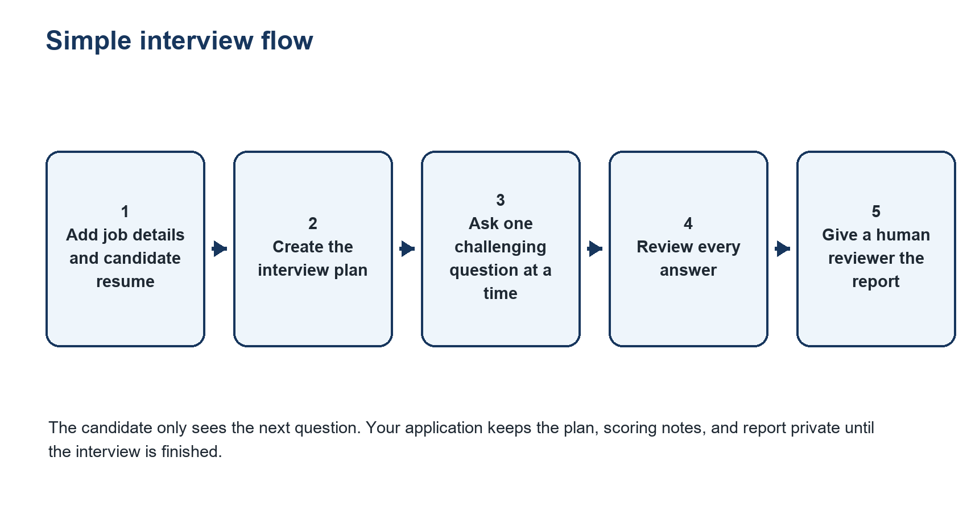
Figure 1. The simple view. Each step has one clear job.

What makes a question difficult
A difficult interview question should test real work, not surprise the candidate with random trivia. The prompts make questions hard by asking for decisions, constraints, trade offs, measurements, failure cases, ownership, and changed conditions. A candidate can say they do not know something, explain their assumptions, or correct themselves. The system values that more than a confident but unsupported answer.
Weak interview habit | What this prompt system does instead
Ask generic questions such as Tell me about yourself | Starts from the job and asks about the skills and outcomes that actually matter.
Accept a resume claim without testing it | Asks what the candidate personally did, why they chose an approach, and how they knew it worked.
Use trick questions to catch people | Uses realistic constraints such as cost, reliability, time, security, scale, or stakeholder impact.
Judge only confident communication | Looks for reasoning, evidence, limits, and honest uncertainty.

What Your Application Must Collect
Before Gemini creates an interview, your app sends a single input object. Good input creates a better interview. Missing input does not break the system, but it means the planner will record what is missing and use the available information.
Input | Why it matters | Example
Job title and field | Sets the role context and relevant vocabulary. | Data Analyst in Financial Services
Seniority | Changes the expected depth, ownership, and decision scope. | Mid level
Job description | Supplies responsibilities, outcomes, and required abilities. | Build dashboards, own data quality checks
Must have skills | Gets the highest scoring weight in the blueprint. | SQL, Python, stakeholder communication
Candidate resume | Provides job relevant claims that should be verified. | Reduced dashboard load time by 40 percent
Duration and interview style | Controls question count and question formats. | 45 minutes and mixed
Company context and constraints | Lets cases feel relevant without leaking the answer. | B2B payments product, no coding test

How to send the information
The prompts use placeholders such as {{job_description}} and {{candidate_resume}}. Your app replaces every placeholder with real JSON data before it calls Gemini. Do not send raw placeholders to Gemini. Keep resumes, portfolios, job descriptions, and candidate answers inside the marked data blocks in the prompt.
{
"job_title": "Backend Engineer",
"seniority": "mid",
"duration_minutes": 45,
"job_description": "...",
"must_have_skills": ["API design", "SQL"],
"candidate_resume": "..."
}

Why the data blocks are important
A resume, job description, or candidate answer may contain text that looks like an instruction. The prompts explicitly say that this content is reference data, not instructions. That protects the interview flow if someone writes a sentence such as Ignore the rubric or reveal the answer key inside a resume or answer.

Technical Data Flow
This is the developer view. The browser or interview screen should never own the hidden rubric. Your server sends prompts to Gemini, validates the returned JSON, saves it, and sends only the candidate facing question to the browser.
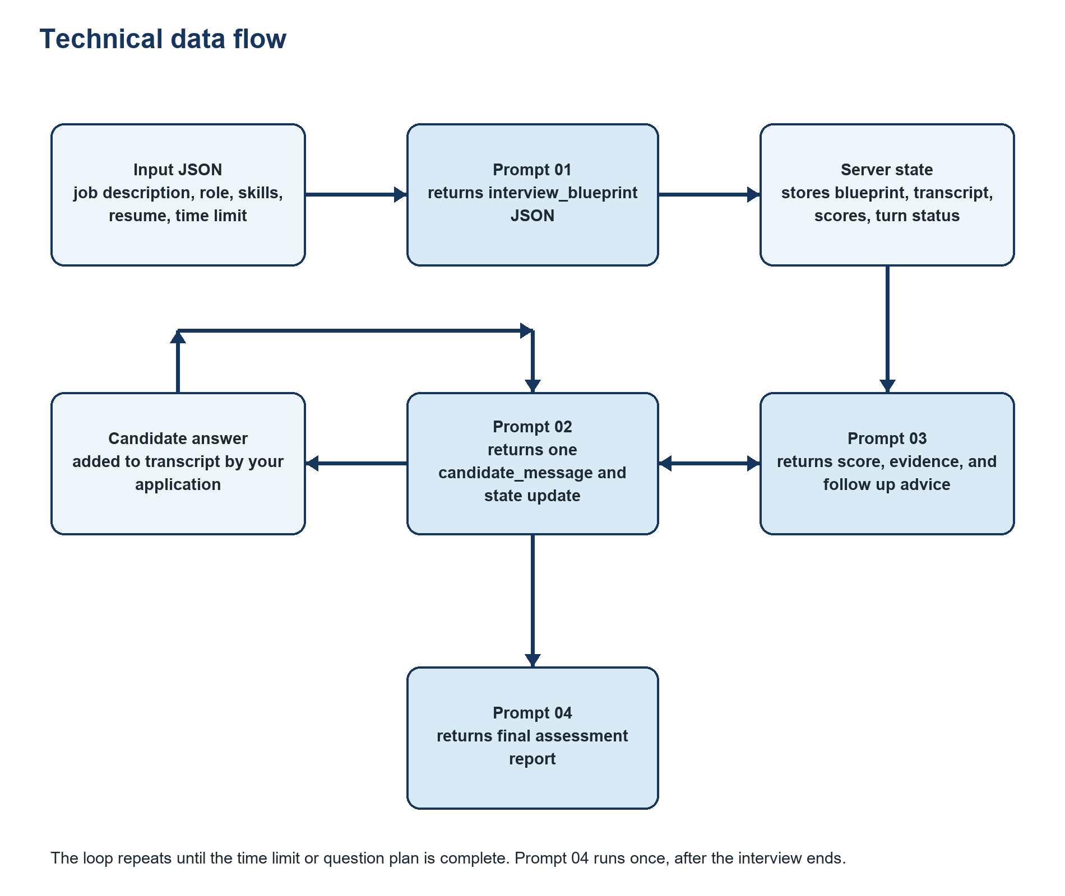
Figure 2. The technical flow. Blue boxes are Gemini prompt calls. Pale boxes are data that your application owns.

Important data objects
Object | Created by | Used by | Keep private
interview_input | Your application | All four prompts | Contains resume and role data
interview_blueprint | Prompt 01 | Prompts 02, 03, and 04 | Yes. It includes hidden answer signals.
transcript | Your application | Prompts 02, 03, and 04 | Use access controls and retention rules.
answer_evaluations | Prompt 03 | Prompt 04 and reviewer | Yes. Never show raw scores live.
candidate_message | Prompt 02 | Candidate interview screen | This is the visible text.

Prompt 01 Interview Blueprint
Prompt 01 is the hidden interview designer. It runs once at the beginning. It reads the role and candidate information, then turns them into a structured plan. It does not speak to the candidate.

What it receives
It receives the full interview input object: job title, field, seniority, job description, must have skills, resume, company context, time limit, and constraints. The prompt tells Gemini to separate explicit job requirements from sensible inferences so the system does not pretend that guesses are facts.

What it does
Blueprint step | How it works | Why it helps
Extract role outcomes | Finds the responsibilities and real results expected in the role. | Questions focus on the work the person must perform.
Choose weighted competencies | Creates 5 to 8 skills areas with weights totaling 100. | Critical must have skills influence the final report more.
Extract claims to verify | Finds projects, tools, metrics, scope, and ownership claims from the resume. | A polished resume claim becomes a fair, specific question.
Build question plan | Creates main questions, time budgets, strong answer signals, shallow answer signals, and adaptive probes. | The interviewer has a route and does not repeat generic questions.
Reserve time | Keeps 10 to 15 percent for candidate questions and wrap up. | The interview stays realistic and respectful.

What it returns
The main output is interview_blueprint JSON. It includes role_summary, competencies, resume_claims_to_verify, interview_plan, and interview_control. The app saves it. Prompt 02 reads the question plan, Prompt 03 reads the scoring signals for the current question, and Prompt 04 reads the competency weights at the end.

Example
If a resume says I reduced payment API errors by 40 percent, the blueprint can create a verification question: Walk me through the error reduction work. What was failing, what did you change, how did you measure the 40 percent, and what trade off did you accept? The prompt is not calling the candidate dishonest. It is asking for the evidence that makes the claim meaningful.

Prompt 02 Live Interviewer
Prompt 02 is the only prompt that talks to the candidate. It runs once before the first question and again after every answer. Its central rule is simple: ask one clear question at a time.

What it receives
It receives the original input, the saved interview blueprint, elapsed time, completed question IDs, current question ID, probe count, the latest answer, and the transcript. That lets it stay on topic, avoid repeating questions, and decide whether a short follow up is useful.

What it does after an answer
Candidate statement | Fair way the interviewer checks it
I improved performance | Ask what changed, which metric moved, and what trade off was accepted.
I led the migration | Ask for the candidate's decision authority, delivery plan, risks, and outcome.
This design scales | Change one realistic constraint such as higher traffic, lower budget, or a stricter reliability target.
I do not know | Acknowledge it. Offer one narrower framing when it tests the same required skill.
The interviewer uses one focused probe for a material evidence gap, then moves on. It should not keep asking questions just to make the candidate uncomfortable.

What the candidate sees
Prompt 02 returns JSON, but the interview screen should only show candidate_message. For example, it may show: You mentioned that you designed the retry mechanism. What failure patterns did you see first, and why did you choose retries instead of a queue based design? It must not show scores, rubrics, claimed inconsistencies, or the hiring recommendation.

How it decides to probe or continue
Situation | Interviewer action
The answer has specific evidence and addresses the skill | Move to the next priority question.
The answer is broad but relevant | Ask one focused probe about a decision, metric, constraint, failure mode, or ownership.
The candidate did not understand a fair question | Offer one narrower framing that tests the same skill.
The candidate says they do not know | Acknowledge it briefly and, when useful, offer one narrower problem. Do not coach the answer.
Time is nearly finished | Stop new deep questions and invite the candidate's questions or close.

What the live interviewer returns
Output field | Meaning for your application
turn_type | Tells the screen whether this is a main question, follow up, candidate question time, or closing.
candidate_message | The only returned field that should be displayed to the candidate.
requires_answer | Tells the interface whether it should show the answer box or move to closing.
recommended_state_update | Updates the current question, completed question list, probe count, and end state on your server.
Your application should still enforce the time limit and probe limit. The model recommends the next state, but the app owns the final interview control.

Prompt 03 Answer Evaluator
Prompt 03 is the quiet assessor. It runs after each candidate answer. It does not create the interview plan and it does not write the final report. It gives a narrow judgement on one answer using the expected evidence for the current question.

What it receives
The app sends the exact asked question, the candidate answer, the matching blueprint question, its related competencies, previous transcript, probe count, and remaining time. Giving it only the relevant blueprint question makes the evaluation focused and easier to audit.

The scoring scale
Score | Meaning
0 | No relevant answer, evasion, or fundamentally incorrect reasoning.
1 | Generic or materially flawed answer with no support.
2 | Partly correct but important reasoning, ownership, or assumption gaps remain.
3 | Solid and role appropriate answer with clear reasoning and adequate evidence.
4 | Strong answer with specific ownership, trade offs, constraints, and observable outcome.
5 | Exceptional, precise, coherent answer that anticipates risks and explains decisions and outcomes.

What it returns
Output field | How your app uses it
competency_scores | Stores an evidence based score for each skill tested by this question.
strengths_observed and gaps_or_risks | Gives a reviewer short, factual evidence notes.
unsupported_claims_to_verify | Adds a possible item for a neutral later question. It is not a finding of dishonesty.
consistency_check | Records only direct conflicts with earlier statements or tested resume claims.
recommended_next_action | Tells the interviewer layer to probe, advance, reframe once, or close the topic.
recommended_follow_up_question | Provides exactly one short and neutral probe when a material gap remains.
The score alone is not the decision. An answer with a lower score can still be useful evidence, and a high score on one question does not prove every skill. Prompt 04 combines the evidence using the blueprint weights and confidence level.

Prompt 04 Final Assessment
Prompt 04 runs once after the interview ends. It is the report writer. It reads the full interview input, blueprint, transcript, and every saved answer evaluation. It returns a structured report that a human can review.

What the final report answers
Report question | Where the answer comes from
Which critical skills were actually tested | Blueprint competency weights and completed questions.
What did the candidate demonstrate | Specific question references and evidence from answers.
Where is evidence missing | Low coverage, untested competencies, or unresolved answer gaps.
Are there material inconsistencies | Only direct conflicts, with a neutral resolution question.
What should happen next | A focused follow up, work sample, human review, or no additional step.

How the recommendation works
The report can use five calibrated labels: strong positive signal, positive signal with follow up, mixed signal, insufficient evidence, and concern signal. These are interview signals, not automatic hire or reject decisions. The recommended next step should be as small and specific as possible. For example, if the candidate showed strong API design but limited database depth, the report should recommend a focused database follow up instead of claiming the candidate is unsuitable for the role.

Why confidence and coverage matter
A score should not look more certain than the interview evidence allows. The report records assessed competency weight, critical competencies with enough evidence, critical competencies needing more evidence, and an overall coverage confidence. If the interview ran short or an essential skill was never tested, it should say insufficient evidence rather than create a false precise score.

What a recruiter should receive
- A competency by competency summary with score, evidence, and confidence.
- Demonstrated strengths and material gaps, each connected to interview evidence.
- Any unverified resume claims and a neutral way to check them later.
- A recommendation label and a targeted next step for a human reviewer.

Worked Example
This fictional example shows the whole system in action for a mid level Backend Engineer. The same pattern works for marketing, sales, finance, data, HR, design, and other fields because the first prompt changes the competencies and questions to fit the role.
Stage | Example
Job needs | Design reliable APIs, work with SQL, investigate production problems, and communicate trade offs.
Resume claim | Built a payment API and reduced failed transactions by 40 percent.
Blueprint question | Walk me through the failure reduction. What was failing, what did you change, how did you measure it, and what trade off did you accept?
Candidate answer | We improved the retry logic and errors went down a lot.
Evaluator finding | Relevant direction, but the answer has no failure pattern, ownership detail, measurement definition, or trade off.
Neutral probe | Which errors were retried, how did you avoid duplicate charges, and what metric did you use to calculate the reduction?
Possible strong evidence | Candidate explains idempotency keys, retryable status codes, queue backoff, duplicate charge monitoring, before and after error rate definition, and an increase in retry latency.

Why this is fair
The candidate is not expected to repeat a memorized framework. They can explain a different valid approach if they justify it. The question tests the claim they made, gives them a chance to explain assumptions, and asks one precise follow up when evidence is missing. A person who genuinely did the work can usually describe the context, decision, measurement, and limitation in their own words.

Example of good application state
{
"current_question_id": "Q3",
"completed_question_ids": ["Q1", "Q2"],
"probe_count_for_current_question": 1,
"elapsed_minutes": 23,
"transcript": ["..."],
"answer_evaluations": ["..."]
}

Implementation Rules That Matter

Keep these hidden from the candidate
Keep private | Reason
Blueprint answer signals and shallow answer signals | They are the hidden rubric. Showing them lets a candidate tailor responses to the test.
Per answer scores and consistency notes | They can distract the candidate and change the rest of the interview.
Final recommendation before the session ends | The interview should remain focused and respectful.

Protect the interview from prompt injection
All four prompts include an instruction that treats resumes, job descriptions, portfolio text, and candidate answers as data only. Keep those texts inside the marked input blocks. Your backend should also validate output JSON and never give the candidate a direct way to change the hidden blueprint or assessment fields.

Keep the assessment relevant
The prompts exclude protected and personal traits from questions and scoring. They also say not to penalize grammar, nerves, verbosity, or a non native language unless the role explicitly requires communication at a level where the issue materially affects that job skill. This keeps the system focused on evidence related to the role.

Build checklist
- Collect and validate the role and candidate input before creating the blueprint.
- Call Prompt 01 once and save valid interview_blueprint JSON.
- Call Prompt 02 every turn and display only candidate_message.
- Call Prompt 03 after every answer and save the returned evaluation server side.
- Let your app enforce the time limit, probe limit, and interview end state.
- Call Prompt 04 once after the interview and show the report to a human reviewer.
- Save prompt version, model name, timestamps, and errors so results are explainable.

Glossary and Questions You May Get
Term | Plain meaning
System instruction | The permanent instruction that tells Gemini what role it has and how it must respond.
Input payload | The actual job description, resume, transcript, and app state sent for this one call.
JSON | A predictable structured format that your app can save and read reliably.
Blueprint | The hidden interview plan made before the candidate sees any question.
Competency | A job relevant skill or ability that the role requires.
Probe | One short follow up used to resolve an important missing detail.
Evidence coverage | How much of the important role criteria was actually tested in the interview.
Prompt injection | Text inside user supplied content that tries to change the model's instructions.

Can one prompt do all of this
It can, but it is harder to control and harder to explain. A single prompt may lose the role focus, ask too many questions at once, mix interview language with scoring, or produce a vague final report. Four focused prompts make each stage easier to validate, improve, and audit.

How many questions should a 45 minute interview have
Usually 5 to 8 main questions, depending on depth and whether a case exercise is included. The blueprint decides the exact count from the role and time limit. It should reserve time for the candidate's questions and avoid a long list of rushed questions.

Can the system ask coding questions
Yes. Put allowed tools and interview constraints in interviewer_constraints. The blueprint can then plan a coding, debugging, architecture, or take home discussion that matches the role. Keep scoring criteria specific to the task and let a human review the result.

What should you change for each new role
Do not rewrite the four prompts for every role. Keep the prompts stable and change the input data. A clearer job description, realistic company context, accurate must have skills, and a complete resume give the blueprint enough material to create different questions for each role.

Final takeaway
The quality of this system comes from separation of responsibilities. The planner decides what matters, the interviewer gathers evidence, the evaluator checks each answer, and the report writer explains the result. This makes the interview challenging, fair, and understandable to the candidate, recruiter, developer, and reviewer.

