**Exercise**

You need to create ErrorLogTable which has the following structure

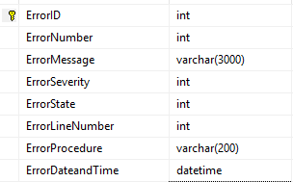

ErrorID is an Identity column and Primary Key in the ErrorLogTable,

ErrorDateandTime has a default constraint value which is getdate()in the ErrorLogTable.

You are required to create a stored procedure named usp_Dividebyzeroerror which will have TRY…CATCH block and you need to generate Divide By Zero Exception in the TRY block and then you need to insert the error information in the ErrorLogTable inside the CATCH block and after this you need to reraise the error