Dominant-Community State Types Define a Deterministic Framework for Microbiome State Representation
Pawel Gajer and Jacques Ravel
Abstract
Microbiome state labels reduce high-dimensional abundance tables to ecological summaries, but clustering-derived labels can drift (that is, the same sample can receive different state labels under different cohort or algorithmic choices) with the comparison cohort, distance metric, initialization, or number of clusters. We present dominant-community state types (dCSTs), a deterministic rank-based framework in which each sample has a dominance-lineage defined over a retained feature family, that is, a curated set of microbial features kept after prevalence and signal filtering. Under the absorb policy used here, the fitted hierarchy is deterministic for a fixed reference cohort, retained features, tie rule, and support schedule; once frozen, it provides stable assignment for aligned cohorts.
We evaluate dCSTs in two microbiome settings. In gut data, a shared-taxonomy American Gut Project dCST vocabulary transfers clinically coherent sample-level IBD structure into external cohorts, especially Halfvarson 2017, while subject-aware sensitivity bounds the portability claim. In vaginal metagenomes, full-VOG dCSTs organize Chlamydia trachomatis clearance and persistence within the labeled CT cohort, with support from feature-cap robustness and taxonomic, product-level, and KEGG-linked interpretation. Together, the two applications use dCSTs as a deterministic state vocabulary for portability analysis and local biological interpretation, not as a universal biomarker set.

Introduction
Microbiome studies often need compact state definitions—built from clustering or a subset of cohort features—that act as a unifying summary across analyses. Community-state types, enterotypes, and related coarse labels turn high-dimensional abundance tables into summaries that can be compared across samples, cohorts, and phenotypes (Ravel et al. 2011; Gajer et al. 2012; Arumugam et al. 2011). However, many widely used state labels are defined by clustering or other cohort-level partitioning procedures, so a given label may not apply consistently to samples from cohorts other than the one in which it was defined, and which samples receive that label can shift with the comparison cohort, distance metric, or partitioning rule. When the label itself drifts, portability and reproducibility become harder to interpret.
This instability matters especially when the scientific question is not only descriptive. External validation, transfer across cohorts, repeated-sample sensitivity, and biological follow-up all benefit from labels that are defined sample by sample rather than only relative to a fitted clustering solution. A state label that changes when neighboring samples are added or removed is less useful as a unit of biological comparison, and it is harder to treat as a stable interface between microbiome measurements and downstream inference. For that reason, there is value in microbiome-state labels built from a deterministic assignment rule rather than a cluster membership produced by a global optimization.
In contrast to clustering-defined CST or enterotype labels, which depend on a clustering algorithm, distance metric, initialization, and number-of-clusters parameter, an absorb-policy dCST (dominant-CST) label is determined by a multi-dimensional retained feature family, a deterministic tie rule, and a depth-specific support schedule. The two fitted hierarchies analyzed in this paper give a sense of the resulting scale (Table 1); the formal construction is given in Methods Section 2.1.
This paper focuses on that representation problem. Existing state frameworks are valuable when the goal is to discover clusters, fit mixture models, or assign samples to a curated centroid vocabulary. dCSTs address a complementary need: once a retained feature family and support policy have been specified, they define rank-based sample states that can be named, frozen, transferred, rebuilt, and tested without refitting a distance-based partition.
Table 1. Fitted dCST hierarchies analyzed in this paper. Cohort $n$ is the structure-learning cohort used to fit the absorb-policy hierarchy; outcome subset $n$ is the labeled subset on which outcome contrasts are evaluated (identical to the structure-learning cohort in gut, restricted to the labeled 604 metagenomes in CT). Retained-state counts at depth $l$ are after absorb-policy reassignment under the support schedules listed in Supplementary Table S2.
 |  |  |  | Retained dCST states
Application | Cohort $n$ | Outcome subset $n$ | Features in $F$ | $$l=1$$ | $$l=2$$ | $$l=3$$ | $$l=4$$
Gut (AGP, taxa) | 24,421 | 24,421 | 340 | 50 | 158 | 219 | 221
CT (full-VOG) | 3,602 | 604 | 509,501 | 12 | 23 | 52 | 68
Dominant-community state types (dCSTs) were developed for this purpose. A pre-policy dCST lineage is a rank-based dominance path built from a retained feature family: samples are assigned first by their dominant retained feature and then recursively refined by the next dominant retained feature within each retained parent state (the state at the previous depth from which the current refinement branches). With the absorb policy used here, small provisional child states (the candidate next-depth refinements branching off a parent state) are reassigned into nearby retained named states rather than pooled into one residual bucket. The fitted absorb-policy vocabulary is deterministic for a specified reference cohort, retained feature family, tie rule, and support schedule; after freezing, it provides stable assignment into explicit retained-feature lineages for aligned samples. The analyses that follow focus on stability, transfer, and interpretation, not universal biomarker discovery.
We evaluate dCSTs in two applications. The gut application tests portability: whether a taxonomic dCST vocabulary learned in a large shared-taxonomy American Gut Project background transfers into clinically annotated inflammatory bowel disease (IBD) cohorts, how direct transfer compares with cohort-specific rebuilt hierarchies, and how those signals behave under subject-aware sensitivity. The vaginal metagenomic Chlamydia trachomatis (CT) application tests within-cohort interpretation: whether the same construction remains useful in a different niche and feature universe, using full-VOG (VOG denotes a non-redundant gene-family group from the VIRGO2 vaginal gene catalog) gene-family states with taxonomic, product-level, and KEGG-linked follow-up. Together, the settings test whether dCSTs can provide deterministic, interpretable state construction without clustering-defined labels; cross-cohort portability under compatible conditions in gut IBD; and within-cohort metagenomic interpretation in an independent CT setting.
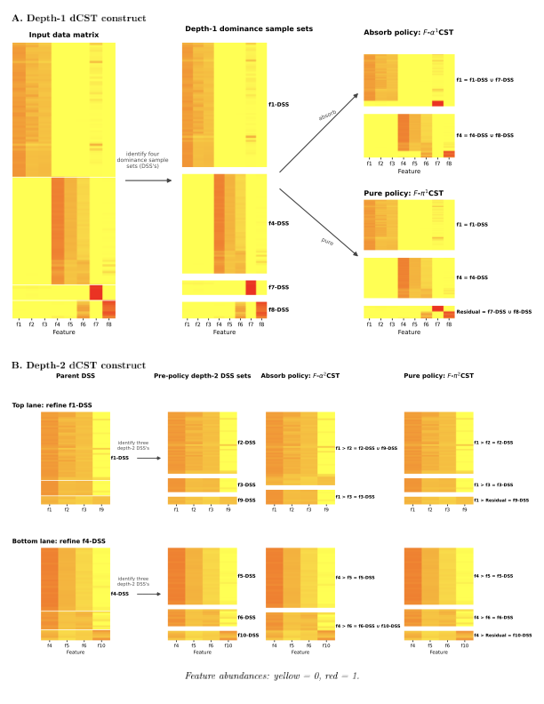
Figure 1. Conceptual dCST construction. Samples are assigned by their dominant retained feature and recursively refined by the next dominant retained feature within each retained parent state. The absorb policy reassigns low-support provisional children into retained sibling states rather than collapsing them into a residual bucket.

Methods

dCST framework
A dCST hierarchy is a recursive, rank-based partition of a sample-by-feature abundance matrix whose columns belong to a retained feature family. At depth 1, each sample is assigned to the state defined by its highest-abundance retained feature. At depth 2, each retained depth-1 state is refined by the next-highest-ranked retained feature among the samples that share that parent assignment, and deeper levels continue the same recursion (Figure 1). A depth-$l$ dCST label is therefore a dominance-lineage: an ordered path through a refinement tree, not a cluster identifier and not a phylogenetic lineage; related mathematical background is given in (Gajer and Ravel 2025).
Formally, let $X∈R_{≥0}^{n×p}$ be a microbiome abundance matrix with samples $i=1,…,n$ and retained features $F=\{f_{1},…,f_{p}\}$. A depth-1 provisional dominance sample set for feature $f$ is
$$D(f)=\{i:X_{if}=\max_{g∈F}X_{ig}\},$$
with ties resolved by the deterministic feature-dictionary-order tie rule, which selects the first retained feature in the fixed feature-dictionary order when more than one feature attains the within-sample maximum. Retained depth-1 states are the dominance sample sets whose support satisfies the depth-specific minimum $n_{1}$, after applying the low-support policy described below. For depth $l>1$, each retained parent lineage $L=(f_{a_{1}},…,f_{a_{l-1}})$ with sample set $S_{L}$ is refined within $S_{L}$. For each sample in the parent, features already used in the lineage are ignored and the next highest-abundance retained feature defines a provisional child. A retained child lineage is therefore $(f_{a_{1}},…,f_{a_{l-1}},f_{b})$, where $f_{b}$ is the next dominant retained feature among samples in $S_{L}$, again subject to the depth-specific support threshold $n_{l}$, the same deterministic feature-dictionary-order tie rule, and the low-support policy. The same recursion defines all fitted depths.
The absorb policy used in the main analyses handles low-support provisional children without creating a single residual state. At each parent, provisional children with support below $n_{l}$ are reassigned to retained sibling children within the same parent. For each reassigned sample, the target retained sibling is the retained child feature with the largest abundance in that sample among the retained sibling features; ties are resolved by the same deterministic feature-dictionary-order tie rule applied to the retained-sibling order. Thus a low-support branch is absorbed into the nearest named dominance context available at that refinement step. This preserves named dominance-lineages for downstream comparison while avoiding unstable rare labels.
Algorithm . Absorb-policy dCST hierarchy fitting and frozen transfer

Input: abundance matrix $X$; ordered retained feature family $F$; maximum depth $L_{max}$; support schedule $(n_{1},…,n_{L_{max}})$; deterministic tie rule; low-support absorb policy. Optional transfer input: aligned external matrix $X^{*}$ and a previously fitted hierarchy.
Fit:
- Initialize the root sample set $S_{∅}=\{1,…,n\}$.
- For each depth $l=1,…,L_{max}$, visit every retained parent lineage $L$ from depth $l-1$. For each sample $i∈S_{L}$, remove from eligibility the features already present in $L$, then assign $i$ to the eligible retained feature with largest $X_{if}$; ties are resolved by the fixed feature-dictionary order. These assignments define provisional child sets $P_{L,f}$.
- Mark provisional children with $|P_{L,f}|≥n_{l}$ as retained children. If no child of $L$ satisfies this condition, keep $L$ terminal.
- For each low-support provisional child $P_{L,f}$, reassign each sample $i∈P_{L,f}$ to the retained sibling $g$ of the same parent with largest $X_{ig}$; ties are resolved by the retained-target order of the fixed feature dictionary. If no retained sibling has positive abundance in sample $i$, use the same ordered fallback retained sibling for that parent.
- Store the realized lineage sets after absorption and continue recursion only from retained child lineages.
Frozen transfer: Align $X^{*}$ to the retained feature dictionary of the fitted hierarchy. For each external sample and requested nominal depth, follow the same dominance and tie rules down the frozen realized lineage sets. If the corresponding reference branch is terminal before the requested nominal depth, assign the sample to that terminal retained lineage.
Determinism and computational cost. For fixed $X$, retained feature order, tie rule, support schedule, and absorb policy, Algorithm [alg:dcst-fit-transfer] is deterministic by induction on depth. At depth 1, each sample has a unique assigned feature because the maximum is evaluated over a fixed ordered feature set with deterministic tie resolution. If all retained parent sets at depth $l-1$ are fixed, then the eligible feature set for every sample in each parent is fixed, provisional child sets are fixed, support filtering is a fixed threshold operation, and absorb reassignment uses a fixed ordered maximum over retained siblings with a deterministic fallback. Thus all retained depth-$l$ lineage sets are fixed, and the argument continues through all fitted depths. Frozen transfer is deterministic for the same reason after the reference hierarchy and feature dictionary have been fixed. A direct dense implementation has worst-case time $O(npL_{max})$ for fitting or transfer, excluding feature filtering and downstream inference, with memory dominated by the input matrix and the stored sample-to-lineage assignments; sparse implementations reduce the practical scan cost when the retained matrix is sparse.
p0.23Y Component & Operational definition
Input abundance matrix & A non-negative sample-by-feature matrix $X$. The input may be counts, proportions, or another sample-wise transformation, provided the within-sample order of retained features is preserved; examples include applying the same strictly increasing transformation to all retained feature values within a sample. CLR preserves order for strictly positive compositions, but any zero-replacement or pseudocount step must also preserve within-sample order for the same pre-policy lineage to be guaranteed.
Retained feature family & A prespecified feature set $F$, such as shared gut taxa or full VOG gene groups, after application-specific filtering. dCST labels are defined only with respect to this retained family.
Depth-wise recursion & Depth 1 assigns each sample by its dominant retained feature. Depth $l$ refines each retained depth-$(l-1)$ parent by the next highest retained feature among samples in that parent, excluding features already present in the parent lineage.
Low-support absorb policy & Provisional children below the depth-specific support threshold are reassigned to retained sibling states within the same parent, using the largest retained-sibling feature abundance in each reassigned sample. Pure-policy residual states are used only for methodological sensitivity, not for the main analyses.
Frozen transfer rule & A hierarchy learned in a reference cohort can be frozen and applied to a new cohort after aligning the new data to the retained feature dictionary. External samples are mapped to realized reference lineage sets at the requested nominal depth; terminal retained lineages remain eligible at later nominal depths when the reference branch did not split further.
Rebuilt-cohort mode & As a comparator to frozen transfer, the same feature filtering and absorb-policy workflow can be run independently within an external cohort. Rebuilt mode asks whether related dominance structure is rediscovered without requiring the reference labels themselves to transfer.
Panel-level inference & At a fitted depth, the full dCST label-by-outcome table is tested as a panel. We use Fisher-exact contingency-table tests, with Monte Carlo evaluation for large tables, and report Cramer’s V as an omnibus effect-size summary.
Label-level inference & Individual dominance-lineages are followed up against all other labels at the same depth using label-versus-rest contrasts, odds ratios, and Benjamini–Hochberg correction within the prespecified family. Bayesian estimates are used as supportive sparse-label summaries.
This construction has three useful properties. First, the pre-policy dominance lineage of a sample depends only on its within-sample rank order, so the same pre-policy lineage is recovered from counts, proportions, or any transformation that preserves the order of retained features within that sample. This includes the same strictly increasing transformation applied to all retained values in a sample, such as $log(1+x)$ or arcsine-square-root transformations. For strictly positive compositions, CLR also preserves within-sample order because it subtracts a sample-specific constant after the log transform; however, CLR requires zero handling, and a pseudocount or zero-replacement procedure preserves dCST lineages only if it preserves within-sample feature order. Transformations that rank-normalize across samples, residualize features, apply feature-specific scaling, or otherwise change within-sample order are outside this invariance claim. Second, the fitted absorb-policy hierarchy is deterministic once the reference cohort, retained feature family, tie rule, and depth-specific support schedule are fixed: it does not depend on a clustering algorithm, distance metric, initialization, or a number-of-clusters parameter. Third, after a hierarchy has been fitted and frozen, aligned external samples are assigned stably into the realized lineage sets of that hierarchy. This separates cohort-level hierarchy fitting from sample-level assignment, in contrast to clustering-defined state labels whose meaning can drift with the comparison cohort.
Because recursive refinement produces many provisional low-frequency child states, the hierarchy also requires an explicit low-frequency policy. We use the absorb policy throughout the primary analyses. Under this policy, provisional child states below the depth-specific minimum-support threshold are reassigned into retained named states rather than pooled into a single residual bucket. This keeps the hierarchy readable and supports direct comparison of named dominance-lineages across downstream analyses. Pure-policy hierarchies remain useful as methodological sensitivity analyses, but the analyses here emphasize absorb-policy dCSTs because they provide a more portable and interpretable state vocabulary.

Shared inferential framework
The two applications share the same representational core but not a single rigid downstream statistical template. In both settings we distinguish panel-level from label-level inference. At a given depth, the primary screen asks whether outcome labels are distributed non-randomly across the full dCST panel at that depth. Panel-level tests use Fisher-exact contingency-table tests, with Monte Carlo evaluation when the full table is large, and summarize panel strength with Cramer’s V. Label-level follow-up then asks whether individual dominance-lineages are enriched or depleted relative to the rest of the panel at the same depth.
Across both applications, multiplicity control is handled with the Benjamini–Hochberg procedure within the prespecified testing family relevant to the comparison being reported (Benjamini and Hochberg 1995). Odds ratios summarize direction and magnitude at the label level. Bayesian follow-up is used as a supportive estimation layer, especially for smaller or deeper states where maximum-likelihood estimates can be unstable, but it does not replace the frequentist panel-level gate. In both applications, the dCST representation is fixed first; the downstream tests then follow the cohort design and available metadata.
Reproducibility settings, including tie handling, Monte Carlo settings, Bayesian draw counts, and the BH families used in each contrast, are summarized in Supplementary Table S3.
Sensitivity to deterministic settings is summarized separately in Supplementary Table S4. The tie rule is not treated as a stochastic analysis choice: it is part of the label definition, and available top-dominance audits show that exact dominant-feature ties are absent or rare in the matrices checked. By contrast, the support schedule and retained feature family are explicit modeling choices. The gut support-schedule audit reports how $±25\%$ threshold perturbations change pre-policy lineage granularity and pre-absorb sample coverage, while the CT capped-VOG analyses evaluate robustness to nested retained-feature caps. These pre-absorb lineage counts are diagnostic quantities and are distinct from the post-absorb retained-state counts reported in Table 1. These checks do not make dCSTs parameter-free; they make the setting dependence visible and separate it from clustering algorithm, distance, initialization, and $k$ choices.
Downstream analyses differ according to study design. In gut IBD, external validation and repeated subjects make covariate adjustment and subject-aware sensitivity essential. In the CT application, label-level enrichment and Bayesian sparse-state summaries are evaluated inside a fixed outcome-labeled subset, followed by taxonomic, product, and KEGG-linked interpretation. Thus the same dCST construction can support application-specific inference without forcing the two applications into the same statistical design.

Gut application design
The gut application is designed to test portability of taxonomic dCSTs across cohorts. Structure learning begins with a local American Gut Project stool table whose amplicon-sequence-variant identifiers were mapped back to sequences from the corresponding redbiom context and then reassigned taxonomy with the same DADA2/SILVA workflow used for the external validation datasets. This shared-taxonomy step places the AGP discovery cohort and the external validation cohorts in the same label universe before dCST construction and transfer (McDonald et al. 2018; Quast et al. 2013). We prioritized this shared-feature compatibility over maximizing the number of AGP samples, because direct transfer is only interpretable when the reference and validation data are aligned to the same retained-taxon dictionary.
The resulting local AGP source table contained 24,566 samples. Samples with library size below 1,000 reads were excluded, leaving 24,421 quality-controlled samples after taxon filtering. Retained taxa were required to reach a count of at least 2 in at least 5% of the retained samples, which yielded a 340-taxon discovery matrix. The AGP hierarchy is then constructed on this filtered AGP matrix under the absorb policy, using a minimum-support schedule of 50 at depth 1 and 25 at depths 2 through 4. We use AGP primarily as a large ecological background cohort rather than as a source of diagnosis-grade IBD case definitions. The AGP phenotype fields are used only for exploratory prioritization and sensitivity analysis, not as the primary disease-association evidence.
The primary gut portability evidence comes from external cohorts with stronger diagnosis metadata. The central comparison separates structure learning from disease inference: the AGP-derived hierarchy is frozen and external samples are mapped into it under the corrected nearest-lineage-set transfer rule, while a parallel rebuilt mode asks whether related dominance structure is rediscovered when each external cohort is filtered and analyzed independently with the same absorb workflow. The validation cohorts analyzed here are Halfvarson 2017, HMP2 / IBDMDB, and Gevers 2014, because they provide the clearest clinically annotated IBD setting for testing portability. These cohorts are used to evaluate whether a fitted taxonomic state vocabulary transfers into compatible disease datasets, not to define a general IBD state classifier. Where the metadata allow it, the primary contrasts separate pooled IBD, Crohn disease, and ulcerative colitis (Halfvarson et al. 2017; Lloyd-Price et al. 2019; Gevers et al. 2014).
Because repeated sampling is a central interpretive issue in the gut data, the validation layer also includes subject-aware sensitivity analyses. Leading comparisons are re-evaluated after keeping one sample per subject, and a bootstrap resample-one-per-subject consensus is used to summarize how strongly the leading sample-level signals depend on which visit is selected. This subject-aware layer shows both what transfers and where portability weakens once longitudinal dependence is taken seriously.

CT application design
The CT application is designed as an independent application of the same framework in a different niche, feature universe, and biological question. The labeled CT outcome cohort contains 604 vaginal metagenomic samples (298 spontaneous-clearance and 306 persistence; overall persistence rate 50.7%). The clearance/persistence label is the binary endpoint supplied in the parent CT cohort metadata; detailed enrolment criteria, follow-up duration, and treatment status for that cohort are documented in the parent CT source, and the analyses here are association tests against the supplied label rather than attempts to infer or to recompute the endpoint (Edwards et al. 2019). These labeled samples are embedded in a broader 3,602-sample CT+reference cohort consisting of the 604 labeled CT metagenomes, 434 additional unlabeled CT metagenomes, and 2,564 reference vaginal metagenomes from the VIRGO2 panel. As in the gut application, the broader cohort is used for structure learning, while the outcome association tests remain restricted to the labeled subset.
Unlike the gut application, the CT analysis is gene-family centric. The primary high-resolution feature universe is a keep-filtered VIRGO2 VOG matrix. Starting from a combined VOG union table, VOGs are retained only if they are observed in at least 10 samples and at least 1% of the combined cohort, yielding the 509,501-VOG universe used for the full-resolution analysis. Smaller 25k, 50k, 100k, and 250k VOG runs are nested robustness analyses drawn from the same keep-filtered universe by variance ranking (France et al. 2026). The full-VOG hierarchy is the primary high-resolution analysis, used to ask whether CT outcome is distributed non-randomly across deeper gene-family-defined dominance-lineages and to identify the leading clearance- and persistence-associated branches. All primary CT hierarchies use the absorb policy. The capped VOG runs are used as robustness analyses for the full-VOG result, not as external replication cohorts.
The CT application then adds a biological follow-up layer. Signal-bearing dominance-lineages are tested for outcome enrichment and interpreted through consensus taxonomy, representative product annotations, and KEGG-linked contrasts (Kanehisa et al. 2023). This design evaluates whether dCSTs can organize function-linked metagenomic outcome structure in a biologically interpretable form, alongside the taxonomic state structure emphasized in the gut application.
Table [tab:application-summary] summarizes the two application designs.
p0.16 p0.38 Y Application & Evaluation design & Main interpretation
Gut (IBD) & Shared-taxonomy stool hierarchy learned in 24,421 local AGP samples, then tested by direct transfer and rebuilt-cohort analysis in external IBD cohorts. & Halfvarson 2017 retained corrected sample-level IBD, Crohn, and UC signal in both transfer and rebuilt modes; subject-aware analyses and HMP2/Gevers boundary cases show that portability is cohort-dependent.
CT (vaginal metagenomics) & Full-VOG hierarchy learned in a 3,602-sample CT+reference cohort, with outcome testing restricted to 604 labeled CT samples. & The full-VOG panel reached its strongest CT association at depth 4 ($q=0.0047$, $V=0.371$); capped VOG runs supported the panel from 50k features onward, and leading lineages were interpretable through taxonomic, product-level, and KEGG-linked follow-up.

Software
The dCST construction used here is implemented in the R package linf version 0.1.0, available under the MIT license at https://github.com/pgajer/linf. A tagged release of linf v0.1.0 archived on Zenodo is the canonical reference for this manuscript; the Zenodo DOI is listed in Data and code availability alongside the corresponding repository commit. The package provides the operations used here for sample-wise normalization, dominant-feature assignment, absorb- and pure-policy dCST construction, recursive refinement, and frozen transfer. The manuscript analyses combine these package operations with application-specific workflows for cohort filtering, rebuilt-cohort analysis, association testing, and biological follow-up. Repository locations, build identifiers, and granular implementation settings are listed in Data and code availability and Supplementary Tables S1–S4.

Results
A dCST label denotes the within-sample dominance order of retained features at the relevant depth: in the gut application, depth-2 labels such as Bacteroides dorei/Faecalibacterium prausnitzii index a retained taxonomic dominance-lineage; in the CT application, depth-$l$ labels are the analogous gene-family-defined dominance-lineages over the retained VOG dictionary (Figure 1; Table [tab:application-summary]).

Gut application: portability across cohorts
The gut application begins with a large ecological structure-learning cohort rather than a diagnosis-grade clinical cohort. In 24,421 quality-controlled AGP stool samples, the absorb dCST hierarchy contained 50 retained states at depth 1, 158 at depth 2, 219 at depth 3, and 221 at depth 4. The largest depth-1 states were centered on Bacteroides dorei, Faecalibacterium prausnitzii, and Segatella sp., and the twelve most common depth-1 states covered 79.8% of the cohort (Table 2). Exploratory AGP condition screening identified self-reported IBD as the strongest AGP phenotype field in this analysis, with Cramer’s V increasing from 0.24 at depth 1 to 0.31 at depth 4. The AGP follow-up itself remained multistate rather than collapsing to one dominant disease label, with recurrent enrichment of [Eubacterium] eligens group eligens, Alistipes sp., and deeper Bacteroides dorei-linked contexts, together with depletion of Segatella sp. We treat this AGP result as exploratory prioritization rather than as the main disease evidence because AGP does not support diagnosis-grade CD/UC subtype interpretation.
Common depth-1 AGP-derived absorb dCST landscape. These twelve states covered 79.8% of the 24,421 quality-controlled AGP stool samples and define the main depth-1 vocabulary used for direct AGP-derived transfer to external cohorts.
Rank | dCST | $$n$$ | Share (%) | Cumulative (%)
1 | Bacteroides dorei | 8,734 | 35.8 | 35.8
2 | Faecalibacterium prausnitzii | 3,703 | 15.2 | 50.9
3 | Segatella sp. | 2,557 | 10.5 | 61.4
4 | Akkermansia muciniphila | 875 | 3.6 | 65.0
5 | Agathobacter faecis | 846 | 3.5 | 68.4
6 | Bacteroides ovatus | 578 | 2.4 | 70.8
7 | Bacteroides sp. | 533 | 2.2 | 73.0
8 | Clostridia UCG-014 ord. | 514 | 2.1 | 75.1
9 | Bacteroides fragilis | 351 | 1.4 | 76.5
10 | Bifidobacterium breve | 287 | 1.2 | 77.7
11 | UCG-002 sp. | 260 | 1.1 | 78.8
12 | Bacteroides caccae | 257 | 1.1 | 79.8
The primary gut portability analysis uses external transfer into clinically richer IBD cohorts. Halfvarson 2017 provided the clearest stool-based support. After filtering, the pooled branch contained 533 stool samples from 118 subjects, of which 99 subjects contributed repeated samples. When the frozen AGP-derived hierarchy was transferred directly into this cohort, pooled IBD, Crohn disease, and ulcerative colitis all retained corrected sample-level signal. The leading transferred pattern was biologically coherent across the three disease-versus-healthy contrasts: depletion of Segatella sp., together with depletion of Akkermansia muciniphila, and enrichment of Bacteroides dorei in pooled IBD and ulcerative colitis. Rebuilt-cohort validation in Halfvarson was also positive for pooled IBD, Crohn disease, and ulcerative colitis, showing that the signal did not depend entirely on exact AGP label transfer.
Halfvarson also illustrates the limits of sample-level portability. After one-sample-per-subject sensitivity, the strong sample-level disease-versus-control transfer contrasts no longer retained $q<0.05$. Direct AGP-derived transfer attenuated most strongly, while rebuilt-cohort validation remained more resilient but still weakened. Rebuilt ulcerative colitis provided the clearest residual subject-aware pattern, with first-sample $q=0.075$, bootstrap recurrence 58.3%, and median bootstrap odds ratio 5.05, which we interpret as the strongest remaining subject-aware support rather than as a second formal BH-significant result. In practical terms, bootstrap recurrence is the proportion of subject-level resampled cohorts in which the same direction of association is recovered, so 58.3% indicates that the contrast direction reappears in roughly six out of every ten resampled cohorts; the median bootstrap odds ratio summarizes the typical effect size across those resampled cohorts. Halfvarson therefore supports sample-level portability of the representation, but the repeated-sample structure limits disease-versus-control transfer interpretation.
The most informative within-disease extension in gut was Crohn location, with ileal-involved versus colonic-only Crohn cases defined according to the Montreal classification (Satsangi et al. 2006). Relative to colonic-only Crohn disease, ileal-involved Crohn disease was marked in direct transfer by depletion of Faecalibacterium prausnitzii and in rebuilt mode by a stronger depth-2 Bacteroides dorei/Faecalibacterium prausnitzii contrast (sample-level odds ratio 0.18, 95% CI 0.074 to 0.41, $q=4.4×{10}^{-5}$). Under one-sample-per-subject sensitivity, the rebuilt depth-2 contrast remained the strongest within-disease subject-aware signal in the gut data ($q=0.042$, bootstrap recurrence 49.6%, just below the prespecified 50% working threshold for subject-level stability), whereas the corresponding AGP-transferred labels attenuated. This asymmetry suggests that within-disease structure can be present in a rebuilt cohort even when a frozen external vocabulary does not capture the same subtype boundary robustly. The rebuilt Crohn-location pattern supports a within-disease microbiome-state contrast, not only a generic disease-versus-healthy axis, and its ileal direction is consistent with prior literature on ileal Crohn disease and adherent-invasive Escherichia coli (Darfeuille-Michaud et al. 2004).
HMP2 / IBDMDB and Gevers 2014 bound the gut portability result. HMP2 was represented by a mucosal slice rather than stool-equivalent samples and did not provide broad stool-equivalent replication of the Halfvarson pattern. Gevers mapped well into the shared-taxonomy hierarchy but did not retain corrected transferred Crohn-versus-healthy labels in this pediatric new-onset setting. Exploratory medication follow-up in Gevers did not restore case-control transfer, suggesting that good mapping into the hierarchy is not sufficient for portable disease association. Within Gevers Crohn cases, however, antibiotic exposure was the clearest medication-associated split: antibiotic-positive samples showed depth-1 transferred Bacteroides depletion ($q=0.001$) and depth-2 transferred Escherichia-Shigella/Bifidobacterium enrichment ($q=0.003$), indicating that the failed Crohn-versus-healthy transfer is consistent with treatment-shaped community structure dominating the AGP-derived label space rather than with absence of disease-associated dCST signal in this cohort. Across these cohorts, the taxonomic dCST vocabulary transferred most clearly into compatible external IBD data. Transfer strength still depended on cohort comparability, sample type, and repeated-subject structure. These results support portable representation under compatible conditions, not broad validation of an IBD disease-state taxonomy (Figure 2).
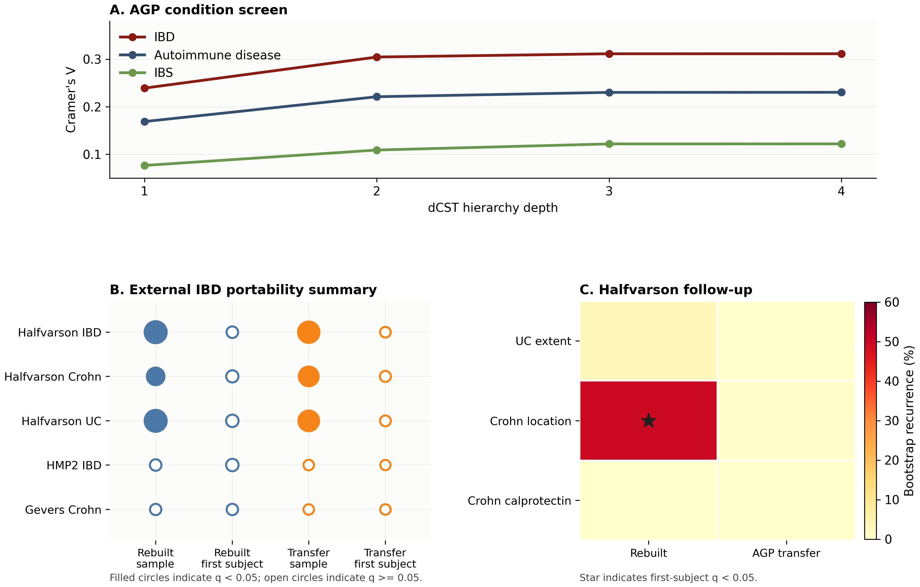
Gut portability and subject-aware sensitivity. An AGP-derived taxonomic dCST vocabulary was evaluated in external IBD cohorts. Panel A shows the exploratory AGP screen in which self-reported IBD was the strongest AGP phenotype field retained in the gut analysis. Panel B summarizes external IBD portability without label-level detail: filled circles indicate corrected $q<0.05$, open circles indicate $q≥0.05$, and marker area scales with corrected signal strength. Panel C summarizes Halfvarson within-disease follow-up by bootstrap recurrence; the star marks the rebuilt Crohn-location contrast that retained first-subject $q<0.05$. Halfvarson supports sample-level transfer and rebuilt-cohort signal, while subject-aware sensitivity and the other external cohorts bound the portability claim and do not provide broad IBD state validation. Expanded label-level details are provided in Supplementary Figure S1.

CT application: outcome-associated and function-linked states
The CT application addresses a different question from the gut transfer analysis: whether dCSTs can organize vaginal metagenomic outcome structure in a biologically interpretable form. The broad 3,602-sample CT+reference cohort provides the ecological background for learning full-VOG hierarchies, while every outcome test remains restricted to the same 604 labeled CT metagenomes.
The primary CT result comes from the full 509,501-VOG hierarchy. In this high-resolution analysis, CT outcome is distributed non-randomly across the panel at every fitted depth and reaches its strongest panel-level effect at depth 4 ($q=0.0047$, Cramer’s $V=0.371$ on the depth-4 CT-occupied panel of 58 dominance-lineages by 2 outcome columns). The signal is distributed across a gene-family-defined dCST panel rather than concentrated in a single deterministic VOG biomarker: the leading single labels do not pass label-level BH correction at the same depth (best within-depth label-level $q=0.084$ at depth 3 and $q=0.102$ at depth 4, versus panel-level $q=0.0047$). Within that panel, the most stable lineage is a clearance-oriented Lactobacillus crispatus/Lactobacillus jensenii branch that persists from depth 1 through depth 4. At depth 4, the extension VOG0146820 > VOG0741118 > VOG0741686 > VOG0741595 contains 18 CT samples, of which 15 are clearance and 3 persistence, with Bayesian odds ratio 0.20 (95% credible interval 0.05 to 0.57). The strongest full-cap persistence-oriented single lineage is a pure L. iners branch with Bayesian odds ratio 3.85 (95% credible interval 1.38 to 12.78), while a Ca. Lachnocurva vaginae-centered lineage, which carries the strongest functional follow-up signal, remains directionally persistence-associated.
The capped VOG analyses support this panel-level interpretation. Relative to the initial 25k-feature run, broader 50k, 100k, and 250k caps moved depth 4 into reproducible omnibus support, and the full 509,501-VOG fit retained the strongest depth 4 panel-level result. At the same time, the exact top-ranked sparse labels were more cap-sensitive than the overall panel signal. Concretely, the top-ranked direction-specific depth-3 label changed identity across caps: a Ca. Lachnocurva vaginae-centered persistence lead at the 25k cap was displaced by an L. iners-centered persistence lead at the 50k cap and broader, even as the panel-level signal stabilized. We therefore interpret the CT result at the panel and dominance-lineage level rather than at the single-label level. It is a robustness-supported within-cohort signal, not external replication of a fixed single-label biomarker.
The CT analysis also supports deeper biological interpretation. The stable clearance branch is functionally enriched for sugar transport, carbohydrate-processing, lactate-linked, and amino-acid transport features, consistent with a protective Lactobacillus-centered state. On the persistence-oriented side, the Ca. Lachnocurva vaginae lineage, which carries the strongest functional follow-up signal even though its label-level odds ratio is smaller than that of the L. iners branch, shows transport together with chemotaxis- and flagellar-related features. The follow-up annotations connect the outcome-associated states to both taxonomy and function at gene-family resolution.
The CT-subset comparison is consistent with the broader reference background stabilizing this signal. It also argues against a simple construction artifact. When the fixed full-VOG reference hierarchy is restricted back to the 604 labeled CT samples, the CT subset still occupies most of the reference labels through depth 4. Specifically, reference-to-CT label purities are 0.88, 0.86, 0.74, and 0.72 across depths 1–4, while CT-to-reference purities are 0.48, 0.25, 0.38, and 0.37, indicating that each broader-cohort label tends to map cleanly to one labeled-CT state, whereas each CT-only label tends to merge several broader-cohort labels. By contrast, a hierarchy learned on the CT subset alone becomes much coarser and loses omnibus support after depth 2. A broader ecological background therefore appears to sharpen the learned state vocabulary, but the biological association is still evaluated only in the outcome-labeled subset. In CT, that vocabulary is structurally stable and interpretable at the functional level (Figure 3).
The CT analysis also illustrates two features of the construction. Panel-level inference was more stable than single-label inference at high feature dimension: the omnibus depth-4 panel-level signal was reproducible from the 50k-feature cap onward, whereas the identity of the single top-ranked direction-specific label changed across caps. The absorb policy also kept named dominance-lineages at depth 4 in a 509,501-feature universe rather than collapsing low-support refinements into one residual bucket, which allowed the clearance and persistence-oriented branches to be interpreted through taxonomic, product-level, and KEGG-linked follow-up.
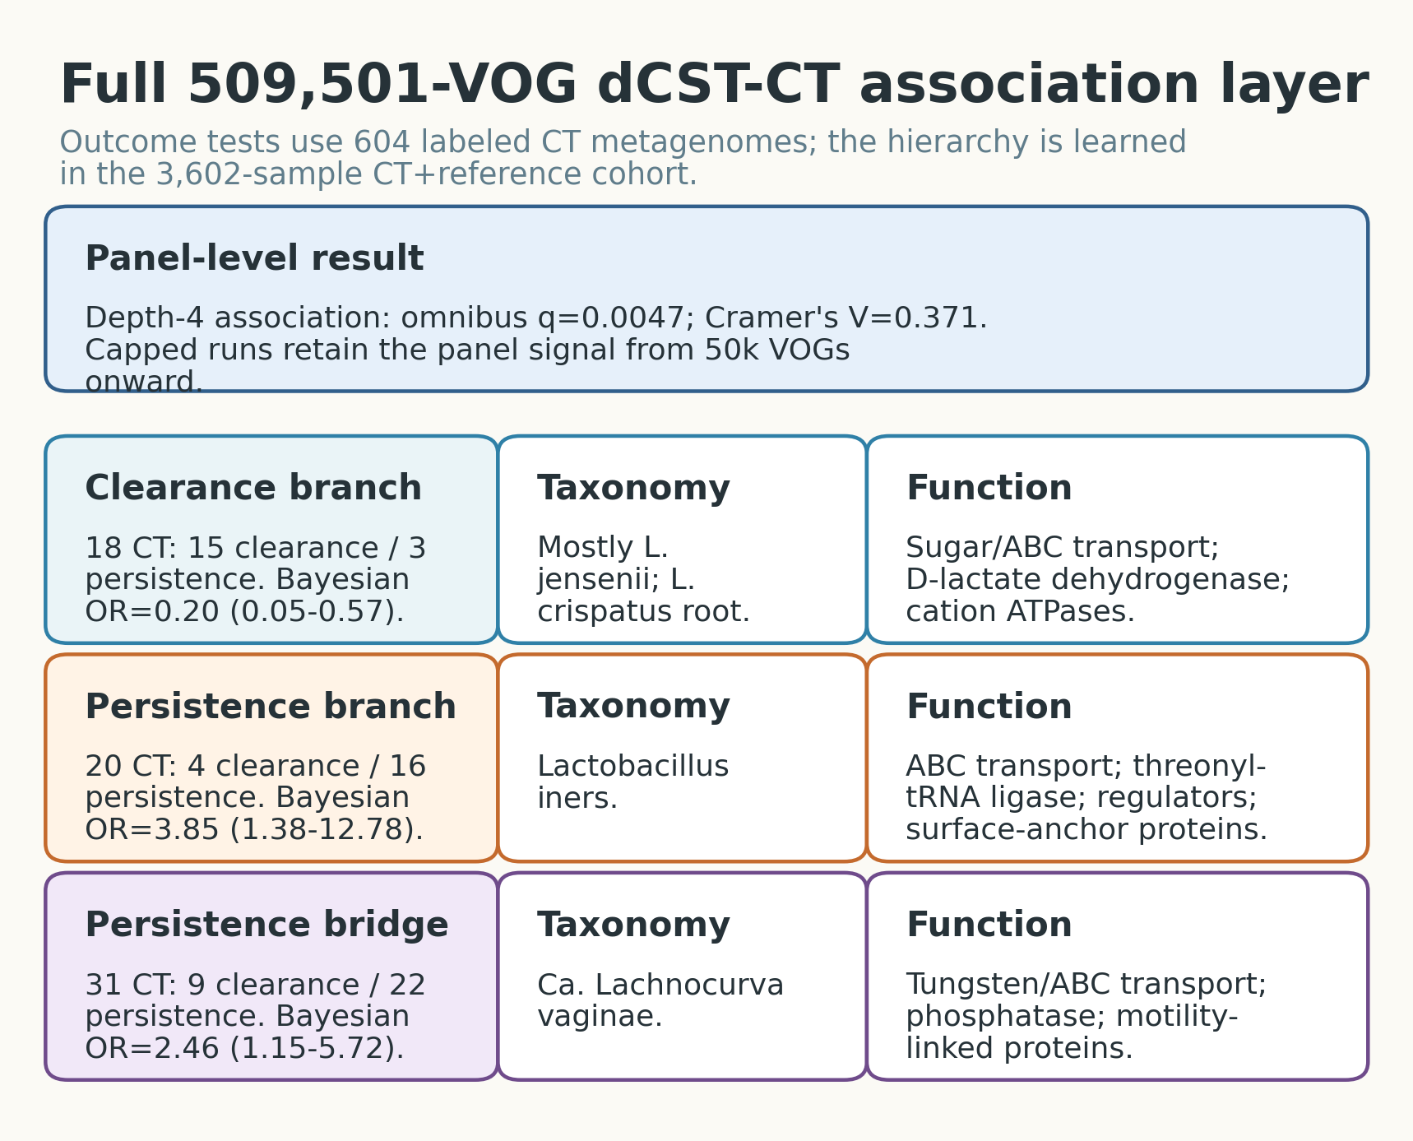
CT full-VOG outcome association and capped-feature robustness. Clearance- and persistence-associated structure was evaluated across a high-resolution gene-family dCST panel in the 604 labeled CT metagenomes. The primary result is a panel-level association in the 509,501-VOG hierarchy, with a stable clearance-oriented Lactobacillus crispatus/Lactobacillus jensenii branch and persistence-oriented L. iners and Ca. Lachnocurva vaginae structure. Capped VOG runs support the panel-level result from 50k features onward, while single-label rankings are more cap-sensitive. The CT evidence is a robustness-supported lineage-and-panel signal, not external replication of one fixed biomarker. Short branch names are used for readability: the clearance branch corresponds to VOG0146820 > VOG0741118 > VOG0741686 > VOG0741595, the L. iners persistence branch to VOG0418718 > VOG0418741 > VOG0418778, and the Ca. Lachnocurva persistence-oriented lineage (smaller label-level OR than the L. iners branch but the strongest functional follow-up signal) to VOG0675840 > VOG0676581 > VOG0675786. Visual conventions in this figure differ from those in Figure 2: the gut overview encodes corrected significance with filled vs. open circles and marker area, whereas this figure uses named branch labels to identify the leading clearance- and persistence-oriented lineages.

Cross-application synthesis
The two applications probe complementary properties of the same representation: gut tests portability of a deterministic taxonomic state vocabulary across external cohorts, while CT tests within-cohort biological interpretation across a much larger feature universe. In both settings, deeper dCST refinement exposed additional outcome structure, although the analyses used different tests and effect-size scales (Figure 4). The common point is the representation itself: deterministic assignment and interpretable dominance-lineages provide a stable substrate for microbiome state analysis, while portability, robustness, and biological interpretation remain empirical properties of each application.
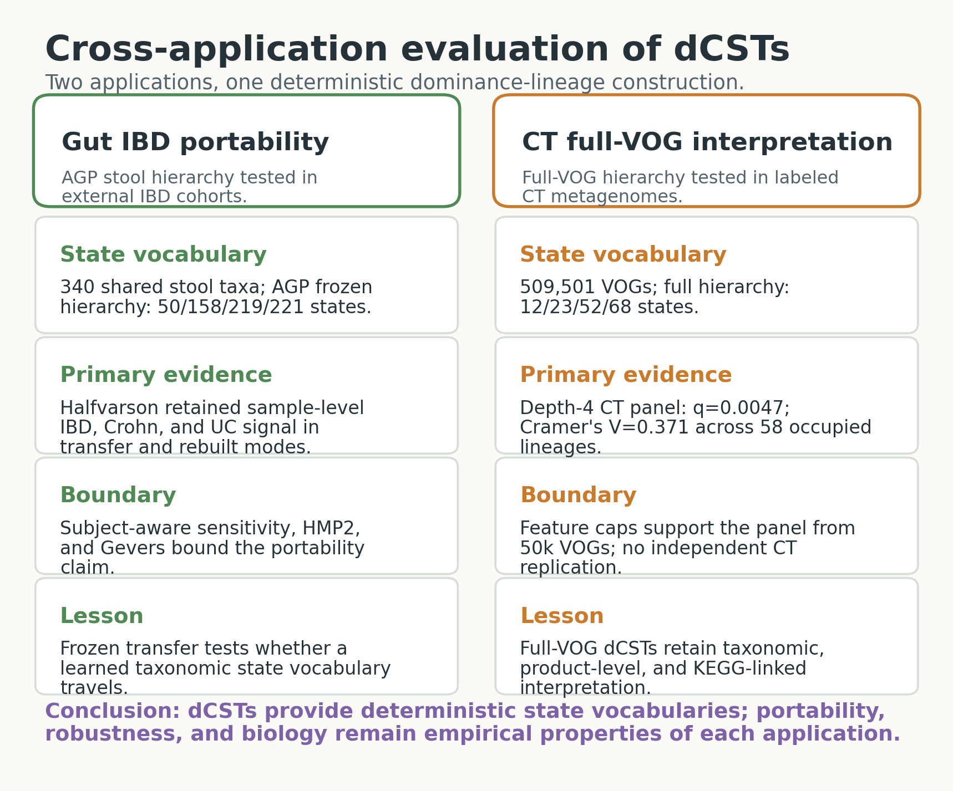
Cross-application synthesis. The gut application asks whether an AGP-derived taxonomic dCST vocabulary transfers into external IBD cohorts and how that signal changes under subject-aware sensitivity; the CT application asks whether full-VOG dCSTs organize clearance- and persistence-associated metagenomic states with taxonomic and functional follow-up. The shared claim is about the reusable representation, not a universal label set.

Discussion
We asked whether microbiome state labels can be made deterministic and interpretable without relying on clustering-defined CST or enterotype constructs (i.e., labels whose values follow a fixed assignment rule and can be read directly in terms of which microbes dominate each sample, rather than being defined by where samples land in a clustering solution). dCSTs replace cluster membership with retained-feature dominance-lineages: the pre-policy dominance order is defined sample by sample, the absorb-policy hierarchy is deterministic for a fixed reference cohort and support schedule, and frozen transfer then assigns aligned samples stably into the realized lineage sets of that hierarchy. This turns a microbiome state label from a model-fit cohort-level partition into an object that can be named, transferred, and interrogated sample by sample.
The comparison to clustering-defined CSTs is definitional, not a claim that a particular clustering algorithm performs poorly. A clustering-derived label is conditional on choices such as distance metric, clustering algorithm, initialization, and number of clusters, whereas an absorb-policy dCST label is determined by the retained feature family, deterministic tie handling, and the support schedule. The applications ask whether this deterministic representation is useful in practice; they do not benchmark one selected clustering implementation against dCSTs on a particular dataset. Supplementary Figure 6 gives a small real-data illustration using AGP gut example samples: PAM/enterotype-style labels based on Jensen–Shannon distance change when $k$ or the comparison set changes, whereas the same target samples retain identical labels when read through an already frozen depth-2 dCST assignment.
This distinction matters when comparing dCSTs with existing microbiome state frameworks. We do not claim that dCSTs replace all of them. PAM-style enterotypes summarize large gut datasets by clustering samples in a distance space (Arumugam et al. 2011; Costea et al. 2018; Knights et al. 2014); Dirichlet-multinomial mixture models provide a generative probabilistic clustering framework for count data (Holmes, Harris, and Quince 2012); and VALENCIA provides a nearest-centroid classifier for established vaginal bacterial CSTs based on 16S rRNA amplicon profiles (France et al. 2020). A direct empirical cross-tabulation between dCSTs and VALENCIA-CSTs is out of scope for this paper: VALENCIA’s centroids are trained on 16S amplicon data, whereas the CT dCST analysis is gene-family-defined on a VIRGO2 metagenomic matrix, and a head-to-head comparison would require a 16S-equivalent profile of the same 604 CT samples that does not exist in the present cohort. These approaches are useful when the scientific goal is cluster discovery, probabilistic mixture modeling, or assignment to a curated centroid vocabulary in their respective input modalities. dCSTs address a narrower representation problem: given a retained feature family and support policy, define a deterministic rank-based state label that can be frozen, transferred, rebuilt, and tested without choosing a distance-based clustering partition.
The gut application shows where that strategy worked and where it weakened. Using a shared-taxonomy AGP reference, the analysis learned a taxonomic dCST vocabulary that transferred meaningful IBD-associated structure into an independent stool cohort with stronger diagnosis metadata. The transferred signals in Halfvarson were sample-level significant and biologically coherent, and rebuilt-cohort follow-up showed that related dominance structure could be rediscovered even without freezing the AGP labels. The same results show why sample-level signal should not be confused with subject-level stability. Once repeated samples were collapsed or re-selected at the subject level, the direct disease-versus-control transfer signal weakened substantially. The gut application supports portable representation under compatible cohort conditions. It does not provide broad IBD disease-state validation or a stand-alone diagnostic test.
The CT application tests a different use case. Here, dCSTs remained informative in a different body site, with a different feature universe, and with a richer biological follow-up layer. The full-VOG hierarchy showed that CT outcome is organized across a high-resolution gene-family-defined panel. The larger capped VOG runs showed that the panel-level signal stabilizes from 50k features onward, supporting the CT result as a within-cohort robustness finding rather than external replication. The clearance-oriented Lactobacillus crispatus/Lactobacillus jensenii branch, the persistence-oriented L. iners and Ca. Lachnocurva vaginae structure, and the supporting transport, lactate, flagellar, and chemotaxis annotations together show that dCSTs can anchor biological interpretation rather than merely partition samples.
The two analyses support different claims. The gut analysis addresses external transfer and rebuilt-cohort behavior in clinically annotated IBD datasets, with explicit limits imposed by cohort mismatch and repeated-subject structure. The CT analysis addresses within-cohort gene-family-level outcome interpretation and feature-cap robustness, but does not provide an external CT replication cohort. Across both, dCSTs separate state construction from downstream inference: the same kind of fitted vocabulary can be used for transfer and rebuilt comparisons in gut, and for outcome association with functional follow-up in CT, without claiming a universal state vocabulary, a diagnostic classifier, a causal mechanism, or guaranteed portability in every microbiome setting.
Several limitations remain important. First, deterministic labels do not guarantee strong biological signal. A dCST vocabulary can be cleanly defined and still prove only modestly portable in some cohorts. Second, shared feature universes matter. The gut results improved materially once the AGP discovery cohort and the external validation cohorts were placed in a common taxonomy universe, and the CT application likewise depended on a clearly defined VOG feature family. Third, deterministic construction should not be confused with robustness to every possible setting: support schedules and retained-feature filters control the granularity of the fitted hierarchy and should be reported as part of the analysis definition. Fourth, the framework is descriptive rather than causal. A dominance-lineage associated with persistence, clearance, or disease does not by itself explain mechanism. Even in the CT application, where the follow-up layer is richer, the taxonomic, product, and KEGG results should be read as biological interpretation and hypothesis generation rather than as resolved mechanistic evidence.
The next steps are straightforward. In gut, subject-aware inference should be strengthened in cohorts with more unique controls, richer subtype metadata, and additional molecular layers. In CT, independent vaginal metagenomic cohorts are needed to test external replication of the leading VOG-defined states, and targeted mechanistic work is needed to evaluate the transport- and motility-linked annotations. More broadly, dCSTs are most useful as a stable interface between high-dimensional microbiome measurements and downstream biological interpretation, particularly when taxonomic, functional, and clinical data are analyzed together. Potential applications include cross-cohort meta-analysis standardization, pre-specified trial stratification, and longitudinal monitoring; each requires prospective validation before clinical use.

Data and code availability
The manuscript source and figure assets are maintained in the linf repository: https://github.com/pgajer/linf. This build was compiled from the local linf working tree based on commit d89c3de5281d610328dc802a210c6b5d410e5454 at unknown. The tagged linf v0.1.0 release used for the analyses in this manuscript is archived on Zenodo (DOI to be inserted at acceptance) and is the canonical citation for the package. Gut application discovery, transfer, rebuilt-cohort validation, and sensitivity analyses are maintained in the gut_microbiome repository: https://github.com/pgajer/gut_microbiome; the current build uses local analyses based on commit 811cafc07dba9a3fef5a843ef1a25e9fc4de0d70, with a tagged release archived on Zenodo (DOI to be inserted at acceptance). CT application analyses are maintained in the CT_clearance repository: https://github.com/pgajer/CT_clearance; the current CT assets are based on commit de9c7444b07251bfc64e28c2cc15771d1dec6c0e, also tagged and archived on Zenodo (DOI to be inserted at acceptance). For final submission, the Zenodo DOIs are the canonical archival references; the commit hashes are included for short-term traceability of the build. Implementation details are summarized in the supplement. Minimal reproduction requires rerunning the gut analysis workflow in gut_microbiome, the CT analysis workflow in CT_clearance, and the manuscript build workflow in linf.
The supplement also maps the conceptual dCST operations in Algorithm [alg:dcst-fit-transfer] to the corresponding linf package functions. The gut application uses the local American Gut Project shared-taxonomy stool table derived from PRJEB11419 together with the external IBD cohorts summarized in Supplementary Table S1. The CT application uses the 604-sample outcome-labeled CT cohort embedded in the 3,602-sample CT+reference cohort summarized in Supplementary Table S1. Supplementary Tables S1–S4 summarize the cohort counts, feature families, filtering thresholds, support schedules, tie handling, Monte Carlo and Bayesian settings, multiple-testing families, transfer rules, and implementation details for the analyses reported here.

Funding
Research reported in this publication was supported by grant number INV-048956 from the Gates Foundation.

Competing Interests
The authors declare no competing interests.

Acknowledgments
We thank the participants and investigators of the American Gut Project, Halfvarson 2017, HMP2 / IBDMDB, PRJEB84421, and Gevers 2014 for making the gut cohort resources available. We also thank the investigators and participants behind the CT outcome-labeled and vaginal reference resources used in the vaginal metagenomic application, and we thank the VIRGO2 project context that made the gene-family-based CT analysis possible.

Supplementary Information
Supplementary Table S1. Cohorts, sample counts, and feature families used in the dCST applications.
Analysis layer | Cohorts and sample counts | Feature family and filtering
Analysis layer | Cohorts and sample counts | Feature family and filtering
Gut AGP discovery and exploratory prioritization | Local AGP stool table derived from PRJEB11419; 24,566 source samples and 24,421 quality-controlled samples after library-size and all-zero post-filter exclusions. AGP phenotype fields were used for exploratory prioritization, not diagnosis-grade CD/UC inference. | Shared-taxonomy stool taxon matrix. ASV sequences were reassigned with the DADA2/SILVA workflow used for the external cohorts. Retained taxa required count $≥2$ in at least 5% of retained samples, yielding 340 taxa.
Gut external IBD transfer and rebuilt-cohort analysis | Main external IBD cohorts: Halfvarson 2017 stool branch, 533 samples from 118 subjects for pooled IBD versus healthy; HMP2/IBDMDB mucosal slice, 166 samples from 81 subjects; Gevers 2014 Crohn-focused stool branch, 396 samples from 363 subjects. Halfvarson subtype branches contained 200 Crohn-case samples from 49 subjects and 279 UC-case samples from 60 subjects, each compared with 54 healthy-control samples from 9 subjects. | External cohorts were aligned to the AGP retained-feature dictionary for direct transfer. Rebuilt analyses used cohort-specific filtered matrices under the same absorb workflow, allowing related dominance structure to be rediscovered without requiring exact AGP labels.
CT full-VOG hierarchy, capped robustness runs, and functional follow-up | The 3,602-sample CT+reference learning cohort contained 604 outcome-labeled CT metagenomes, 434 additional unlabeled CT metagenomes, and 2,564 VIRGO2 reference metagenomes. The 604 labeled CT samples were used for all CT outcome contrasts: 298 spontaneous-clearance and 306 persistence samples. | Primary high-resolution feature family was the keep-filtered VIRGO2 VOG matrix. From 960,439 VOGs in the combined union table, VOGs were retained if observed in at least 10 samples and at least 1% of the combined cohort, yielding 509,501 VOGs. Capped robustness runs used 25k, 50k, 100k, and 250k VOG subsets drawn from the same retained universe by variance ranking.
Cross-application synthesis and assets | The synthesis integrates the gut transfer/rebuilt analyses and CT full-VOG analyses as complementary evaluations of the dCST state vocabulary. | No new feature family is introduced for the synthesis; it reuses the gut shared-taxonomy and CT full-VOG feature families above.
Supplementary Table S2. dCST construction, testing families, and transfer rules used in the dCST applications.
Analysis layer | dCST support schedule | Testing, BH family, and transfer rule
Analysis layer | dCST support schedule | Testing, BH family, and transfer rule
Gut AGP discovery and exploratory prioritization | Absorb-policy hierarchy fit through depth 4. Minimum support: $n_{0}=50$ at depth 1; $n_{0}=25$ at depths 2–4. Pure-policy results were retained as sensitivity analyses. | AGP condition screens and label follow-up used depth-specific panel and label families with Benjamini–Hochberg correction. Bayesian follow-up was supportive; BH-adjusted frequentist results were treated as screen-level evidence. No external transfer is involved in this discovery row.
Gut external IBD transfer and rebuilt-cohort analysis | Direct transfer used the frozen AGP absorb hierarchy through depths 1–4. Rebuilt-cohort analyses used the same absorb-policy construction and depth range used for the AGP-derived hierarchy. | Direct transfer used transfer.dcsts() with the corrected nearest-lineage-set rule: external samples were compared against realized AGP lineage sets at each nominal depth, and stable terminal lineages remained assignable at later nominal depths. Rebuilt mode analyzed each external cohort independently. Label-level and panel-level tests used BH correction within the prespecified comparison/mode/depth families. Repeated-subject sensitivity retained one sample per subject and used bootstrap one-sample-per-subject recurrence for leading rows.
CT full-VOG hierarchy, capped robustness runs, and functional follow-up | Absorb-policy full-VOG and capped-VOG hierarchies fit through depth 4. Minimum support: $n_{0}=50$ at depth 1; $n_{0}=25$ at depth 2; $n_{0}=12$ at depth 3; $n_{0}=10$ at depth 4. | Primary readout was panel-level CT outcome association across the full dCST label panel at each depth, with BH correction over the prespecified depth-level family. Label-level Fisher tests and Jeffreys-prior Bayesian prevalence contrasts were supportive sparse-label summaries. Product, taxonomy, and KEGG contrasts were descriptive post hoc interpretation layers, not independent discovery gates. No independent CT replication cohort is included.
Cross-application synthesis and assets | No additional dCST hierarchy is fit for the synthesis figure. | The synthesis is descriptive and does not introduce a new testing family. It summarizes the complementary application evidence: gut portability and external transfer, and CT biological and functional interpretability.
Supplementary Table S3. Implementation-level settings for deterministic assignment, stochastic inferential summaries, and multiple-testing families.
Implementation item | Setting used in the reported analyses
Implementation item | Setting used in the reported analyses
dCST package-operation mapping | The linf package functions used for Algorithm [alg:dcst-fit-transfer] were: normalize.linf() for sample-wise normalization; linf.cells() for dominant-feature assignment; linf.csts() for depth-1 dCST construction with pure or absorb low-support policies; refine.linf.csts() and refine.linf.csts.iter() for recursive depth-wise refinement, including absorb reassignment; and transfer.dcsts() for assigning aligned samples into a frozen fitted hierarchy. Application-specific repository workflows then performed cohort filtering, rebuilt-cohort analysis, association testing, and biological follow-up.
dCST tie handling and feature identity | All primary dCST pipelines used the linf default tie.method = "first". For primary dominance assignment, tied features are resolved by the fixed feature-dictionary/column order; duplicate feature IDs or labels are made unique before assignment. Absorb reassignment uses the same ordered retained-feature dictionary restricted to the retained sibling targets for the active parent. If a low-support or all-zero sample has no positive retained-sibling value, it is assigned to the fallback retained sibling defined by that same ordered retained-target list. Observed top-feature ties were absent or rare in the reported audits, so tie handling is specified for reproducibility rather than because ties drive the analyses.
Monte Carlo Fisher settings | AGP exploratory condition-depth screening used the recorded seed $20260411$, standard Monte Carlo Fisher mode, and $B=1,000$ simulations per panel in the run reported here. CT full-VOG omnibus panels used Fisher tests with Monte Carlo evaluation and $B=50,000$ simulations per panel. The CT association scripts did not set a separate Fisher-test seed, so exact simulated $p$-value digits are reproduced from the generated result tables rather than regenerated deterministically from the script alone. dCST labels themselves do not depend on Monte Carlo draws.
Bayesian sparse-label summaries | Gut follow-up used 4,000 posterior draws for Jeffreys-prior beta-binomial prevalence contrasts, $p_{in}∼Beta(a+0.5,b+0.5)$ and $p_{out}∼Beta(c+0.5,d+0.5)$, and used arm::bayesglm binomial logistic models for adjusted label-presence summaries when complete-case support was sufficient. Available AGP covariates were host age bin, sex, and BMI. CT follow-up used the same Jeffreys-prior prevalence contrast with 4,000 draws and did not run gut-style adjusted Bayesian logistic regression. CT Bayesian follow-up runs used seeds $20260411$ and $20260415$.
Benjamini–Hochberg families | AGP exploratory phenotype screening adjusted the eligible phenotype-by-depth omnibus panels as one screen family; AGP label follow-up reported both global label-level BH values across tested labels/depths within each outcome and depth-specific BH values. Gut external transfer and rebuilt-cohort analyses adjusted label tests within each prespecified cohort/comparison/mode/depth family. CT full-VOG and capped-VOG omnibus tests adjusted across depths within each feature-cap run; label-level tests adjusted within each depth panel.
Supplementary Table S4. Setting-dependence and robustness checks for deterministic dCST construction.
Check | Summary | Interpretation
Check | Summary | Interpretation
Deterministic tie rule | All reported dCST fits used tie.method = "first": first retained feature for primary dominance and first retained target for absorb reassignment. This is part of the label definition, not a random analysis option. | The reported labels are reproducible by definition once feature order is fixed.
Observed top-feature ties | Dominant-feature ties were absent in the bundled AGP gut example (0/766 rows) and rare in the CT cap audit: 1/3602 rows in the 50k-VOG cap audit (0.03%); maximum tied top set size 2. | Tie handling is specified for exact reproducibility; available audits do not suggest that top-feature ties drive the reported examples.
Gut support-schedule perturbation | Using the existing AGP raw-lineage size audit, a $±25\%$ perturbation around the manuscript support schedule 50/25/25/25 changed pre-policy hierarchy granularity but preserved high pre-absorb sample coverage at shallow depths. These diagnostic counts are pre-absorb raw-lineage counts and should not be compared directly with the post-absorb retained-state counts in Table 1. -25%: thresholds 38/19/19/19; retained raw lineages 45/170/221/123; pre-absorb retained sample share 96.8%/83.3%/52.1%/16.8%. nominal: thresholds 50/25/25/25; retained raw lineages 40/141/154/89; pre-absorb retained sample share 96.2%/81.3%/47.4%/14.4%. +25%: thresholds 63/31/31/31; retained raw lineages 35/115/114/64; pre-absorb retained sample share 95.3%/79.0%/43.8%/12.1%. | The support schedule controls naming granularity and should be treated as an explicit modeling choice, not as a hidden clustering parameter.
CT retained-feature cap robustness | Capped VOG analyses used nested variance-ranked subsets from the same 509,501-VOG retained universe. 25k: depth-3 q=0.0414, V=0.325, depth-4 q=0.2125; 50k: depth-3 q=0.0053, V=0.360, depth-4 q=0.0074; 100k: depth-3 q=0.0042, V=0.358, depth-4 q=0.0063; 250k: depth-3 q=0.0044, V=0.357, depth-4 q=0.0053; 509,501: depth-3 q=0.0046, V=0.357, depth-4 q=0.0047. The 25k cap was shallower, whereas 50k and larger caps retained depth-4 support. | This supports the CT result as a within-cohort feature-family robustness result, not as external replication.
Gut feature-filter scope | The gut taxonomic analysis is conditional on the stated shared-taxonomy retained family: count $≥2$ in at least 5% of retained AGP samples, yielding 340 taxa. The combined manuscript does not claim robustness to all alternative gut prevalence filters. | This bounds the gut portability claim to the retained feature family used for transfer and rebuilt analyses.
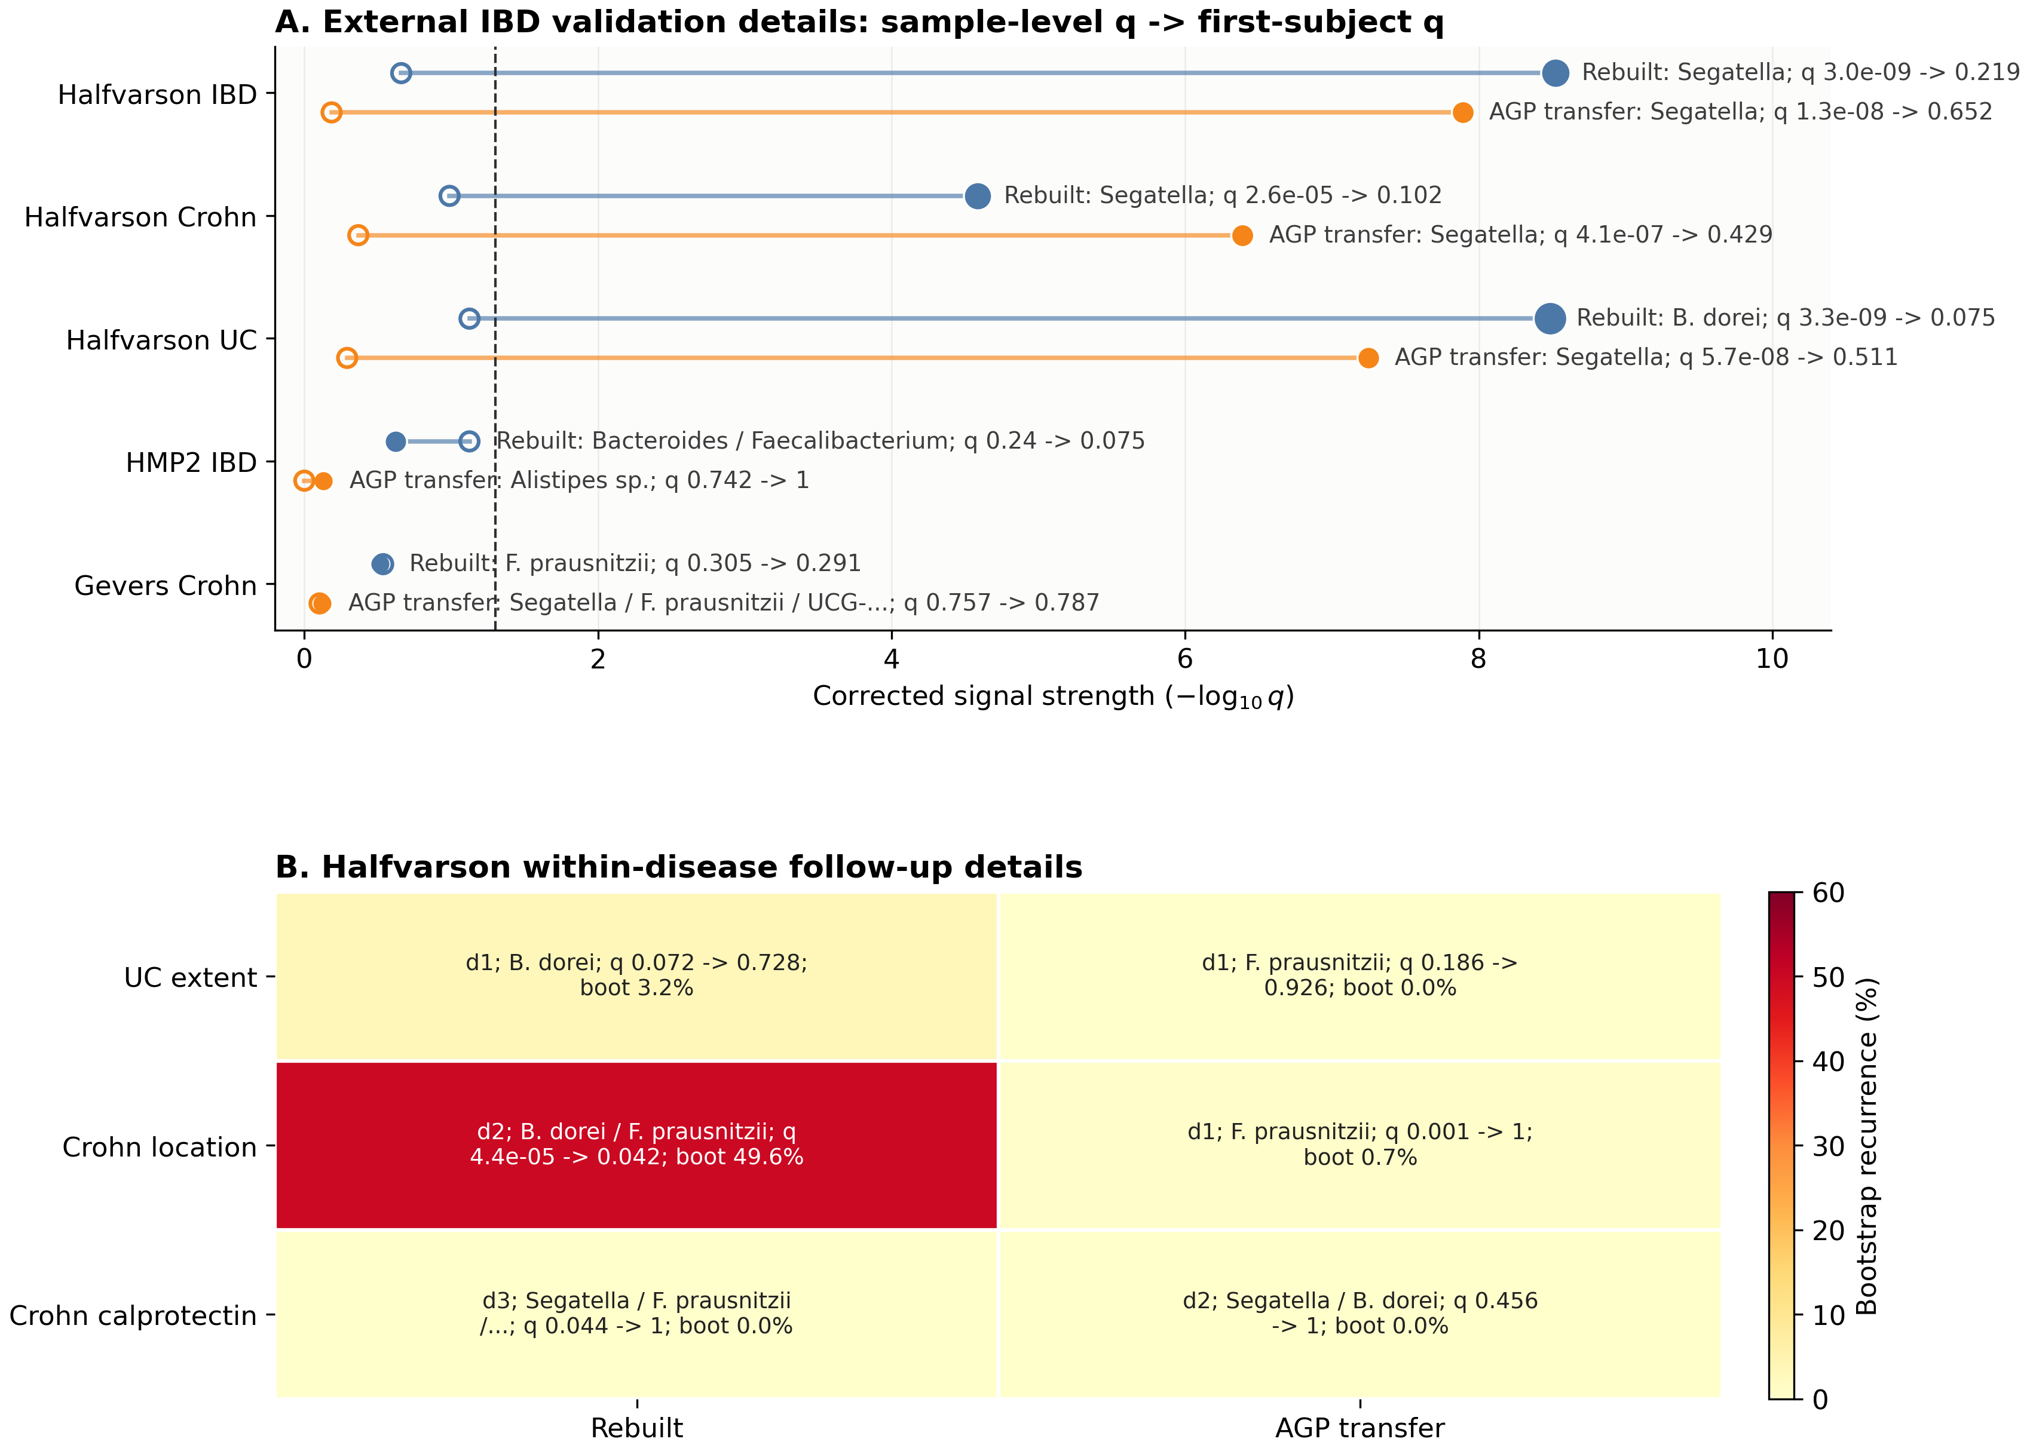
Expanded gut validation details. Panel A shows label-level details for the external IBD validation contrasts summarized in Figure 2, including sample-level corrected $q$-values and first-subject sensitivity. Panel B shows the Halfvarson within-disease follow-up details, including the leading label, hierarchy depth, sample-level corrected $q$-value, first-subject corrected $q$-value, and bootstrap recurrence.
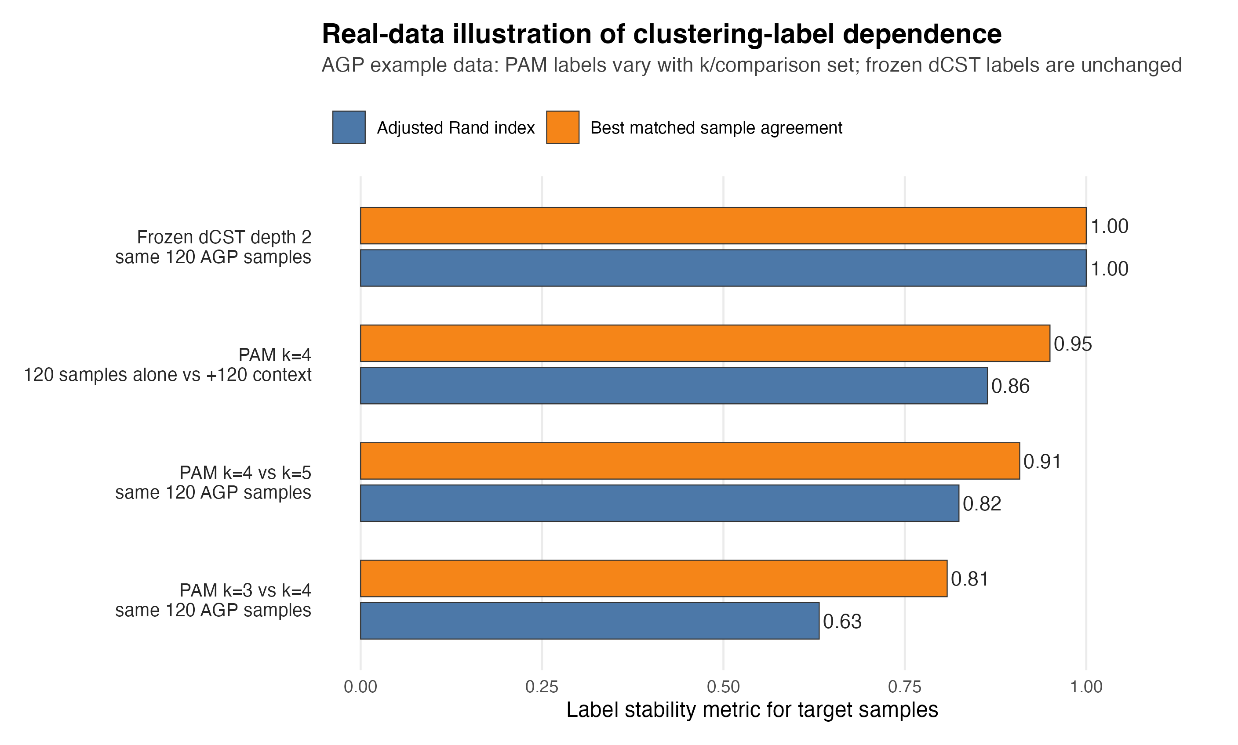
Real-data illustration of clustering-label dependence and frozen dCST assignment. The analysis used the bundled AGP gut example matrix, with 120 target samples and 120 additional context samples selected using a fixed random seed (20260428). PAM/enterotype-style clustering used Jensen–Shannon distance. Label stability is summarized by the adjusted Rand index and by the best matched sample agreement after one-to-one relabeling. The same target samples show lower stability when $k$ changes from 3 to 4 or 4 to 5, and when a $k=4$ partition is fit with or without the context samples. The frozen dCST row is not a clustering benchmark; it shows the definitional contrast that once a dCST hierarchy has been fitted and frozen, the same aligned target samples are assigned to the same realized depth-2 labels without refitting.
Arumugam, Manimozhiyan, Jeroen Raes, Eric Pelletier, et al. 2011. “Enterotypes of the Human Gut Microbiome.” Nature 473: 174–80. https://doi.org/10.1038/nature09944.
Benjamini, Yoav, and Yosef Hochberg. 1995. “Controlling the False Discovery Rate: A Practical and Powerful Approach to Multiple Testing.” Journal of the Royal Statistical Society Series B 57: 289–300. https://doi.org/10.1111/j.2517-6161.1995.tb02031.x.
Costea, Paul I., Falk Hildebrand, Manimozhiyan Arumugam, et al. 2018. “Enterotypes in the Landscape of Gut Microbial Community Composition.” Nature Microbiology 3: 8–16. https://doi.org/10.1038/s41564-017-0072-8.
Darfeuille-Michaud, Arlette, Jérôme Boudeau, Philippe Bulois, Christel Neut, Anne-Lise Glasser, Nicolas Barnich, Marie-Agnès Bringer, Alexander Swidsinski, Laurent Beaugerie, and Jean-Frédéric Colombel. 2004. “High Prevalence of Adherent-Invasive Escherichia Coli Associated with Ileal Mucosa in Crohn’s Disease.” Gastroenterology 127: 412–21. https://doi.org/10.1053/j.gastro.2004.04.061.
Edwards, Victoria L., Sarah B. Smith, Elias J. McComb, et al. 2019. “The Cervicovaginal Microbiota-Host Interaction Modulates Chlamydia trachomatis Infection.” mBio 10 (4): e01548–19. https://doi.org/10.1128/mBio.01548-19.
France, Michael T., Issac Chaudry, Lindsay Rutt, Melanie Quain, Breanna Shirtliff, Elias McComb, Amaury Maros, et al. 2026. “VIRGO2: An Enhanced Gene Catalog of the Vaginal Microbiome Provides Insights into Its Functional and Ecology Complexity.” Nature Communications 17: 449. https://doi.org/10.1038/s41467-025-67136-2.
France, Michael T., Bing Ma, Pawel Gajer, Sarah Brown, Michael S. Humphrys, Johanna B. Holm, L. Elaine Waetjen, Rebecca M. Brotman, and Jacques Ravel. 2020. “VALENCIA: A Nearest Centroid Classification Method for Vaginal Microbial Communities Based on Composition.” Microbiome 8: 166. https://doi.org/10.1186/s40168-020-00934-6.
Gajer, Pawel, Rebecca M Brotman, Guoyun Bai, et al. 2012. “Temporal Dynamics of the Human Vaginal Microbiota.” Science Translational Medicine 4: 132ra52. https://doi.org/10.1126/scitranslmed.3003605.
Gajer, Pawel, and Jacques Ravel. 2025. “A New Approach to Compositional Data Analysis Using $L^{∞}$-Normalization with Applications to Vaginal Microbiome.” arXiv Preprint arXiv:2503.21543. https://doi.org/10.48550/arXiv.2503.21543.
Gevers, Dirk, Subra Kugathasan, Lee A Denson, et al. 2014. “The Treatment-Naive Microbiome in New-Onset Crohn’s Disease.” Cell Host and Microbe 15: 382–92. https://doi.org/10.1016/j.chom.2014.02.005.
Halfvarson, Jonas, Colin J. Brislawn, Regina Lamendella, et al. 2017. “Dynamics of the Human Gut Microbiome in Inflammatory Bowel Disease.” Nature Microbiology 2: 17004.
Holmes, Ian, Keith Harris, and Christopher Quince. 2012. “Dirichlet Multinomial Mixtures: Generative Models for Microbial Metagenomics.” PLoS ONE 7 (2): e30126. https://doi.org/10.1371/journal.pone.0030126.
Kanehisa, Minoru, Miho Furumichi, Yoko Sato, Masayuki Kawashima, and Mari Ishiguro-Watanabe. 2023. “KEGG for Taxonomy-Based Analysis of Pathways and Genomes.” Nucleic Acids Research 51: D587–92. https://doi.org/10.1093/nar/gkac963.
Knights, Dan, Tonya L. Ward, Christopher E. McKinlay, Hannah Miller, Antonio Gonzalez, Daniel McDonald, and Rob Knight. 2014. “Rethinking ‘Enterotypes’.” Cell Host & Microbe 16 (4): 433–37. https://doi.org/10.1016/j.chom.2014.09.013.
Lloyd-Price, Jason, Cesar Arze, Ashwin N Ananthakrishnan, et al. 2019. “Multi-Omics of the Gut Microbial Ecosystem in Inflammatory Bowel Diseases.” Nature 569: 655–62. https://doi.org/10.1038/s41586-019-1237-9.
McDonald, Daniel, Embriette Hyde, Justine W Debelius, et al. 2018. “American Gut: An Open Platform for Citizen Science Microbiome Research.” mSystems 3: e00031–18. https://doi.org/10.1128/mSystems.00031-18.
Quast, Christian, Elmar Pruesse, Pelin Yilmaz, et al. 2013. “The SILVA Ribosomal RNA Gene Database Project: Improved Data Processing and Web-Based Tools.” Nucleic Acids Research 41: D590–96. https://doi.org/10.1093/nar/gks1219.
Ravel, Jacques, Pawel Gajer, Zaid Abdo, Gail M. Schneider, Samuel S. K. Koenig, Stacey L. McCulle, Shervin Karlebach, et al. 2011. “Vaginal Microbiome of Reproductive-Age Women.” Proceedings of the National Academy of Sciences 108 (Supplement 1): 4680–87. https://doi.org/10.1073/pnas.1002611107.
Satsangi, Jack, Mark S Silverberg, Severine Vermeire, and Jean-Frédéric Colombel. 2006. “The Montreal Classification of Inflammatory Bowel Disease: Controversies, Consensus, and Implications.” Gut 55: 749–53. https://doi.org/10.1136/gut.2005.082909.

Center for Advanced Microbiome Research and Innovation (CAMRI), Institute for Genome Sciences, Department of Microbiology and Immunology, University of Maryland School of Medicine, Baltimore, Maryland, USA.
Research reported in this publication was supported by grant number INV-048956 from the Gates Foundation.

