SOLUTION DESIGN DOCUMENT
Salesforce Customer 360 Platform
NovaPeak Financial Services

Document Version | v1.2 — Draft for Architecture Review
Date | June 2026
Prepared By | Delivery Team — SI Partner
Status | Pending Architecture Review Board Sign-off
Salesforce Products | Service Cloud, Experience Cloud, Apex, Flow, Platform Events
Data Region | ap-southeast-2 (Sydney)

This document is intended for Architecture Review Board assessment only.

1. Executive Summary
NovaPeak Financial Services is a mid-tier financial services firm operating across Australia and New Zealand, providing personal lending, wealth management, and insurance products to approximately 380,000 customers. The business has identified significant gaps in customer experience and operational efficiency stemming from fragmented customer data across four legacy systems.

This Solution Design document describes the technical architecture for a unified Salesforce Customer 360 platform that consolidates customer data, digitalises service interactions, and enables proactive customer engagement. The solution spans Service Cloud for case management, Experience Cloud for a customer self-service portal, and a real-time integration layer connecting Salesforce to the core banking system (CBS), policy management system (PMS), and customer data warehouse (CDW).

The platform is expected to serve 450 internal agents and 380,000 external customers at go-live, with peak load estimated at 2,400 concurrent portal sessions and 180 concurrent agent sessions during business hours.

1.1 Key Business Objectives
- Reduce average case handling time from 18 minutes to under 10 minutes
- Enable 24/7 self-service for top 15 customer request types
- Consolidate 4 customer data sources into a single Salesforce record
- Improve first-contact resolution from 61% to 80%
- Comply with Australian Privacy Act 1988 and APRA CPS 234 information security standards

1A. Architecture Diagrams
The following diagrams illustrate the key integration patterns, portal component architecture, and core data model for the NovaPeak Customer 360 platform. Architectural risks are annotated inline for ARB review.

Figure 1: CBS Integration Sequence
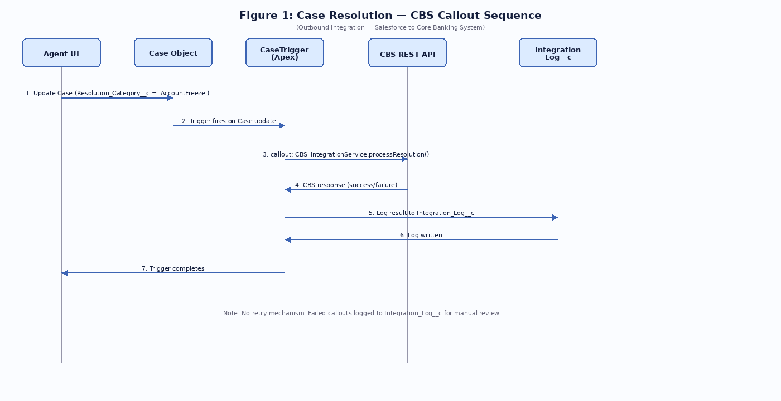
Figure 1: Synchronous CBS callout from CaseTrigger — known risk flagged for ARB review.

Figure 2: Experience Cloud Portal Component Architecture
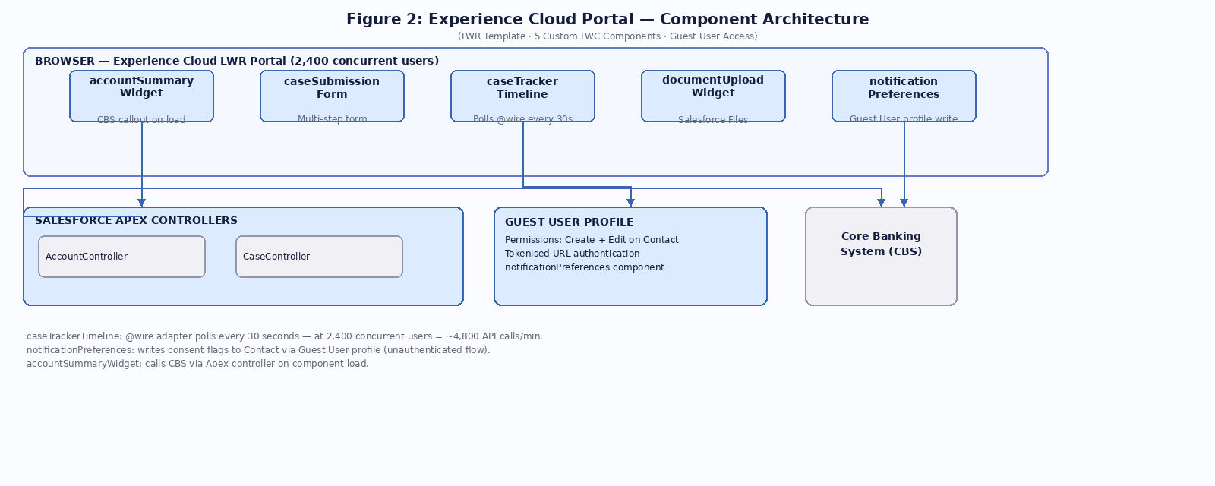
Figure 2: Portal components — Guest User write access and 30s polling anti-patterns annotated.

Figure 3: Core Data Model and Integration Architecture
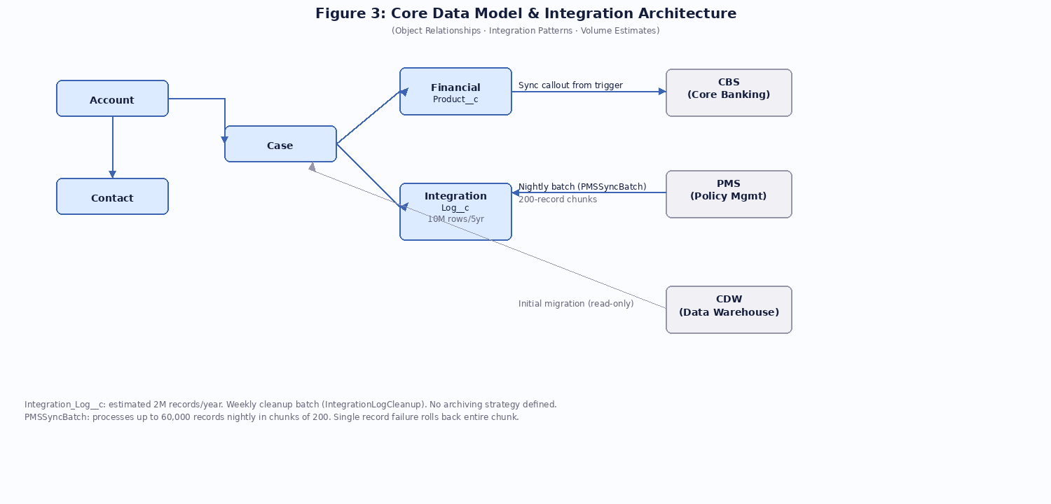
Figure 3: Object relationships and integration patterns — PMSSyncBatch and Integration_Log__c risks annotated.

2. Solution Architecture Overview
The solution is built on Salesforce Enterprise Edition with Service Cloud and Experience Cloud licenses. The architecture follows a hub-and-spoke model with Salesforce as the customer engagement hub, receiving and publishing events to downstream systems via a middleware integration layer.

2.1 Technology Stack
Layer | Technology | Purpose
CRM Platform | Salesforce Enterprise Edition | Core customer data and case management
Service Layer | Service Cloud (Voice + Digital) | Agent desktop, omni-channel routing
Self-Service Portal | Experience Cloud (LWR) | Customer portal, 24/7 self-service
Automation | Apex Triggers + Flow | Business logic and process automation
Integration | Outbound Messaging + REST API | Core banking and policy system sync
UI Components | Lightning Web Components (LWC) | Custom agent and portal UI
Analytics | Salesforce Reports & Dashboards | Operational and customer KPIs

2.2 Architecture Principles
- Salesforce-native first — no custom code where declarative tooling suffices
- API-led connectivity — all integrations via versioned REST APIs
- Event-driven where possible — reduce synchronous coupling to legacy systems
- Zero-trust security — no data leaves Salesforce without explicit authorisation
- Configuration over customisation — maximise upgradability

3. Data Model

3.1 Core Objects
The data model extends standard Salesforce objects with custom fields to accommodate NovaPeak's financial services domain requirements. No custom objects have been introduced for entities that can be modelled on standard objects.

Object | Type | Key Custom Fields
Account | Standard | NovaPeak_Customer_ID__c (External ID), Customer_Segment__c, Risk_Rating__c, AML_Status__c, Consent_Marketing__c
Contact | Standard | Date_of_Birth__c, TFN_Encrypted__c, Identity_Verified__c, Preferred_Channel__c
Case | Standard | Product_Type__c, CBS_Reference__c, SLA_Breach_Risk__c, Resolution_Category__c
Financial_Product__c | Custom | Product_Type__c, Account_Number__c, Balance__c, Status__c, Origination_System__c
Integration_Log__c | Custom | Direction__c, Payload__c, Status__c, Retry_Count__c, Error_Message__c

3.2 Data Volume Estimates
Object | Initial Load | Annual Growth | 5-Year Projection
Account | 380,000 | 25,000/yr | 505,000
Contact | 420,000 | 28,000/yr | 560,000
Case | N/A (new) | 600,000/yr | 3,000,000
Financial_Product__c | 950,000 | 60,000/yr | 1,250,000
Integration_Log__c | N/A | 2,000,000/yr | 10,000,000

3.3 Sensitive Data Handling
The following fields contain personally identifiable information (PII) or financial sensitive data subject to Australian Privacy Act obligations:
- TFN_Encrypted__c — Tax File Number stored using AES-256 encryption at rest. Decryption key managed via Salesforce Shield Platform Encryption.
- Date_of_Birth__c — PII, field-level security restricts to Identity Verification team profile only.
- Balance__c — Financial data, restricted to relationship manager and customer service profiles.
- AML_Status__c — Anti-money laundering classification, restricted to compliance team profile only.

Note: Salesforce Shield has been licensed for this engagement. Platform Encryption will be configured for the above fields prior to go-live.

4. Integration Architecture

4.1 Integration Overview
Salesforce integrates with three downstream systems: the Core Banking System (CBS), Policy Management System (PMS), and Customer Data Warehouse (CDW). All integrations are bidirectional with the exception of CDW which is read-only for initial data migration.

4.2 Core Banking System (CBS) Integration
The CBS integration is the highest volume and most latency-sensitive integration in the solution. It handles real-time balance enquiries, transaction history retrieval, and account status updates.

4.2.1 Inbound (CBS to Salesforce)
Account status changes and transaction alerts from CBS are pushed to Salesforce via Outbound Messaging from the CBS middleware layer. The Salesforce endpoint receives SOAP messages and processes them via an Apex web service handler.

The Apex handler class (CBSInboundHandler) processes each message synchronously, updating the relevant Account and Financial_Product__c records. If the account does not exist in Salesforce, the handler creates it via an upsert operation using NovaPeak_Customer_ID__c as the external ID.

Volume estimate: 15,000 to 45,000 inbound messages per day during business hours, with peaks of up to 800 messages per minute during end-of-day settlement processing.

4.2.2 Outbound (Salesforce to CBS)
When a case is resolved in Salesforce with a resolution category that requires CBS action (e.g. account freeze, limit adjustment), an Apex trigger on the Case object fires and makes a synchronous callout to the CBS REST API to action the change.

The trigger fires on Case update, checks the Resolution_Category__c field, and if it matches a CBS-actionable category, calls CBS_IntegrationService.processResolution(). The callout uses a Named Credential for authentication. Retry logic is not currently implemented — failed callouts are logged to Integration_Log__c and flagged for manual review.

4.3 Policy Management System (PMS) Integration
Policy data is synchronised from PMS to Salesforce nightly via a scheduled Apex batch job (PMSSyncBatch). The batch queries a PMS REST endpoint for policies modified in the last 24 hours and upserts corresponding Financial_Product__c records in Salesforce.

The batch job processes records in chunks of 200. Each chunk makes a single REST callout to PMS, deserialises the JSON response, and performs a bulk upsert. The job runs at 2:00 AM AEST daily.

Note: The batch job does not currently implement error partitioning — if any record in a chunk fails validation, the entire chunk is rolled back. This will be reviewed post-go-live.

4.4 Event Architecture
Platform Events are used for internal Salesforce pub/sub communication between the integration layer and business logic components. The following Platform Events have been defined:

Event | Publisher | Subscriber
CBS_AccountUpdate__e | CBSInboundHandler (Apex) | Account update Flow
Case_Escalation__e | Case trigger (Apex) | Escalation notification Flow
PMS_SyncComplete__e | PMSSyncBatch | Dashboard refresh trigger

5. Automation & Apex Design

5.1 Trigger Architecture
Apex triggers have been implemented on the following objects. The team has adopted a one-trigger-per-object pattern with a handler class responsible for dispatching logic based on trigger context.

Object | Trigger | Handler Class
Case | CaseTrigger | CaseTriggerHandler — SLA calculation, CBS callout on resolution, Platform Event publish on escalation
Account | AccountTrigger | AccountTriggerHandler — duplicate detection, segment recalculation, CDW sync flag
Financial_Product__c | FinancialProductTrigger | FinancialProductTriggerHandler — balance threshold alerts, risk rating recalculation
Contact | ContactTrigger | ContactTriggerHandler — identity verification status, consent management

5.2 Governor Limit Strategy
The solution operates at significant data volumes. The following governor limit considerations have been identified:

- SOQL queries — all triggers use collections-based queries. No SOQL inside loops.
- DML operations — handler classes accumulate records in lists and perform single DML operations per context.
- Callouts — the CBS callout from CaseTrigger is synchronous. At peak case resolution volume (estimated 120 cases/hour), this may approach per-transaction limits.
- CPU time — FinancialProductTriggerHandler includes a risk rating recalculation algorithm estimated at 800ms per 200 records. This has not been load tested at full volume.

Bulkification has been implemented for SOQL and DML. The callout pattern from within a trigger context is acknowledged as a risk and will be reviewed if volume testing reveals issues.

5.3 Scheduled & Async Jobs
Job | Type | Schedule | Est. Records
PMSSyncBatch | Batch Apex | Daily 2:00 AM | Up to 60,000
SLAMonitorScheduler | Scheduled Apex | Every 15 min | Up to 5,000 cases
IntegrationLogCleanup | Batch Apex | Weekly Sunday | Up to 500,000
CDWExportBatch | Batch Apex | Daily 4:00 AM | Up to 80,000

6. Customer Portal — Experience Cloud & LWC

6.1 Portal Overview
The customer self-service portal is built on Experience Cloud using the Lightning Web Runtime (LWR) template for performance. The portal serves authenticated customers and allows them to view account balances, submit service requests, track case status, and update contact preferences.

6.2 Custom LWC Components
Component | Purpose
accountSummaryWidget | Displays real-time balance and product summary. Calls CBS via Apex controller on load.
caseSubmissionForm | Multi-step form for submitting service requests. Validates inputs client-side before Apex submission.
caseTrackerTimeline | Visual timeline of case status. Polls for updates every 30 seconds via @wire.
documentUploadWidget | Allows customers to upload supporting documents. Stores to Salesforce Files with content delivery enabled.
notificationPreferences | Manages customer communication consent flags. Writes directly to Contact via unauthenticated guest user API.

6.3 Authentication & Guest Access
Portal authentication uses Salesforce Identity with email/password login. Multi-factor authentication (MFA) is enabled for all portal users as required by APRA CPS 234.

The notificationPreferences component allows customers to update their communication consent without full authentication, using a tokenised URL sent via email. The component uses the Experience Cloud Guest User profile to write to the Contact record. The Guest User profile has been granted Create and Edit permissions on Contact to support this flow.

7. Security Model

7.1 Profile & Permission Set Architecture
The solution uses a profile-based foundation with permission sets for additive access. Four base profiles have been defined:

- Customer Service Agent — read/write access to Case, Account, Contact. No access to Financial_Product__c balance fields.
- Relationship Manager — full read/write to all customer and product objects. Can view but not edit AML_Status__c.
- Compliance Officer — read-only to all objects. Edit access to AML_Status__c and Risk_Rating__c.
- Portal Customer (Experience Cloud) — access to own Account and Cases via sharing rules. No direct object access beyond self-service scope.

7.2 Sharing Model
The organisation-wide default (OWD) for all custom objects is Private. Account and Contact use the standard Role Hierarchy for sharing. Cases are shared via Criteria-Based Sharing Rules that grant access to the assigned agent's queue.

7.3 Data Residency
All Salesforce data is stored in the ap-southeast-2 (Sydney) region in compliance with Australian data residency requirements. No data replication to other regions has been configured. Integration payloads transiting to CBS and PMS are encrypted in transit via TLS 1.2 minimum.

8. Open Items & Design Risks
The following items are acknowledged as open or requiring Architecture Review Board guidance:

# | Item | Severity | Notes
1 | Synchronous CBS callout from Case trigger | High | Acknowledged risk. Triggers with callouts are vulnerable at high volume. No retry mechanism in place.
2 | PMSSyncBatch error partitioning absent | Medium | Entire 200-record chunk rolls back on single failure. Potential for data gaps post-go-live.
3 | Guest User write access to Contact | High | notificationPreferences component writes via Guest User. Broad Create/Edit on Contact is a security risk.
4 | caseTrackerTimeline polling pattern | Medium | 30-second polling via @wire on portal. At scale (2,400 concurrent users) this creates significant API load.
5 | CPU time on FinancialProductTrigger | Medium | Risk rating algorithm untested at full batch volume. Potential CPU governor limit breach.
6 | Integration_Log__c volume | Low | 2M records/year projected. No archiving strategy defined. Will hit storage limits within 3 years.

9. Appendix — Glossary
Term | Definition
CBS | Core Banking System — NovaPeak's primary account and transaction ledger
PMS | Policy Management System — insurance and wealth management product records
CDW | Customer Data Warehouse — historical analytics store, read-only source for initial data load
AML | Anti-Money Laundering — regulatory classification per AUSTRAC requirements
APRA CPS 234 | Australian Prudential Regulation Authority standard for information security
LWR | Lightning Web Runtime — modern Experience Cloud template for performance
OWD | Organisation-Wide Default — baseline sharing setting for Salesforce objects

