Creating the scheduelp schema in your MySQL instance

- There is a file called “scheduelpdb.sql” under docs folder in github: https://github.com/pganesan/schedu-elp/blob/master/docs/scheduelpdb.sql. Copy this file to your C:\ drive directly (not inside any folder)
- Open MySQL workbench
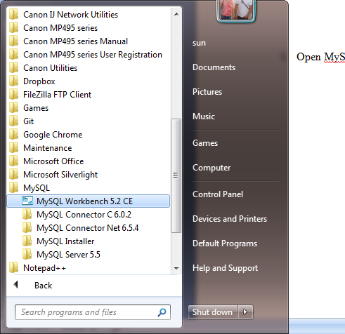

- Connect to your local instance
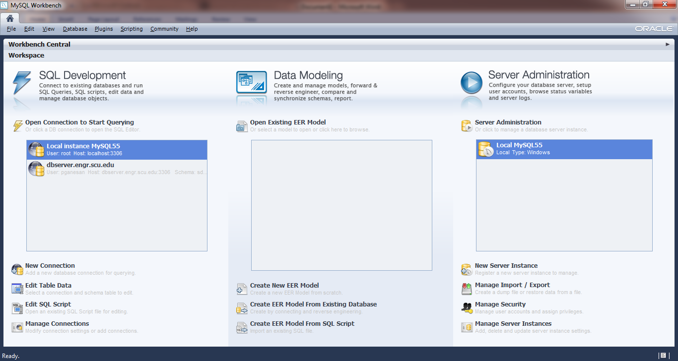
- Create new schema
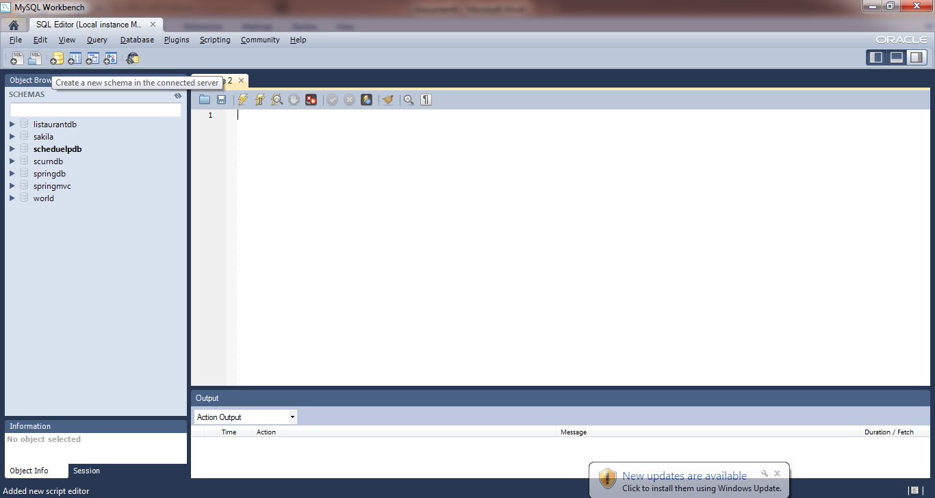
Click the 3rd icon that looks like a cylinder
- Enter scheduelpdb for schema name and click Apply button
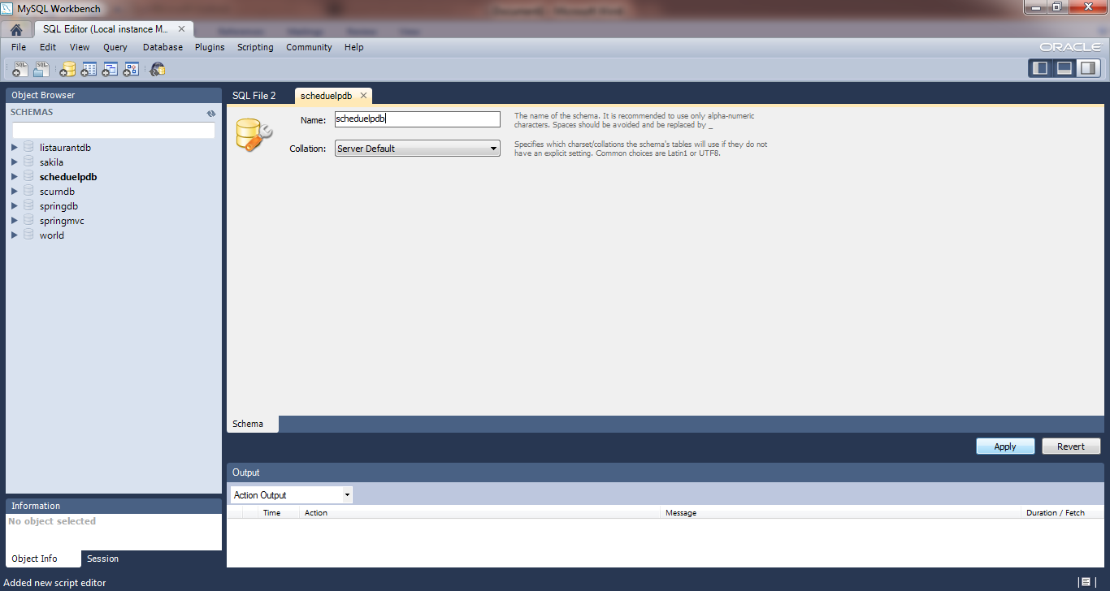
- Now open command window (or terminal in case of Mac) and type the following (where ‘root’ is the value of the root username and ‘password’ is the value of the root password for your local MySQL instance).
mysql -u root -ppassword scheduelpdb < C:\scheduelpdb.sql
NOTE that there is no space between –p option and the value of root password.

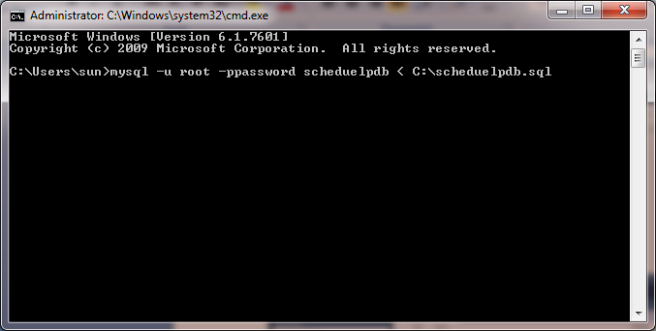
- Go back to workbench and refresh scheduelp db schema. You should see all the tables for our database.
