ALWAYS EXECUTE GIT COMMANDS FROM schedu-elp FOLDER IN YOUR WORKSPACE. When working with MSWord documents, ensure that you close the document before you perform git add. Otherwise the temporary word file also gets added for git index.

GIT PULL
Before you begin to edit any source code/document in your working copy, the first thing you should do is pull the latest version of all code/documents from the github repository. This will ensure that there are no merge conflicts when you push your changes later to the github repository.
$ git pull origin master
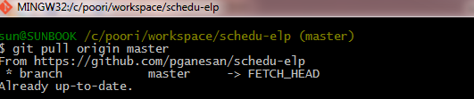

GIT ADD
Whenever you add a new file, edit an existing file, delete a file – you should do a git add from schedu-elp folder to add the change to the git index. This does not add/commit change to the github repository.
$ git add –A
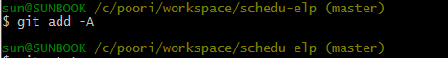

GIT STATUS
Any time you want to check the status of your changes to your working copy, that have been added to the git index but not yet committed, you can do a git status. It is a good practice to check the status after doing git adds.
$ git status
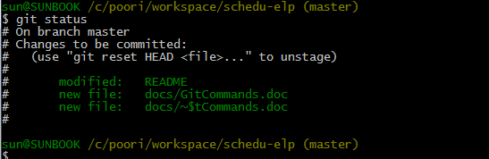

GIT COMMIT
After performing git add, you have to do git commit. Every commit requires that you provide a meaningful commit message in double quotes. With a message, the commit operation aborts,
To commit all changes,
$ git commit –m “commit message”
To commit a specific file X.doc under schedu-elp/docs folder
$ git commit docs/X.doc –m “commit message”
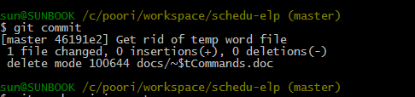

GIT PUSH
After performing git commit, you now have to push your commits to the github repository.
To push all changes,
$ git push origin master
There is no command to push a single file so use this command at last when you are done with all changes in your working copy.
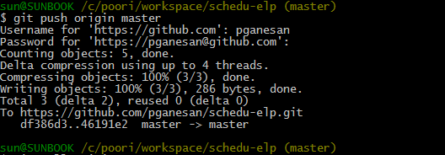

Reverting changes - GIT CHECKOUT
After you change a file(s) you might want to revert the changes.
To revert a change in docs/X.doc before you do git add,
$ git checkout docs/X.doc

To revert a change in docs/X.doc after you do git add and before you do git commit (you should execute 2 commands in the below order)
$ git reset HEAD docs/X.doc
$ git checkout docs/X.doc

To revert a change in docs/X.doc after you have added and committed,
$ git reset --hard origin/master
Note that the above reset does not specify a filename. This reset touches all files and not just X.doc. No command is available to just undo commit of single file. So use this command with caution.

After reverting changes, run git status to verify that the changes have been reverted.

