COEN 285 - Software Engineering – Fall 2012

Team Gamma
Poornima Ganesan (pganesan@scu.edu)
Sheila Castillo (scastillo@scu.edu)
Shradha Cripe (scripe@scu.edu)

9 November 2012

Schedu-elp
SCU Student Academic Planner
Deliverable #3 – Sprint 1 Progress



Table of Contents
1 Estimation of User Stories 2
2 Sprint 1 3
2.1 Sprint Goal 3
2.2 Sprint Duration 3
2.3 Sprint Backlog 3
2.4 Burn-down Chart 4
3 Sprint Implementation 5
3.1 Design Decisions 5
3.2 Spike Solution 5
3.3 Challenges 6
3.3.1 Environmental 6
3.3.2 Technical 6
3.3.3 Process 7

Table of Figures
Figure 1 - Story Point Estimate 3
Figure 2 - User stories in Sprint 1 4
Figure 3 - Sprint 1 Burn-down Chart 4
Figure 4 - Spike Solution 5
Figure 5 - Application Screenshot for Spike 6

Estimation of User Stories
Below is a table showing the user stories in Schedu-elp product backlog with their story point estimation:
User Stories |  | Story Point  Estimate
Title | Description | Story Point  Estimate
US001 - Access the Schedu-elp Home Page | As a SCU student, I want to view the Schedu-elp Home Page so that I can read an overview of the Schedu-elp system. | 5
US002 – Sign-in to Schedu-elp | As a SCU student, I want to be able to sign in to the Schedu-elp system so that I can create and access my profile. | 3(5?)
US003 – Sign-out of Schedu-elp | As a SCU student, I want to be able to signout of the Schedu-elp system so that I can end my session. | 2
US004 – Access Link to Advertisers’ Websites | As a SCU student, I want to access a displayed Schedu-elp advertiser’s website so that I can learn more about the services offered by an advertiser. | 3
US005 – Search Courses by Course Name | As a SCU student, I want to search for available courses by inputting the course name so that I can view the details of that course. | 8
US006 – Search Courses by Course Number | As a SCU student, I want to search for available courses by inputting the course number so that I can view the details of that course. | 3
US007 – Search Courses by Day of Week and/or Time of Day | As a SCU student, I want to search for available courses by inputting preferred scheduling days and times so that I can find a class that is scheduled during my available times. | 3
US008 – Search Courses by Pre-requisite | As a SCU student I want to search for available courses that would be succeeding a pre-requisite so that I can maximize use of the pre-requisite courses. | 3
US009 – Search Courses by Name of Professor | As a SCU student, I want to search for courses by Professor name so that I can tailor my coursework to professors who are in the same field of interest or who’s teaching styles I enjoy | 3
US010 – Search Courses by Program Special Requirement | As a SCU student, I want to search for courses that meet a special Program requirement so that I can ensure that all degree requirements are met | 3
US011 – Add a Course to Program of Studies | As a SCU student, I want to be able to add a course to my Program of Studies so that I can create a plan for my graduate studies. | 3
US012 – Remove a Course from Program of Studies | As a SCU student, I want to be able to remove a course from my Program of Studies so that I can remove a previously added course. | 2
US013 – View Program of Studies | As a SCU student, I want to view my Program of Studies online so that I can verify the courses that I added to my graduate program. | 13(8?)
US014 – Print Program of Studies | As a SCU student, I want to be able to print my Program of Studies form so that I can have a hardcopy of the form. | 5
US015 – View all Reviews for a Course | As a SCU student, I want to view all reviews for a specific course so that I can read the course reviews and decide whether to add the course to my Program of Studies or not. | 8
US016 – Post a Course Review | As a SCU student, I want to be able to post a review for a specific course so that I can share my course experience with fellow students. | 5
US017 – Access Contact Information | As a SCU student, I want to easily access Schedu-elp contact information so that I can communicate with an administrator if I have questions about the Schedu-elp system | 1
US018 – Access Online Help/FAQ | As a SCU student, I want to view a list of frequently asked questions so that I can see if my question on the Schedu-elp system has previously been answered. | 2
Figure 1 - Story Point Estimates

Sprint 1

Sprint Goal
Sprint 1 will establish the main web interface and database system for the Schedu-elp system, allowing the user to access the Home Page, sign-in and sign-out of the Schedu-elp system, search courses by Course Name and Course Number, and also access the Contact Information. Sprint 1 will willl establish an initial working version of the Schedu-elp system.

Sprint Duration
Sprint 1 spans for 3 weeks starting from 10/19/2012 to 11/8/2012.

Sprint Backlog
Sprint 1 user stories, along with their respective task lists, are presented below.

User Stories | Tasks | Owner | Estimate  (in hrs)
US001 – Access Schedu-elp Homepage | Create user interface for Schedu-elp home page | Shradha | 3
 | Add overview of Schedu-elp system in home page | Shradha | 1
US002 – Sign-in to Schedu-elp | Create user interface to allow for sign in | Sheila | 2
 | Create student class to contain student information | Sheila | 1
 | Create student table in Database Schema to store student account information | Sheila | 2
 | Create login service in middle tier | Sheila | 2
 | Create SQL queries to verify student login | Sheila | 2
US003 – Sign-out of Schedu-elp | Create user interface to allow for sign out | Sheila | 2
 | Add session cleanup in login service | Sheila | 2
US005 – Search Courses by Course Name | Create user interface to allow for search | Poornima | 6
 | Create course class to contain basic course information | Poornima | 1
 | Create course table in Database Schema to store basic course details | Poornima | 2
 | Create search service in middle tier | Poornima | 3
 | Create SQL queries to search by Course Name | Poornima | 2
US006 – Search Courses by Course Number | Modify user interface to allow for search by Course Number | Poornima | 1
 | Modify search service in middle tier to allow for search by Course Number | Poornima | 2
 | Create SQL queries to search by Course Number | Poornima | 2
US017 – Access Contact Information | Create User Interface to access Contact Information | Shradha | 1
Figure 2 – Sprint 1 User Stories

Burn-down Chart
Sprint 1 Burn Down Chart, along with projected and actual hours are shown below. Please refer to TeamGamma_scrum.xls for the day-to-day progress and burn down on each task.
Beginning of day | Planned remaining  (hrs) | Actual remaining (hrs)
1 | 37.00 | 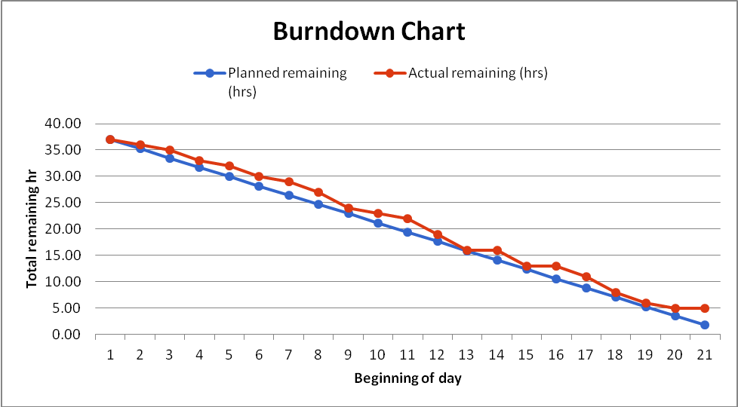  37.00  Figure 3 - Sprint 1 Burn-down Chart
2 | 35.24 | 36.00
3 | 33.48 | 35.00
4 | 31.71 | 33.00
5 | 29.95 | 32.00
6 | 28.19 | 30.00
7 | 26.43 | 29.00
8 | 24.67 | 27.00
9 | 22.90 | 24.00
10 | 21.14 | 23.00
11 | 19.38 | 22.00
12 | 17.62 | 19.00
13 | 15.86 | 16.00
14 | 14.10 | 16.00
15 | 12.33 | 13.00
16 | 10.57 | 13.00
17 | 8.81 | 11.00
18 | 7.05 | 8.00
19 | 5.29 | 6.00
20 | 3.52 | 5.00
21 | 1.76 | 5.00

Sprint Implementation

Design Decisions
Schedu-elp was designed as an online web application that can be accessed by visiting a URL in client’s browser. The design was chosen as a web based application to serve the comfort and accessibility needs of the SCU student base. The design methodology presented in Project Proposal (Deliverable #1) created the following demands for the development of Schedu-elp application.
- Need for an application server – Apache Tomcat (ver 6.0.35), an open source implementation for deploying J2EE web applications, was chosen by the team.
- Need for a database - Popular open source DB, MySQL, was chosen to store Schedu-elp information.
- Need for J2EE web technologies for application development – A unanimous decision was made to use MVC layered architecture for Schedu-elp after performing a feasibility test using prototyping (spike solution).

Spike Solution
The objectives of prototyping were established to solve two primary concerns:
- Feasibility Test – Ensure that the proposed design works thereby create a framework (skeleton) for implementation.
- Group user stories and create a site structure/layout – As the development of user stories involved multiple sprints, we wanted to come up with a site structure that would categorize user stories according to user workflow.
The spike involved the following steps:
- Create a sample home page for the application.
- Create a tabbed layout to categorize Schedu-elp functionality. (accomplishes objective #2).
- Create a controller class for home page.
- Create a single row,single column table in MySQL database containing a string.
- Fetch the string from the database and display on home page (accomplishes objective #1).
The conceptual diagram is presented below:
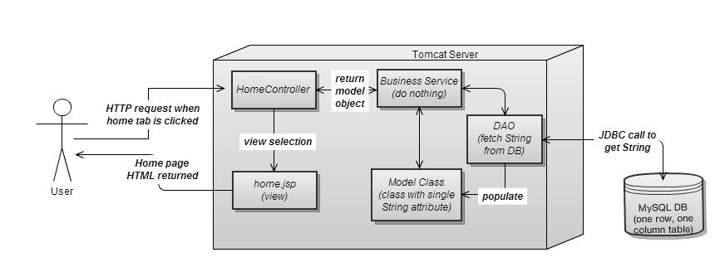
Figure 4 - Spike Solution
Below is a screenshot of the prototype.

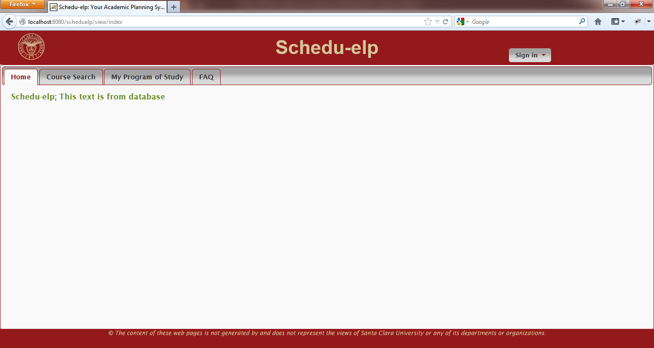
Figure 5 - Application Screenshot for Spike

Challenges
In this section, we discuss the challenges faced by Team_Gamma during Sprint 1. The challenges have been categorized as Environmental, Technical and Process-related.

Environmental
Include software installation, environment setup issues here – tomcat, MySQL, eclipse etc.
Team Member | Challenge | Solution
Poornima | Poornima wanted to host the Schedu-elp database on the SCU design center (host: dbserver.engr.scu.edu) so that every team member just needed to have only a SQL client to connect to the remote DB. | Though Poornima was able to host the DB in the SCU database server, none of the team members could connect to the remote server from local machines. The requests kept timing out. Due to time constraint, the team decided to work with local DB instances for Sprint 1.
Shradha | Through the background research that Poornima did, Shradha was advised that a windows machine would be the simplest installation environment. She tried to get a virtual PC environment on her Mac installed via VMware Fusion. | Shradha was able to acquire VMware Fusion but was not able to access Windows OS software within her cost budget for this assignment. There she continued with installation on her Mac which involved some extra time in installation and problem-solvin.

Technical
List technical issues here – skills, learning etc.
Team Member | Challenge | Solution
Poornima | Hibernate for Object-Relational Mapping | During the creation of spike, the team wanted to use an ORM library like hibernate to make the JDBC calls. But this was making the code complex and hard to read. Poornima felt it was much easier for the team if they used straight JDBC calls from DAO. So the decision was made not to go for hibernate.
Shradha | Shradha had not developed code nearly 8 years so many of the tools were new to her as was refreshing her programming skills. | Poornima outlined the tools needed, along with providing links on instructions for installation. Poornima then served as the installation/implementation software lead in managing installation and troubleshooting issues for both Shradha and Sheila.  Poornima also served the software manager in explaining the development framework for implementation.
All | The team wanted to categorize and group user stories so that we create a site structure/layout that will enable the members to develop independently. | The team used a tabbed view for the site structure. The team later learned in class that this is a UI design pattern called ‘Card Stack’.

Process
If you had a specific process related issue, you can list it here.

Team Member | Challenge | Solution
All | Configuration Management was becoming a high risk. Managing versions of Deliverable #1 was very difficult. We wanted to get this resolved before we start sprint 1 implementation. | Team took the time to learn how to install and use github before beginning to write code. The framework developed using the spike solution was immediatedly committed to github repository so that all members worked from the repository during Sprint 1
All | We wanted to use a simple and efficient way to track Sprint 1 progress. Because of varying schedules, we wanted to be sure that if we were to skip the daily standup meeting on a few days, we would still be able track each other’s status. | We created a scrum_tracking excel sheet where each member could go and update the hours she burnt on a daily basis. The burn-down chart was linked to this data so that everybody had a visual representation of data and knew how Sprint 1 was progressing.
All | How to share knowledge or solutions to common problems? | To increase productivity, if a team member faced an issue, she would first email the other members to see if they have encountered and resolved it. This approach worked better than searching the internet for a solution!  Additionally the team had standing “tag-ups” before class to resolve issues they were encountering.

