**COEN 285 - Software Engineering – Fall 2012**

**Team Gamma**

Poornima Ganesan ([pganesan@scu.edu](mailto:pganesan@scu.edu))

Sheila Castillo ([scastillo@scu.edu](mailto:scastillo@scu.edu))

Shradha Cripe ([scripe@scu.edu](mailto:scripe@scu.edu))

29 September 2012

**Schedu-elp**

**SCU Student Academic Planner**

**Deliverable #1**



Table of Contents

1 Project Overview 2

1.1 Project Description 2

1.2 Scope 2

1.3 Stakeholders 3

2 Business Case for the Project 3

2.1 Economic Benefit 3

2.2 Existing Tools 3

3 Design Methodology 4

4 Team Skills, Technical and Domain Knowledge 4

5 Key Success Contributors 5

**Table of Figures**

Figure 1: Venn Diagram of Key Issues 2

Figure 2: High Level Architecture 4

Figure 3: Skill Set Matrix 5

Figure 4: Key Success Contributors 5

# Project Overview

## Project Description

The Schedu-elp concept was developed out of recognition that there was not a single Santa Clara University (SCU) resource to help the working graduate community. Graduate students often have jobs, families, or a combination of both. In such cases, they need further insight to plan courses for the quarter. Additionally, the majority of graduate students are truly interested in the experience and education from a course in order to increase their career potential. They are not looking for an “easy A”, rather looking for a skill set that will serve them for their future post-graduation. Additionally, graduate students see a need to expedite their degree completion. Schedu-elp will help streamline their course selection process by providing course options which accommodate prerequisite requirements per course plan.

As Figure 1 shows, Schedu-elp solves the key issues affected by students juggling multiple priorities.

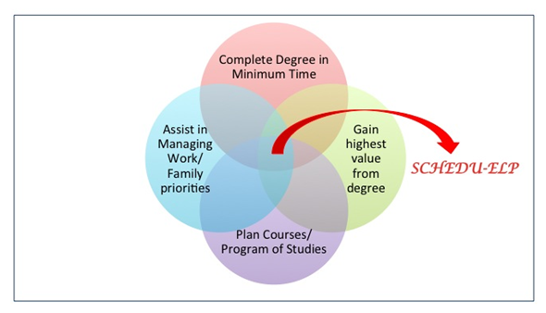

Figure 1: Venn Diagram of Key Issues

While Schedu-elp will ultimately be rolled out to the entire campus community, undergraduate and graduate students in all SCU departments, we have chosen Graduate Engineering students as the primary phase beta testers.

## Scope

Schedu-elp is designed to serve multiple problem areas with one easy to use tool. The Schedu-elp tool allows for the users to access course overviews and search on a subset of content to aid with planning purposes. The course overview will include the items below. Additionally, some fields are searchable criteria, as is needed for academic planning needs of SCU graduate students:

* + Materials for class (text books, hand outs, etc.)*
    - Assists in Financial Planning
  + Pre-requisite Courses*
    - Searching on a Pre-requisite course show a list of subsequent courses that you can take once the Pre-requisite is met.
  + Course Availability*
    - Days of Week and Time of Day
      * Meets Childcare demands
      * Allows to schedule around key work meetings
  + Nature of work (Group or Individual)
    - May be a necessity in balancing uncertain work or family demands
  + Momentum of Workload (Stable vs. Peaks/Valleys)
  + Reviews on course/professor
    - Not tailored for Easiness
    - Focused on interactive style of professor
    - Focused on skills gained from course
  + Participation
    - Is class presence required; may present conflict for those who travel frequently
  + Meets special Requirements*
    - Issues in Professional Practice
    - Science, Technology, Society (STS) Minor

*\* Searchable fields.*

## Stakeholders

* Team Gamma: Developers and Management team for Schedu-elp
* University Student: Customer, End Users of Schedu-elp
* SCU Program of Study departments: Help provide valuable input for Schedu-elp courses; Act as administrators to ensure product maintains integrity in postings. SCU Grad Engineering Department for Beta phase.
* SCU Financing Department: Also a Customer, the “buyer” of the system, providing financial payment for Schedu-elp
* Advertisers: Campus Services: Bookstore, Childcare, and Restaurants.

# Business Case for the Project

## Economic Benefit

Schedu-elp will provide students the economic benefit of strategic planning for their Program of Studies. This will save the students unnecessary drop fees which are $50 per course. Additionally, if a student finishes their number of units without satisfying all credentials, taking another course would cost a minimum of $1635, including quarterly fees. As “Time is Money” and graduate students do not have a lot of extra time, this tool helps with scheduling which does provide a non-monetary value of increased time with work/family. Also, with the added stress of work and family, this tool can help mitigate the stress of planning a schedule. Additionally, offering SCU specific ad space brings economic value back to the University.

## Existing Tools

Schedu-elp will be tailored for the Santa Clara University environment. Therefore, there is not an identical system in existence. There are however, other systems that offer reviews or class information. Sites such as *Rateyourteacher.com, chegg.com*, or SCU’s *eCampus* search may offer some of these services, but none offer a full-service site to meet the needs of today’s graduate students: working full or part time, caring for a family, or simply looking to obtain the best quality degree without sacrificing finances. Schedu-elp is offering SCU not only a unique solution, but one that also continues to support the school’s reputation and integrity.

# Design Methodology

Schedu-elp will be an online web application that can be accessed by visiting a URL in client’s browser. Schedu-elp users will interact with the application using a simple, yet powerful user interface. The user request will be sent to the application server that executes the business code to provide the requested functionality. The application code will interact with the database to fetch/update student course information. The high level data flow is depicted below:

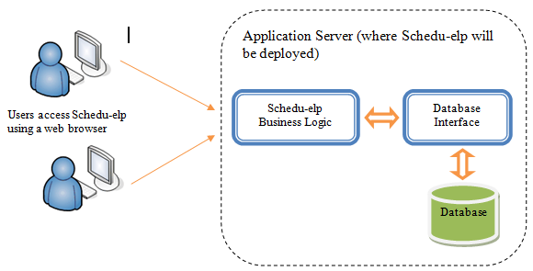

Figure 2: High Level Data Flow

Schedu-elp will utilize J2EE web technologies for application development. The user interface will be developed using JSP, XHTML and CSS. Client side scripting will be done using JavaScript. All business logic will be implemented in Java, which communicates with the underlying database.

# Team Skills, Technical and Domain Knowledge

Schedu-elp will be developed by SCU graduate students (Team Gamma) who understand the product needs and hence possess the necessary domain knowledge required for implementation. Additionally, the team interacts with fellow students to understand what students are looking for in an online academic planner.

Schedu-elp will require knowledge of basic J2EE web technologies and experience with development in Java language. The J2EE based technology was proposed because all members had experience in Java and familiarity with web programming. Figure 3 shows skill set matrix detailing the experience of each team member. This matrix also highlights some potential areas of risk where there is lacking expertise in particular skills.

|  |  |  |  |  |  |  |
| --- | --- | --- | --- | --- | --- | --- |
| Team Member/  Skill | UI Development  (JSP, XHTML, CSS) | Client Side Scripting (JavaScript) | Java | SQL | UML Modeling, Documentation Tools | Familiarity with web programming |
| Poornima | ● | ◖ | ● | ● | ◖ | ● |
| Sheila | ◖ | ◖ | ● | ● | 🞅 | ◖ |
| Shradha | ◖ | ◖ | ◖ | 🞅 | ● | ◖ |

Figure 3: Skill Set Matrix

# Key Success Contributors

We, the members of Team Gamma, believe Schedu-elp will be a one-stop online academic planner for SCU students. We identified that the following factors will be the key contributors to the success of Schedu-elp:

|  |  |  |
| --- | --- | --- |
| Success Contributor | How will it be achieved? | Benefit |
| Focus is on quality rather than quantity | The first release of Schedu-elp (beta phase) will focus on delivering primary functionality for the product such as course search and academic planner. | Delivering focused functionality with high quality will make Schedu-elp likable by the student community. This likeability will increase the popularity and demand for future releases. |
| Ease of use | Schedu-elp will be an online web application that requires no configuration from the end user. All that is needed a web browser to access the application. | The ability to use Schedu-elp anywhere without any pre-installation/configuration will attract large number of students. |
| Focused user group | Release 1 will target SCU graduate engineering students and hence will contain functionality relevant to this student group. | Schedu-elp will be a boon for this user group since majority of graduate students are working in the industry and will appreciate a time-saving Degree Planner. |
| Periodic Status Updates | We believe periodic status updates within the development team is imperative to check project health and take correction actions, when necessary. | This will keep the team focused on delivering primary functionality and manage risks. |
| Appropriate Software Process | We believe Agile software methodology will be suitable for rolling out our first release since we have a focused functionality to develop within a short development cycle. | The agile process will enable evolutionary development and delivery of Schedu-elp |

Figure 4: Key Success Contributors