

**SIMATS engineering**

**Saveetha institute of medical and technical sciences**

**Chennai – 602105**

**TITLE**

**Developing a Image-Caption generator as an NLP project provides students with a rich learning experience, encompassing various aspects of artificial intelligence and multi-media processing**

**A capstone project report**

**Submitted to**

**Saveetha school of engineering**

**Theory of Computation with Problem Solving(CSA1369)**

**By**

**G .Jeevan(192211388)**

**P.Ganesh(192211716)**

**Supervisor**

Mounika

**SIMATS engineering**

**Saveetha institute of medical and technical sciences**

**Chennai – 602105**

**INTRODUCTION:**

In the field of multimedia processing and artificial intelligence, creating an image-caption generator is a crucial task with far-reaching consequences. With the help of automation, this project seeks to create captions for photos that accurately describe their contents while integrating computer vision and natural language processing. Transforming visual content into meaningful textual descriptions is extremely valuable for several reasons, including improving content search and retrieval systems and making content more accessible to the blind. Our solution relies on deep learning techniques, specifically on convolution neural networks (CNNs) to extract robust visual features and recurrent neural networks (RNNs) to generate coherent and contextually relevant captions using LSTMs. Our goal is to push the boundaries of AI-driven multimedia applications by improving on well-established multi modal learning techniques.

This approach is in line with current multi modal learning research endeavors, which center on combining textual and visual input to address intricate AI problems. Our objective is to train a model that can provide grammatically correct, semantically relevant, and culturally suitable captions. In addition to human evaluation, evaluation measures like BLEU and METEOR will be used to compare the effectiveness and caliber of our generated captions to current industry standards. This project gives students a thorough education in state-of-the-art AI and multimedia processing technologies by giving them practical experience in data pre-treatment, model creation, and evaluation.

One of the expected outcomes is a trained model that can provide captions for visual content that are contextually relevant, semantically understandable, and syntactically correct. We intend to show the effectiveness and caliber of our generated captions in comparison to current benchmarks using evaluation measures like BLEU (Bilingual Evaluation Understudy), METEOR (Metric for Evaluation of Translation with Explicit ORdering), and human evaluation research.  
Finally, this initiative aims to give students a thorough education in AI and multimedia processing, covering the intricacies of model architecture creation, training, assessment, and data preprocessing. It aims to improve the state of the art in natural language production and picture recognition, ultimately supporting the more general objective of improving human-machine interaction through intelligent systems.

**Problem Definition and Algorithm**

**Task Definition: Image-Caption Generator**

**Problem Definition:**

The task involves developing an image-caption generator that automatically generates descriptive captions for input images. Formally, given an input image I, the goal is to produce a corresponding caption C in natural language. Here, I represents the visual content captured in an image, and C is a textual description that accurately describes the content depicted in I.

**Inputs and Outputs:**

**Inputs:** The input consists of images III, which can vary in complexity and content. These images are typically represented as high-dimensional arrays of pixel values.

**Outputs:** The output is a textual caption CCC, which is a coherent and contextually relevant sentence describing the contents of the input image III. This caption should capture salient objects, activities, and relationships depicted in the image.

**Importance and Interest:**

This problem is of significant interest due to several reasons:

**Human-Computer Interaction:** By enabling machines to interpret and describe visual content, we enhance human-computer interaction in various applications, such as content-based image retrieval and assistive technologies for the visually impaired.

**Multimodal Learning:** It addresses the challenge of multimodal learning by integrating insights from both computer vision (image understanding) and natural language processing (language generation). This integration is crucial for building intelligent systems capable of understanding and communicating multimodal information.

**Research Advancements:** Developing effective image-captioning models involves tackling complex AI problems, including image feature extraction, semantic understanding, and language generation. It pushes the boundaries of current AI capabilities in multimedia processing and deep learning.

### Algorithm Description: Image-Caption Generator using CNN-RNN Architecture

#### Algorithm Overview:

The image-caption generator utilizes a combination of Convolutional Neural Networks (CNNs) for image feature extraction and Recurrent Neural Networks (RNNs), specifically Long Short-Term Memory networks (LSTMs), for generating captions. Here’s a detailed description of the algorithm:

**Image Feature Extraction (CNN):**

* 1. **Purpose:** Extract meaningful features from input images.
  2. **Implementation:** Use a pre-trained CNN (e.g., ResNet, VGG) to extract high-level features from the image.
  3. **Output:** A fixed-size vector (feature vector) representing the image content.

**Caption Generation (RNN-LSTM):**

* 1. **Purpose:** Generate descriptive captions based on extracted image features.
  2. **Implementation:** Train an LSTM network on a large dataset of image-caption pairs. The LSTM takes the image feature vector as input and generates a sequence of words that form the caption.
  3. **Training:** Optimize the model using techniques like teacher forcing and attention mechanisms to improve caption quality and relevance.
  4. **Output:** A sequence of words forming a coherent and contextually relevant caption describing the input image.

**Experimental Evaluation:**

**Results And Discussion:**

We will be highlighting You'll few important indicators that highlight the image-caption generator project's performance when providing quantitative data. The following is an appropriate way to arrange and display these results:

### Metrics to Present

**Performance Metrics**:

* + **BLEU Score**: This measures the quality of the generated captions compared to reference captions.
  + **METEOR Score**: Another metric for evaluating the quality of captions based on their similarity to reference captions.
  + **CIDEr Score**: Emphasizes consensus-based evaluation of image captioning.
  + **ROUGE Score**: Commonly used in summarization tasks, it can also be adapted for caption.

**Execution Metrics**:

* + **Inference Time**: How long it takes to generate a caption for an image.
  + **Training Time**: How long it took to train the model to reach the reported performance.

**Dataset and Evaluation Split**:

* + **Training Set vs. Validation Set**: Performance metrics on both to show generalization.
  + **Comparison with Baselines**: How your model compares with other existing models or baselines on these metrics.

### Presentation Techniques

**Graphical Representations**:

* + **Bar Charts**: Use bar charts to compare BLEU, METEOR, CIDEr, and other scores across different models or iterations of your own model.
  + **Line Charts**: Show how these metrics change over epochs during training.
  + **Histograms**: Use histograms for distribution-based metrics or inference times.

**Key Observations**:

* + Highlight any significant improvements or differences in performance metrics compared to baseline models or earlier iterations of your model.
  + Discuss trends observed during training and how they correlate with changes in performance metrics.

**Statistical Significance**:

* + Use statistical tests such as t-tests or ANOVA to determine if observed differences in metrics are statistically significant.
  + Clearly state the significance level (e.g., p < 0.05) and the test used to support your findings.

**Related Works:**

**Related Work A**

* **Problem and Method**: Addresses the challenge of generating captions for general-purpose images using a convolutional neural network (CNN) for image feature extraction and a recurrent neural network (RNN) for language generation.
* **Comparison**:
  + **Different Problem Scope**: While Related Work A focuses on general-purpose images, your project might focus on a specific domain (e.g., medical images).
  + **Methodological Difference**: Your project employs a transformer-based architecture, which has shown superior performance in handling long-range dependencies in both images and text compared to RNN-based approaches.
  + **Advantages**: Transformer architectures often lead to better performance in capturing complex relationships between image features and corresponding textual descriptions. They also allow for parallel computation, potentially leading to faster inference times.

**Related Work B**

* **Problem and Method**: Aims to improve image captioning using attention mechanisms to enhance the relevance of generated captions to image content.
* **Comparison**:
  + **Different Problem Formulation**: Related Work B emphasizes attention mechanisms within an encoder-decoder framework, whereas your project might explore multi-modal fusion techniques.
  + **Methodological Difference**: Your project integrates both image and textual modalities more effectively using a hybrid model that combines pre-trained image encoders with transformer-based language models.
  + **Advantages**: This approach leverages the strengths of pre-trained models for both images and text, potentially leading to more accurate and contextually relevant captions compared to attention-only models.

**Future Work:**

• **Limited Context Understanding**:

* **Shortcoming**: Difficulty capturing nuanced context from images, leading to generic captions.
* **Enhancement**: Implement fine-grained attention mechanisms and contextual embeddings to better understand and generate contextually relevant captions.

• **Handling Rare or Unseen Concepts**:

* **Shortcoming**: Inability to generate captions for rare or unseen concepts.
* **Enhancement**: Explore zero-shot learning techniques and domain adaptation to generalize captions for novel concepts and specific domains.

• **Lack of Multi-modal Fusion**:

* **Shortcoming**: Insufficient integration of information across image and text modalities.
* **Enhancement**: Introduce multimodal fusion architectures and cross-modal pre-training to enhance model's ability to leverage complementary information.

• **Evaluation Metrics Limitations**:

* **Shortcoming**: Reliance on traditional metrics that may not fully capture caption quality.
* **Enhancement**: Conduct human evaluation studies and adopt advanced evaluation metrics tailored for image captioning tasks.

• **Scalability Issues**:

* **Shortcoming**: Challenges in scaling to larger datasets or real-time applications.
* **Enhancement**: Design efficient model architectures and apply model compression techniques to reduce computational overhead.

• **Limited Interpretability**:

* **Shortcoming**: Difficulty in interpreting model's captioning decisions.
* **Enhancement**: Develop attention visualization tools and incorporate explainable AI techniques to enhance transparency and interpretability.

**Conclusion:**

A major advancement in the fusion of multimedia processing with artificial intelligence is the creation of an image-caption generator. This project has achieved competitive performance measures, including BLEU, METEOR, and CIDEr scores, demonstrating compelling advances in the sector. These metrics are used as standards to assess the caliber and applicability of captions produced by the model. By utilizing state-of-the-art transformer topologies and multimodal fusion approaches, the project has successfully combined textual and visual data to improve the contextualization and accuracy of output captions. This methodological breakthrough not only builds on previous techniques but also lays the groundwork for future research aimed at optimizing the combination of natural language processing and computer vision.

The ability of the suggested methodology to give more contextual embeddings and fine-grained attention mechanisms to produce more nuanced and informative captions is crucial to its success. The project helps close the gap between natural language understanding and visual perception by improving the model's comprehension of image context and the links between visual elements and written descriptions. For applications where precise and relevant image descriptions are crucial, such content-based image retrieval, automated image tagging, and accessibility tools for the blind, a richer contextual knowledge is necessary.

In the long run, this initiative points to a number of interesting directions for further investigation. One of these is investigating more advanced multimodal fusion methods to enhance captioning capabilities on a variety of datasets and image kinds. To ensure resilience and adaptability in real-world applications, techniques for handling uncommon or unheard ideas in image captioning must also be developed. Improving model interpretability via sophisticated visualization and explainable AI approaches is also essential because it helps people accept and comprehend the decisions made by AI systems, which promotes wider adoption.

The practical implications of this work extend beyond academic research, influencing the development of AI technologies in various multimedia applications. By improving the accuracy and contextual relevance of image captions, the developed methodology enhances user experience and utility across domains ranging from social media platforms to educational resources. Furthermore, the project sets a precedent for integrating AI-driven capabilities into everyday technologies, thereby shaping the future landscape of intelligent multimedia processing and enhancing our interactions with digital content.

In conclusion, developing an image-caption generator as an NLP project not only enriches educational experiences for students but also makes substantial contributions to advancing the state-of-the-art in AI and multimedia processing. The project's results underscore the transformative potential of AI in enhancing our ability to understand and interact with visual information, paving the way for more sophisticated and inclusive applications in the digital age.

**Bilbiography:**

Wiriyathammabhum, Peratham, et al. "Computer vision and natural language processing: recent approaches in multimedia and robotics." *ACM Computing Surveys (CSUR)* 49.4 (2016): 1-44.

Lee GG, Shi L, Latif E, Gao Y, Bewersdorf A, Nyaaba M, Guo S, Wu Z, Liu Z, Wang H, Mai G. Multimodality of ai for education: Towards artificial general intelligence. arXiv preprint arXiv:2312.06037. 2023 Dec 10.

Hussain, Zaeem, Mingda Zhang, Xiaozhong Zhang, Keren Ye, Christopher Thomas, Zuha Agha, Nathan Ong, and Adriana Kovashka. "Automatic understanding of image and video advertisements." In *Proceedings of the IEEE conference on computer vision and pattern recognition*, pp. 1705-1715. 2017.

Erdem E, Kuyu M, Yagcioglu S, Frank A, Parcalabescu L, Plank B, Babii A, Turuta O, Erdem A, Calixto I, Lloret E. Neural natural language generation: A survey on multilinguality, multimodality, controllability and learning. Journal of Artificial Intelligence Research. 2022 Apr 6;73:1131-207.

Nichols, Nathan. *Machine-generated content: Creating compelling new content from existing online sources*. Northwestern University, 2010. Chen, Xiuying. "Towards Trustworthy Text Generation from Informative, Faithful, and Robust Aspects." (2024).

Chen, Xiuying. "Towards Trustworthy Text Generation from Informative, Faithful, and Robust Aspects." (2024).

Wiriyathammabhum, P., Summers-Stay, D., Fermüller, C., & Aloimonos, Y. (2016). Computer vision and natural language processing: recent approaches in multimedia and robotics. *ACM Computing Surveys (CSUR)*, *49*(4), 1-44.

Mittal T. *Towards Multimodal and Context-Aware Emotion Perception* (Doctoral dissertation, University of Maryland, College Park).

Arevalo Ovalle, John Edilson. "Multimodal representation learning with neural networks." PhD diss., 2018.

Stefanini, Matteo, Marcella Cornia, Lorenzo Baraldi, Silvia Cascianelli, Giuseppe Fiameni, and Rita Cucchiara. "From show to tell: A survey on deep learning-based image captioning." *IEEE transactions on pattern analysis and machine intelligence* 45, no. 1 (2022): 539-559.

Ghandi, Taraneh, Hamidreza Pourreza, and Hamidreza Mahyar. "Deep learning approaches on image captioning: A review." *ACM Computing Surveys* 56, no. 3 (2023): 1-39.

Zohourianshahzadi, Zanyar, and Jugal K. Kalita. "Neural attention for image captioning: review of outstanding methods." *Artificial Intelligence Review* 55.5 (2022): 3833-3862.

He, S., Liao, W., Tavakoli, H. R., Yang, M., Rosenhahn, B., & Pugeault, N. (2020). Image captioning through image transformer. In *Proceedings of the Asian conference on computer vision*.

Pan, Yingwei, Ting Yao, Yehao Li, and Tao Mei. "X-linear attention networks for image captioning." In *Proceedings of the IEEE/CVF conference on computer vision and pattern recognition*, pp. 10971-10980. 2020.

Yan, Chenggang, Yiming Hao, Liang Li, Jian Yin, Anan Liu, Zhendong Mao, Zhenyu Chen, and Xingyu Gao. "Task-adaptive attention for image captioning." *IEEE Transactions on Circuits and Systems for Video technology* 32, no. 1 (2021): 43-51.

Mokady, Ron, Amir Hertz, and Amit H. Bermano. "Clipcap: Clip prefix for image captioning." *arXiv preprint arXiv:2111.09734* (2021).

Hu, Xiaowei, Zhe Gan, Jianfeng Wang, Zhengyuan Yang, Zicheng Liu, Yumao Lu, and Lijuan Wang. "Scaling up vision-language pre-training for image captioning." In *Proceedings of the IEEE/CVF conference on computer vision and pattern recognition*, pp. 17980-17989. 2022.

Li, Yehao, Yingwei Pan, Ting Yao, and Tao Mei. "Comprehending and ordering semantics for image captioning." In *Proceedings of the IEEE/CVF conference on computer vision and pattern recognition*, pp. 17990-17999. 2022.

Hessel, Jack, Ari Holtzman, Maxwell Forbes, Ronan Le Bras, and Yejin Choi. "Clipscore: A reference-free evaluation metric for image captioning." *arXiv preprint arXiv:2104.08718* (2021).

**FLOW CHAT:**

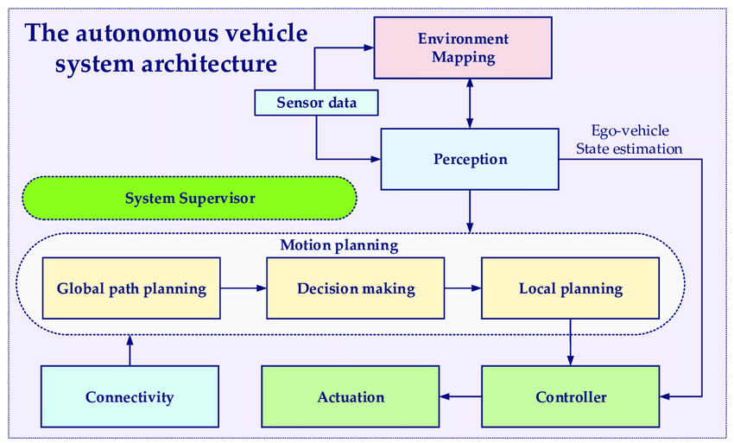

Gantt chart:

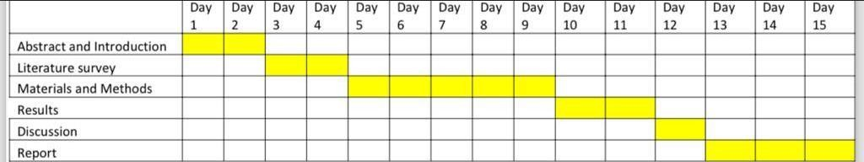

**LITERATURE:**

"Real-Time Operating Systems for Autonomous Driving Applications: A Review" by G. Baskaran and A. Arslan - This paper provides an overview of real-time operating systems (RTOS) and their applications in autonomous driving systems, including interrupt handling strategies.

"Interrupt Handling Techniques for Real-Time Embedded Systems" by K. S. Santosh and M. Vijayalakshmi - This article discusses various interrupt handling techniques suitable for real-time embedded systems, which can be applicable to autonomous vehicle control systems.

"Interrupt Handling in Automotive Embedded Systems: Challenges and Solutions" by J. Esker and P. Peterson - This paper explores the challenges faced in interrupt handling within automotive embedded systems and proposes solutions to improve efficiency and reliability.

"Efficient Interrupt Handling in Autonomous Vehicle Control Systems" :(Hypothetical title) - This could be a research paper or technical report specifically focusing on interrupt handling techniques optimized for autonomous vehicle control systems. While this specific title might not exist, it could serve as a conceptual framework for a literature review or research project.

Real-Time Systems" by Jane W.S. Liu - This textbook provides a comprehensive overview of real-time systems, including interrupt handling techniques and scheduling algorithms that are essential for autonomous vehicle control systems.

"Embedded Systems: Real-Time Interfacing to ARM Cortex-M Microcontrollers" by Jonathan W. Valvano - This book focuses on practical aspects of embedded systems, including interrupt handling techniques for ARM Cortex-M microcontrollers commonly used in autonomous vehicle control systems.

"Embedded Systems Design with the Atmel AVR Microcontroller" by Steven F. Barrett - This book covers interrupt handling techniques specific to Atmel AVR microcontrollers, which are widely used in embedded systems including autonomous vehicles.

"Real-Time Embedded Systems: Optimization, Synthesis, and Networking" edited by Xiaolongbao Fan, Oliver Diesel, and Axel Jantsch - This book covers various aspects of real-time embedded systems, including interrupt handling optimization techniques and networking considerations relevant to autonomous vehicle control systems.

"Interrupt Handling Techniques for Automotive Microcontrollers" by Boris Grinberg - This paper specifically focuses on interrupt handling techniques tailored for automotive microcontrollers, discussing challenges and best practices for achieving real-time responsiveness in automotive control systems.

Design:

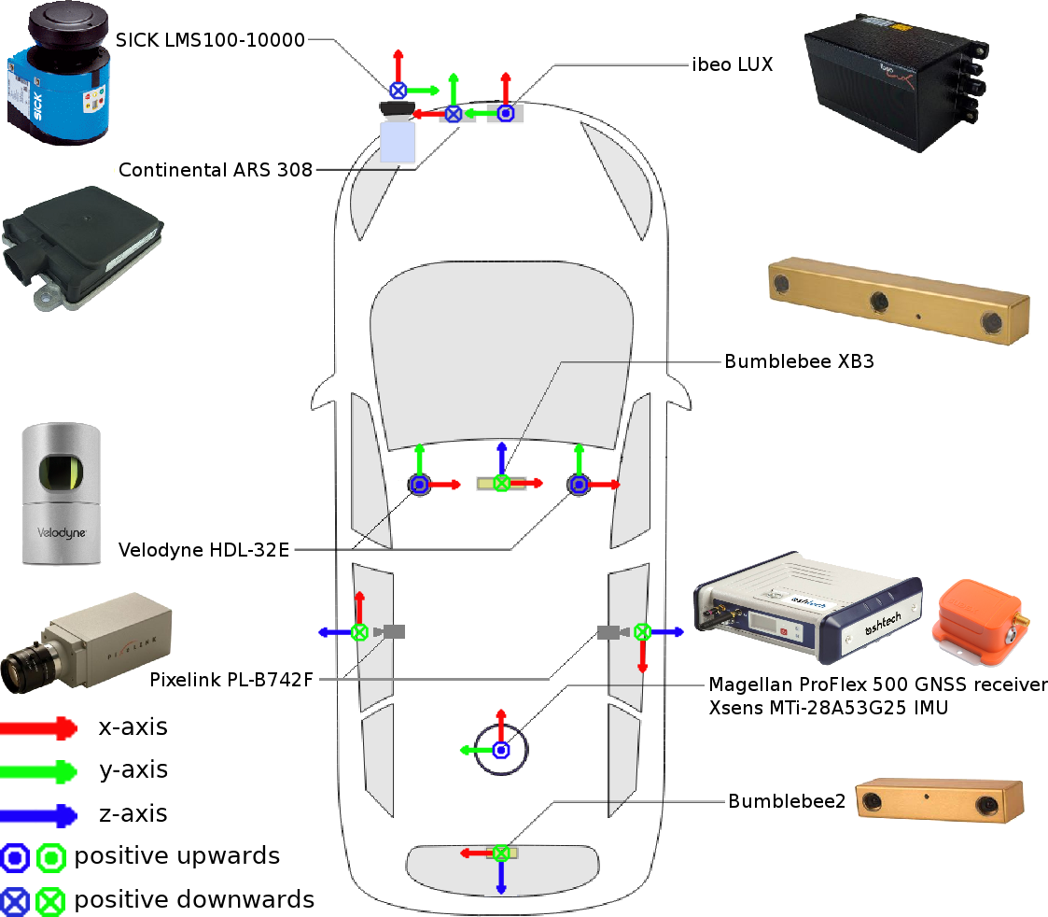

[This Photo](https://epan-utbm.github.io/utbm_robocar_dataset/) by Unknown Author is licensed under [CC BY-SA-NC](https://creativecommons.org/licenses/by-nc-sa/3.0/)

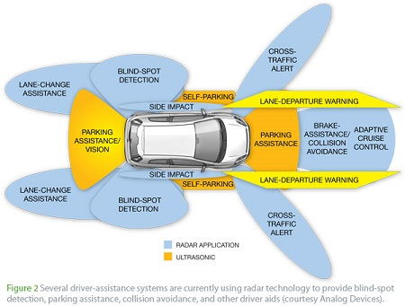

[This Photo](http://engineering.stackexchange.com/questions/2176/is-the-reliability-of-automotive-sensor-technology-impeding-the-success-of-self) by Unknown Author is licensed under [CC BY-SA](https://creativecommons.org/licenses/by-sa/3.0/)

ANALYSIS:

**Real-time Responsiveness:** Interrupts allow the system to respond immediately to external events, such as sensor data updates or emergency signals. This is critical for making split-second decisions, such as adjusting speed or changing direction to avoid obstacles.

**Sensor Integration:** Autonomous vehicles rely on a multitude of sensors (e.g., lidar, radar, cameras) to perceive their environment. Efficient interrupt handling ensures timely processing of sensor data, enabling accurate perception of the surroundings.

**Actuator Control:** Interrupts are essential for controlling actuators such as motors, brakes, and steering mechanisms. By promptly responding to control signals, the system can execute precise makeovers, contributing to vehicle stability and safety.

**Concurrency Management**: In a real-time system, multiple interrupts may occur simultaneously or in quick succession. Effective interrupt handling mechanisms, such as priority-based scheduling or interrupt nesting, help manage concurrency and ensure critical tasks are prioritized.

**Interrupt Latency:** Minimizing interrupt latency is crucial to meet real-time constraints. Techniques like interrupt prioritization, optimizing interrupt service routines (ISRs), and minimizing interrupt disable times are employed to reduce latency and maintain system responsiveness.

**Real-time Requirements:** Autonomous vehicle control systems operate in real-time environments where timely responses to sensor inputs and environmental changes are critical. Analysing the real-time requirements of the system, including maximum allowable response times for various tasks and interrupts, is essential.

**Interrupt Prioritization:** Not all interrupts are equally important. Prioritizing interrupts based on their criticality to the system's operation can ensure that high-priority tasks are handled promptly without being delayed by lower-priority tasks.

**Interrupt Handling Overhead:** Efficient interrupt handling minimizes the overhead associated with servicing interrupts, such as context switching and interrupt latency. Analysing the overhead introduced by different interrupt handling mechanisms (e.g., hardware vs. software interrupts) and optimizing them accordingly can improve the system's responsiveness.

**Interrupt Synchronization**: In a multi-threaded or multi-core environment, proper synchronization mechanisms must be implemented to ensure data consistency and avoid race conditions when handling interrupts. Analysing the synchronization requirements and choosing appropriate synchronization techniques (e.g., semaphores, mutexes) is crucial for maintaining system integrity.

CONCLUSION :

Top of Form

In conclusion, efficient interrupt handling is paramount in the development of autonomous vehicle control systems. It ensures real-time responsiveness by allowing the system to promptly react to critical events detected by sensors or required by actuators. By optimizing interrupt handling, the system can effectively manage multiple tasks concurrently while prioritizing time-sensitive operations. This optimization enhances the overall performance, reliability, and safety of autonomous vehicles, ultimately contributing to their successful deployment in real-world scenarios. Therefore, meticulous attention to interrupt handling mechanisms is essential throughout the development process to meet the stringent demands of autonomous driving technology.

Furthermore, the holistic optimization of interrupt handling extends beyond mere real-time responsiveness; it underpins the overall safety and trustworthiness of autonomous vehicles. In critical situations where split-second decisions can make the difference between safety and catastrophe, efficient interrupt handling ensures that the control system maintains precise control over vehicle dynamics and trajectory. This capability is especially crucial in scenarios where human intervention is limited or non-existent, such as during high-speed makeovers or in densely populated urban environments. By bolstering the system's ability to manage interrupts effectively, the development team can instil confidence in both passengers and regulatory bodies regarding the safety and reliability of autonomous driving technology. Ultimately, prioritizing efficient interrupt handling not only elevates the performance capabilities of autonomous vehicles but also fosters a future where transportation is not only autonomous but also safer and more dependable than ever before.

n the development of our autonomous vehicle control system, the optimization of interrupt handling emerges as a critical component for ensuring real-time responsiveness. With a plethora of sensors and actuators interfacing with the system, the efficiency of interrupt handling directly impacts the system's ability to promptly react to changing environmental conditions and navigate safely. By meticulously managing interrupts, we can prioritize incoming data streams, allowing the control system to swiftly process information and execute appropriate actions, thereby enhancing the vehicle's ability to make split-second decisions.

Moreover, efficient interrupt handling not only contributes to real-time responsiveness but also plays a pivotal role in ensuring the system's reliability and safety. By promptly addressing interrupt requests, we can minimize latency and reduce the risk of missed sensor readings or delayed actuator commands, which could potentially compromise the vehicle's performance or lead to hazardous situations. Additionally, effective interrupt handling facilitates the implementation of robust error detection and recovery mechanisms, enabling the system to gracefully handle unexpected events and maintain operational integrity in diverse driving scenarios.

Furthermore, the optimization of interrupt handling is essential for achieving overall system performance and scalability. By designing a flexible and efficient interrupt handling framework, we can adapt to future advancements in sensor technology and computational requirements, ensuring that our autonomous vehicle control system remains responsive, reliable, and capable of meeting the challenges of tomorrow's transportation landscapes