Assignment 3

**Sleeping Barber using Semaphores**

**-:Ganesh _B14CS017**

* A semaphore is initialized by calling –

sem_init(&name, 0, initvalue);

* Wait on semaphore is called by –

sem_wait(&name);

* Semaphore is signaled by –

sem_post(&name);

* Schematics:-

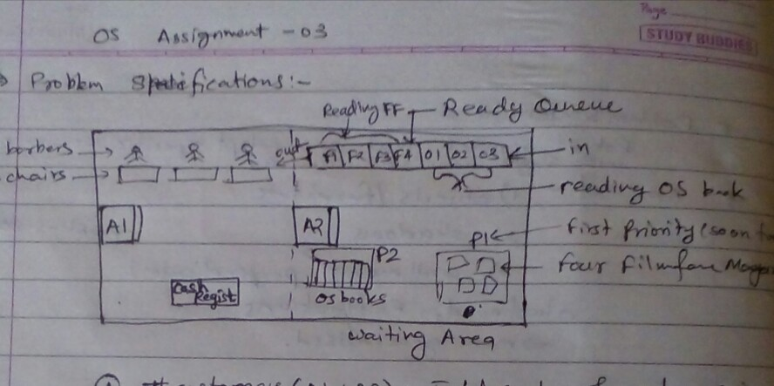

* ***Functions implemented –***
* **void** **\* customer(int id)**

Customer is reading OS book. If film fare magazine is available then the first person in OS book queue gets to read film fare magazine and is pushed into film fare queue. If a chair is free then the first person in film fare queue gets to the chair and signals cust_ready semaphore. After haircut, the customer leaves the chair and signals for the payment. After payment and receiving the receipt, the customer leaves the shop signaling seatsfree semaphore.

* **void** **\* barber(int id)**

Barber waits for a ready customer and when a customer is ready, he cuts his hair. Then he accepts payment after waiting for cash counter. Receiving a signal of giving receipt from cash counter he gives receipt to customer and signals himself free in the barberfree semaphore.

* **void** **\* cashCounter(int id)**

Cash counter waits for customer to signal payment and then signals barber to receive payment. When it gets the signal of completed payment it signals barber to give receipt.

* **int main()**

It initializes the semaphores and barber and cash counter threads. On user input it creates one customer thread for every input till 50 customers are there. Thread creation for customers is done by “pthread_create(&cust_thread, NULL, (void *(*) (void *)) compute, (void *) (numberOfCustomers));”

Before creating thread, it checks if at least one seat is available or not. If available, it enters the customer into OS book queue.

* Other methods like entershop(int id), readfilmfare(int id), cutHair(int id), pay(int id), leave(int id) etc. are for the log of the activities in the shop.

**Global variables –**

* queue<int> osbook, filmfare – Queues for reading OS book and Film fare magazine.
* int numberOfCustomers – Total number of customers entered into the shop in the day
* pthread_t cust_thread – Customer thread to be invoked for every incoming customer
* pthread_t barber_thread[3] – Barber threads for three barbers
* pthread_t cash_thread – ­Cash counter thread
* pthread_mutex_t lock – Lock for individual printing log
* sem_t filmfarefree(4), osbookfree(3), barberfree(3), chairfree(3), cust_ready(0), leavechair(0), payment(0), receipt(0), seatsfree(10), cuthair(0), receive(0), paid(0) – Semaphores to control the order of execution of the threads. Value in the bracket is their initialization value.