CHAPTER 1

INTRODUCTION TO JAVA

Java is an object-oriented programming language developed by Sun Microsystems in 1991, originally called oak. Java provides high level security by performing compile time as well as runtime code checking. Java is architectural neutral and platform independent. Dynamic memory management is the main power of java. Multi-threading allows the system to process number of clients request at a time.

The original and reference implementation Java compilers, virtual machines, and class libraries were developed by Sun from 1991 and first released in 1995. As of May 2007, in compliance with the specifications of the Java Community Process, Sun relicensed most of its Java technologies under the GNU General Public License. Others have also developed alternative implementations of these Sun technologies, such as the GNU Compiler for Java and GNU Classpath.

1.1 Characteristics of Java

Simple: Java was designed to be easy for the professional programmer to learn and use effectively. Java will be easy even easy if we already know the concept of object-oriented programming. Some of confusing concepts like pointers in C/C++ are implemented in a cleaner and more approachable manner.

Object-Oriented: Java is 100% object oriented. The object model is simple and easy to extend Simple types, such as integers, are kept as high-performance non objects.

Security: Executing a program needs a particular class or set of classes to be loaded which the byte code verifier does. The execution of java byte codes can be visualized as a set of classes partitioned into separate name space for the local file system classes, and for the network source when the class is loaded the class will be checked in the local name space and network name space.

Robust: Java is a strictly a typed language, manages memory allocation & de-allocation provides object-oriented exception.

Portability: Java programs can run on any platform without being recompiled. There are no platform specific features on the JAVA languages specification.

Multithreaded: Multithreaded is the capability for a program to perform several tasks simultaneously within a program. Multithreading has been incorporated in java in smooth way.
Architecture-Neutral: Architecture neutral means that it is platform independent. A java program can be run on any platform with a JVM. Many major OS vendors have adopted the JVM.
Interpreted and high performance: Java enables the creation of cross-platform programs by compiling into an intermediate representation called java byte code. This code can be interpreted on any system that provides a java virtual machine.

Distributed: Java is built with network communications in mind. It has a comprehensive library of routines for dealing with network protocols such as TCP/IP, HTTP and FTP. As a result, Java application can open and access objects across the internet with the same ease that programmers normally expects while accessing a local file system computing.

Dynamic: Fundamentally distributed computing environment must be dynamic. Java was designed to adapt in constantly evolving environment. It is capable of incorporating new functionality regardless of where that functionality comes from the local computer system, the local and wide area networks, and the internet are all potential contributors.

1.2 Performance
Programs written in Java have a reputation for being slower and requiring more memory than those written in C++. However, Java programs' execution speed improved significantly with the introduction of Just-in-time compilation in 1997/1998 for Java 1.1, the addition of language features supporting better code analysis (such as inner classes, the StringBuffer class, optional assertions, etc.), and optimizations in the Java virtual machine itself, such as HotSpot becoming the default for Sun's JVM in 2000. As of December 2012, microbenchmarks show Java 7 is approximately 44% slower than C++ .

1.3 Syntax
The syntax of Java is largely derived from C++. Unlike C++, which combines the syntax for structured, generic, and object-oriented programming, Java was built almost exclusively as an object-oriented language. All code is written inside a class, and everything is an object, with the exception of the primitive data types (e.g. integers, floating-point numbers, boolean values, and characters), which are not classes for performance reasons.

Unlike C++, Java does not support operator overloading or multiple inheritance for classes. This simplifies the language and aids in preventing potential errors and anti-pattern design.
Java uses similar commenting methods to C++. There are three different styles of comments: a single line style marked with two slashes (//), a multiple line style opened with /* and closed with */, and the Javadoc commenting style opened with /** and closed with */. The Javadoc style of commenting allows the user to run the Javadoc executable to compile documentation for the program.
Example: Hello world

The traditional Hello world program can be written in Java as:

class HelloWorldApp {
public static void main(String[] args) {
System.out.println("Hello World!"); // Display the string.
}
}

CHAPTER 2
JAVA DATABASE CONNECTIVITY (JDBC)

Java Database Connectivity, commonly referred to as JDBC, is an API for the Java programming language that defines how a client may access a database. It provides methods for querying and updating data in a database. JDBC is oriented towards relational databases. A JDBC-to-ODBC bridge enables connections to any ODBC-accessible data source in the JVM host environment.

2.1 Functionality
JDBC allows multiple implementations to exist and be used by the same application. The API provides a mechanism for dynamically loading the correct Java packages and registering them with the JDBC Driver Manager. The Driver Manager is used as a connection factory for creating JDBC connections.
JDBC connections support creating and executing statements. These may be update statements such as SQL's CREATE, INSERT, UPDATE and DELETE, or they may be query statements such as SELECT. Additionally, stored procedures may be invoked through a JDBC connection. JDBC represents statements using one of the following classes:
Statement – the statement is sent to the database server each and every time.
PreparedStatement – the statement is cached and then the execution path is pre-determined on the database server allowing it to be executed multiple times in an efficient manner.
CallableStatement – used for executing stored procedures on the database.
Update statements such as INSERT, UPDATE and DELETE return an update count that indicates how many rows were affected in the database. These statements do not return any other information.

Query statements return a JDBC row result set. The row result set is used to walk over the result set. Individual columns in a row are retrieved either by name or by column number. There may be any number of rows in the result set. The row result set has metadata that describes the names of the columns and their types.
There is an extension to the basic JDBC API in the javax.sql.

2.2 Examples
The method Class.forName (String) is used to load the JDBC driver class. The line below causes the JDBC driver from some jdbc vendor to be loaded into the application. (Some JVMs also require the class to be instantiated with .newInstance ().)
Class.forName (“com.somejdbcvendor.TheirJdbcDriver" );

CHAPTER 3
SERVLETS

A Servlet is an object that receives a request and generates a response based on that request. The basic Servlet package defines Java objects to represent servlet requests and responses, as well as objects to reflect the servlet's configuration parameters and execution environment. The package javax.servlet.http defines HTTP-specific subclasses of the generic servlet elements, including session management objects that track multiple requests and responses between the web server and a client. Servlets may be packaged in a WAR file as a web application.
Servlets are the server side programs. Servlet engines like JRun3.1 or Tomcat servlet runner execute these programs.
Servlets are cross-platform
Because Servlets are written in java, they can be used on multiple platforms without worrying about compatibility issues or recompilation. Servlets are executed in java run-time environment of the server.
Servlets are fast
Standard CGI programs are slow because a new process must start up and run for every client request.
Example: if a Perl CGI search engine is being used by 100 users, 100 separate versions of the program have to be loaded into memory and executed. It consumes more memory as well as
CPU capacity. Java servlets are fast because they are persistent. The same search engine as a servlet would load only once and then service all 100 clients using multiple threads. It would then stay loaded in memory and wait for more requests instead of shutting down.
Servlets are secure
Servlets are executed in the java security sandbox so can be insulated from disrupting the operating system or breathing security. Additionally, many security holes in traditional CGI languages result from those languages being weakly typed .Java’s strong typing helps to ensure fewer accidental security mistakes.

3.1 The Life cycle of a servlet
Three methods are central to the life cycle of a servlet. These are init(), service(), and destroy(). They are implemented by every servlet and are invoked at specific times by the server. Let us consider a typical scenario to understand when these methods are called. Refer to fig 3.1

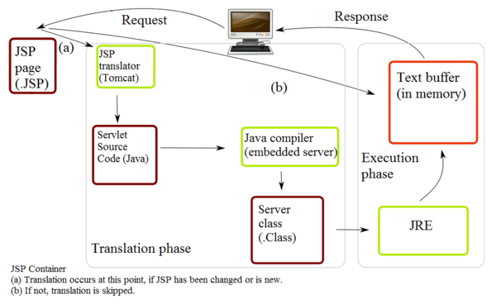

Fig 3.1 The Life cycle of a servlet

First, assume that a user requests to visit an URL.The browser then generates an HTTP request for this URL.This request is then sent to the appropriate server.

Second, this HTTP request is received by the web server and forwarded to the servlet server.The server maps this request to a particular servlet. The servlet is dynamically retrieved and loaded into the address space of the server.

Third, the server invokes the init () method of the servlet. This method is invoked only when the servlet is first loaded into memory. It is possible to pass initialization parameters to the servlet so that it may configure itself.

Fourth, the server invokes the service () method of the servlet. This method is called to process the HTTP request. The servlet may read data that has been provided in the HTTP request. It servlet may also formulate an HTTP response for the client. The servlet remains in the server's address space and is available to process any other HTTP requests received from clients. The service () method is called for each HTTP request.

Finally, the server may, at some point, decide to unload the servlet from its memory. The algorithms by which this decision is made are specific to each server. The server calls the servlet's destroy() method to relinquish any resources such as file handles that are allocated for the servlet. Important data may be saved to a persistent store. The memory allocated for the servlet and its objects can then be garbage collected.

CHAPTER 4
JAVASERVER PAGES (JSP)

JavaServer Pages (JSP) is a technology that helps software developers create dynamically generated web pages based on HTML, XML, or other document types. Released in 1999 by Sun Microsystems,[1] JSP is similar to PHP, but it uses the Java programming language.

JSP is an easy-to-use solution for generating HTML pages with dynamic content. A JSP file contains combinations of HTML tags and JSP syntax. The JSP files have the extension.jsp. One of the many advantages of JSP is that it enables us to effectively separate the HTML coding from the business logic in the web pages. It can be used to access reusable components, such as servlets, java beans. JSP also supports embedding inline java code within web pages.

4.1 Advantages of JSP

1. Servlets use println statements for printing an HTML document which is usually very difficult to use. JSP has no such tedius task to maintain.
2. JSP needs no compilation, CLASSPATH setting and packaging.
3. In a JSP page visual content and logic are separated, which is not possible in a servlet.
4. There is automatic deployment of a JSP; recompilation is done automatically when changes are made to JSP pages.
5. Usually with JSP, Java Beans and custom tags web application is simplified.

4.2 JSP Syntax
JSP syntax consists of these formats, as described in detail in the sections that follow:
Directives, enclosed with <@>
Script lets, enclosed with <% %>
Expressions, enclosed with < %=%>

CHAPTER 5

PROCEDURAL LANGUAGE/STRUCTURED QUERY LANGUAGE (PL/SQL)

Procedural Language/Structured Query Language (PL/SQL) is Oracle Corporation's procedural extension language for SQL and the Oracle relational database. PL/SQL's general syntax resembles that of Ada or Pascal.PL/SQL is one of three key programming languages embedded in the Oracle Database, along with SQL itself and Java.PL/SQL is available in Oracle Database (since version 7), TimesTen in-memory database (since version 11.2.1), and IBM DB2 (since version 9.7).
PL/SQL supports variables, conditions, loops and exceptions. Arrays are also supported, though in a somewhat unusual way, involving the use of PL/SQL collections.
Implementations from version 8 of Oracle Database onwards have included features associated with object-orientation.

While programmers can readily embed Data Manipulation Language (DML) statements directly into their PL/SQL code using straightforward SQL statements, Data Definition Language (DDL) requires more complex "Dynamic SQL" statements to be written in the PL/SQL code. However, DML statements underpin the majority of PL/SQL code in typical software applications.
In the case of PL/SQL dynamic SQL, early versions of the Oracle Database required the use of a complicated Oracle DBMS_SQL package library. More recent versions have however introduced a simpler "Native Dynamic SQL", along with an associated EXECUTE IMMEDIATE syntax.

Each PL/SQL program consists of SQL and PL/SQL statements which from a PL/SQL block.

A PL/SQL Block consists of three sections:
- The Declaration section (optional).
- The Execution section (mandatory).
- The Exception (or Error) Handling section (optional).

Declaration Section:

The Declaration section of a PL/SQL Block starts with the reserved keyword DECLARE. This section is optional and is used to declare any placeholders like variables, constants, records and cursors, which are used to manipulate data in the execution section. Placeholders may be any of Variables, Constants and Records, which stores data temporarily. Cursors are also declared in this section.

Execution Section:

The Execution section of a PL/SQL Block starts with the reserved keyword BEGIN and ends with END. This is a mandatory section and is the section where the program logic is written to perform any task. The programmatic constructs like loops, conditional statement and SQL statements form the part of execution section.

Exception Section:

The Exception section of a PL/SQL Block starts with the reserved keyword EXCEPTION. This section is optional. Any errors in the program can be handled in this section, so that the PL/SQL Blocks terminates gracefully. If the PL/SQL Block contains exceptions that cannot be handled, the Block terminates abruptly with errors.

Every statement in the above three sections must end with a semicolon ; . PL/SQL blocks can be nested within other PL/SQL blocks. Comments can be used to document code.

Example:
DECLARE
Variable declaration
BEGIN
Program Execution
EXCEPTION
Exception handling
END;

CHAPTER 6
RATIONAL APPLICATION DEVELOPMENT (RAD)

Rapid application development (RAD) is a software development methodology that uses minimal planning in favor of rapid prototyping. The "planning" of software developed using RAD is interleaved with writing the software itself. The lack of extensive pre-planning generally allows software to be written much faster, and makes it easier to change requirements.

Rapid Application Development (RAD) is a term originally used to describe a software development process first developed and successfully deployed during the mid 1970s by the New York Telephone Co's Systems Development Center under the direction of Dan Gielan.

IBM Rational Application Developer for WebSphere Software (RAD) helps developers quickly design, develop, test, analyze, and deploy high-quality Java™, Java Platform, Enterprise Edition (Java EE), Web 2.0, service-oriented architecture (SOA), and portal applications. Rational Application Developer includes features to quickly build skills on emerging Java EE and Web technologies, automate code verification, build and test, and enables agile software development for today's fast-paced software delivery needs.

6.1 The overview of the RAD environment

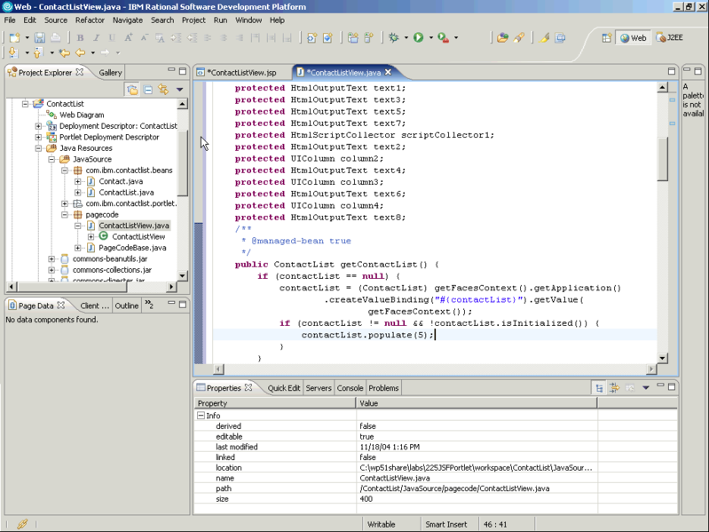
Fig 6.1 Snapshot of RAD software Environment

CHAPTER 7
PROJECT WORK
7.1 Problem Statement
Student Information has to be managed and the facility to be given to creation of student information, retrieving student information, updating student information and deleting student information. The users of the system have the facility of searching the student information by course and semester also by USN.User should be able to generate reports based on the course and semester.
The system should accommodate to validate the information provided by the user and also system should have the facility to log the exceptions thrown by the application for future maintenance.

7.2 Design: System Architecture

Servlets

Java Beans

JSP

DB Class

Error logger

Validator
Student
DB

Fig 7.1 System architecture
7.3 Implementation

Index.html
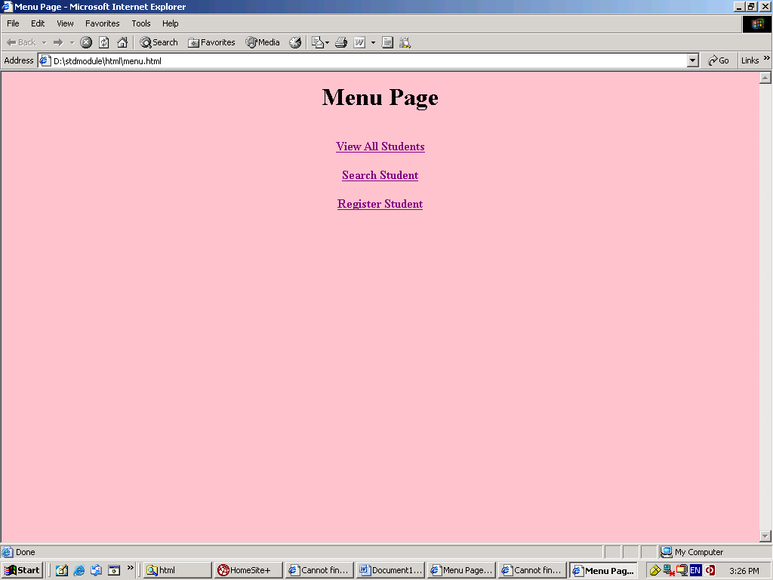
Fig 7.2 Index page of the Student Information System

Login.jsp

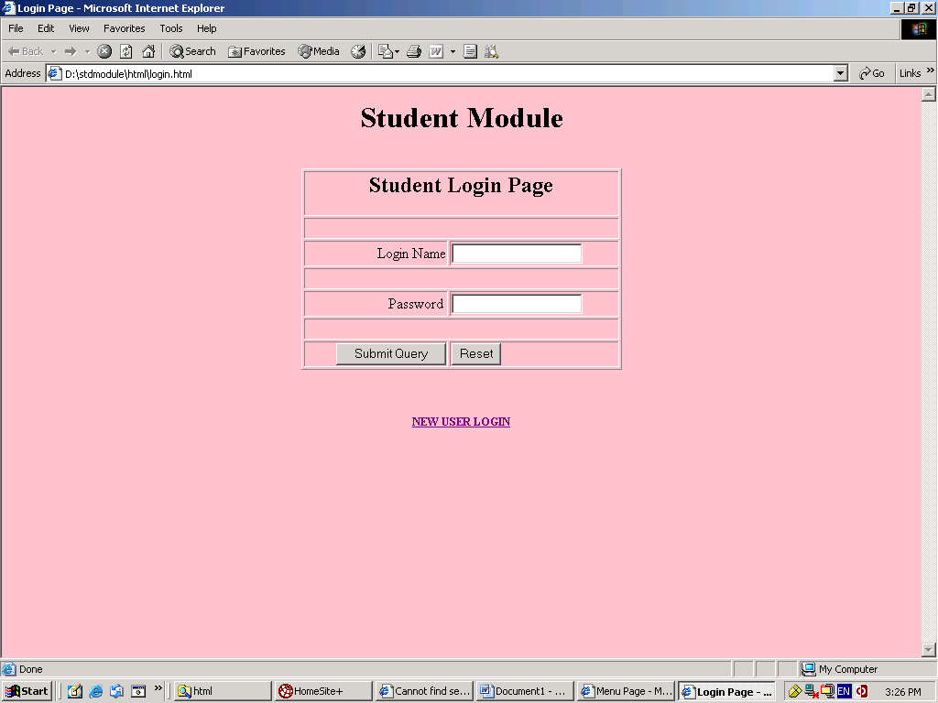
Fig 7.3 Login page of the Student Information System

Registration.jsp

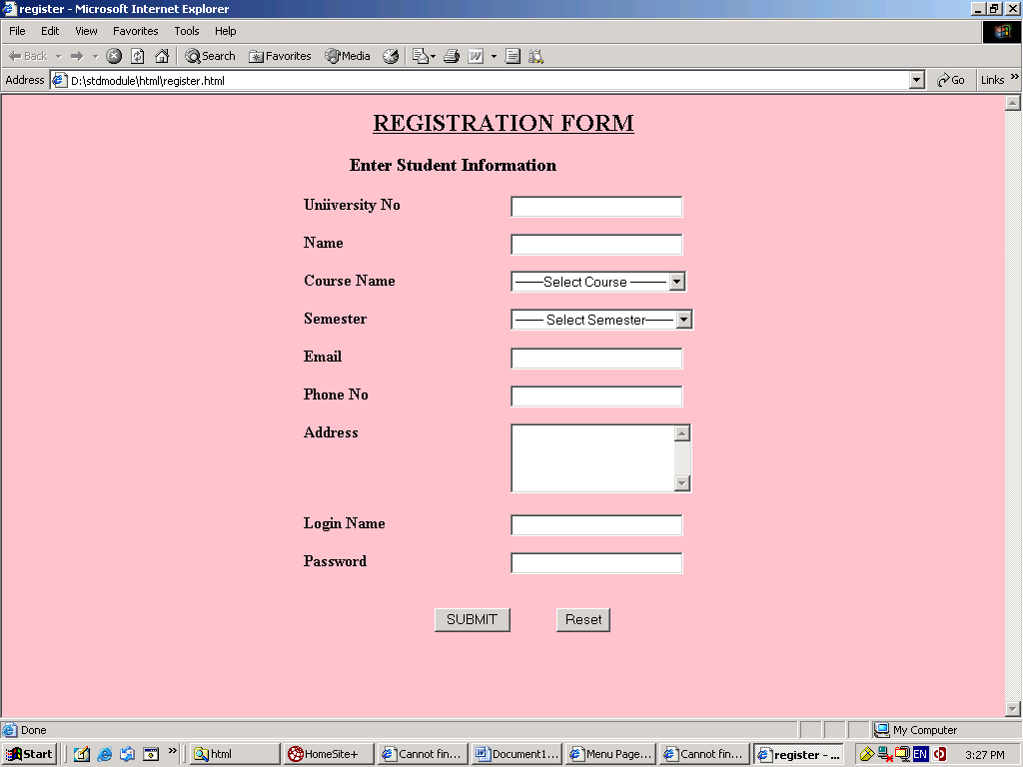

Fig 7.4 Registration page of the Student Information System

Modify.jsp

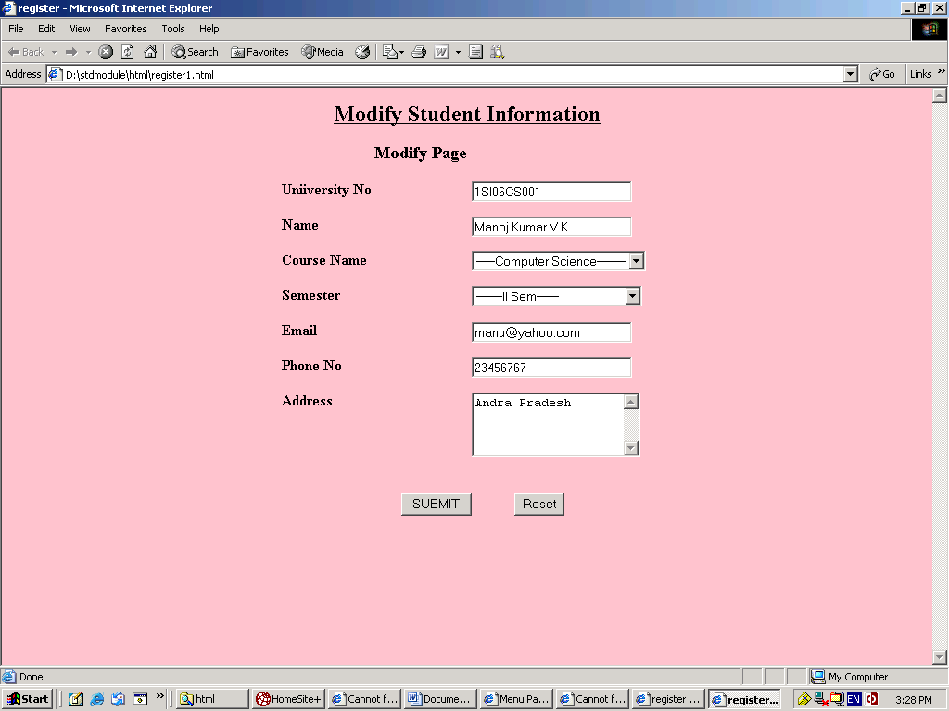

Fig 7.5 Modification page of the Student Information System

Search.jsp
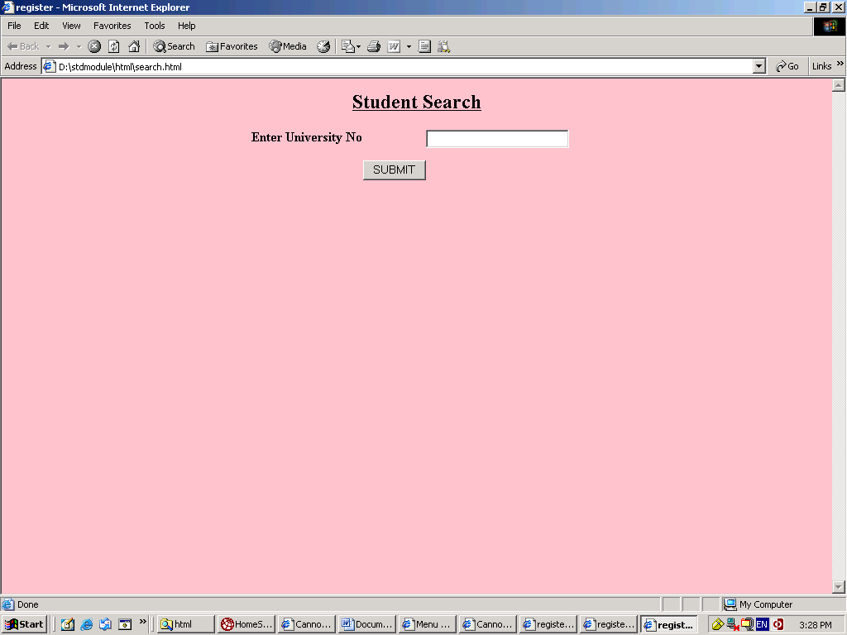

Fig 7.6 Search page of the Student Information System

