MatlabTM interface to read AgilentTM data (RA)
Lana Kaiser, Application Scientist, lana.kaiser@agilent.com

Files: 1) Readprocpar, 2) ReadAgilentFDF, 3) ReadAgilent 4) ReadAgilentStart, 5) ReadAgilentStartSpec

Getting started:
This interface is designed to open Agilent files for further data processing.
Type RA at the matlab prompt. In File Open… menu choose fid file (for kspace data). You should have several global variables in the matlab window.

- See example on the right for loading various variables (all global) into the matlab workspace.
.
- There is no user interaction to enter the required parameters, as all the parameters are read from Agilent procpar file (in ReadAgilentStart.m script)

Tested data types:

- Raw fid 2D and 3D files:
a)seqcon=='ncsnn'
b)seqcon=='nccnn'
c)seqcon=='nccsn'
Example: gems, sems, fse3D

- Processed fdf images: 2D and 3D, old and new format

- Spectroscopy(including CSI) fid

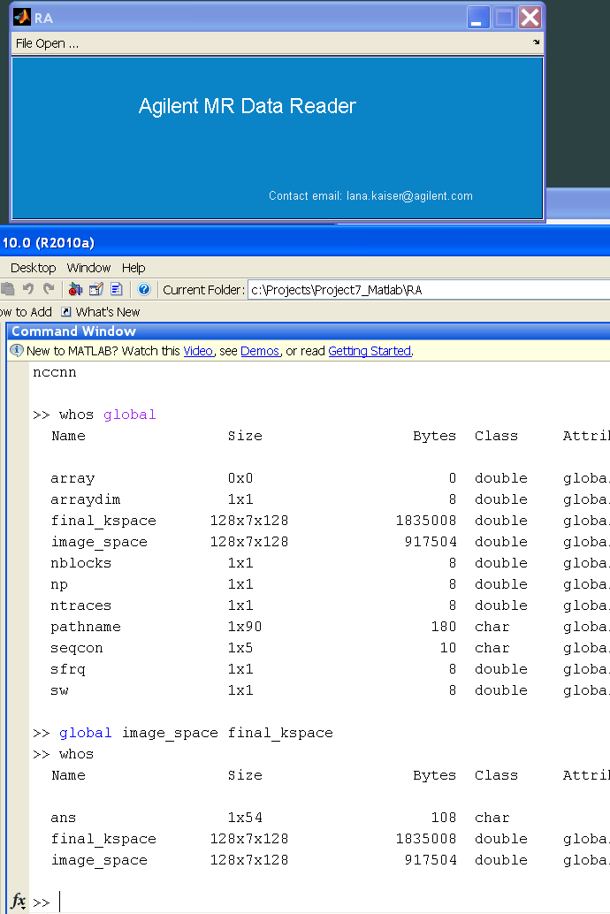
Additional Notes:

1) Variable final_kspace contains the time domain data for both imaging and spectroscopy.
2) To learn about Agilent fid data structure see ReadAgilent.m script
3) To learn how to extract parameters from the procpar, see ReadProcpar.m script.
4) To read parameter from the procpar:
“ns=ReadProcpar('ns',filenameProc)”, where ns is the number of slices and filenameProc is the directory where procpar is located
5) For older types of imaging procpar files, additional table of phase encoding steps maybe required to be in the same directory as fid file (e.g. fse3d types of sequences). Find out the name of the petable from the procpar and find the corresponding table in the vnmrJ tablib directory.

