Metering and Cost
Management for
Sovereign Clouds
How datacenter and sovereign cloud providers can monetize infrastructure services without compromising data sovereignty

A Red Hat White Paper
2026

Contents

Executive Summary
Sovereign cloud providers and enterprise datacenter operators face a paradox. They build infrastructure to keep data, operations, and control within jurisdictional borders — yet the tools they need to meter usage and bill for services often require sending telemetry to external SaaS platforms, breaking the very sovereignty guarantees they promise their customers.
This paper argues that metering, costing, and chargeback are foundational capabilities for any provider that wants to monetize sovereign infrastructure. It examines why existing FinOps tools fall short in sovereign and on-premise environments, introduces an architecture that keeps all financial and usage data inside the provider’s perimeter, and shows how Red Hat Lightspeed Cost Management and the DCM (Data Center Management) project together close the gap between “we provision infrastructure” and “we get paid for it.”
The audience is CIOs, CTOs, and technology leaders at sovereign cloud providers, datacenter operators, managed service providers, and large enterprises that operate an internal IT-as-a-service model for their divisions or subsidiaries.

1. The Sovereignty Imperative — and Its Blind Spot
Digital sovereignty has moved from a niche concern to a defining principle of technology strategy. The numbers are unambiguous:
- 85% of cloud decision-makers say sovereignty constraints completely or partially influence their choice of cloud vendor.¹
- 79% of countries worldwide now have data protection and privacy legislation.²
- 50% of European organizations plan to adopt sovereign cloud solutions, up from 31% in 2024.³
- EUR 12 billion — the EU AI Factories initiative commitment to sovereign AI infrastructure.⁴
Governments, banks, insurers, defense organizations, and critical infrastructure operators are building or procuring sovereign clouds at an accelerating pace. The regulatory drivers are well understood: GDPR, DORA, NIS2, the EU AI Act, and their equivalents in Asia-Pacific, Latin America, and the Middle East.
But there is a blind spot. While the industry has invested heavily in sovereign compute, storage, networking, and security controls, the financial layer — metering, costing, chargeback, and billing — has received far less attention.
Most sovereign cloud projects begin with a focus on provisioning: “Can we deploy clusters, VMs, and containers inside our borders?” The question of “How do we know what was consumed, what it cost, and how to bill for it?” is often deferred to a later phase — or addressed with tools that were never designed for sovereign environments.
This gap is not merely an operational inconvenience. It is a business-model risk. A sovereign cloud provider that cannot accurately meter and price its services cannot sustain itself commercially. An internal IT organization that cannot show business units what their infrastructure costs cannot justify its budget. The sovereignty promise is incomplete without a sovereign financial layer.

2. Why Existing FinOps Tools Fail in Sovereign Environments
The FinOps market offers a range of tools for cloud cost management: Cloudability, Apptio, and others in the commercial space; KubeCost and OpenCost in the open source ecosystem. These tools were designed for a world where workloads run on public hyperscalers and telemetry flows freely to centralized SaaS platforms.
In a sovereign cloud, this model breaks down in three ways.

2.1 Data Exfiltration by Design
Commercial FinOps platforms such as Cloudability and Apptio operate exclusively as SaaS. They require that usage data — CPU hours, memory consumption, storage volumes, network traffic, namespace metadata, and workload identifiers — be transmitted to servers outside the provider’s sovereign perimeter.
For a sovereign cloud provider, this is a fundamental conflict. Usage telemetry is not just operational data; it reveals the structure, scale, and behavior of workloads running inside the sovereign boundary. Transmitting it externally violates the same data sovereignty principles the provider exists to uphold. Under regulations like DORA and GDPR, it may also create compliance risk.

2.2 Insufficient Depth for Commercial Operations
Open source tools like KubeCost and OpenCost provide useful cost visibility for Kubernetes environments and offer some multi-cluster capabilities. However, they lack the depth required for a sovereign cloud provider to build a commercial billing operation on top of OpenShift:
- No overhead distribution. They cannot categorize and allocate the cost of running the platform itself — control plane nodes, platform-level projects, unallocated worker capacity, storage overhead, GPU overhead, and network overhead — back to tenant workloads.
- Limited cost model flexibility. They do not support the fine-grained metering and rating that a commercial provider needs: configurable per-core-hour, per-GB-month, per-PVC, per-VM-hour, or tiered rates with markup percentages.
- No deep OpenShift awareness. These tools treat OpenShift as generic Kubernetes. They lack native understanding of OpenShift-specific constructs such as OpenShift Virtualization VMs, operator-managed workloads, and the platform’s overhead categorization model.

2.3 No Path from Metering to Billing
Even where an open source tool provides raw utilization data, it stops at the boundary of metering. It does not answer the questions a provider needs to run a business:
- What is the fully loaded cost of running Tenant A’s workloads, including their share of platform overhead?
- How should I price a namespace, a VM, or a managed cluster for a customer who signed a 3-year contract with committed spend?
- What is my margin on each customer, and which services are underpriced?
These are the questions that separate a technology platform from a viable business. Answering them requires a cost management system that goes beyond raw metrics and supports configurable cost models, price lists, markup, distribution rules, and exportable reports that can feed into billing and ERP systems.

3. The Business Case: Why a CIO Should Care
Sovereign cloud infrastructure is expensive to build and operate. Hardware procurement, datacenter facilities, power and cooling, staffing with security-cleared personnel, compliance certification — these represent significant capital and operating expenditure. Without a clear path to monetization, the investment case is difficult to sustain.

3.1 Revenue Enablement
A sovereign cloud provider’s revenue model depends entirely on its ability to measure what was consumed and attach a price to it. Without metering, there is no usage record. Without costing, there is no invoice. Without an invoice, there is no revenue. The financial layer is not a nice-to-have — it is the mechanism that turns infrastructure investment into a going concern.
The same logic applies to large enterprises that operate an internal IT-as-a-service model. A multinational corporation, a government ministry, or a conglomerate with multiple subsidiaries — each running workloads on shared OpenShift infrastructure — faces the identical challenge: demonstrating what each business unit consumed and what it cost.

3.2 Operational Visibility
Even before pricing is applied, metering data provides critical operational insight. Understanding where compute capacity is consumed, which namespaces are over-provisioned, and how platform overhead compares to tenant workloads enables the provider to optimize infrastructure utilization and defer capital expenditure.
A leading Swiss sovereign cloud provider found that introducing transparent metering reduced customer onboarding time from weeks to hours and enabled a self-service portal where tenants could see their own consumption in real time — increasing customer satisfaction while reducing the provider’s support burden.

3.3 Compliance and Auditability
Regulators increasingly expect not just technical sovereignty but financial transparency. DORA, for example, requires financial institutions to manage ICT third-party risk, which includes understanding the cost and dependency structure of cloud services. A sovereign cloud provider that can demonstrate auditable metering and costing — with all data retained within the sovereign perimeter — is better positioned to serve regulated customers.

3.4 Competitive Differentiation
The sovereign cloud market is growing rapidly, but so is competition. National and regional providers in Europe, the Middle East, and Asia-Pacific are building offerings at pace. A provider that can offer not just sovereign infrastructure but also transparent, self-service cost management and chargeback creates a differentiated customer experience that rivals the financial transparency of the hyperscalers — without the sovereignty trade-offs.

4. The On-Premise Advantage: Keeping Financial Data Sovereign
The core requirement is straightforward: all metering, costing, and financial data must stay inside the sovereign perimeter. This eliminates SaaS-only FinOps tools from consideration and narrows the field to solutions that can be deployed and operated entirely on-premise.
Red Hat Lightspeed Cost Management meets this requirement. It is 100% open source, developed as the upstream project Koku, and available both as a managed SaaS service on console.redhat.com and as a fully self-managed, on-premise deployment. The on-premise mode is specifically designed for environments where data must not leave the provider’s infrastructure. Because it is open source, sovereign cloud providers gain the same transparency and auditability for their financial layer that they expect from the rest of their technology stack.

What It Measures
Red Hat Lightspeed Cost Management provides three tiers of visibility, each building on the previous:
Tier 1 — Basic Metering. Without any configuration beyond deploying the metrics operator on each OpenShift cluster, the system collects and reports raw utilization and capacity data: CPU, memory, and storage.
Tier 2 — Metering with Distribution. By attaching a cost model to a cluster, the system activates its overhead distribution engine. The cost of running OpenShift itself — control plane, platform projects, worker unallocated capacity, storage, GPU, and network overhead — is categorized and distributed proportionally across tenant projects.
Tier 3 — Full Cost Management. By adding a price list to the cost model, the system applies rates to every measurable dimension: CPU core-hours, memory GB-hours, persistent volume claims, node utilization, VM hours, and more.

Why It Leads the Market for On-Premise OpenShift
For sovereign cloud providers running OpenShift, Red Hat Lightspeed Cost Management offers capabilities that no competing tool matches in an on-premise deployment:
- Deep OpenShift integration. The metrics operator is purpose-built for OpenShift, collecting data directly from Prometheus and Thanos with full awareness of OpenShift constructs.
- Overhead distribution. No other on-premise tool can categorize and distribute platform overhead back to tenant projects.
- Configurable cost models. Providers can define per-cluster cost models with tiered rates, tag-based rates, markup, and distribution rules.
- Multi-cluster aggregation. A single instance manages cost data from an entire fleet of clusters.
- Complete data residency. All metering data, cost calculations, and reports are stored and processed locally.
- 100% open source. The entire stack is open source (Project Koku). Providers can inspect, audit, and modify any component.

5. From Metering to Monetization: The DCM Approach
Metering and costing solve the financial visibility problem. But a sovereign cloud provider also needs to solve the operational problem: how to provision infrastructure, enforce policies, manage a service catalog, and integrate cost tracking as a seamless part of the infrastructure lifecycle.
This is where the DCM (Data Center Management) project enters the picture.

5.1 What Is DCM?
DCM is an open source, API-first control plane that provides a hyperscaler-like cloud experience for on-premise and sovereign cloud infrastructure. It is not a provisioning engine — it is a routing, governance, and lifecycle management framework that delegates actual provisioning to pluggable service providers.
- Service Catalog. A curated catalog of infrastructure offerings with validated configurations and constraints.
- Policy Engine. An Open Policy Agent (OPA)-based governance layer that enforces rules at every decision point.
- Provider Abstraction. Infrastructure provisioning is delegated to service providers — pluggable microservices that implement a standard HTTP contract.
- Lifecycle Management. DCM tracks every provisioned resource through its lifecycle — from request to decommissioning.

5.2 Closing the Loop: Cost as a First-Class Service
The integration of Red Hat Lightspeed Cost Management with DCM closes the loop between provisioning and monetization. When DCM provisions a new cluster for a tenant, the cost management integration automatically:
- Registers the cluster for metering — the metrics operator begins collecting utilization data within minutes.
- Applies the appropriate cost model based on the tenant’s contract tier and the catalog item they selected.
- Begins tracking costs from the moment the cluster is operational, with no manual setup required.

5.3 Three Operating Models
Fully Automated. A policy-driven model where every cluster provisioned through DCM is automatically enrolled for metering and costing. The platform operator configures the rules once; the system applies them consistently.
Operator-Directed. The platform operator manually selects which clusters to enroll and which cost model to apply. Suitable for smaller deployments or environments where cost tracking is introduced incrementally.
Tenant Self-Service. Tenants can view their own metering and cost data through read-only dashboards, understanding their consumption without needing access to the underlying cost management system.

6. Real-World Applications
Sovereign cloud providers and datacenter operators across multiple regions and industries are already finding that the combination of on-premise cost management and sovereign infrastructure orchestration addresses critical business needs.

Sovereign Cloud Providers
A leading Swiss sovereign cloud provider built its platform on Red Hat OpenShift, offering public and private cloud options to customers in regulated sectors including finance, healthcare, and government. By integrating cost transparency directly into its self-service portal, the provider reduced customer onboarding time and enabled tenants to monitor their own consumption in real time.
An Indian sovereign AI infrastructure provider built a sovereign AI factory on Red Hat technologies, serving government entities and businesses that require localized, high-performance AI infrastructure with data that remains within the country’s borders.

Regulated Financial Services
A leading European bank is running a sovereign AI factory platform built on Red Hat OpenShift AI, delivering GPU-as-a-Service and LLM-as-a-Service across the group. To sustain the investment and allocate costs fairly across business units, the bank requires granular metering of GPU hours, model inference requests, and storage consumption — all retained within its own infrastructure.

Defense and Government
Defense organizations represent perhaps the most demanding use case for sovereign cost management. A European air force deployed Red Hat OpenShift on portable edge datacenters to maintain operations during network outages, running AI workloads locally in disconnected environments.
Government agencies across Europe are building sovereign cloud infrastructure aligned with national strategies: France’s SecNumCloud, Germany’s BSI C5, Italy’s Polo Strategico Nazionale, Spain’s National Cloud Strategy, and Nordic “Plan B” hybrid architectures.

Internal IT-as-a-Service
The same architecture applies to large enterprises operating an internal shared-services model. Red Hat Lightspeed Cost Management’s overhead distribution capability enables the central IT organization to transparently allocate not just direct workload costs but also the shared platform overhead — proportionally to each business unit based on their actual usage.

7. Architecture at a Glance
The following diagram illustrates the high-level architecture of a sovereign cloud with integrated metering and cost management.
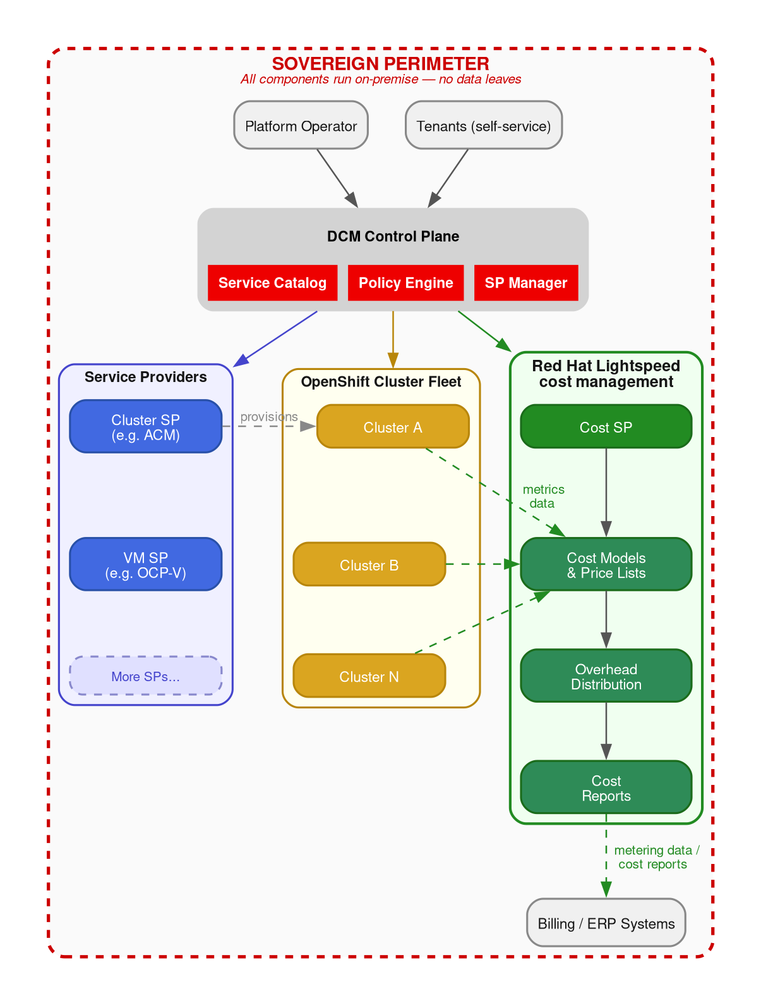
Figure 1: Sovereign cloud architecture. All components — from provisioning through metering, costing, and reporting — run within the sovereign perimeter.
Key characteristics of this architecture:
- All components run on-premise within the provider’s infrastructure.
- Metering data flows locally from OpenShift clusters to the cost management system via the metrics operator.
- Cost models and reports are stored locally in the provider’s database.
- DCM orchestrates the lifecycle, ensuring every provisioned resource is automatically enrolled for metering and costing.
- Cost reports can feed local billing/ERP systems, completing the path from metering to monetization.

8. Getting Started
The path from sovereign infrastructure to sovereign monetization is incremental. Organizations do not need to implement all three tiers simultaneously.
Start with metering. Deploy the metrics operator on existing OpenShift clusters. Within minutes, Tier 1 basic metering provides visibility into CPU, memory, and storage consumption across the fleet.
Add distribution. Attach cost models to clusters to activate Tier 2 overhead distribution. This reveals the true cost structure of the platform.
Enable full costing. Add price lists to cost models to activate Tier 3. Define rate cards that match commercial agreements, apply markup, and generate cost reports suitable for billing.
Automate with DCM. Integrate the cost management system with DCM to automate enrollment, cost model assignment, and lifecycle management.
Each tier delivers standalone value. The progression is additive, not disruptive.

9. Conclusion
The sovereign cloud market is growing rapidly, driven by regulation, geopolitics, and the strategic imperative for digital autonomy. Providers are investing heavily in sovereign compute, storage, networking, and security. But without a sovereign financial layer — metering, costing, chargeback, and billing that operates entirely within the sovereign perimeter — the business model remains incomplete.
Red Hat Lightspeed Cost Management and the DCM project close this gap. Together, they provide a complete, on-premise architecture that takes a sovereign cloud from provisioning through metering, costing, overhead distribution, and reporting — all without a single byte of financial or operational data leaving the sovereign perimeter.
For the CIO of a sovereign cloud provider or a datacenter operator, this is not a technology decision. It is a business-model decision. The question is not whether you need metering and cost management, but how quickly you can implement it — and whether you can afford the sovereignty trade-offs of the alternatives.

References
1. Forrester, The Sovereign Cloud Platform Landscape, Q4 2025, October 2025.
2. UN Trade and Development, Privacy and Data Protection Legislation Worldwide, February 2025.
3. IDC InfoBrief, Digital Sovereignty in Action: Building Resilient, Compliant, and Transparent Cloud Ecosystems, Document #EUR153367225, August 2025.
4. IDC Market Perspective, Beyond Cost and Compliance: How Red Hat Is Shaping AI, Sovereignty, and Modernization, Document #EUR153890425, November 2025.
5. Gartner, Predicts 70% of Enterprises Adopting GenAI Will Cite Sustainability and Digital Sovereignty as Top Criteria, February 2024.
6. Linux Foundation, The State of Sovereign AI, August 2025.

