Detecting Pallet Payload Instability,
or Whoops, the autonomous forklift just dumped a load on the floor!

An approach is presented using computer vision, point cloud geometry, and machine learning – complete with code.

An autonomous forklift - often called an autonomous mobile robot (AMR) has been directed to pick up the pallet below. Hmm, the pallet is in a fine location. But something tells me picking this up isn’t a good idea. Let’s call this a key task – figuring out if we can avoid problems before they happen.

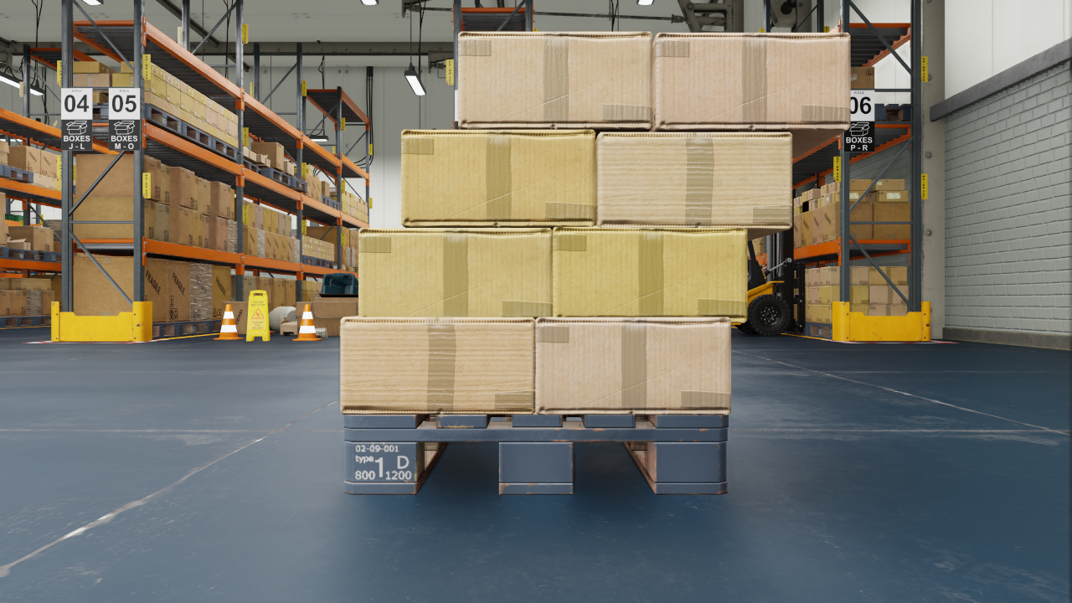
Using our sensors on the forklift we can detect situations where issues could occur. We won’t limit this to simply the payload, but will also include the environment in the area. Here’s my take on root causes for pallet ‘instability’:

- The payload extends outside of the pallet. We’re allowing 10cm extension beyond the pallet. The payload in the picture above exhibits this problem.
- The payload is too close to another object. Upon pickup this interaction is ‘not good’.
- There is something between the forklift and the front of the pallet. Basically the forklift will hit this before the pallet.
- The Payload is leaning, enough to topple on a pickup. This can be either/both left/right or front/back. The payload in the picture above shows a distinct, dangerous lean.
- Others, e.g., the pallet itself is in poor condition, the floor has a liquid spill on it, and most certainly more, feel free to add in the comments!

For now, I’m only going to address 1 – 4.

Additionally, though less related to payload instability other useful tests may be performed at this time. For example, testing if the payload is of similar size and shape to what was expected (as we often placed the pallet there in the past for storage.)

Getting Started

The scenario is that we have an autonomous forklift – motors, battery, probably running a ROS stack, etc. - but that’s all out of our scope here. What we’re given is that the forklift has one or more sensors. To start with there is a point cloud producing sensor such as a 3D LIDAR. In the ‘next steps’ section we’ll talk about solely using an RGB sensor and inferring the point cloud.

Here’s a visualization of a point cloud. This shows the RGB image superimposed on the 3D point cloud.
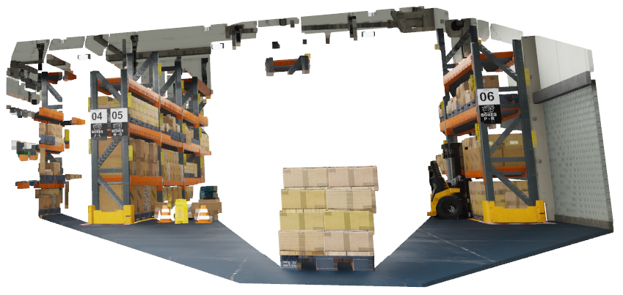
Prior to our invocation, the forklift as navigated to a position to pickup a pallet. It was provided this information from a warehouse control system (WCS), managing the overall movement of pallets and multiple forklifts. For this situation, we’re also assuming that we know the precise location of the pallet – enough for a pickup – the WCS only provided an approximate location. Again, in the ‘next steps’ we mention how this also has been implemented.

We can also specify precises figures that surround our pallet and payload – in terms of dimensions and safety zones.
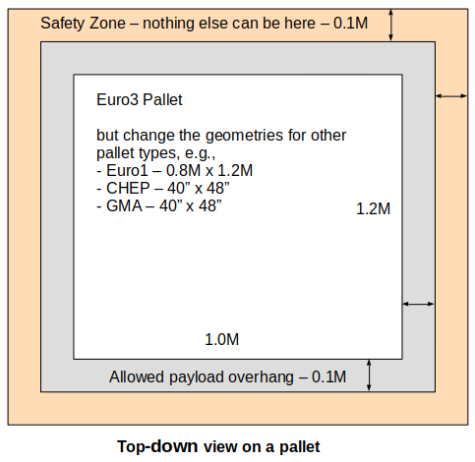

The size of the allowed payload overhang and safety zone can of course be altered depending on needs.

Note that all data here is created using a simulator, in this case using Nvidia Isaac Sim. Clearly, duh for practicality this needs to be done in the real world – real sensors (with noise), real situations.

Let’s Solve This!

Note that this is a conceptual proof of concept. As noted in ‘next steps’, there is much work to be done to take this to production.

Point Clouds

Given that we have a point cloud, the place to start are some tests based on ‘stuff’ being in rectangular boxes. Btw, this can get more sophisticated – but let’s solve the base cases for now.

Take the ‘root causes’ defined earlier:
- The payload extends beyond where it should. Solution – is there any ‘stuff’ in the safety zone? (defined in the image above.)
- The payload is too close to another object. Solution – again, is there any ‘stuff’ in the safety zone?
- There is something between the forklift and the front of the pallet. Solution – is there any ‘stuff’ between the front of the pallet (allowed pallet overhang) and the camera/forklift?
- Payload leaning. Solution - look at the lean separately for the left/right and the front/back rotations (pitch and roll.) Determining the extent of allowed lean angle is left for some fun experimentation. :)

Point Cloud zone - Calculate ‘stuff’ in a zone

We can use as a proxy for how full a zone is by the number of points in that zone in the point cloud. This is easily found using:
len ( pc.points )

Using some simple geometry mathematics, we can find the size of more interesting shapes, such as for only the Safety Zone Border - as seen in the following diagram.
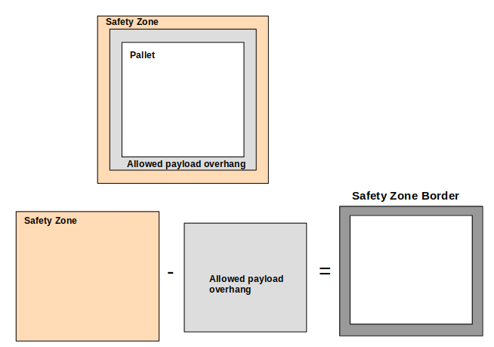

Angles of Lean

We’re going to look at both the front-on view for roll (XZ) as well as a side view for pitch (YZ). Either can cause instability.

To find the angle of the stack, the approach is:
- Convert the point cloud into an image mask
- Using OpenCV
  - find the largest contour
  - perform fitLine to that contour – this gives us our angle
- Overlay this line on the image for presentation.

Here are examples from a slight lean – to the right and a little forward.

First the front/roll view

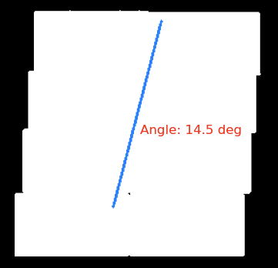
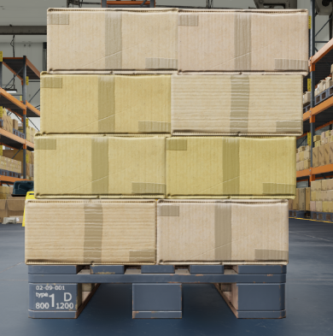

Then a side/pitch view, note the limited data as this comes from the point cloud

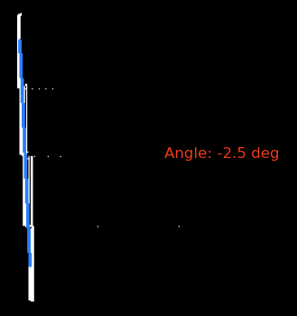

The angle where the payload is unstable is left as a fun exercise for the lab!

Code

To see the code for this solution, see the GitHub at

My tools of choice include VS Code and Python. For a point cloud library I used Open3D – this is easier to use and includes nice visualization as compared to python wrappers on the point cloud library (PCL)

Open issues / Next steps

- Inferring a point cloud from an RGB sensor. The approach given assume a point cloud. The assumption is that this came from an (expensive) 3D LIDAR sensor. However, the needs here to be honest don’t require that accuracy, so perhaps a simpler, less expensive solution is available. One option is to use an RGB sensor backed by Machine Learning – monocular dense estimation. In the past I’ve used various ML models – a simple and fast, but aging model is https://fastdepth.mit.edu/. There is newer work available.
- Accurately identifying the pallet pose from an RGB sensor. In this case the assumption was that we know the exact pose of the pallet. In the real world, the estimated position can be estimated to be off by up to 0.3M or so from the real pose – so a step must be taken to find the exact pose. There are multiple approaches to take here – I’ve gravitated to ML based solutions. I’ve had great success with a relatively simple approach using key point detection followed by PnP to estimate the pose – in the real world this has provided X and Y precision to well under 0.01M and under 1° in error – more than adequate. For further research one group is https://cmp.felk.cvut.cz/sixd/workshop_2023/.
- The ‘real world’. This takes work. Some thoughts to consider:
  - The 3D LIDAR data above comes directly from the Isaac Sim simulator – the accuracy is perfect. A real sensor will require filtering to manage noise and other sensor concerns. And perhaps other sensor types might be utilized, e.g., time of flight (TOF), stereo vision, or other, e.g., IR ala RealSense (note that each sensor has challenges, such as things that are invisible to it.)
  - Testing for the breadth of situations. Lots of things to test.
  - Testing at all, i.e., where are things? Using a tape measure gets old quick. April tags can be clumsy, take work, and only get you so far. A full motion capture (MOCAP) environment is great – but expensive.
  - And of course, adding conditions that come from real world operations!

