Overview
This document is the Administrator Manual for the Calipso platform. It provides a guide for system, user, role, workflow and asset management functionality and options.
Calipso is a simple but horizontal and highly configurable task management and workflow platform. It can be eaily customized and adapted to your organization's business procedures, goals and structure. Calipso's features include unlmited workflows, user and roles management, custom fields with per-worflow-state permissions, e-mail and LDAP integration, configurable file attachments, detailed history and reporting and fully customizable asset management.
Bellow you can find an overview of the features available in Calipso, as well as the terms used to describe those.

Workflow Management
A Calipso workflow defines all aspects of a business procedure, including the states (steps) composing it, the participating roles or users, the organizational assets involved and the custom fields that capture all relevant information. An item in Calipso is what other systems call a “ticket” or “case”. Items may have dependencies between them and follow the rules of the workflow they belong to. Access to workflow items is subject to workflow roles configuration.
Workflow States break a workflow down into steps. Calipso allows fine-grained access rights to be defined for any custom field per role and workflow step combination. States also define business logic plugins and email notification rules. A workflow can have any number of possible paths from one state to another depending on role rights.
State Plugins are used for implementing custom business logic within a workflow and are defined per workflow state. Plugins are often used for pulling or pushing information from and to third-party systems. Calipso includes some commonly used plugins useful for copying asset information into an item, creating or updating assets etc.

Custom fields are mapped in the Calipso user interface as form or other user interface elements of an item. There are different types of fields and their values may be entered by users or automatically by business logic plugins. Field access rights depend on the roles and workflow state in context. The available access rights per state are invisible, read-only, mandatory-if-empty and mandatory.

Workflow Roles are perhaps the most important role type from a user's functional perspective since they allow the definition and management of access rights within a specific workflow. Workflows may use predefined roles such as “Workflow Administrator” or “Guest”, or custom roles such as “Support Engineer” or “Sales Representative”. Workflow roles may also be explicit or implicit regarding the users they apply to, for example the “QA Engineer” is an explicit role as it applies to specific users. Implicit roles may also be used depending on workflow configuration; those include “Guest” (any logged-in user) and “Anonymous”.
A role has specific field level rights per state as well as origin-destination state combination rights. For example consider a simplistic bug reporting workflow, where a QA Engineer is able to change the state of an item to “Open” and “Closed” whereas a Developer can only change the state to “Fixed” and assign the item to the QA Engineer for review.

Asset Management
An asset in Calipso is a reference to any material or immaterial object that has a business meaning within your organization, such as hardware or software, buildings or conference rooms, vehicles, SLAs or other contracts etc. Calipso allows you to create asset types to structure the characteristics (attribute types) for any class of objects that is meaningful for your organization. Assets of a specific type may then be created or updated manually, or as a result of a workflow. Assets may also be exported as PDF for printing. Calipso also lets Workflow Administrators define their own print templates with Velocity and converts the resulting HTML to PDF documents.

Search and Reporting
Calipso includes powerful search and reporting tools. You can search for items in any or all workflows, according to your access rights of course. Your search criteria can map directly to custom fields created for a workflow, allowing you to express any filters that are meaningful to your business. System or workflow Administrators can also save search criteria, thus promoting searches to reports other users can view any time depending on item visibility settings. Both search and reporting results can be exported to spreadsheets for further processing using office suites such as MS Office or OpenOffice.org.

Administrative Tasks

Login
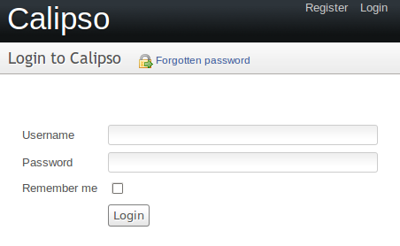Screen 1: Login form

Your Account

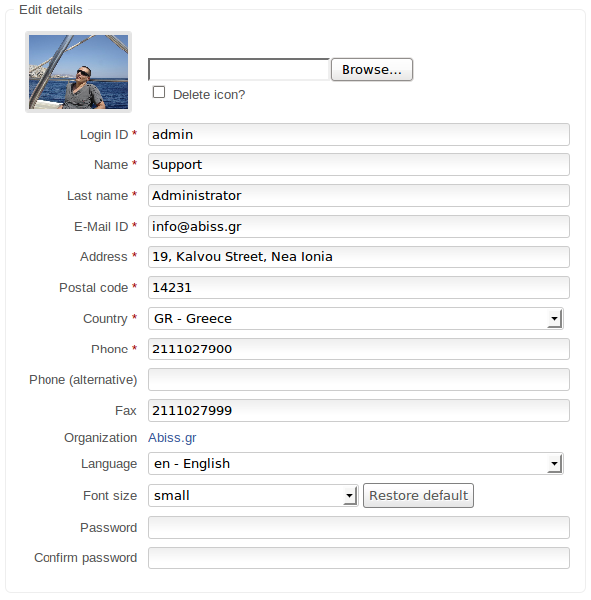Screen 2: Editing your user details

Options Page

Managing Users

User List
To see the list of registered users navigate to Options > Manage Users. You will then be presented with a list of registered users; from there you can search using user-based criteria, edit an existing user and associated roles, as well as create a new user.
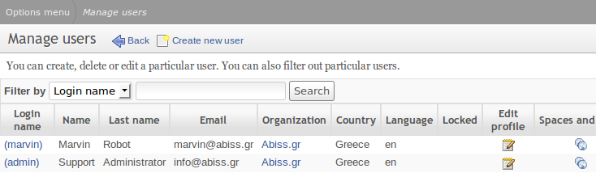Screen 3: The user list

Create or Update a User
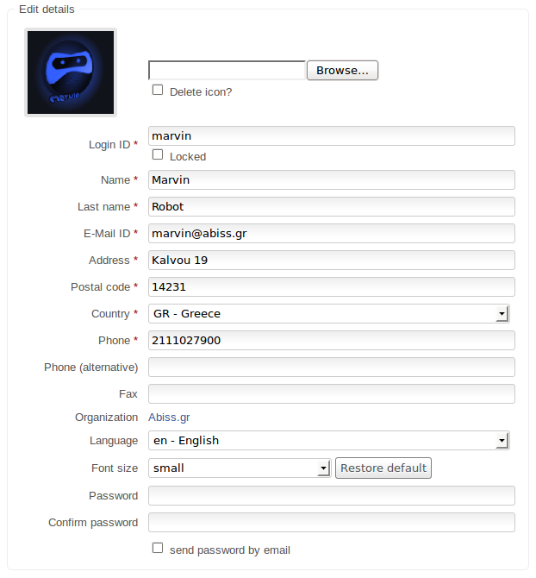

Self Registration

Managing a Workflow

Languages

Details

Custom fields

Roles and States

Adding Users

