The spot EUR/USD quoted in Bloomberg (I call it ${FX}_{EUR/USD}^{ON}$) is the spot for a exchange that happens in two days (depending on the convention) and cannot be used to convert a transaction that happens asof today.
The FX convertion asof today is equal to:
$$S_{EUR/USD}={FX}_{EUR/USD}^{ON}-{FXSwap}_{ON}-{FXSwap}_{TN}$$

In T, we have 1 unit in EUR
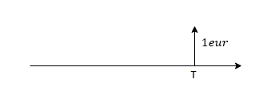
We convert it into $1eur*{FX}_{eur/usd}^{T}$ if USD where ${FX}_{eur/usd}^{T}$ is the FX forward prevailing at 0 for maturity T
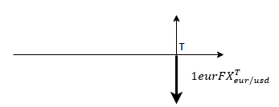
We discount this amount into the local curve at 0, giving us $1eur*{FX}_{eur/usd}^{T}*{DF}_{USD}^{T}$
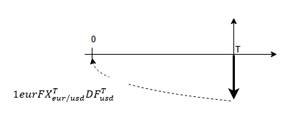
We convert this amount back in EUR:
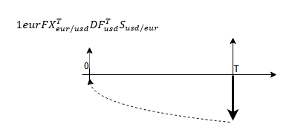
This give us $1eur*{FX}_{\frac{eur}{usd}}^{T}*{DF}_{USD}^{T}*S_{USD/EUR}$
This present value of 1 EUR si had we discount if on the FXCurve :

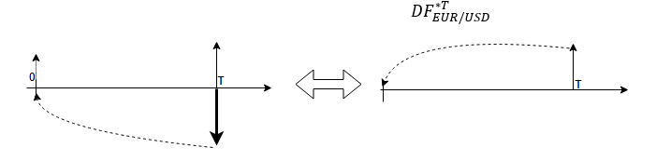

$${DF}_{EUR/USD}^{*T}={FX}_{EUR/USD}^{T}*{DF}_{USD}^{T}*S_{USD/EUR}$$
${DF}_{EUR/USD}^{*ON}$=${FX_{EUR/USD}^{ON}*DF}_{USD}^{ON}*S_{USD/EUR}$
So:
$${DF}_{EUR/USD}^{*T}=\frac{{FX}_{EUR/USD}^{T}}{FX_{EUR/USD}^{ON}}\frac{{DF}_{USD}^{T}}{{DF}_{USD}^{ON}}*{DF}_{EUR/USD}^{*ON}$$

$${DF}_{EUR/GBP}^{*T}={FX}_{EUR/GBP}^{T}*{DF}_{GBP}^{T}*S_{GBP/EUR}$$
$${DF}_{EUR/GBP}^{*T}={FX}_{EUR/USD}^{T}*{FX}_{USD/GBP}^{T}*{DF}_{GBP}^{T}*S_{GBP/USD}*S_{USD/EUR}$$
$${DF}_{EUR/GBP}^{*T}=\frac{{FX}_{EUR/USD}^{T}*S_{USD/EUR}}{{DF}_{USD}^{T}}*{DF}_{USD}^{T}*{FX}_{USD/GBP}^{T}*{DF}_{GBP}^{T}*S_{GBP/USD}$$
$${DF}_{EUR/GBP}^{*T}=\frac{{FX}_{EUR/USD}^{T}*{DF}_{USD}^{T}*S_{USD/EUR}}{{DF}_{USD}^{T}}*{FX}_{USD/GBP}^{T}*{DF}_{GBP}^{T}*S_{GBP/USD}$$
$${DF}_{EUR/GBP}^{*T}=\frac{{DF}_{EUR/USD}^{*T}}{{DF}_{USD}^{T}}*{FX}_{USD/GBP}^{T}*{DF}_{GBP}^{T}*S_{GBP/USD}$$
$${DF}_{EUR/GBP}^{*T}=\frac{{DF}_{EUR/USD}^{*T}}{{DF}_{USD}^{T}}*\frac{{DF}_{GBP}^{T}*{DF}_{USD}^{T}}{{FX}_{GBP/USD}^{T}{DF}_{USD}^{T}S_{USD/GBP}}$$
$${DF}_{EUR/GBP}^{*T}={DF}_{EUR/USD}^{*T}\frac{{DF}_{GBP}^{T}}{{DF}_{GBP/USD}^{*T}}$$

Standard of the Market: CrossResetables Swaps (Resetability is on the USD leg, Spread is on the EUR leg)
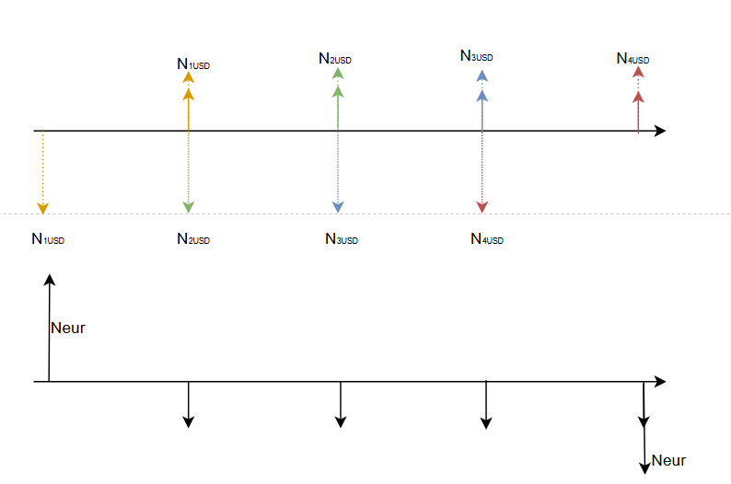
$${{NPV of EUR leg}_{EUR}=N}_{EUR,0}{DF}_{T_{0}}^{*}$$
$-\sum_{i=1}^{n}{N_{EUR}θ_{i}\left(r_{i}^{EUR}+XCCY\right){DF}_{T_{i}}^{*}}$
${-N}_{EUR,0}{DF}_{T_{n}}^{*}$
Let’s define: $N_{USD,i}=\frac{{FX}_{EUR/USD}^{ON}+{Spread}_{i}}{{FX}_{EUR/USD}^{ON}}N_{USD,0}$

$${NPV of USD leg}_{USD}=N_{USD,0}{DF}_{T_{0}}$$
$$-\sum_{i=1}^{n}{\left(N_{USD,i-1}-N_{USD,i}\right)}{DF}_{T_{i}}$$ $-\sum_{i=1}^{n}{N_{USD,i}θ_{i}}r_{i}^{USD}{DF}_{T_{i}}$
$$-N_{USD,i}{DF}_{T_{i}}$$ then NPV of CrossCurrencyBasisSwap:
$$TotalNPV=\left({NPV of EUR leg}_{EUR}\right)S_{EUR/USD}-\left({NPV of USD leg}_{EUR}\right)$$

$r_{i}^{EUR}$: ith forward rate on the ESTEUR curve
$r_{i}^{USD}$: ith forward rate on the SOFR curve
${DF}_{T_{i}}$: ith DF on the SOFR Curve
${DF}_{T_{i}}^{*}$: ith DF on the FXCurve
$XCCY$: quoted Cross Currency basis swap spread
$N_{USD,0}$: Nominal in USD at inception of the swap
$N_{EUR}$: Nominal in EUR at inception of the swap
${FX}_{EUR/USD}^{ON}$: Spot EUR/USD
${FX}_{EUR/USD}^{ON}+{Spread}_{i}$: Forward EUR/USD
$S_{EUR/USD}$: FXInstant
From ${DF}_{T_{i}}^{*},$ we can imply zc*, which could be considered as yield that we would get if we refinance EUR variation margins using USD collateralization.

est le discountFactor tel que :
est le discountFactor tel que :

