/\*\*\*\*\*\*\*\*\*\*\*\*\*\*\*\*\*\*\*\*\*\*\*\*\*\*\*\*\*\*\*\*\*\*\*\*\*\*\*\*\*\*\*\*\*\*

Workshop #1

Course: JAC444NCC - Fall2020

Last Name: Nguyen

First Name: Pham Gia Bao

ID: 125433177

Section: NCC

This assignment represents my own work in accordance with Seneca Academic Policy.

Signature

Date: September 26th 2020

\*\*\*\*\*\*\*\*\*\*\*\*\*\*\*\*\*\*\*\*\*\*\*\*\*\*\*\*\*\*\*\*\*\*\*\*\*\*\*\*\*\*\*\*\*\*/

Instruction: Open the workshop1 project folder in eclipse then run and build the class the src folder.

Below are output screenshots.

Tas1:

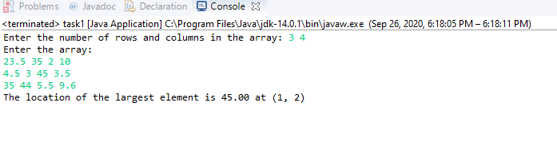

Logic: input array -> assign temp max variable to the first element in the array[0][0] -> Loop through the array -> if max < array[row][column] -> assign max = array[row][column] -> prompt max value and its location

Task 2:

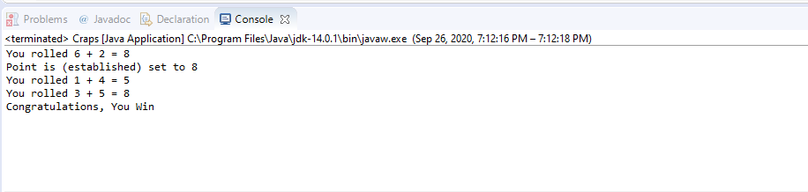

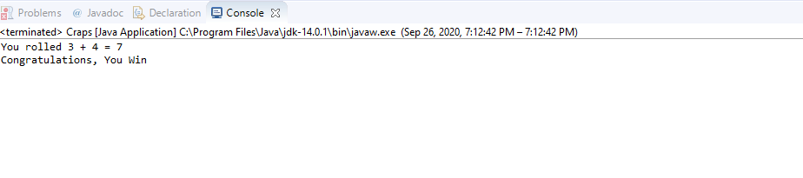 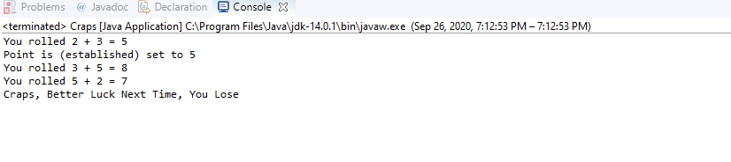

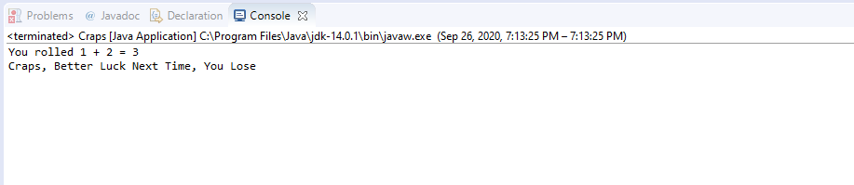

Logic:

Reflection:

During this workshop I have learn the practice of creating method class. Further, it remind me about the datatype concept especially for datatype for 2 dimension array. I also using conditional statements in these workshops to direct the logic of the program.