Cosmo Apparel provides an online shopping experience to users with designs that put emphasis on the cosmos and a color palette to match.

The website contains a navigation bar that allows users to visit the Home page, Shop, FAQ, and About Us.

The Hompage contains the website’s logo, a carousel of the different items for sale, and a button that redirects the user to the shop.

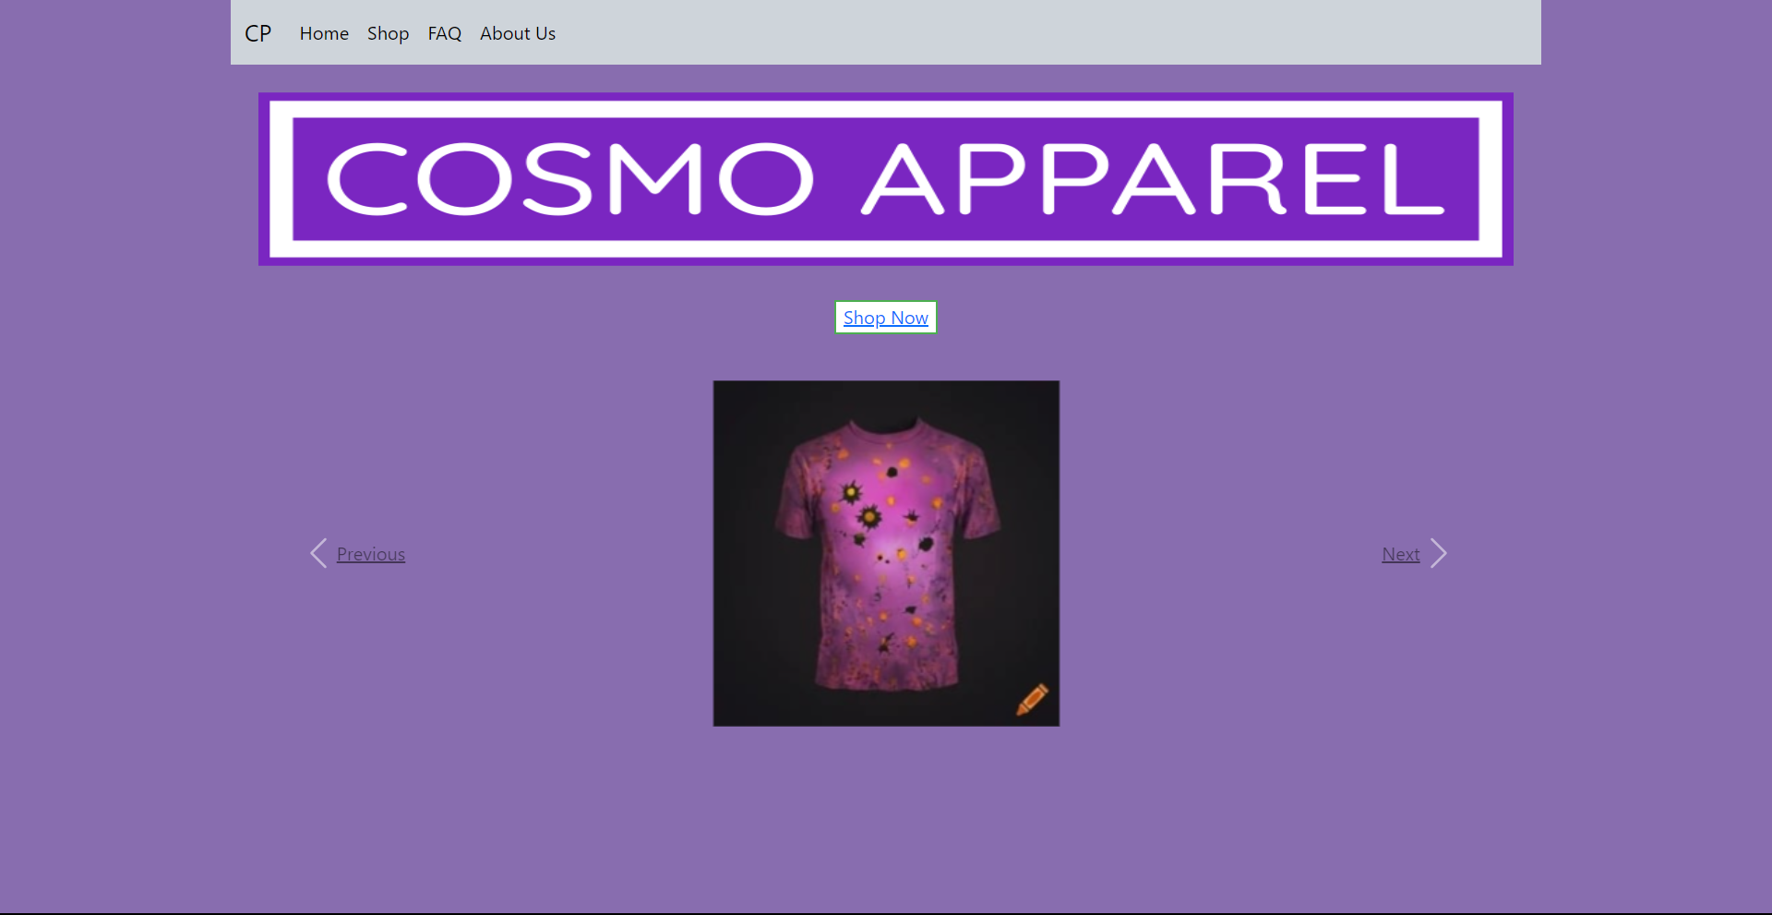

At the shop, users may browse the products through either a grid view or a list view.

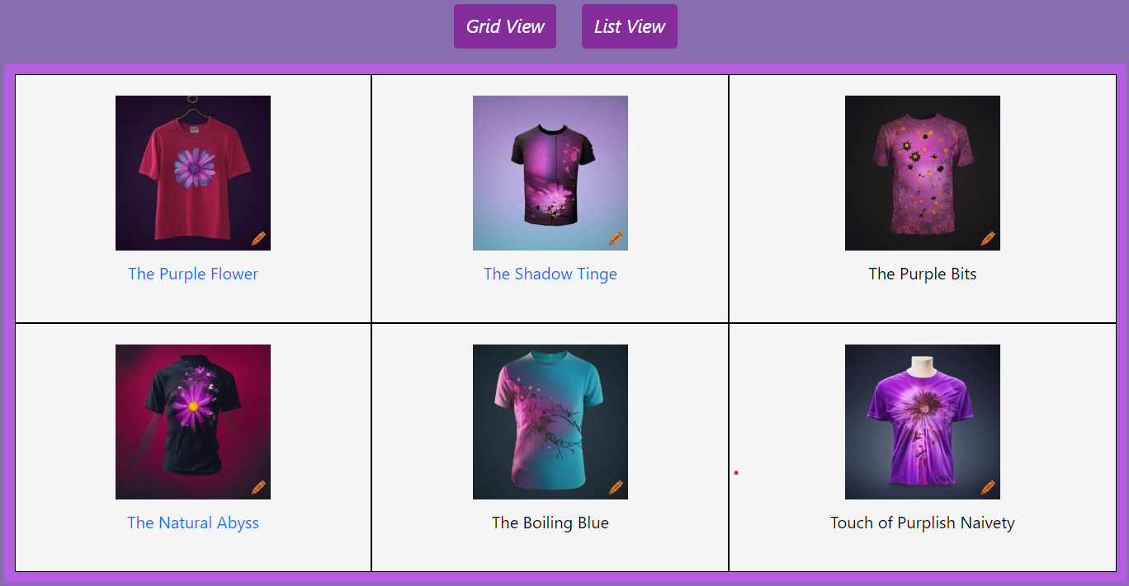

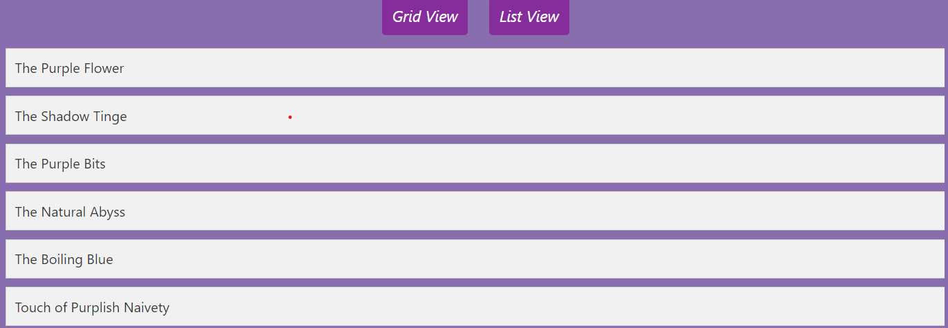

After choosing a design, the user will be asked to select the desired size of the shirt.

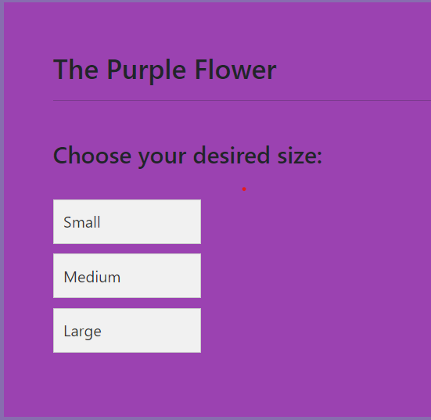

Before buying, the user will be able to see the shirt’s design, description (“c” is used as a placeholder), size, price, and the remaining stock.

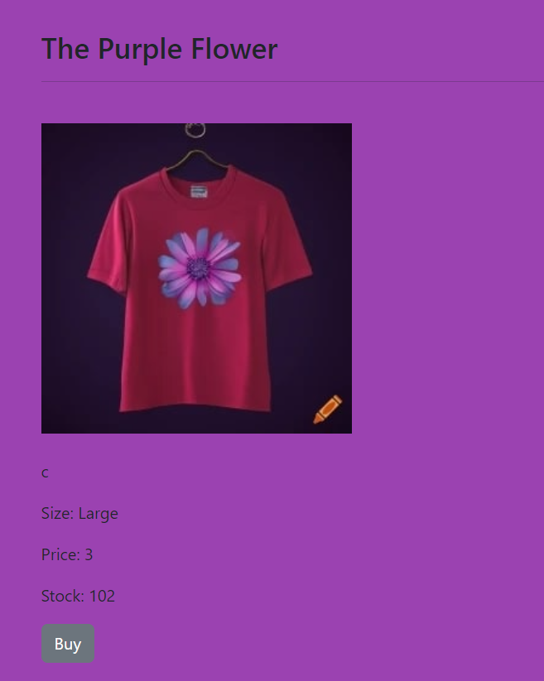

Users will then have to provide their name, contact details, address, and proof of payment which will be stored in the database.

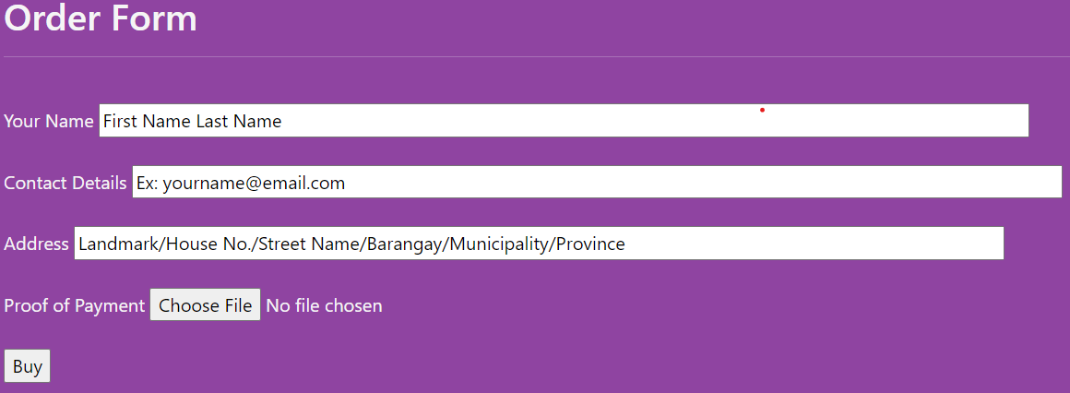

After providing the necessary information, the user will be shown their purchase summary and will be given the option to return to the home page or to continue browsing the products.

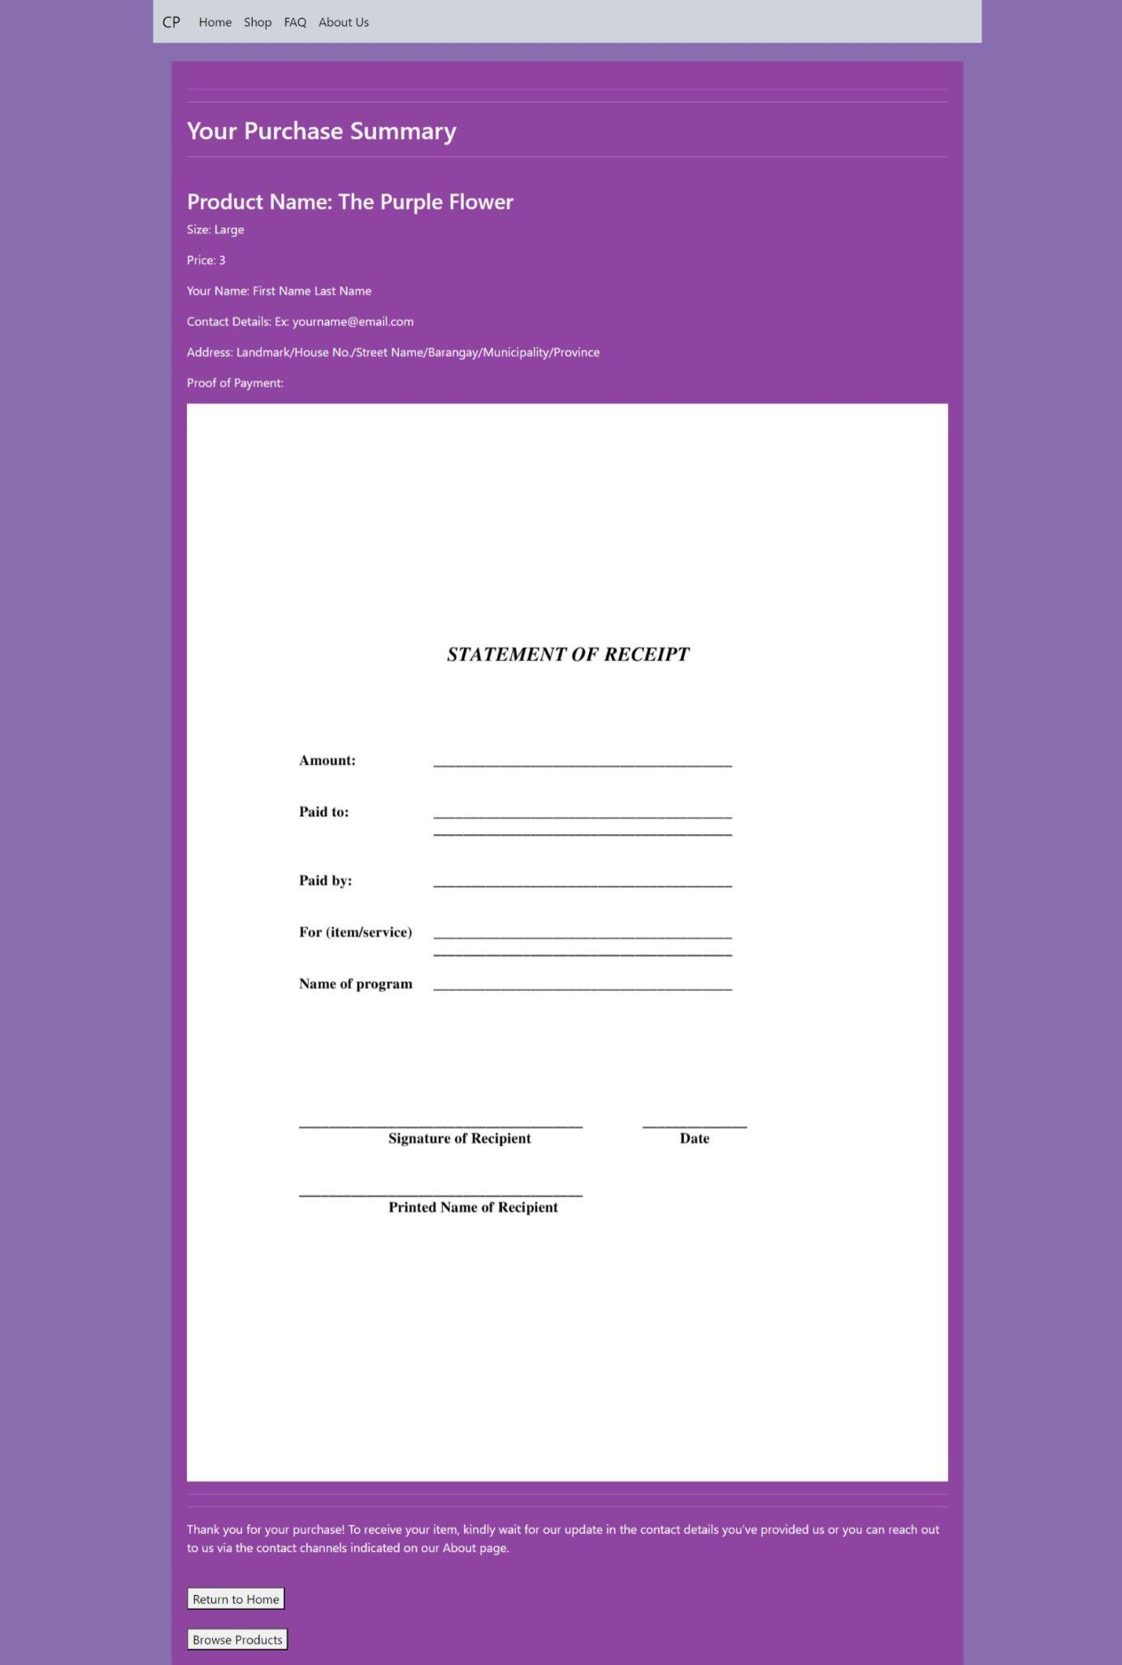

Below, is the FAQ containing information on the shirt sizes and accepted mode of payment.

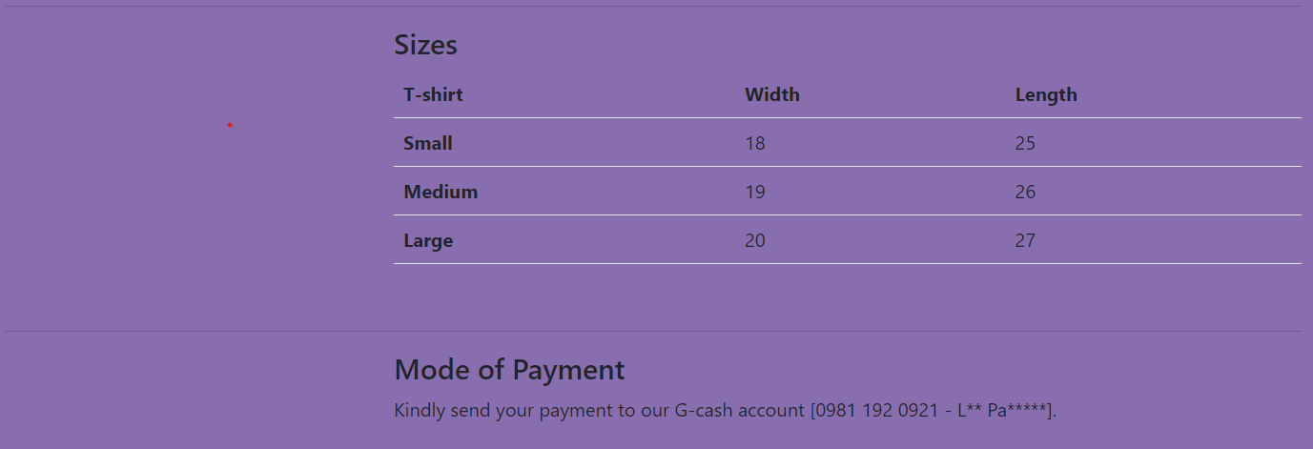

The About page contains information about the website and a login option for the seller.

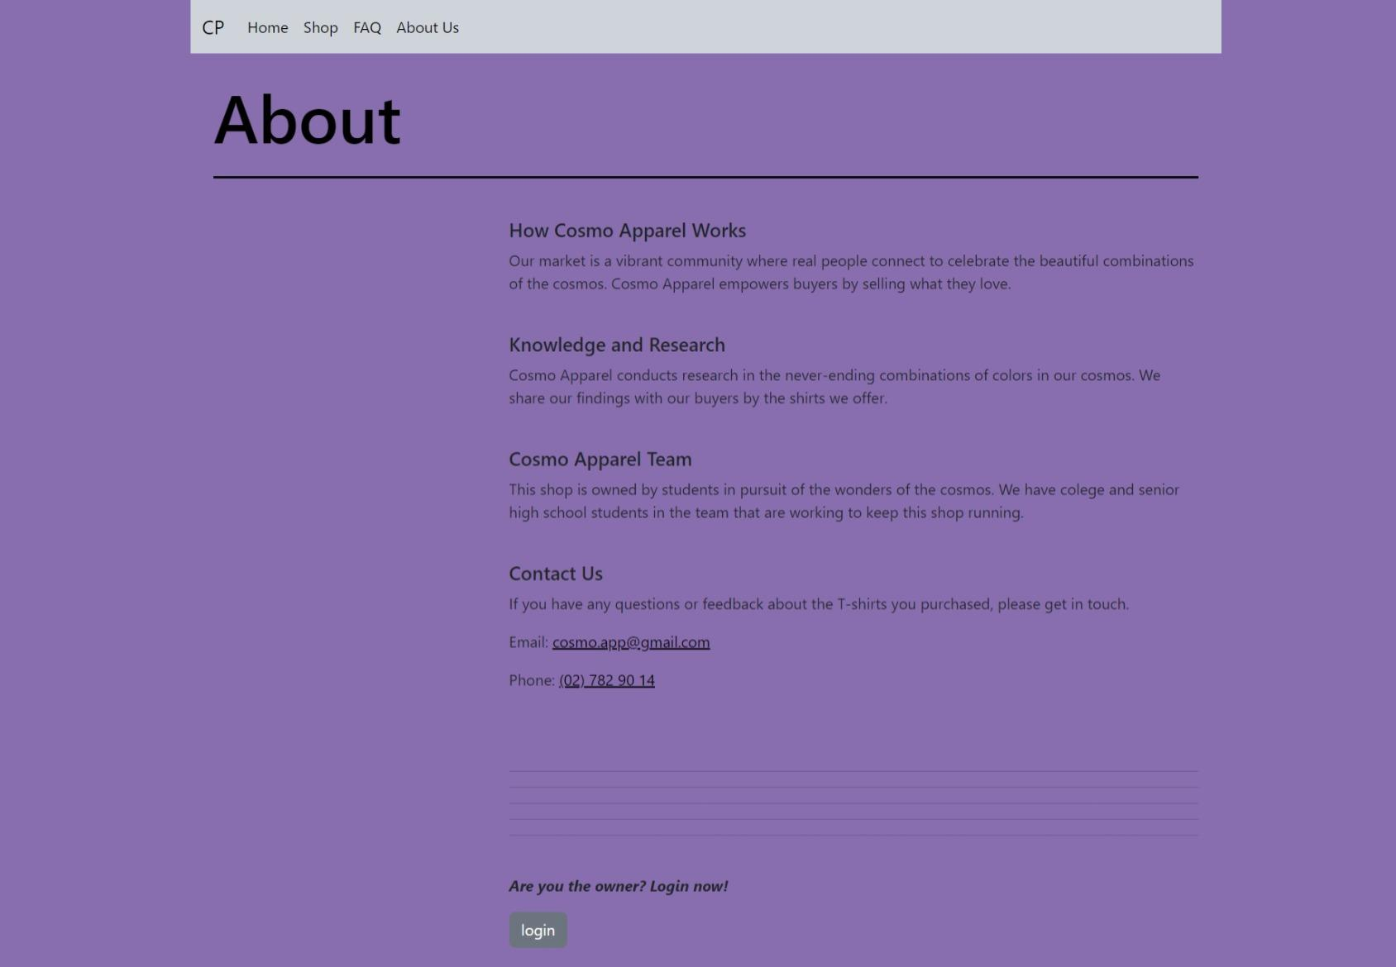

After inputting the correct password (“itsme”) and logging in, the user will be able to register a new product. The navigation bar will also contain new links, Sell and Logout.