# 

Downloading the VM (includes data sets)

Alternative - download data sets

Virtual machine setup

Using Oracle VirtualBox

Using VMWare

# Downloading the VM (includes data sets)

1. Download it from <http://content.udacity-data.com/courses/ud617/Cloudera-Udacity-Training-VM-4.1.1.c.zip>. Warning - the zipped file size is 1.7 GB
2. MD5sum file can be found here <http://content.udacity-data.com/courses/ud617/Cloudera-Udacity-Training-VM-4.1.1.c.zip.md5>
3. Unzip it. Warning - the unzipped size is 4.2GB

# Alternative - download data sets

Download and unzip data sets from:

* <http://content.udacity-data.com/courses/ud617/access_log.gz>
* <http://content.udacity-data.com/courses/ud617/purchases.txt.gz>

# Virtual machine setup

## Using Oracle VirtualBox

1. Download and install VirtualBox from <https://www.virtualbox.org/wiki/Downloads>
2. Create a new Virtual machine:
   1. Create a new virtual machine by pressing the ‘New’ button:  
      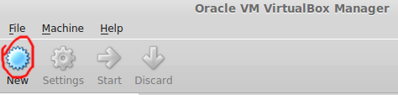
   2. Choose a name, use ‘Type’: ‘Linux’: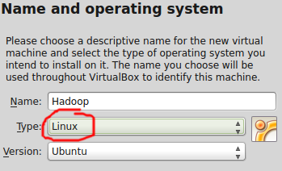
   3. Press Next
   4. Select memory size for the VM.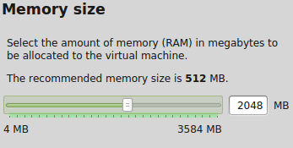
   5. Press Next
   6. Select ‘Use an existing virtual hard drive file’’, click the button to browse to the directory you unzipped the provided VM image and press ‘Create’.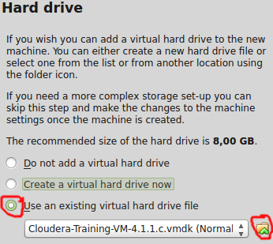
   7. Start the VM!  
      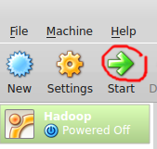

## Using VMWare

1. Download and install from <https://my.vmware.com/web/vmware/free#desktop_end_user_computing/vmware_player/6_0>
2. Create the Virtual Machine:
   1. Click on ‘Open a Virtual Machine’ and, when prompted, navigate to the folder you unzipped the VM, choose the file and click ‘Open’.  
      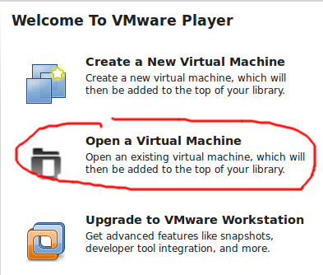
   2. Select the machine and click ‘Play virtual machine’