REPOSITORY REPORT
New Castle, Colorado
Every piece of LIHTC, demographic, market, and policy data the COHO Analytics repository carries for New Castle (Garfield County · place GEOID 0853395).

1. Identity
Place name | New Castle (town)
Place GEOID | 0853395
Place type | Incorporated town
Containing county | Garfield County (FIPS 08045)
Region | Western Slope · Roaring Fork Valley
Centroid | 39.577645, -107.526453
Census tract(s) | 08045951902 (100% coverage)
Area | 6,699,613 m² (≈6.7 km²)
QCT 2026 | No (no QCT tracts in Garfield County)
DDA 2026 (county-level) | YES — Garfield County is a county-wide Non-Metro DDA (DDA_CODE: NCNTY08045N08045, DDA_TYPE: NM)
DDA 2026 (for New Castle) | YES — by inheritance.

Why New Castle is DDA-eligible even though it isn't on the HUD list by name. HUD designates DDAs at two scales: by ZIP code in metro areas (SDDA) and by entire county in non-metro areas (NM-DDA). There is no separate town-level designation. New Castle is non-metro, so the relevant designation is the county-level NM-DDA — and Garfield County IS on the 2026 NM-DDA list. Any LIHTC project anywhere in Garfield County, including every parcel in New Castle, qualifies for the 30% basis boost under IRC §42(d)(5)(B).
On a 9% deal with $10M eligible basis, the DDA boost lifts qualified basis to $13M. At ~$0.85 credit-price-to-equity over the 10-year credit period, that translates to roughly $2.55M of additional equity from the boost alone.

2. Demographics & population
Source: ACS 2024 · HNA ranking index.
Population | 4,880
20-year projection (county proxy) | ≈6,117
CO statewide percentile | 68.5th
Median household income | $80,084
Total housing units | 2,056
Owner-occupied | 73.1% (1,510)
Renter-occupied | 26.9% (546)
Vacancy rate | 0.0%
Single-family detached | 66.7%
Multifamily 5+ unit | 20.6%
In-commuters (LEHD) | 602
Out-commuters (LEHD) | 2,277
Internal jobs | 121
Out-commute ratio | 83.3%

3. Housing market & affordability
Source: ACS 2024 · HUD MTSP FY2025 · CHAS 2018-2022.
Median gross rent | $1,393 / month
Median home value | $454,300
4-person AMI (HUD MTSP FY25) | $97,600
Affordable rent at 30% AMI | $732 / month
Affordable rent at 40% AMI | $976 / month
Overall cost-burdened households | 70.2%
Owner cost-burdened (≥30% income) | 31.2%
Need score (HNA composite) | 72.4 (high)

Renter cost burden by AMI tier (CHAS)
AMI band | Share cost-burdened
≤30% AMI | 100%
31–50% AMI | 100%
51–80% AMI | 22%
81–100% AMI | 100%
>100% AMI | 0%

Units needed to close the affordability gap
AMI tier | Units needed
≤30% AMI | 220
≤50% AMI | 305
≤60% AMI | 385

4. Affordable housing properties in New Castle
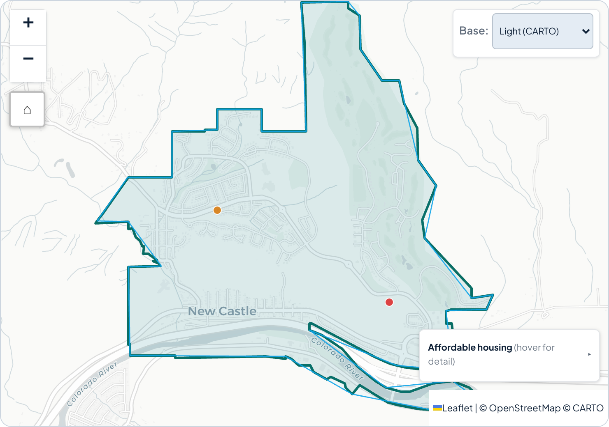
Figure 4.1 · New Castle town boundary with affordable-housing overlays. Orange dot is Lakota Ridge Senior Housing. · Geography: New Castle place · #
The repository records two affordable housing properties in New Castle — one LIHTC, one HUD multifamily. Both are on the CHFA preservation candidate list.

Property 1 — Lakota Ridge Senior Housing
Program type | LIHTC (9% Competitive) + Preservation candidate
Address | 705 Castle Valley Blvd, New Castle, CO 81647
Coordinates | 39.572127, -107.517518
Total units | 50
Affordable units | 49
Project type | New Construction
Award / PIS year | 2016 / 2016 (AwardDate 2016-09-01)
Urban / Rural | Rural
Region | Western Slope
Population mix | Senior: 50 · Family / Homeless / Veteran / Supportive: 0
AMI unit mix | 30% AMI: 5 · 40%: 5 · 50%: 10 · 60%: 29 · ≥70%: 0
Compliance status | Active Compliance
Non-profit sponsor | Not recorded
Property ID | lihtc:189

Property 2 — New Castle Senior Housing
Program type | HUD Multifamily (Section 202 / 811) + Preservation candidate
Address | 201 Castle Valley Blvd, New Castle, CO 81647
Coordinates | 39.579559, -107.535462
Total units | 24
Assisted units | 23
Subsidy type | HUD 202 or 811
Property category | 202/811
Use restriction | No
Troubled status | No
Property ID | hud-mf:800219534
Source | HUD MULTIFAMILY_PROPERTIES_ASSISTED · CHFA PreservationProperties_Layer_Final_view_new
Total affordable inventory in New Castle: 74 units across 2 properties · 72 affordable. No USDA RD, no PBV-local, no other independent deed-restricted properties are recorded for the town.

5. Awarded LIHTC projects in Garfield County
Twelve projects across the county, from the CHFA HousingTaxCreditProperties live feed filtered to CNTY_FIPS == "08045". Sorted by award year, most recent first.
Year | Project | City | Units | LIHTC | Credit | Population
2024 | Canyon Vista | Glenwood Springs | 80 | 80 | 4% + State | Family
2024 | Aster Place | Parachute | 58 | 58 | 9% + State | Family
2023 | Rifle Apartments | Rifle | 60 | 60 | 9% Competitive | Family
2023 | Benedict | Glenwood Springs | 34 | 34 | 9% Competitive | Senior
2019 | Red Hill Lofts | Carbondale | 30 | 30 | 9% Competitive | Family
2019 | Maxfield Heights | Rifle | 50 | 50 | 9% Competitive | Senior
2016 | Manors I and II | Glenwood Springs | 76 | 76 | 4% Tax Exempt | Senior
2016 | Lakota Ridge Senior Housing (New Castle) | New Castle | 50 | 49 | 9% Competitive | Senior
2011 | Glenwood Green Apartments | Glenwood Springs | 60 | 60 | 9% Competitive | Family
2002 | White River Village | Rifle | 29 | 29 | 9% Competitive | Family
1998 | Eagles Nest Rifle | Rifle | 30 | 30 | 9% Competitive | Family
1994 | Villas de Santa Lucia | Carbondale | 61 | 60 | 9% Competitive | Family
By city: Glenwood Springs 4 (250 units), Rifle 4 (169), Carbondale 2 (91), New Castle 1 (50), Parachute 1 (58). Totals: 12 projects · 618 units · 614 LIHTC-restricted. The 2026 R1 bridge file shows no Garfield-area award in 2026.

6. Failed LIHTC application attempts — New Castle only
Filtering the repository's failed-application records (the .notAwarded array in chfa-awards-historical.json) to New Castle and Garfield County (FIPS 08045) across calendar years 2021–2026 returns these results:
Headline finding — 0 failed deals on file for New Castle.

This zero is not authoritative. The repository's failure dataset is a five-row, hand-curated qualitative sample — built to feed the policy-briefs evidence panel, not a complete record of every Letter of Intent CHFA received. The authoritative LOI Reports exist as PDFs on CHFA's site; their row data is not parsed into structured form anywhere in this repository.
Sponsor-level search. The 27 awarded rows in chfa-awards-historical.json carry no sponsor field, so queries like "has Shopworks ever applied in New Castle?" cannot be answered against the current data.

7. Charts for New Castle
The charts in this section come straight from New Castle's page on the COHO Analytics website. Only the charts that actually have New Castle-level data are shown here — charts that fell back to containing-county data (the age pyramid, senior growth pressure, population projections, the Prop 123 trackers) are deliberately left out of this report. Each chart below carries a Geography tag in its caption so you know exactly what the numbers reflect.

Housing stock & tenure
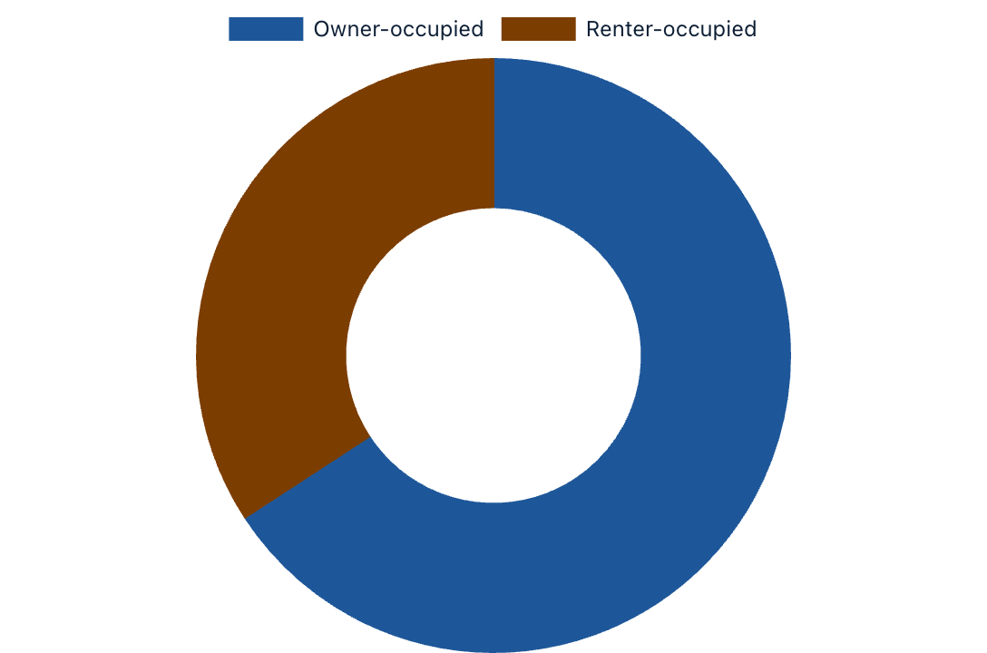
Tenure mix — owner / renter / vacant · Geography: New Castle · #chartTenure
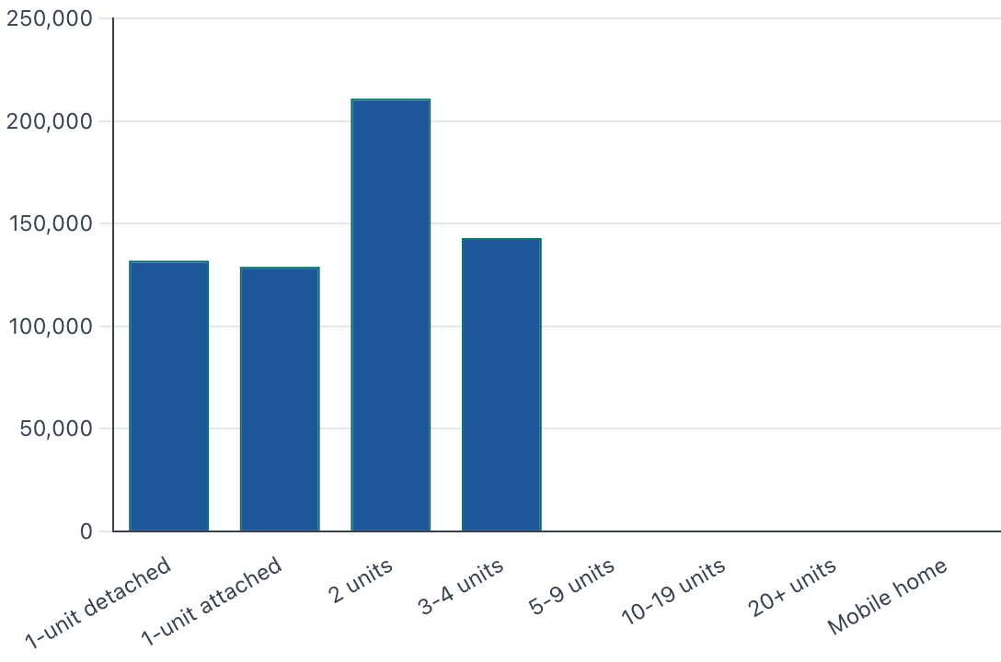
Housing units by structure type · Geography: New Castle · #chartStock
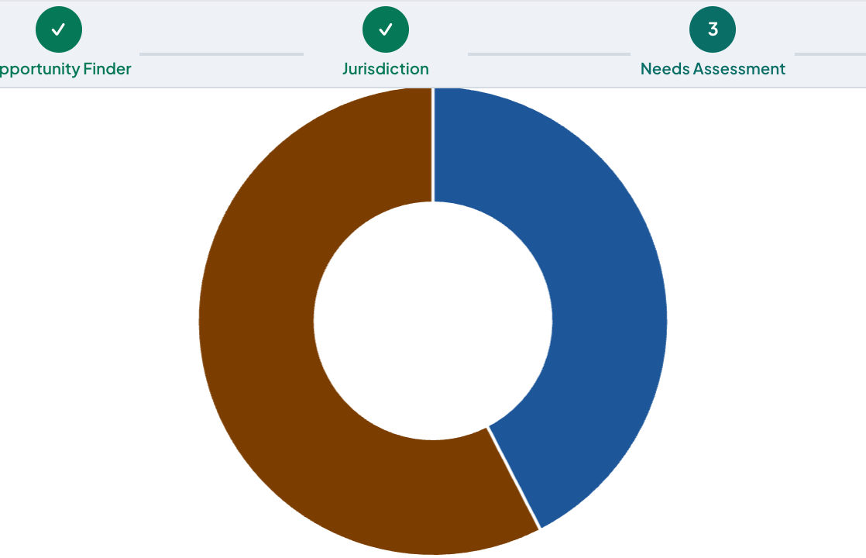
Housing-type composition · Geography: New Castle · #chartHousingTypeComposition
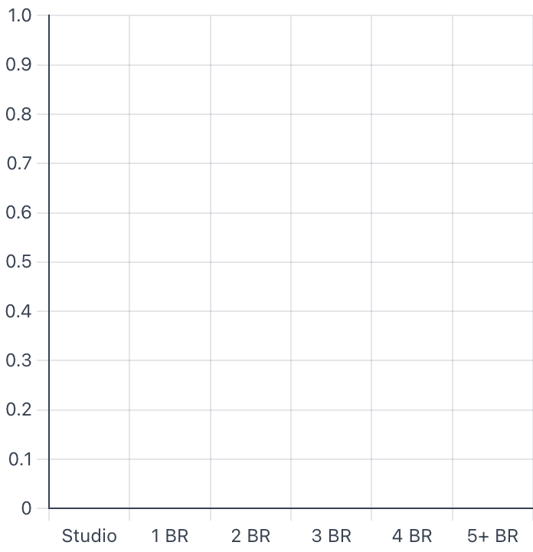
Bedrooms per unit · Geography: New Castle · #chartBedroomMix
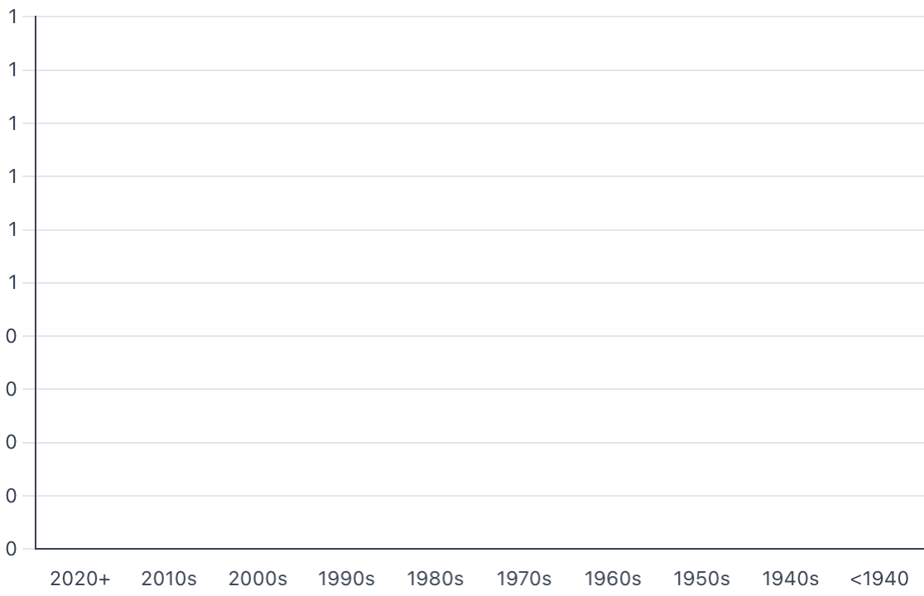
Year structure built · Geography: New Castle · #chartConstructionEra

Affordability & cost burden
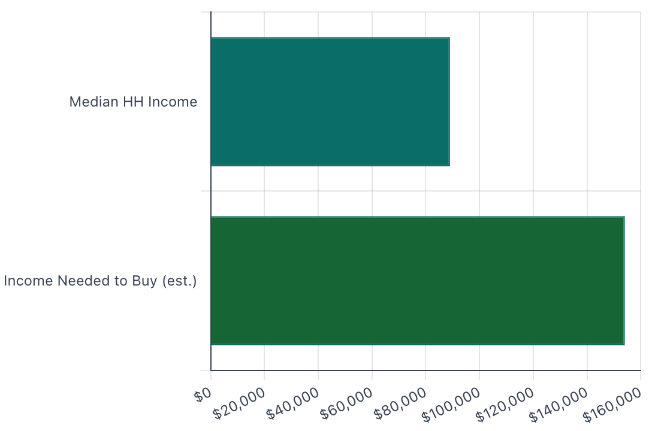
Income required to buy the typical home · Geography: New Castle · #chartAfford
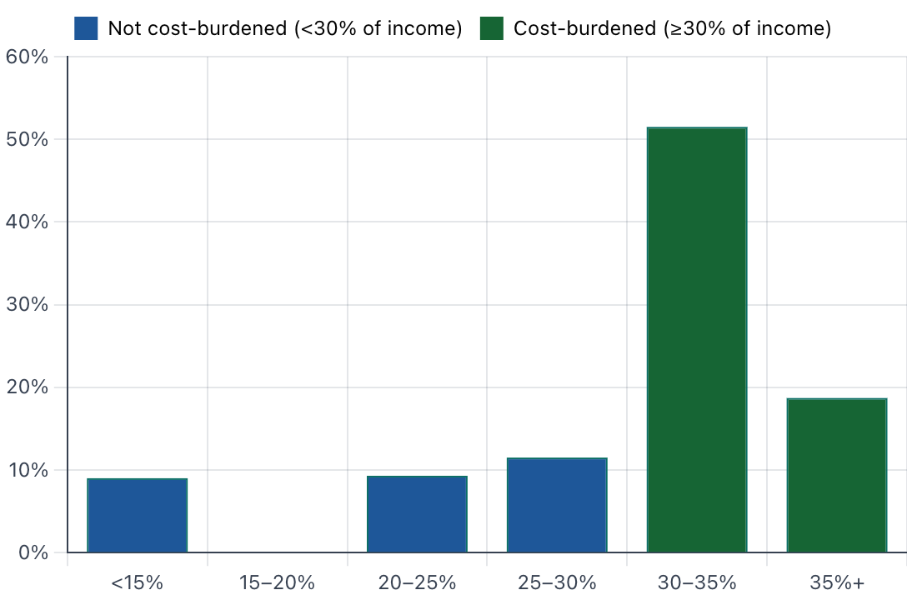
Rent burden distribution (GRAPI bins) · Geography: New Castle · #chartRentBurdenBins
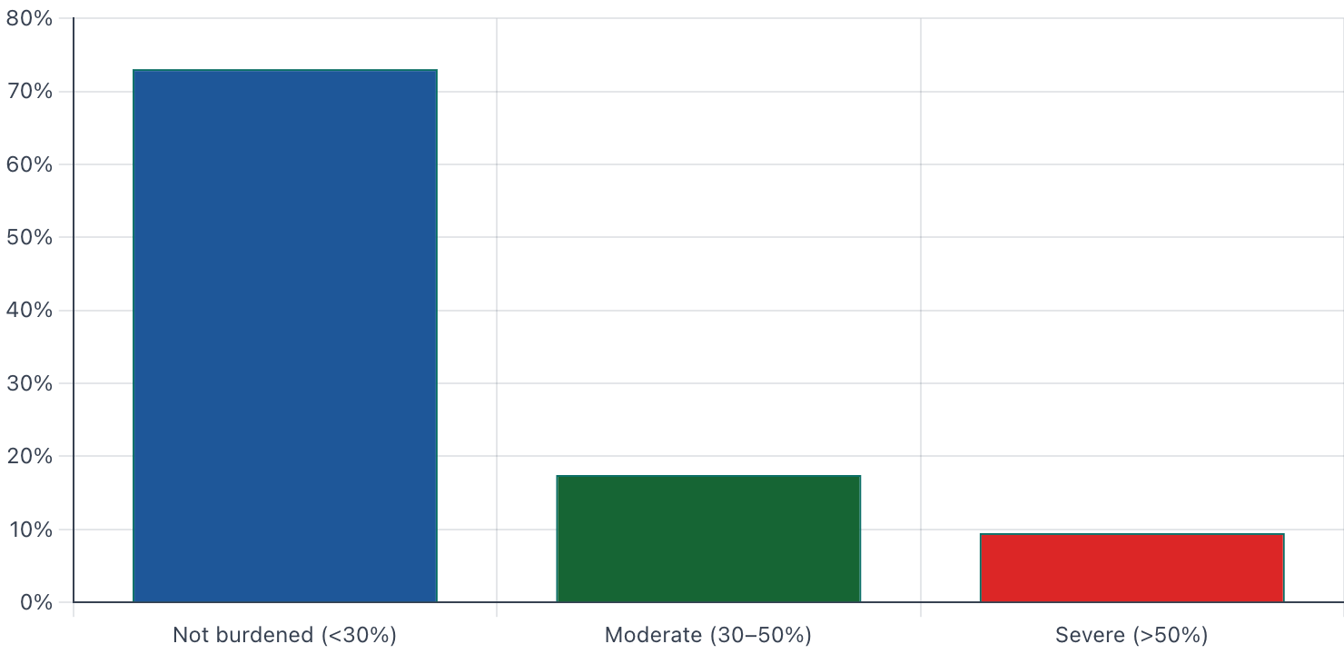
Owner cost burden (SMOCAPI bins) · Geography: New Castle · #chartOwnerCostBurden
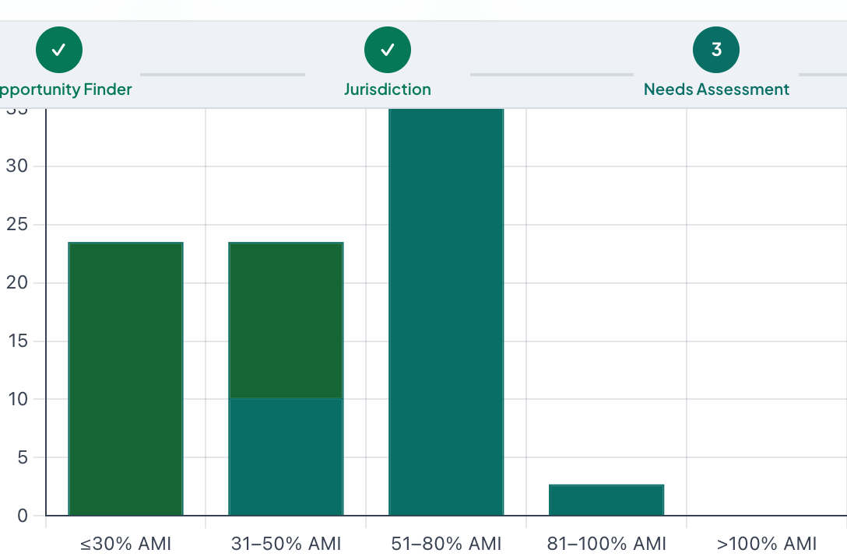
Cost-burden gap by AMI tier (HUD CHAS) · Geography: New Castle · #chartChasGap
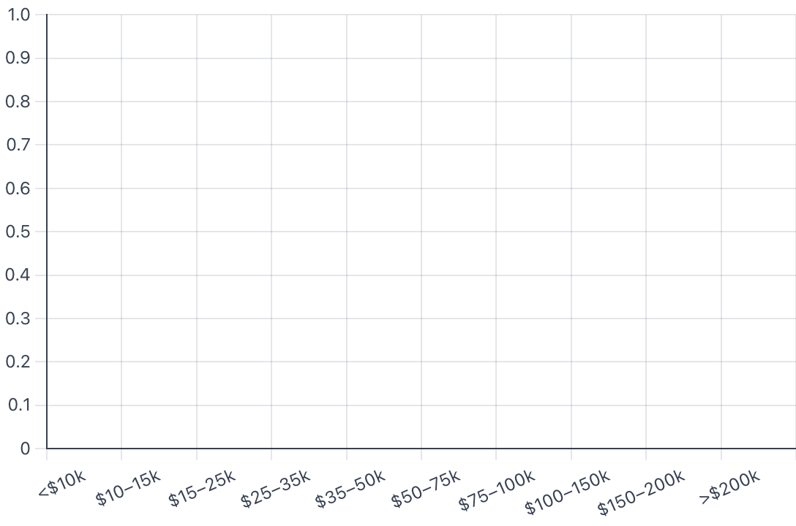
Household income distribution · Geography: New Castle · #chartIncomeDistribution

Economy + employment
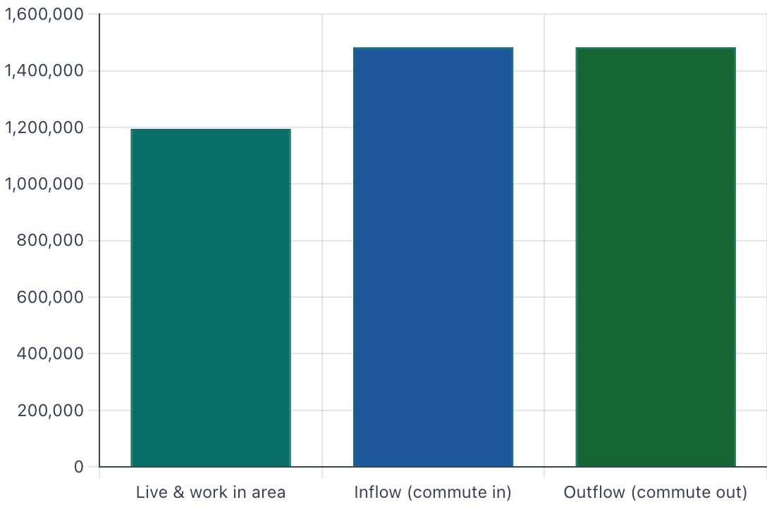
LEHD jobs trend · Geography: New Castle · #chartLehd
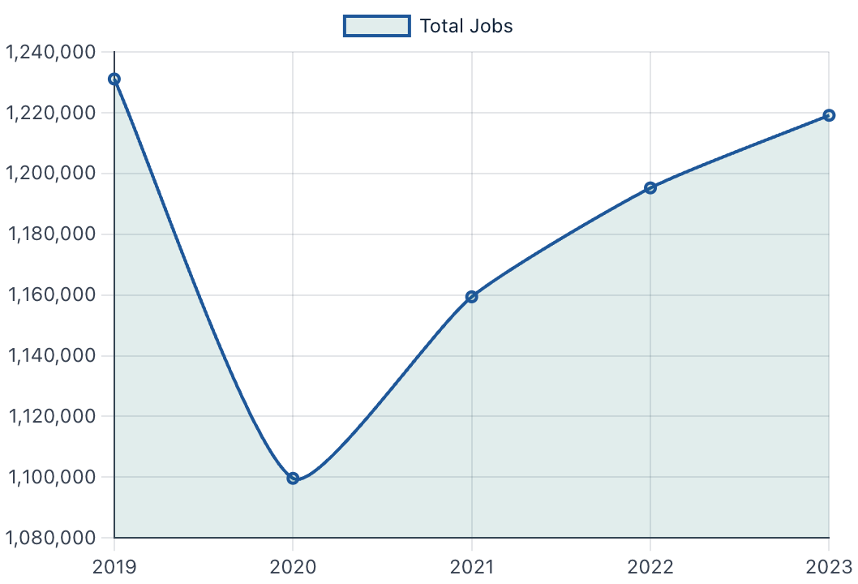
Employment trend · Geography: New Castle · #chartEmploymentTrend
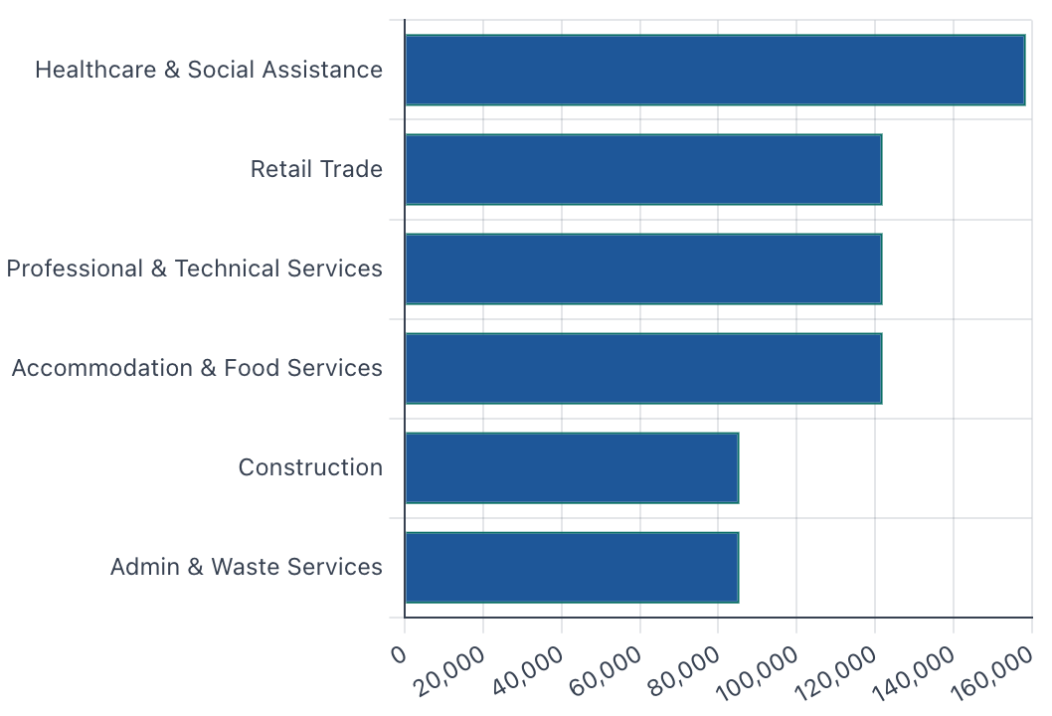
Employment by industry · Geography: New Castle · #chartIndustry
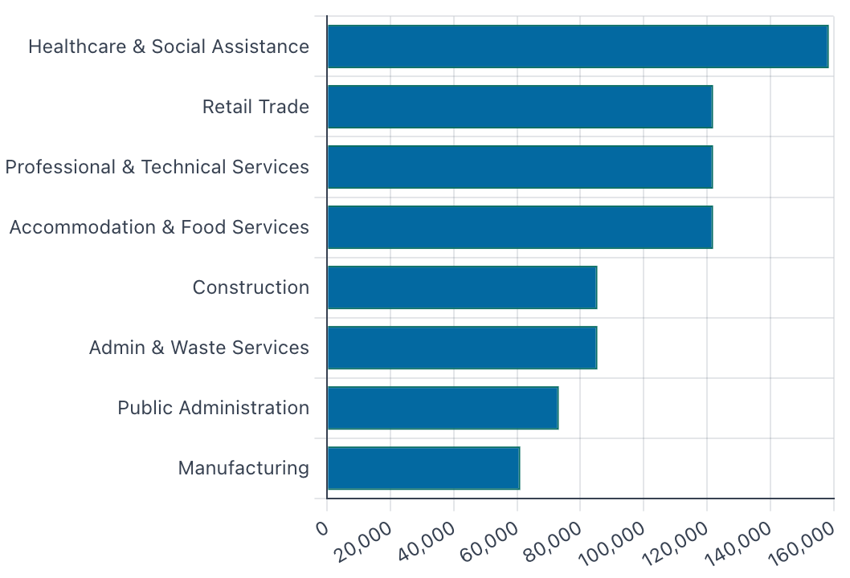
Industry analysis · Geography: New Castle · #chartIndustryAnalysis
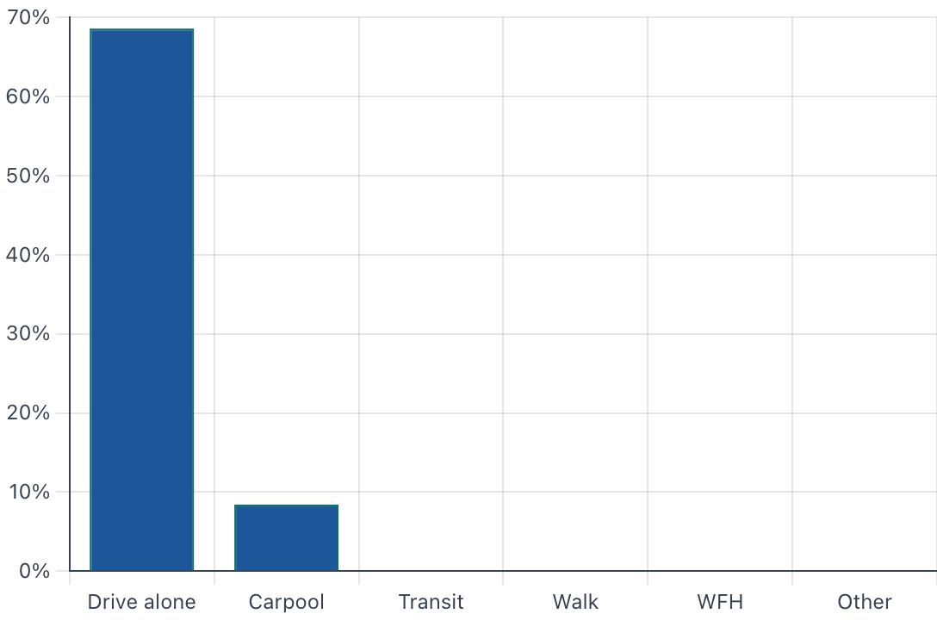
Commute mode share · Geography: New Castle · #chartMode
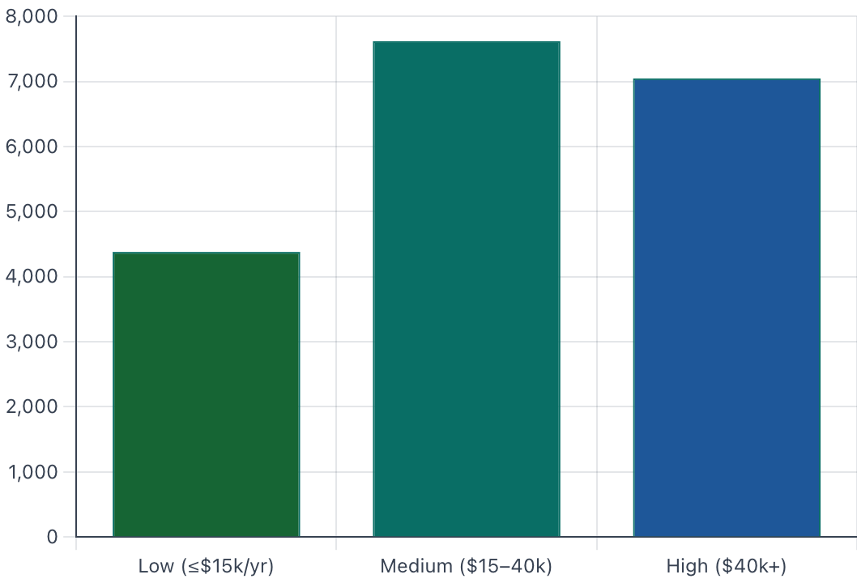
Wage distribution · Geography: New Castle · #chartWage
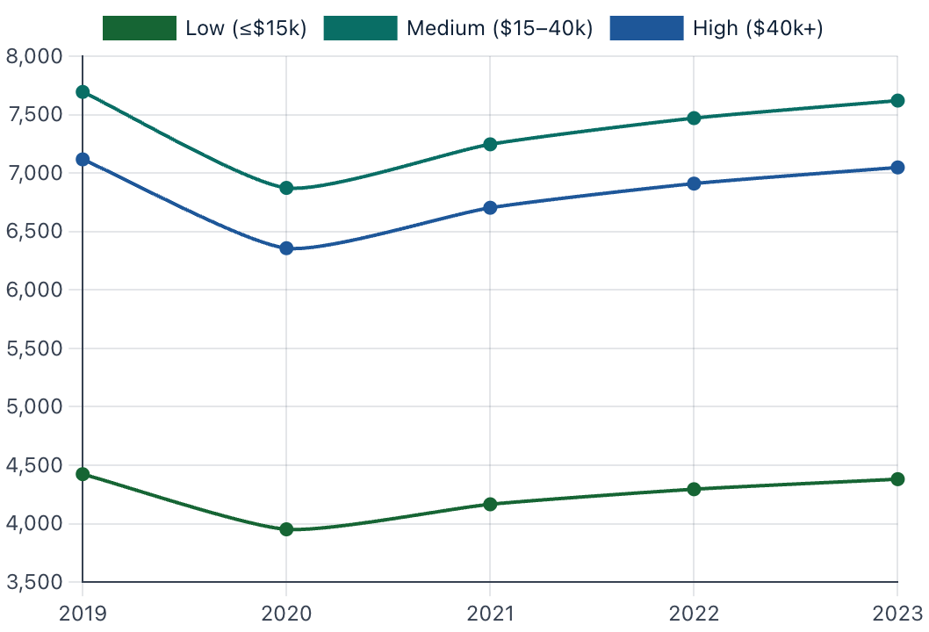
Wage trend · Geography: New Castle · #chartWageTrend

8. Policy & local resources

Housing-policy scorecard (4 of 7 dimensions met)
Prop 123 committed | ✓ Committed
Housing authority | ✓ Garfield County Housing Authority
Housing nonprofits | ✓ Multiple
Housing in comprehensive plan | ✓ Comprehensive Plan 2019
Dedicated HNA | ✗ Not on file
Dedicated local housing funding | ✗ Not reported
Inclusionary zoning / IZ incentives | ? Unknown

Housing lead + key links
Housing lead | Town of New Castle — Community Development
Housing authority | Garfield County Housing Authority (rental assistance + Housing Choice Vouchers)
Town website | newcastlecolorado.org
Council agenda center | newcastlecolorado.org/AgendaCenter
Prop 123 commitment | cdola.colorado.gov/commitment-filings

Advocacy & nonprofit partners
Regional food + emergency assistance
Ownership development
Youth + family stabilization

Major in-town employers
Garfield Re-2 School District | Largest in-town employer; service area New Castle / Silt / Rifle
 | New Castle clinic
Town of New Castle | Municipal staff

