DIGITAL VIDEO STREAMING

DASAR MULTIMEDIA

Dosen Pengampu : A. Ais Prayogi Alimuddin, S.T., M.Eng.



Disusun Oleh:

Kelompok 1:

Ady Ulil Amri, D121231080, Kelas B

Farid Wajdi, D121231032, Kelas B

Ahmad Fiqri Nawwaf, D121231107, Kelas B

Platform:

Youtube & Netflix

DEPARTEMEN TEKNIK INFORMATIKA

FAKULTAS TEKNIK UNIVERSITAS HASANUDDIN

2024

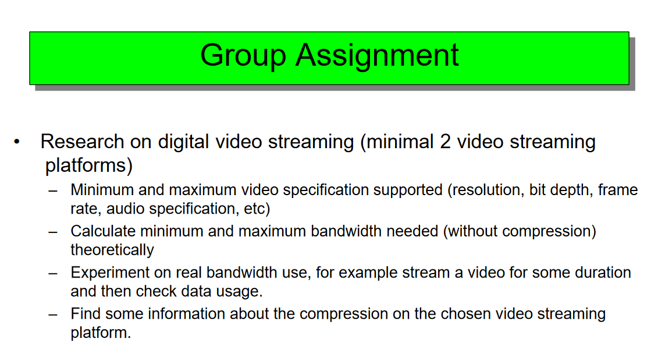

**Answer**

1. Minimum and maximum video specification supported (resolution, bit depth, frame rate, audio specification, etc)

**YouTube**

1. **Resolution**

Minimum = 144p Maximum = 8K (4320p)

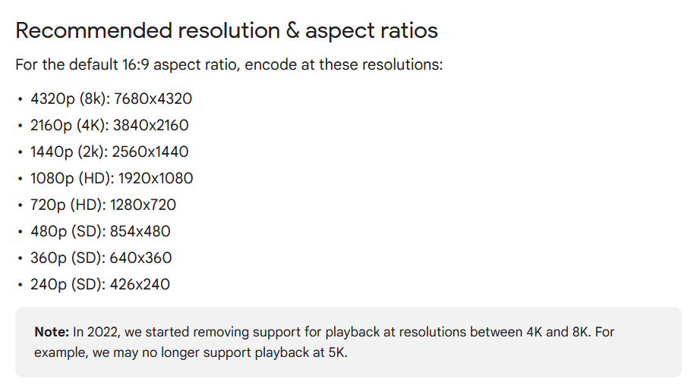

1. **Bit Depth**

Standar: 8-bit

HDR: 10-bit

1. **Frame Rate**

Standard = 24 fps sd. 30fps. Maximum = 60fps

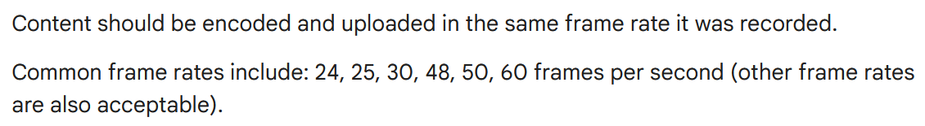

1. **Audio Specification**

Channels: Stereo or Stereo + 5.1

Sample rate 96khz or 48khz

**Netflix**

1. **Resolution**

****Minimum = 144p Maximum = 8K (4320p)

1. **Bit Depth**

Standar: 8-bit HDR: 10-bit

1. **Frame rate**

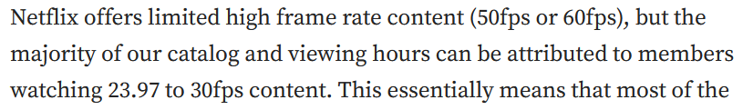

1. **Audio Specification**

5.1 surround sound, 2.0 stereo (jika 5.1 tidak tersedia), dan mono



1. Calculate minimum dan maximum bandwidth needed (without compression) theoretically

Bandwidth (bps) = Resolution width × Resolution height × Frame rate × Bit depth × 3

**YouTube**

**Minimum (144p, 24 fps, 8-bit)**

Resolution: 256 x 144

Frame Rate: 24 fps

Bit Depth: 8-bit

Bandwidth = 256×144×24×8×3

= 212,336,640 bps

= 0.212 Mbps

**Maximum (8K, 60 fps, 10-bit)** Resolution: 7680 x 4320 Frame Rate: 60 fps

Bit Depth: 10-bit

Bandwidth = 7680×4320×60×10×3

= 59,719,680,000 bps

= 59.72 Gbps

**Netflix**

**Minimum (480p, 24 fps, 8-bit)**

Resolution: 640 x 480

Frame Rate: 24 fps

Bit Depth: 8-bit

Bandwidth = 640×480×24×8×3

= 1,768,857,600 bps

=1.77 Mbps

**Maximum (4K, 60 fps, 10-bit)**

Resolution: 3840 x 2160

Frame Rate: 60 fps

Bit Depth: 10-bit

Bandwidth = 3840×2160×60×10×3

= 14,929,920,000 bps

= 14.93 Gbps

1. Experiment on real bandwidth use, for example stream a video for some duration and then check data usage.

**Youtube**

**Netflix**

1. Find some information about the compression on the chosen video streaming platform.

**Youtube**

**Netflix**

**Referensi**

<https://support.google.com/youtube/answer/6375112?hl=en&co=GENIE.Platform%3DDesktop&oco=1>

<https://support.google.com/youtube/answer/1722171?hl=en#zippy=%2Ccontainer-mp%2Caudio-codec-aac-lc%2Cvideo-codec-h%2Cbitrate%2Cframe-rate>

<https://help.netflix.com/en/node/13444>

<https://partnerhelp.netflixstudios.com/hc/en-us/articles/360001794307-Netflix-Sound-Mix-Specifications-Best-Practices-v1-5#h_01ESQ5ZG1Y7AEBJQQE4V7HBZBV>