|  |  |
| --- | --- |
| **Application:** | JobPRO |
| **Description:** | Job PRO |
| **Revision:** | V1.9.24 |
| **Date:** | 2021/01/21 |
|  |  |

Table of Contents

1. Overview 3

2. Release Notes 3

2.1. 1.9.18 3

2.1.1. The Reserve Stock Report showing incorrect records 3

2.2. 1.9.22 3

2.2.1. Cancel Lines to check if line already processed 3

2.3. 1.9.23 4

2.3.1. Cancel lines changed to Portuguese 4

2.4. 1.9.24 5

2.4.1. Asset to check that only 1 job is active. 5

# Overview

* To be confirmed

# Release Notes

## 1.9.18

### The Reserve Stock Report showing incorrect records

Stock drawn quantity was not be updated correctly.

## 1.9.22

### Cancel Lines to check if line already processed

Cancel lines checks if there was any stock issue or PO processed, if there was it does not allow cancelling of the line.

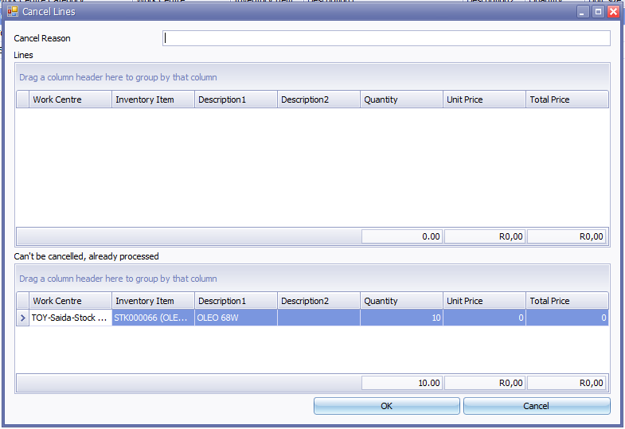

## 1.9.23

### Cancel lines changed to Portuguese

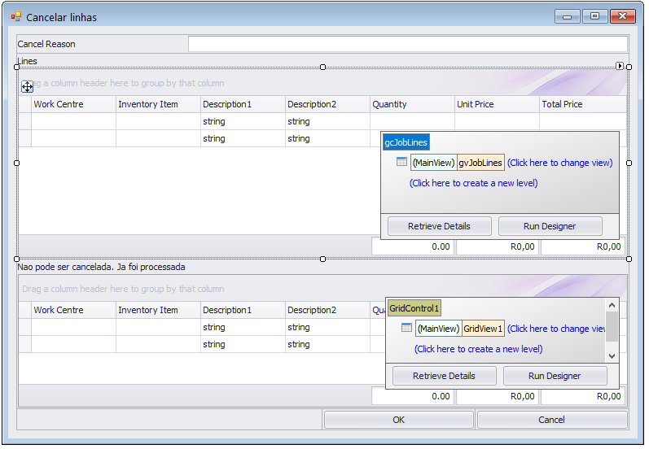

## 1.9.24

### Asset to check that only 1 job is active.

Added check to make sure only 1 active job is created for an asset.

To enable check box under defaults and specify job stages to be checked

