|  |  |
| --- | --- |
| **Application:** | Shopfloor Scheduler |
| **Description:** | Shopfloor Scheduler test cases |
| **Revision:** | V1.0 |
| **Date:** | 03-06-2014 |
|  |  |

Table of Contents

1. Job Copy 3

2. Import Job Activities 4

3. Reactivate Job 5

4. Reactivate Activities 5

5. Created User on activity line 6

# Job Copy

Select job with time logged against it to copy and 1 with no time logged against it to copy

Highlight job to copy in Jobs screen click on copy

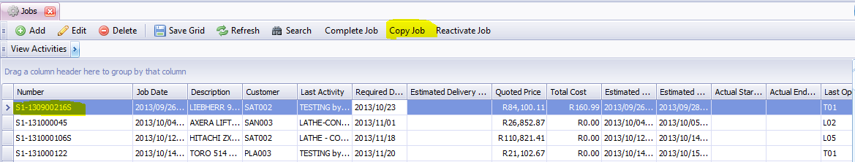

Select Yes (do another test with no as well)

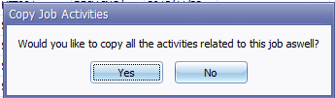

Complete form detail

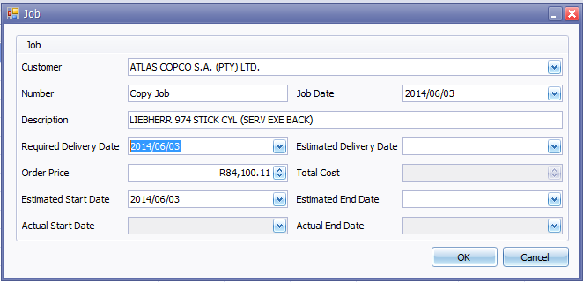

Click OK

Compare job copied against copied job and make sure all lines are there and no times logged were copied.

Outcome of test:

|  |
| --- |
|  |
|  |
|  |
|  |
|  |

# Import Job Activities

Open activities screen for job by going to Jobs>>view activities

Select 2 different jobs 1 with lines 1 without lines

Click

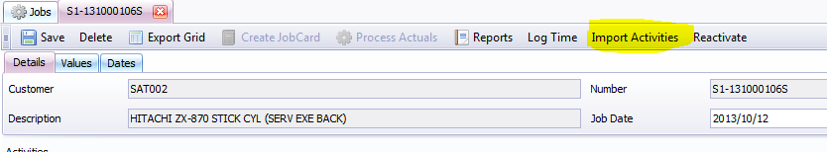

Select OK without selecting a job

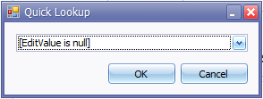

Select a job to import 1 with time logged against it 1 without

Check that lines imported and no times were also imported.

Outcome of test:

|  |
| --- |
|  |
|  |
|  |
|  |
|  |

# Reactivate Job

Open Job History click on Reactivate job

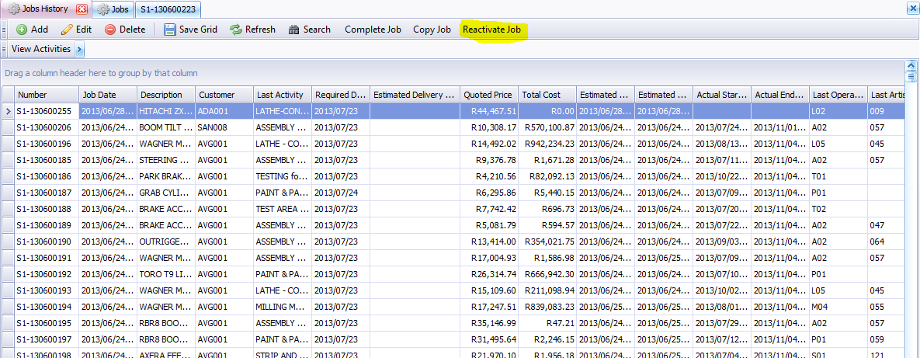

Select no job and click OK

Select Job and click OK

Select yes on the one and no on the other and check if yes was selected if activities was reactivated.

Outcome of test:

|  |
| --- |
|  |
|  |
|  |
|  |
|  |

# Reactivate Activities

Open Job screen click view activities activate activities that is in the following states

{Nothing} – – Activity is active (No time logged to it yet)

None – Activity is active

Stop - Reactivate

Delete – Activity is deleted

Start – Activity is active

Active – Activity is active

QIR – Activity is active

NextActivityForce – Activity is active

NextArtisanForce – Activity is active

Open history Jobs view activities activate lines

None should be activated should say Job not active

Outcome of test:

|  |
| --- |
|  |
|  |
|  |
|  |
|  |

# Created User on activity line

Edit an activity line where there is already a user it should not change

Add an activity and it should get the logged in users code.