ASSIGNMENT NO 2

Q1. Chess Agents :

Consider two intelligent agents playing chess with a clock. One of them is called “Deep Blue” while the other is called Gary Kasparov.

Specify the task environment in terms of “PEAS”

Specify the Properties of this task environment.

Answer:

PEAS Description

P = Performance Measure

1. Win or lose

2. Numbers of move

E = Environment

1. Chess board

2. Time clock

3. Chess Players (Deep Blue and Garry Kasparov)

4. Chess pieces

A = Actuators

1. Robotic arm for Deep Blue

2. Human Player

S = Sensors

1. Position Detector

2. Timer

3. camera

Properties of Task Environment

Multi-Agent = Two Agents.

Observable = Both agents can see entire board and movement of pieces.

Deterministic = There either will be Winner or Loser, sometime Tie.

Sequential = Future moves depend upon current moves.

Static = Position of the board does not change with time.

Discrete = There might be n numbers of moves.

Q2. Design State space for agent which:

- Can move in four directions up, down, right and left

- Can sense heat in cell on left or right or up or down

- Environment is rectangle of size n by m

- Environment has agent, a lion and home

- Goal of the agent is to reach home

- All cells adjacent to lion have heat

- If Agent goes to adjacent cell to lion then agent loses

Answer:

Initial Position = ( 0 , 1 , False )

/ \

Left (-1 , 0 , False ) Up (0 , -1 , True )

/ \

Left (-1 , 0 , False) Up (0 , -1 , True)

/ \

Up (0 , -1 , False) Left (-1 , 0 , False)

/ \ |

Left (-1 , 0 , False) Up (0 , -1 , True) Up (0 , -1 , False)

| |

Up (0 , -1 , True) Home (0 , 0 , True)

|

Home (0 , 0 , True)

Write conditions for movement precisely and design the space tree

Q3. The missionaries and cannibals problem is usually stated as follows. Three missionaries

and three cannibals are on one side of a river, along with a boat that can hold one or

two people. Find a way to get everyone to the other side without ever leaving a group of missionaries

in one place outnumbered by the cannibals in that place. This problem is famous in

AI because it was the subject of the first paper that approached problem formulation from an

analytical viewpoint (Amarel, 1968). Formulate the problem precisely, making only those distinctions necessary to ensure a valid solution. Draw a diagram of the complete state space.

Answer:

(3, 3, 0) ---> (2, 2, 1) ---> (2, 3, 0) ---> (1, 2, 1) ---> (0, 2, 1) ---> (0, 3, 0)

| | | |

(3, 1, 0) (1, 1, 1) (0, 1, 1) (0, 0, 1)

| |

..

M = Numbers of Missionaries

C = Numbers of Cannibals

B = Boat on side(Left or Right)

Initial State

M = 3, C = 3, B = L (3,3,L)

Goal State

M = 0, C = 0, B = R (0,0,R)

Q4. Draw a diagram of the complete state space for block world problem in AI.

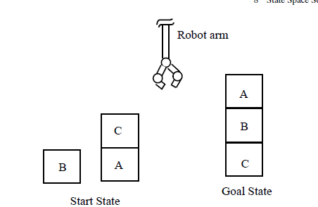

Assume that following rules for moves will be followed by the robot arm for

carrying out this job:

• stack(x, y): stack block x on block y,

• lift(x): lift-up the block x,

• putg(x): put block x on ground,

• unstack(x, y): unstack block x from block y.

ANSWER:-

The robot can:

* Lift(x) → Pick up block x
* Putg (x) → Put block x on the ground
* Stack (x, y) → Stack block x on block y
* Unstack (x, y) → Unstack block x from block y

Step 1. Unstack ( C , A )

Step 2. Putg C

Step 3. Lift B

Step 4. Stack ( B , A )

Step 5. Lift C

Step 6. Stack ( C , B )

State Space Diagram:-

[A] [B] [C]

/ \

lift(B) Unstack(C)

/ \

Stack(C,B) Putg C

|

Stack (B,A)

|

Stack (C,A)