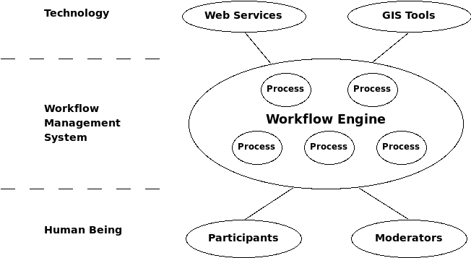

Workflow management system works like a glue. It associates human being with technology organically and flexibly. For the human part, workflow management system selectively incorporate people of different roles into different phases of the process. For the technology part, it decouples web services and GIS tools modules, hence eases the development effort and reduces development cost; and combines different services and tools in an organized way, thus greatly increases the system usability.

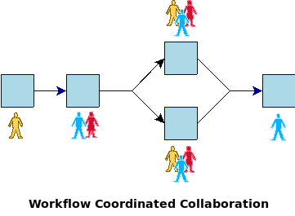

When the collaboration is coordinated by workflow management system, the participation process is controllable and manageable. The process is represented in a formalized way (normally in workflow diagrams). Powered by workflow patterns, it gives an analytical frame to process evaluation. In PPGIS, such a collaboration diagram, together with a discussion capability, can be shown to the public. Moreover, the feedbacks from the public can be incorporated into the revision of the process, so that such a collaboration is not only coordinated, but also adaptive.

