|  |  |  |  |
| --- | --- | --- | --- |
|  | STANDARD OPERATING PROCEDURE  ***Real time search tracker*** | | |
| Created by: | *Judith Tan* | Approved by: |  |
| Effective date: | *4th October 2021* | Last update: | *1th November 2021* |
| Version Number: | *1.0* | Document type: | *SOP* |

Background

Central team aims to minimize the manual efforts behind tracking search execution on platform and conserve team energy for identifying opportunities and prioritizing actions for Agency.

Purpose

This document outlines our real time Search Tracker process. if you have any questions or feedback, please contact @aditya @sonal @gina @Ari

|  |  |
| --- | --- |
| **Central Team** | **Contact** |
| SBM | Aditya |
| SBM | Gina |
| A&I | Sonal |
| IT | Ari |

## Data Input

Central Team SBM will initiate request from MBCI SBM to provide:

* 1. Search Strategy (incl priority/position) and Paid target

**Proposal: To Standardise Search Strategy format**

|  |  |  |  |  |  |  |  |  |  |  |  |
| --- | --- | --- | --- | --- | --- | --- | --- | --- | --- | --- | --- |
| **Category** | **KW Type** | **KW** | **Shop Name** | **Brands** | **SKU** | **SKU ID** | **Priority/Position** | **Match Type** | **Link** | **eCustomer** | **Market** |
| Home | Category | Air Freshener | P&G Official Store | Ambi Pur | Ambi Pur Gel Lemon | 719864464 | 1 | Exact | https://shopee.com.my/Ambi-Pur-Air-Freshener-Room-Fresh-Scented-Gel-Refreshing-Lemon-(180g-x-2)-Value-Pack--i.44437739.719881043 | Shopee | MY |
| Home | Category | Air Freshener | P&G Official Store | Ambi Pur | Ambi Pur Gel Lavender | 719864464 | 2 | Exact | https://shopee.com.my/Ambi-Pur-Air-Freshener-Room-Fresh-Scented-Gel-Relaxing-Lavender-(180g-x-2)-Value-Pack--i.44437739.719864464 | Shopee | MY |

* 1. Keywords input from MBCI SBM

**Brand category template:**

|  |  |  |
| --- | --- | --- |
| **Brand** | **Type of keyword (category/brand)** | **Keyword** |
| Braun | Brand | Braun |
| Braun | Category | Electric Shaver |
| Braun | Category | IPL |
| Braun | Category | Hair removal |
| Braun | Brand | Braun IPL |

* + **Deposit Destination:** [AMA eBiz Data Hub - 10.10 - All Documents (sharepoint.com)](https://pgone.sharepoint.com/sites/AMAeBizDataHub/Shared%20Documents/Forms/AllItems.aspx?id=%2Fsites%2FAMAeBizDataHub%2FShared%20Documents%2FXByte%20Data%2FKCP%2F2021%2F10%2E10&viewid=d8c5ca36%2D7c18%2D4258%2D8cd3%2D5def826d1313)
  + **Standardise Brand format:**
  + **https://pgone.sharepoint.com/:x:/s/eAMAeCommIT-AI-DS/EcwEAWOiaZRKqbTiybj7oIcBVlIVUlceY6CEAPK1HpF6vw?email=tan.j.53%40pg.com&e=XfAe11**
    - 1. **New brand please contact @Judith**

|  |  |  |  |  |  |  |  |  |  |  |  |  |  |  |  |  |  |  |  |  |  |  |  |  |  |  |  |  |  |  |  |  |  |  |  |  |  |  |  |  |  |  |  |  |  |  |  |  |
| --- | --- | --- | --- | --- | --- | --- | --- | --- | --- | --- | --- | --- | --- | --- | --- | --- | --- | --- | --- | --- | --- | --- | --- | --- | --- | --- | --- | --- | --- | --- | --- | --- | --- | --- | --- | --- | --- | --- | --- | --- | --- | --- | --- | --- | --- | --- | --- | --- |
| |  |  | | --- | --- | | **Category** | **Brand** | | Baby | pampers | | FE | downy | | Fem | whisper | | Grooming | braun | | Grooming | gillette | | Grooming | gillettevenus | | Hair | pantene | | Hair | herbalessences | | Hair | headandshoulders | | Hair | bearfruits | | Hair | rejoice | | Home | ambipur | | Home | febreze | | Home | joy | | Laundry | dynamo | | Laundry | tide | | Laundry | ariel | | Oral | oral-b | | PCC | safeguard | | PCC | oldspice | | PCC | secret | | PHC | vicks | | Skin | olay | |

1. **SBM Aligned with IT and Set a deadline (ideally should be in 10 days before actual day)**
   1. Inform deadline to A&I and IT Team
   2. IT to provide Search Keyword template and Plan

 **Keyword Scraper Schedule Template** ([KCP 1010 Plan.xlsx (sharepoint.com)](https://pgone.sharepoint.com/:x:/r/sites/AMAeBizDataHub/_layouts/15/Doc.aspx?sourcedoc=%7B6A59F23C-6FF0-4782-BCC7-C22EE1195B5F%7D&file=KCP%201010%20Plan.xlsx&action=default&mobileredirect=true)

1. **Deposit Destination:** [AMA eBiz Data Hub - 10.10 - All Documents (sharepoint.com)](https://pgone.sharepoint.com/sites/AMAeBizDataHub/Shared%20Documents/Forms/AllItems.aspx?id=%2Fsites%2FAMAeBizDataHub%2FShared%20Documents%2FXByte%20Data%2FKCP%2F2021%2F10%2E10&viewid=d8c5ca36%2D7c18%2D4258%2D8cd3%2D5def826d1313)

|  |  |  |  |  |  |  |  |
| --- | --- | --- | --- | --- | --- | --- | --- |
| SEARCH |  |  |  |  |  |  |  |
|  | Scrape Date | Scrape Time (Local Time) | Delivery Date | Delivery Time (Local Time) | Markets | Customer | Remarks |
| D-1 | 9-Oct | 10:00PM | 9-Oct | 11:00PM | SG PH MY VN TH ID | (1) Lazada (2) Shopee | SG PH MY GMT +8    ID VN TH GMT +7 |
| D-Day | 10-Oct | 12:00AM | 10-Oct | 1:00AM | SG PH MY VN TH ID | (1) Lazada (2) Shopee | SG PH MY GMT +8    ID VN TH GMT +7 |
| D-Day | 10-Oct | 2:00AM | 10-Oct | 3:00AM | SG PH MY VN TH ID | (1) Lazada (2) Shopee | SG PH MY GMT +8    ID VN TH GMT +7 |
| D-Day | 10-Oct | 9:00AM | 10-Oct | 10:00AM | SG PH MY VN TH ID | (1) Lazada (2) Shopee | SG PH MY GMT +8    ID VN TH GMT +7 |
| D-Day | 10-Oct | 11:00AM | 10-Oct | 12:00PM | SG PH MY VN TH ID | (1) Lazada (2) Shopee | SG PH MY GMT +8    ID VN TH GMT +7 |
| D-Day | 10-Oct | 1:00PM | 10-Oct | 2:00PM | SG PH MY VN TH ID | (1) Lazada (2) Shopee | SG PH MY GMT +8    ID VN TH GMT +7 |
| D-Day | 10-Oct | 5:00PM | 10-Oct | 6:00PM | SG PH MY VN TH ID | (1) Lazada (2) Shopee | SG PH MY GMT +8    ID VN TH GMT +7 |
| D-Day | 10-Oct | 7:00PM | 10-Oct | 8:00PM | SG PH MY VN TH ID | (1) Lazada (2) Shopee | SG PH MY GMT +8    ID VN TH GMT +7 |
| D-Day | 10-Oct | 9:00PM | 10-Oct | 10:00PM | SG PH MY VN TH ID | (1) Lazada (2) Shopee | SG PH MY GMT +8    ID VN TH GMT +7 |
| D+1 | 11-Oct | 9:00AM | 11-Oct | 10:00AM | SG PH MY VN TH ID | (1) Lazada (2) Shopee | SG PH MY GMT +8    ID VN TH GMT +7 |

## Validate Keyword input (QA)

Our A&I will refresh auto-validation script and output validation result in the Data input search dashboard every 2 hours, the dashboard will highlight

1. Inconsistent Brand format
2. Duplicates Brand-Keyword
3. > 15 KWS
4. Missing Keywords

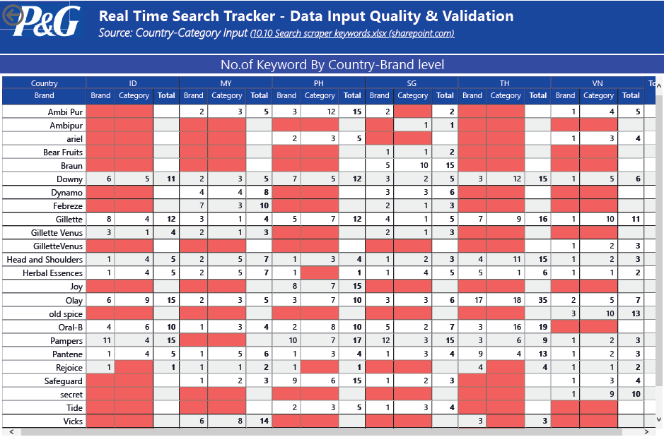

SBM to track and alert **MBCI SBMs**:

* missing KWS *(might also be because your market doesn’t carry the brand)*
  + *Enhancement from A&I* 
    - *Get complete list of market – brands*
    - *Auto validate*
* more than 15 keywords, alert to adhere to the max capacity
  + alternatives: Check with IT if able to proceed for 10.10 but 11.11 onwards we cut down the keywords?

## Validate Scraper Output Validation (QA)

## Track and Validate Keyword Scraper output

Our A&I will refresh auto-validation script and output validation result in Power BI dashboard and auto-send alert IT if there are:

1. Duplicates Brand
   1. This is done by the count of brand – (keyword-country-combi)
2. No. of rows match <> keyword input rows
   1. By Market Level
      1. Assumption: expect 10 keywords for every category-brand-brandtype-kw

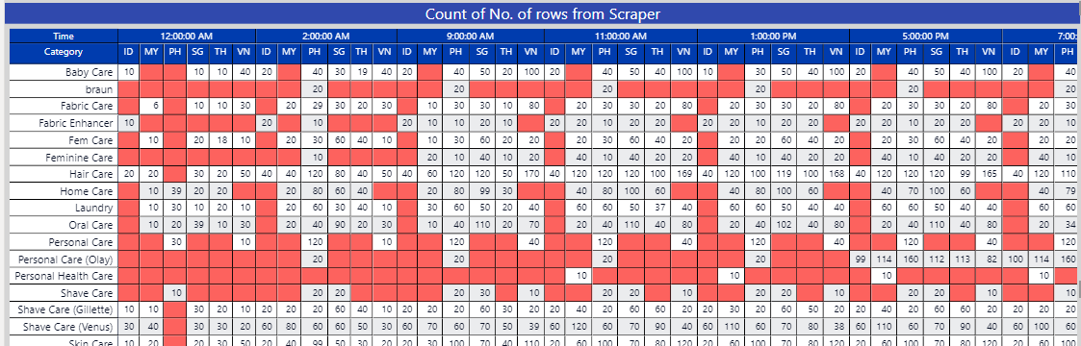

Data Transformation Logic

**Classficiation of Ad Type:**

**Paid** - **sum of paid spots taken by P&G brands sold by official sellers**

**Organic** - **Sum of organic spots taken by P&G brands sold by official sellers**

**PGOthers** - **Sum of organic and paid spots taken by P&G brands but sold by other sellers**

**Othersbrand** - **Sum of organic and paid spots taken by other brands**

These should be Paid and Organic. I had corrected in earlier conversation as well that check:

if the listing is from “P&G Official Store” if Yes tag as Organic or Paid depending upon data.

If its not P&G official store then check if brand is any of P&G brand,

if yes then tag as “P&G others”.

“Other Brands”.

[@Prahasto, Ari](mailto:prahasto.a@pg.com) why does top 3 positions in screenshot below has official seller us still brand name as not H&S?

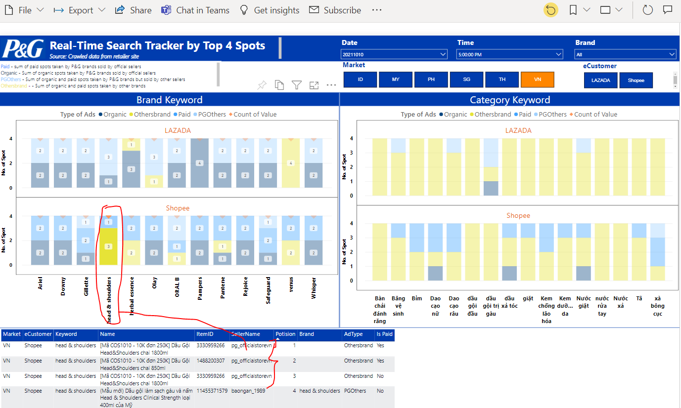

**MBCI SBM Key contacts:**

MBCI SBM will coordinate with Categories to provide keywords at destinated directory contacts:

|  |  |  |  |
| --- | --- | --- | --- |
| **Market** | **Contact** | **Position** | **Email** |
| VN | Diem, VoThi | SLS - E-Merchandiser | VN E-Commerce | [diem.vt@pg.com](mailto:diem.vt@pg.com) |
| SG | Lio, Maureen | BRD-BRM | [lio.m@pg.com](mailto:lio.m@pg.com) |
| MY | Ung, XueWenSophia | BRD-BRM | [ung.x@pg.com](mailto:ung.x@pg.com) |
| PH | Laguna, MarkAnthony | PS=SNO (Sales Logistics – WS, IMR, DO, Ecomm) | [laguna.ml@pg.com](mailto:laguna.ml@pg.com) |
| TH | Hachavanich, Suyanee | BRD-BRM | [hachavanich.s@pg.com](mailto:hachavanich.s@pg.com) |
| ID | Lin, ZhiQi | PS-PUR | [lin.z.1@pg.com](mailto:lin.z.1@pg.com) |

## Final Process Flow

## 

## Real time search tracker

Our A&I will refresh auto-etl script and output real time search tracker result in Power BI dashboard

## Search Strategy

**Paid** - sum of paid spots taken by P&G brands sold by official Seller

**Organic** - Sum of organic spots taken by P&G brands sold by official seller

**PGOthers** - Sum of organic and paid spots taken by P&G brands sold by other seller

**Others** - - Sum of organic and paid spots taken by other brands sold by other seller

## 

## 

Table Name: No. of paid spot taken by &G brands sold by other official seller

1. Green - met/above share of search target.
2. Red – below share of search target.

Table Name: Paid Search Position taken by SKU

1. Green – Paid position is between top 1 and top 2
2. Red - Paid position not in Top 1 or Top

## Key Learnings

* + - 1. **Different Strategy format for different Region**
      2. **Challenge to get input from MBCI SBM**
      3. **How does MBCI translate strategy format to detailed KW**
      4. **To guide our MBCI SBM to provide data required and changes to pSKU list windows.**

[29/09/2021 11:26 am] Laguna, MarkAnthony

for the scraping exercise, we will need to pick a few important ones

[29/09/2021 11:26 am] Laguna, MarkAnthony

or all?

1. Different Brand terminology,inconsistent format
2. 