================================================================================
BEARDOWN-TP LAB - ONE PARAGRAPH SUMMARY FOR STUDENTS
================================================================================

WHAT IS THIS LAB?

In this lab, you will implement a reliable data transfer protocol called BEARDOWN-TP,
which teaches you how the internet actually works. You will then answer 10 questions related to the program.

Imagine you are sending important information across the internet, but the network is not perfect, packets can get lost, corrupted (bits flip), duplicated, or delayed. Your job is to write two Python files:
a SENDER (beardown_sender.py) that breaks your data into packets and sends them while
keeping track of what needs to be resent, and a RECEIVER (beardown_receiver.py) that
accepts packets, validates they are correct, and sends back acknowledgments ("I got it!")
so the sender knows when to stop waiting and send the next packet. The TestHarness.py
file is an automated grading system that simulates a broken network and tests your
implementation—it runs six different tests to see if your sender and receiver can handle
perfect conditions, packet loss, corrupted data, duplicates, and delays. When a test
"passes," it means your code correctly handled that network scenario; when it "fails,"
your code did not work correctly (maybe packets were lost forever, or the data arrived
corrupted, or duplicates weren't handled). You will fill in 8 methods in the sender and
6 methods in the receiver, with the annotated files (beardown_sender_STUDENT.py and
beardown_receiver_STUDENT.py) showing you exactly what each method should do and even providing example code. By implementing this lab, you will learn the fundamental concepts behind TCP (the protocol your web browser uses), including sequence numbers (to keep packets in order), checksums (to detect corruption), timeouts and retransmission (to handle loss), and acknowledgments (to confirm delivery)—these are the core building blocks of reliable communication on the internet that happens billions of times per second around the world.

================================================================================
KEY TERMS EXPLAINED
================================================================================

PASS vs FAIL:
PASS = Your code worked for that test (e.g., "Data Transfer with Packet Loss passed")
FAIL = Your code did not work for that test (e.g., "Corrupted packets were not detected")
Score = Number of points you earned (0-10 total)
Goal = Get 10/10 (all tests pass!)

THE SENDER FILE (beardown_sender.py):
What it does: Creates packets from your data and sends them
Your job: Implement 8 methods that:
1. Load data to send
2. Create packets
3. Handle timeouts (if no ACK received)
4. Process acknowledgments ("I got it!" messages)
5. Detect when transfer is complete
Think of it as: The person mailing letters

THE RECEIVER FILE (beardown_receiver.py):
What it does: Receives packets, validates them, and sends acknowledgments
Your job: Implement 6 methods that:
1. Validate packet integrity (check if data is corrupted)
2. Parse packets (extract the data inside)
3. Detect duplicates (if same packet arrives twice)
4. Create acknowledgments ("I got it!")
5. Buffer data in order
Think of it as: The person receiving letters and sending receipts

THE TEST HARNESS (TestHarness.py):
What it does: Automatically tests your sender and receiver
How you use it: Run one command: python3 TestHarness.py
What happens: Simulates 6 network scenarios and grades your code
Score: Shows you 0-10 points based on what passed
Tests:
1. Perfect Network (no problems)
2. Speed Test (fast transfer)
3. Random Packet Loss (some packets lost)
4. Corruption Test (bits flip in packets)
5. Duplication Test (packets arrive twice)
6. Delay Test (packets are slow)

WHAT YOU LEARN:
✓ How packets are created and validated
✓ How checksums detect corrupted data
✓ How sequence numbers prevent duplicates
✓ How timeouts and retransmission handle lost packets
✓ How acknowledgments confirm delivery
✓ How real networking protocols work (TCP is very similar!)
✓ Why the internet is reliable despite an unreliable network

What you must do.
Download all the files into the same directory.
Remove the word student from the sender and receiver files. Update the sender and receiver files.
Fun the test harness. Make sure all tests pass.
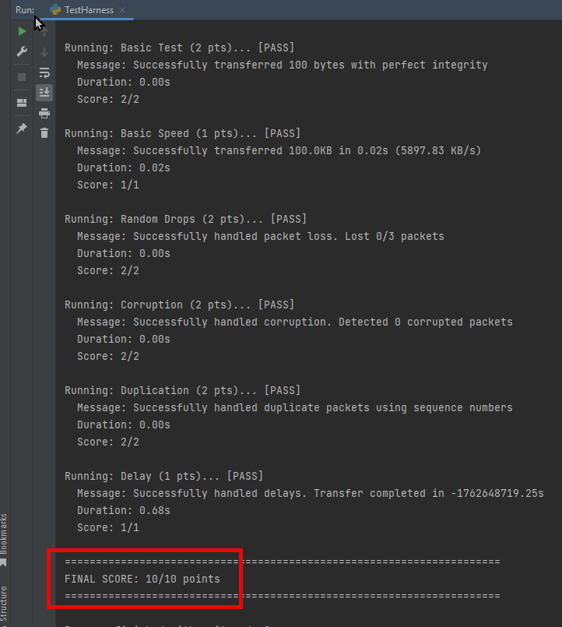
Answer the 10 questions associated with the lab.
Submit all three files to D2L for testing and grading.

Files:
https://github.com/pgkireland/MIS-543-Python-2-2025

