This is a file recording some of the different KCa channel implementations found and their implementation in ChannelML.

Original Bhalla & Bower 1993 paper:

From Appendix C:

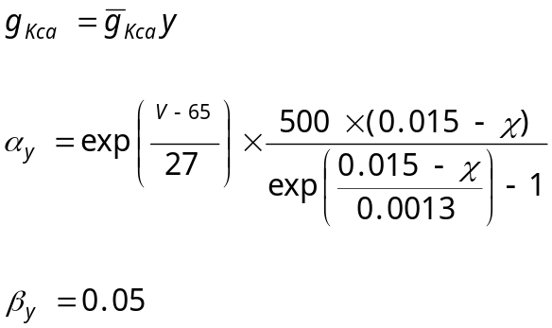

V in mV, χ in millimoles per liter (note this is same as mol m-3, the SI unit).

Note: for χ << 0.015, α is ~0 so g never rises much above 0

