PC Keyboard Scan Codes

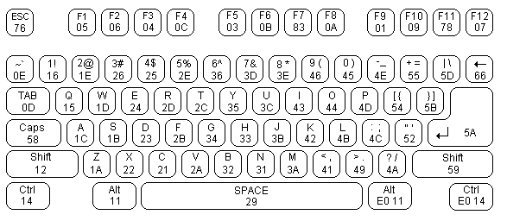

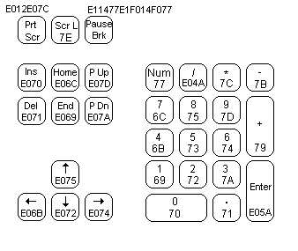

Scan code | Base case | Upper case | Scan code | Base case | Upper case | Scan code | Base case | Upper case
29 | ` | ~ | 02 | 1 | ! | 03 | 2 | @
04 | 3 | # | 05 | 4 | $ | 06 | 5 | %
07 | 6 | ^ | 08 | 7 | & | 09 | 8 | *
0A | 9 | ( | 0B | 0 | ) | 0C | - | _
0D | = | + | 0E | Backspace | Backspace | 0F | Tab | Back Tab
10 | q | Q | 11 | w | W | 12 | e | E
13 | r | R | 14 | t | T | 15 | y | Y
16 | u | U | 17 | i | I | 18 | o | O
19 | p | P | 1A | [ | { | 1B | ] | }
2B | \ | | | 3A note 1 | Caps Lock | na | 1E | a | A
1F | s | S | 20 | d | D | 21 | f | F
22 | g | G | 23 | h | H | 24 | j | J
25 | k | K | 26 | l | L | 27 | ; | :
28 | ' | " | 2B note 2 | # | ~ | 1C | Enter | Enter
2A note 1 | Left Shift | na | D5 note 2 | \ | | | 2C | z | Z
2D | x | X | 2E | c | C | 2F | v | V
30 | b | B | 31 | n | N | 32 | m | M
33 | , | < | 34 | . | > | 35 | / | ?
36 note 1 | Right shift | na | 1D note 1 | Left Ctrl | na | 38 note 1 | Left Alt | na
39 | Spacebar | Spacebar | E0,38 note 1 | Right Alt | na | E0,1D note 1 | Right Ctrl | na
E0,52 | Insert | na | E0,53 | Delete | na | E0,4B | Left Arrow | na
E0,47 | Home | na | E0,4F | End | na | E0,48 | Up Arrow | na
E0,49 | Pg Up | na | E0,51 | Pg Dn | na | E0,4D | Right Arrow | na
45,C5 note 1 | Num Lock | na | 47 | Keypad 7 | Home | 4B | Keypad 4 | Left Arrow
4F | Keypad 1 | End | E0,35 | Keypad / | Keypad / | 48 | Keypad 8 | Up Arrow
4C | Keypad 5 | na | 50 | Keypad 2 | Dn Arrow | 52 | Keypad 0 | Insert
E0,37 | Keypad * | Keypad * | 49 | Keypad 9 | Pg Up | 4D | Keypad 6 | Right Arrow
51 | Keypad 3 | Pg Dn | 53 | Keypad . | Delete | 4A | Keypad - | Keypad -
4E | Keypad + | Keypad + | E0,1C | Keypad Enter | Keypad Enter | 01 | Escape | Escape
3B | F1 | note 3 | 3C | F2 | note 3 | 3D | F3 | note 3
3E | F4 | note 3 | 3F | F5 | note 3 | 40 | F6 | note 3
41 | F7 | note 3 | 42 | F8 | note 3 | 43 | F9 | note 3
44 | F10 | note 3 | D9 | F11 | note 3 | DA | F12 | note 3
2A,37 | Prnt, Scrn | na | 46 | Scroll Lock | na

All Scan Codes are given as Hexadecimal numbers.
- note 1: These codes are not passed on to the buffer RAM by the Keyboard Service Routine.
- note 2: Only applicable to non-U.S. keyboard installations.

Key/s pressed | Aux byte | Key/s pressed | Aux byte | Key/s pressed | Aux byte
Shift Tab | 0F | Alt Q | 10 | Alt W | 11
Alt E | 12 | Alt R | 13 | Alt T | 14
Alt Y | 15 | Alt U | 16 | Alt I | 17
Alt O | 18 | Alt P | 19 | Alt A | 1E
Alt S | 1F | Alt D | 20 | Alt F | 21
Alt G | 22 | Alt H | 23 | Alt J | 24
Alt K | 25 | Alt L | 26 | Alt Z | 2C
Alt X | 2D | Alt C | 2E | Alt V | 2F
Alt B | 30 | Alt N | 31 | Alt M | 32
F1 | 3B | F2 | 3C | F3 | 3D
F4 | 3E | F5 | 3F | F6 | 40
F7 | 41 | F8 | 42 | F9 | 43
F10 | 44 | Home | 47 | Up Arrow | 48
Page Up | 49 | Left Arrow | 4B | Right Arrow | 4D
End | 4F | Down Arrow | 50 | Page Down | 51
Insert | 52 | Delete | 53 | Shift F1 | 54
Shift F2 | 55 | Shift F3 | 56 | Shift F4 | 57
Shift F5 | 58 | Shift F6 | 59 | Shift F7 | 5A
Shift F8 | 5B | Shift F9 | 5C | Shift F10 | 5D
Ctrl F1 | 5E | Ctrl F2 | 5F | Ctrl F3 | 60
Ctrl F4 | 61 | Ctrl F5 | 62 | Ctrl F6 | 63
Ctrl F7 | 64 | Ctrl F8 | 65 | Ctrl F9 | 66
Ctrl F10 | 67 | Alt F1 | 68 | Alt F2 | 69
Alt F3 | 6A | Alt F4 | 6B | Alt F5 | 6C
Alt F6 | 6D | Alt F7 | 6E | Alt F8 | 6F
Alt F9 | 70 | Alt F10 | 71 | Ctrl Prnt Scrn | 72
Ctrl Left Arrow | 73 | Ctrl Right Arrow | 74 | Ctrl End | 75
Ctrl Page Down | 76 | Ctrl Home | 77 | Alt 1 | 78
Alt 2 | 79 | Alt 3 | 7A | Alt 4 | 7B
Alt 5 | 7C | Alt 6 | 7D | Alt 7 | 7E
Alt 8 | 7F | Alt 9 | 80 | Alt 0 | 81
Alt hyphen | 82 | Alt = | 83 | Ctrl Page Up | 84

