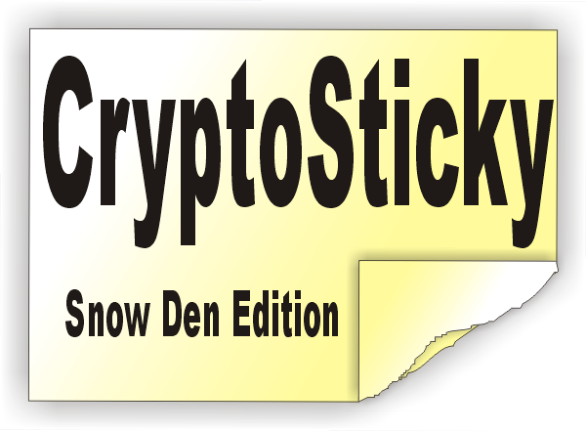
FOR IMMEDIATE RELEASE: Aug/13/2013

CryptoSticky - Encryption Product Release

Venice, FL, 8/13/2013 CryptoSticky, an innovative memo authoring product is released to the public. Among its numerous features, it offers industrial strength encryption, to cater to the privacy needs of any computer user. It is easy to use, and virtually every application is capable of taking advantage of the Encryption offered by CryptoSticky.

In these uncertain times of privacy issues and data safety, CryptoSticky offers a simple and effective tool for self protection. Keep important information like bank account numbers, site passwords, financial details, contact numbers and addresses under strong encryption.

With CryptoSticky, memos or parts of memos can be encrypted, and they become forever secrets. They can only be unlocked if someone has the encryption key / password. The encryption is super strong, more combinations than grains of sand in the universe. CryptoSticky can also Encrypt documents or part of any document via the clipboard. Copy any content to the clipboard, fire up CryptoSticky (via HotKey) Encrypt and Paste … that's it.

Make your Personal Computer Personal again. CryptoSticky can be found on Amazon.com, retails for $29.95 or a 30 day demo can be downloaded from CNET or the Author's site. (see below)

Peter Glen is a senior software developer, author of several mainstream software products, and inventor / creator of a US patent.

Contact Information:

Peter Glen
109 Palmetto Dr, Venice, FL
941 412 6080
http://www.robotmonkeysoftware.com/cryptosticky

###

