Charles & Margery Barancik Foundation
2 North Tamiami Trail, Suite 314
Sarasota, FL 34236

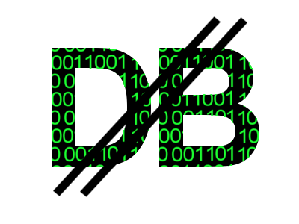 | Digital Bank  /DIBA/
Welcome to the world of Digital Bank, DIBA for short. DIBA is a crypto currency. It departs from the traditional model, by preallocating all the world's currency.

Currency is represented by a cryptographically special set of numbers. These numbers are generated at the time of the birth of Digital Bank. It is temper resistant and speculation free. The cryptographically special numbers are symbolic, creating a placeholder for the currency to be the deposited, withdrawn, transferred or spent.

On the following lines, there is an example of five cryptographically special numbers:

9e558141a3e31637ea4f3ddeb7db5f098c9f5462db9677f72c1eead6cb35a029
518764c6310e5f3aa98f5ef0e1c54ba44cb3e934cfa7a482f929db8f37fc3185
6a4b5b4bdaa07e08e6ce19084e61cdc047b6b1ba5cd84ab9f0b9a4602c0698bc
f18c0c90f1a11106ffc8bd6b4595448cf887314701172cf4c73cf245abb447be
90298292dc06dade2364319d6f557141f8070167cd3651ebc4cfbba26a5e93e7
(This is a test output from the DIBA gen generator, does not represent any currency)
So what is so special about these numbers? They are a hash of a group of numbers that meet a certain criteria. They are resistant to modifications and are very easy to verify. It makes them ideal to use in crypto currency.
A similar set of numbers can be used to identify customers. (We call it mode-ing) In this case we mean Digital Bank customers which could be institutions, corporations countries or individuals.
DIBA would operate on top of its own block chain. Blockchain technology has evolved to the point where one can create a transaction ledger that is immutable. DIBA would use the immutable transaction ledger to allow customers to deposit into the DIBA system, withdraw from it, or transact with other customers.

Advantages:
DIBA would solve a host of challenges. Possibly, the most important one is stability. As DIBA pre-allocates all its numbers, (all its currency) there is no room for speculation. The currency will not be able to exhibit sways up or down, and it would represent a grounding foundation for global transactions.
It would also solve the white-market black-market phenomena, were some currencies can only be traded on the black market. DIBA would welcome all entities. Difference in opinions and beliefs will no longer influence the value of the currency.
Another important aspect is fine-tuning of privacy. Every customer is allocated a cryptographically created, secure number. Only authorized representatives would have access to the information of who is the actual owner of that number. This allows balancing of privacy and accountability. The privacy of every transaction is protected, and allowance to lawful investigation is given. As a consequence, DIBA would create a legitimate path to global accountability.
Last but not least, this is a vehicle where Universal Basic Income (UBI) could take foothold. As a global entity, the payload on this universal basic income would be evenly distributed. The benefit in worldwide stability alone is immeasurable.

Global Currency Allocation:
From the image below, one can decipher current distribution of currency.
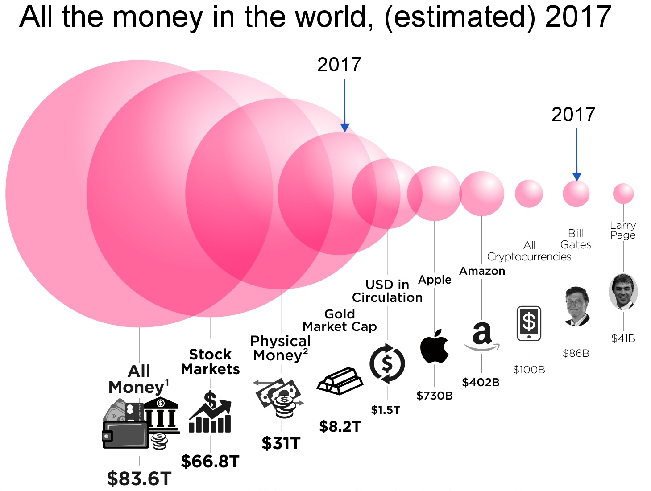
An estimated $100 trillion is a good starting point to encapsulate all the money that exists currently, and will exist in the foreseeable future.
At the initial stages of Digital Bank (DIBA), the hundred trillion dollars would be symbolically placed in the global ledger. As depositors acquire parts of the currency, the matching cryptographic numbers would be activated and marked as owned by that particular depositor. The publicly visible block chain would permit the verification and truthfulness of every transaction.

The current state of the project.
The cryptographically secure numbers are generated. Verification of those secure numbers will be published as open source. Special encryption algorithm for this project has been developed, and it passes the bit distribution and the byte distribution study better than any known algorithm thus far.

Reasons for this crypto currency?
DIBA would represent a non speculative entity. In a world, where speculation, instability, fraud is so prevalent, one needs a solid foundation to preserve value.

Another reason is globalization. There are trends and opinions that would like to reverse globalization. But we cannot put it back in the box, might as well create happiness and abundance out of it. DIBA would represent an equitable platform throughout the globe, assisting exchange.

Preventing money-laundering. A true 21st-century plague, and it has taken many many forms. With the semi-anonymity of DIBA, criminal investigations can uncover illegal activity. It can also uncover “ currency hoarding” a truly harmful trait for our century.

Universal basic income. (UBI) With automation and artificial intelligence, not to mention mass production we have upset the balance of the employment curve. No longer the traditional adage of “you don't work you don't eat” is true. Quite the opposite. Our talent and creativity has blessed us with productivity beyond our wildest dreams. But not everyone could participate. In those who cannot, still need to be provided with basic dignities. We can afford that relatively easily. It would create global stability.

Erasing black-markets and creating global prosperity. No longer ideologies can interfere with our created value and exchange of that value.

Secure Voting technology.
The cryptographically special numbers can be securely mode-ed in an almost infinite way. The technology is so powerful, that with very little modification, we can create a cryptographically special set of numbers that represent voters. With few transactions, we can craft a voting system that is publicly verifiable. Better yet, verifiable by every individual voter that voted. The few transactions would be: Register for voting; Approve registration; Cast vote; Un-cast vote;

For more information please contact PeterGlen99@gmail.com

