Digital Bank Operation

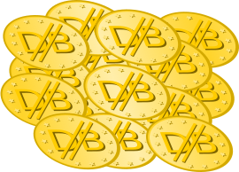 | All the world's currency is allocated at inception.
 | A digital symbol is created for every currency unit. Digital Bank Currency Unit. (DBCU)
 | Clients may take possession of a currency unit, and trade it, exchange it for goods and labor.
Because the currency represents a known value that is accepted planet wide, no currency manipulation is possible. It creates a uniform value across the globe, preventing exploitation. The currency is semi anonymous, creating a framework for global privacy and accountability.

