LoraWiFi Drone Detector
User manual and description

Introduction:
Welcome to the LoraWiFi drone detector. This device listens with a powerful microphone, analyses the sound it hears, and sends an alert if it detects a drone’s sound. The alert is then sent on a LORA radio communication line. The counterpart of the drone detector device listens to these messages.

Deployment:
The drone detectors can be deployed as a line or array of detectors. For instance protecting a physical border. But if an area or an installation needs to be protected, any configuration which covers the target area is acceptable. The microphone’s angular characteristic is approximately a 45 degree cone.
Detector
Mic
Drone

Innovation:

The LoraWiFi drone detector contains a state of the art signal analysis algorithm. The algorithm analyzes the incoming sound spectrum, and identifies the dominant frequency components. These frequency components are then compared to a reference set of frequency components. When a match is detected, the drone detector sends the alert signal.

The challenge was to run the frequency analysis on a low power micro-controller. As it has significantly lower processing power than a real microprocessor, extreme innovation was necessary. Happy to announce, that we successfully invented a new type of signal analysis that fulfills the task perfectly. The tests thus far prove excellent performance. The drone noise is successfully and accurately distinguished from many other signals. For instance motorcycle engine noise is not detected as a drone noise. The detection is so accurate, that we venture that the category of drone can also be identified with this algorithm. The false positive ratio and the false negative ratio of a single unit is better than 15 to 1. Multiple units improve this ratio cumulatively.

Functional description:
The drone detector is built on top of a state of the art consumer micro-controller, an ultra sensitive microphone and a low power, long range (LORA) transmitter.
Pre-Amplifier
Analog to Digital
Converter
Frequency
Analysis
Drone Spectrum
Detection
Mic
TX
Y
N
Antenna
Micro Processor
Please note that the flowchart above is an oversimplified version of the operational logic.

Power supply:
The device can be powered from a 5V standard USB connector. This can be then extended to any power arrangement; for instance a solar panel powered battery solution.

Alert Communication:
The alert is communicated with a LORA radio. This operates in the 433 MHz range, and is license free. The specified range of the LORA radio is from 500 meters (in built up areas) to 10 kilometers (line of sight). The practical range is about 300 meters to 5 kilometers.
The alert itself can be freely specified, any text up to 230 characters. We recommend as short as possible. For example, the alert text can be: “Alert: Station 34”
The station identification is an essential part of the alert, as it identifies the source of the message.

Communication robustness:
The LoraWiFi Drone detector can send a heartbeat, signaling the receiving station that everything is OK. This confirms that the radio link is operational, that the detector is listening, and everything is in working order. If and when the heartbeat is missing, there is something not operational or jammed. In that case, appropriate measures can be taken by the operator of the drone detector system.
The heart beat string can be specified, any text up to 230 characters. We recommend as short as possible. For example, the heart beat text can be: “OK, Station 34” The station identification may be an essential part of the heartbeat, as it identifies the source of the message.
Listen and Delay
N minutes
Heartbeat
Arrived?
Y
N
Missing Heartbeat
Alert
Increment Heartbeat counter
Reset
Heartbeat counter
Missing Heartbeat
Counter too big?
Heart beat
Arrived?
N
Y
Please note that the flowchart above is an oversimplified version of the required logic.
Any LoraWiFi Drone detector can be used as a monitoring station as well. The occurrence of the alert can be communicated in several ways. One of the most diverse of those is a terminal string. The LoraWiFi USB can be connected to a computer (or cell phone), and a terminal emulation program can read the output of the drone detector. The alert is delivered as a text, which is configurable.
The second monitoring facility is a WiFi transmission. This essentially acts as a LORA to WiFi router. Whatever comes in via the LORA channel, is replicated to WiFi. The WiFi signal than can be interpreted as desired.
The third monitoring facility is a simple colored LED. The LED is lit up in bright red color.
The fourth monitoring facility is a small buzzer. This sounds briefly on detection.
The missing heartbeat signal can be communicated by the same method. The difference is the actual value of the terminal string, or the WiFi repeat signal, or the color of the LED, which is lit up orange.

Configuring the LoraWiFi Drone Detector unit:
In order to configure the device, one needs to connect to the WiFi interface presented. The name of the device is ‘LoraWiFi-NNNN’ where the ‘NNNN’ is the last 4 digits of the device ID. (mac address) For example, one of the development board’s name was: ‘LoraWiFi-0567’ (without the quotes). The default password to connect to the board is ‘12345678’ (without the quotes). After the connection is established, one may connect to the device’s browser. In the browser’s URL bar enter:
http://192.168.4.1
The device’s home page should be presented, which is pictured below.
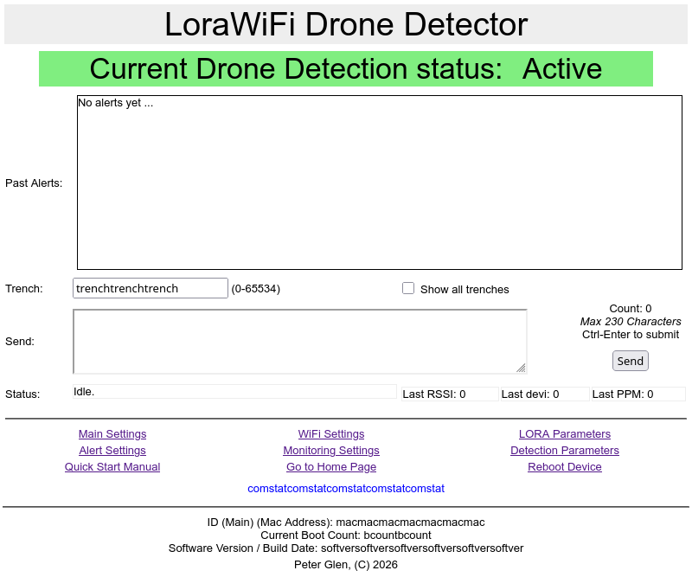
The device configuration consists of three main sections.
- The Communication section
- The Detection section
- The Monitoring section

The Communication section
This section allows one to configure the wireless radio subsystem related items. The first screen configures the WiFi host name and password. This is standard configuration item, the screen below is mostly self explanatory.
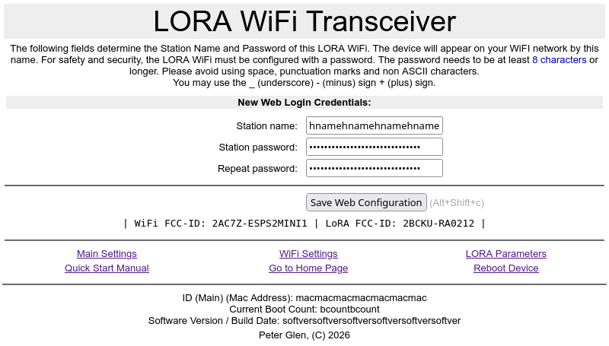

The LORA config section
The second screen configures the LORA subsection. The screen below depicts the configuration items. The defaults of the communication parameters can be restored
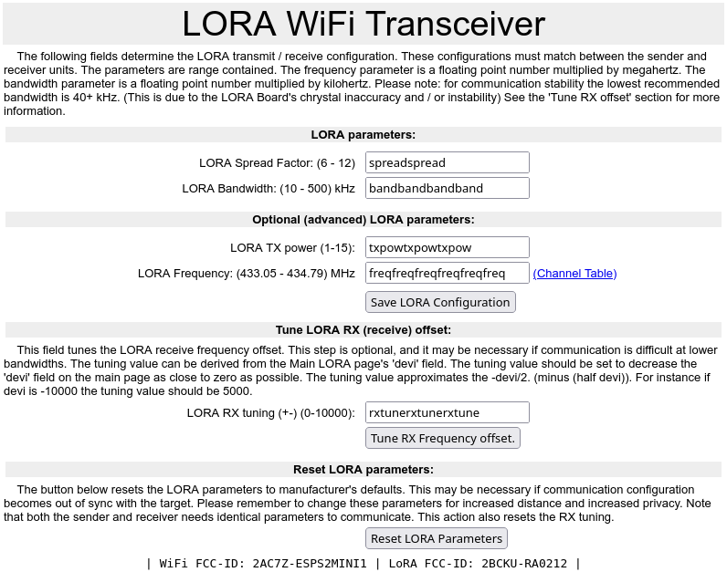

The Detection section

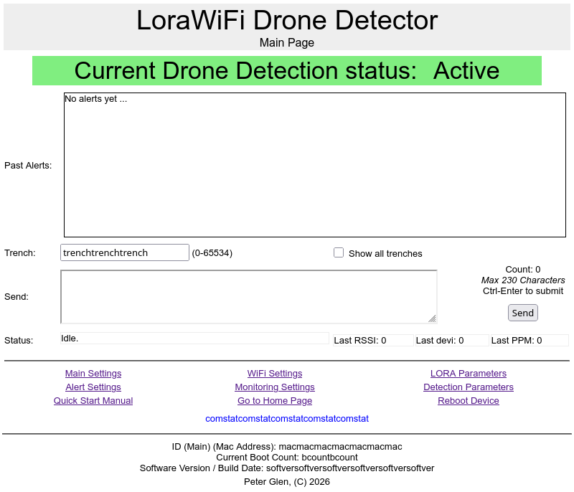

The Monitoring section

