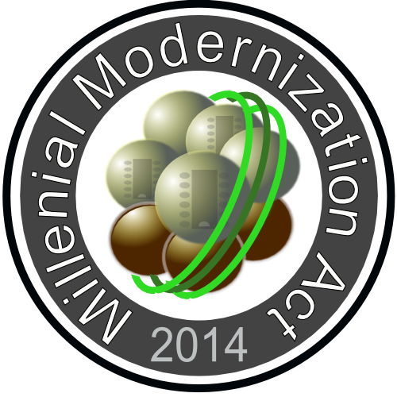

Millennial Modernization Community

Millennial Modernization Community is a subset of the Millennial Modernization Act.

Introduction, Purpose:

The Millennial Modernization Community (MMC) is created with the purpose of starting an organization that ends hunger, promotes self expression, stops needless suffering and encourages peaceful co-habitation. We are inviting you to be part of this revolutionary solution for today's greatest problems.

No child should go hungry; No person should go hungry; No human being should be without basic needs like food, facilities for fundamental hygiene, facilities for rest, and basic care for health including mental help. The Millennial Modernization Community is created to provide for this very need. The directive is simple. Any person that shows up at an MMC location will be fed, given a spot to rest, and will be provided any assistance necessary. Assistance from resources that the community can make available.

Discussion:

To this end, the Millennial Modernization Community is soliciting help in a form of donation and/or investment. a.) To create the organization, b.) To rent/lease/purchase/build facilities to render services from, c.) To employ minimal staff to run the organization, d.) To maintain accounting and reporting as needed, e.) To purchase supplies and equipment that is necessary to execute the operation. f.) To lease / buy land to allow self sustaining communities to form.

Naturally, the bulk of the help will come from existing Infrastructures and from Volunteers. There are food banks, that already cater for some of this need. They provide an essential service, however, the food banks themselves have limited resources to distribute the food. They are mostly open (and provide services) one or two days a week. The TRUE breakthrough of the Millennial Modernization Community is creating a space, where a person in need shows up at any time, and gets his / her basic necessities met.

No person is left behind. The Millennial Modernization Community promotes human equality, advances avenues to improve quality of life, secures better distribution of resources. Among many other things, it paves the path to self expression, dignity and freedom for all. Restores the sanctity of life, peace and non interference.

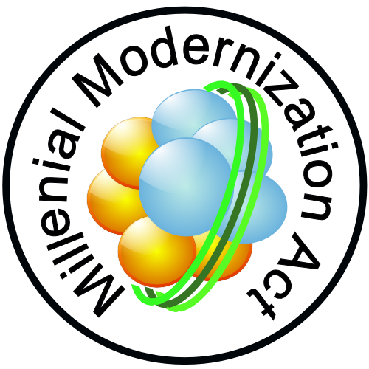

Millennial Modernization
Community

Millennial Modernization Community is a subset of the Millennial Modernization Act

Stopping greed at its source:

Greed awakens when a person recognizes that no one helps him/her. While greed has useful implications, the greed induced by severe need is a harmful greed. The kind of greed, that makes people grab as much as they can, when the opportunity arises. Erasing that kind of greed is our top priority as a human race. For peace, harmony and for the sake of future generations.
In today's modern world, where resources are plentiful, no human being should suffer from the lack of basics. Inequality does not have to hurt. While there is nothing wrong with creating abundance, and being rewarded by abundance, there is something wrong with having great abundance for some, and having the ultimate suffering for most. We are calling upon the people with plenty, to share.

Offering True Help:

When a person is in need, all the his or her basic needs will be met by MMC. Additionally, the MMC system will assist the person on the path for useful and fulfilling life by assigning a volunteer to be an agent of recovery. The assignment is voluntary, MMC will act as a clearing house for connecting helper to helped.

The Pilot Study:

The root location for the the initial Millennial Modernization Community is Venice, FL, USA. Because the Millennial Modernization Community addresses a fundamental human need, we anticipate, that after the pilot study, the assistance system can be replicated easily, and the MMC system has a distinct chance to go global.

Contributions:

Be part of a solution for easing humanity's greatest suffering. Contributions can be made to the author's PayPal account at peterglen99@gmail.com. Your contributions are appreciated, and we issue a written receipt. Please give clear instructions where the receipt should be sent. Also specify if you want to remain anonymous, or you wish your contributions to be announced.

The Millennial Modernization Community document is in the public domain. Unlimited and unrestricted access is granted. Feedback and updates to this document is encouraged.

Please contact the author, Peter Glen if you have any questions at the email above.

