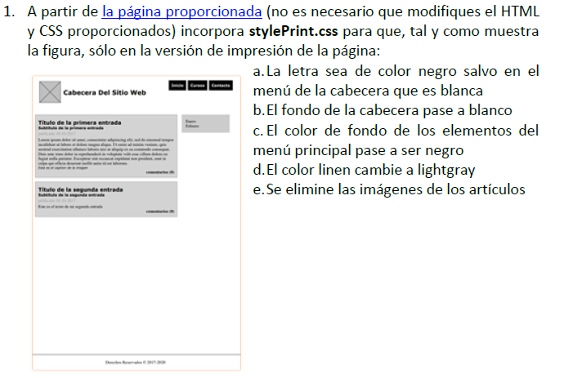

* <https://pgmonreal.github.io/DIW/U2/PRAC2/E1/index.html>

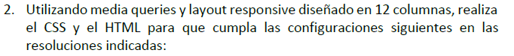

* <https://pgmonreal.github.io/DIW/U2/PRAC2/E2/index.html>

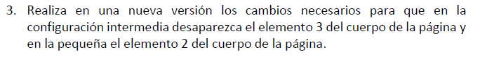

* <https://pgmonreal.github.io/DIW/U2/PRAC2/E3/index.html>