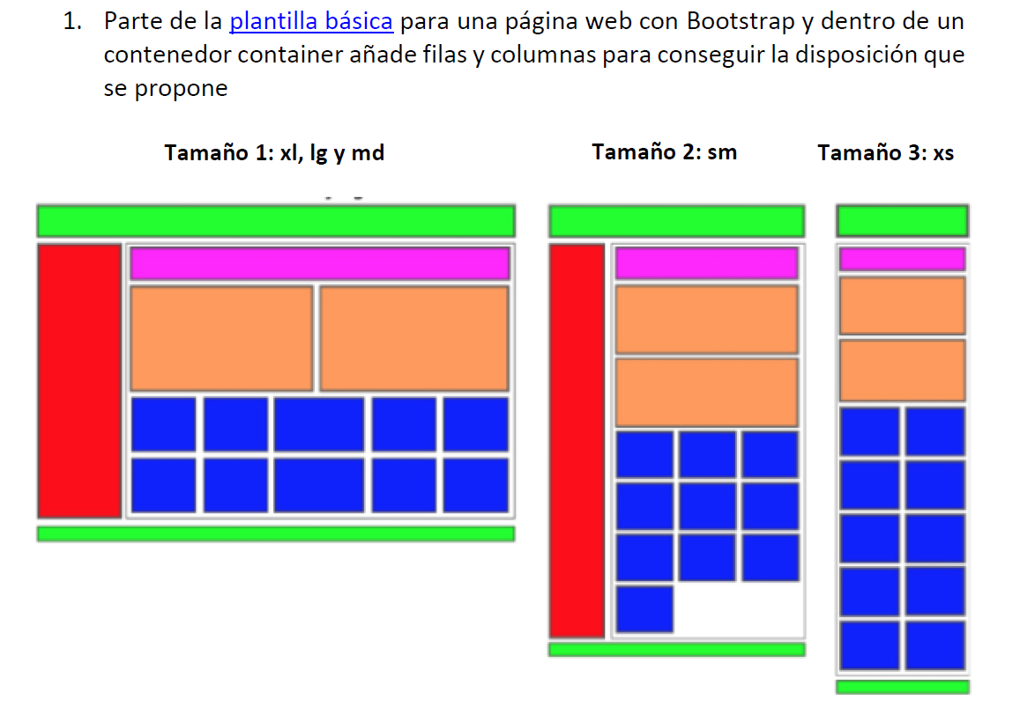

* <https://pgmonreal.github.io/DIW/U2/PRAC3/E1/index.html>



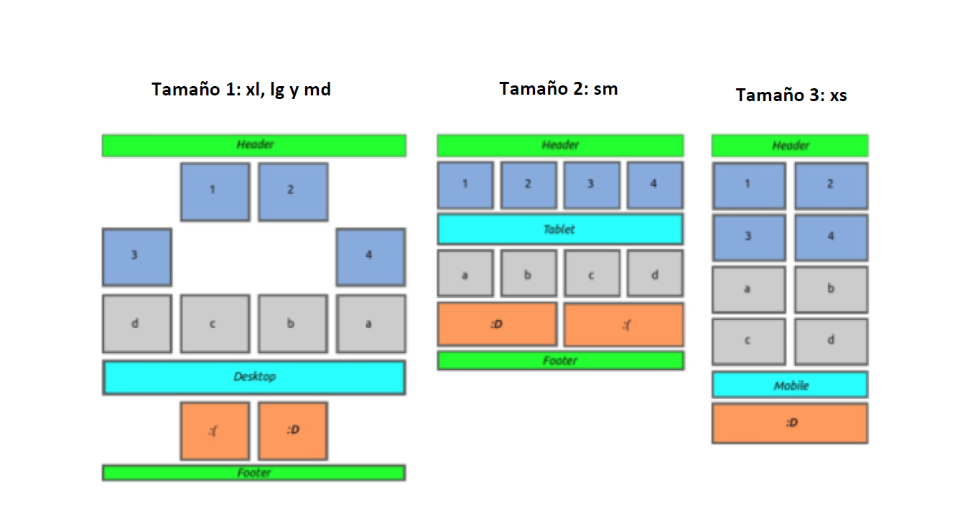

* <https://pgmonreal.github.io/DIW/U2/PRAC3/E2/index.html>